Configuring Integration Package SuccessFactors LMS Curricula with SAP HCM Qualification
Contents
1. Introduction 2
2. Common Steps 3
2.1 OAuth Token Credential Deployment 3
2.2 SAP Credential Deployment 5
2.3 SFSF Credentials Deployment 7
2.4 Value Mapping Maintenance 10
3 Curriculum Catalog Synchronization 10
Scheduling the iFlow 12
Parameter Settings: 13
Value mapping settings: 14
4 Curriculum Status Synchronization 14
Scheduling the iFlow 16
Parameter Settings: 17

1. Introduction
This document provides an overview of the artifacts delivered as part of SAP HCM – LMS integration using HCI and configuration of it in a customer landscape.
The document discusses some of the common configuration steps first which are needed across all the scenarios and then give a detailed configuration of the individual iFlows.

Common Steps

2.1 OAuth Token Credential Deployment
The sreenshots below shows the steps required to configure an OAuth2 Token credential.
In the Node Explorer view, right-click on the cluster and choose ‘Deploy Artifacts’ from the context menu.
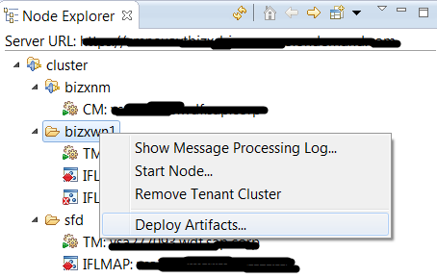
A wizard would be displayed as shown below. Choose the ‘OAuth2 Authentication’ option and click on ‘Next’ button.
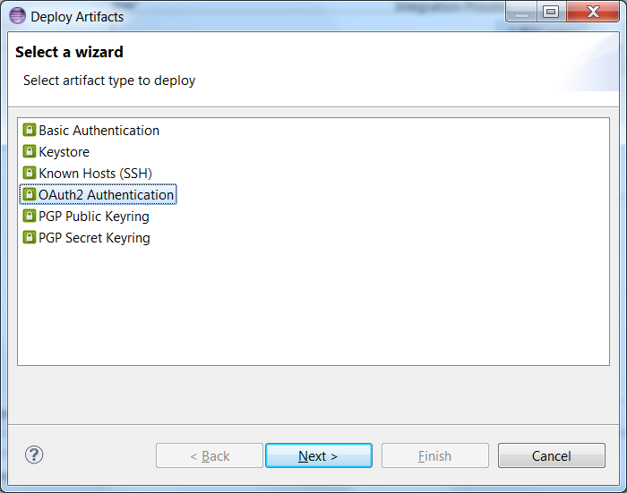

Fill the text boxes below with the appropriate values for connecting with an LMS system.
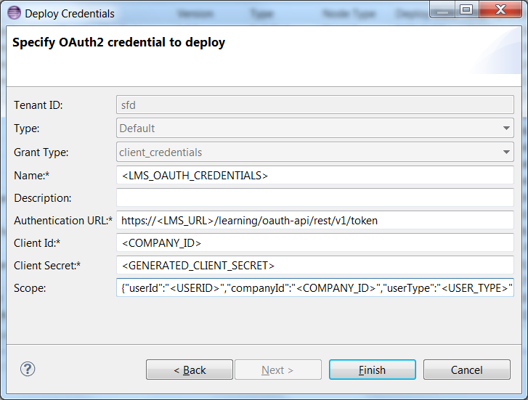
Authentication URL: https://<LMS_URL>/learning/oauth-api/rest/v1/token
Client Id: <COMPANY_ID>
Client Secret: <GENERATED_CLIENT_SECRET>
Scope: {"userId":"<USERID>","companyId":"<COMPANY_ID>","userType":"<USER_TYPE>","resourceType":"learning_public_api"}

Finally click on the ‘Finish’ button and a success message like below should be displayed.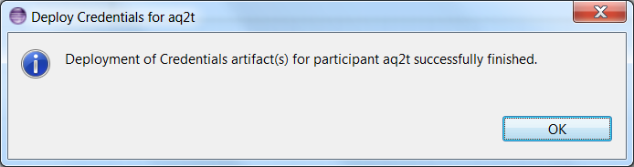

2.2 SAP Credential Deployment
The sreenshots below shows the steps required to configure an SAP credential.
In the Node Explorer view, right-click on the cluster and choose ‘Deploy Artifacts’ from the context menu.
A wizard would be displayed as shown below. Choose the ‘Basic Authentication’ option and click on ‘Next’ button.
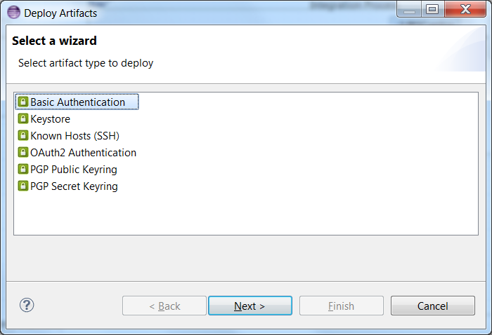

Fill the text boxes below with the appropriate values for connecting with an SAP system.
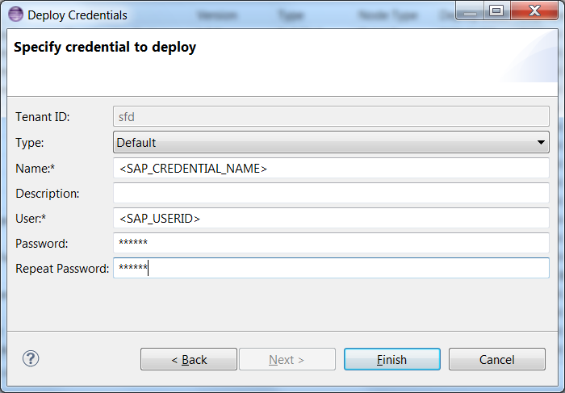
Finally click on the ‘Finish’ button and a success message like below should be displayed.

SFSF Credentials Deployment

The sreenshots below shows the steps required to configure an SFSF credential.
In the Node Explorer view, right-click on the cluster and choose ‘Deploy Artifacts’ from the context menu.

A wizard would be displayed as shown below. Choose the ‘Basic Authentication’ option and click on ‘Next’ button.

Choose the Type as ‘SuccessFactors’ and fill the text boxes below with the appropriate values for connecting with an SFSF system. Click on the Next button.
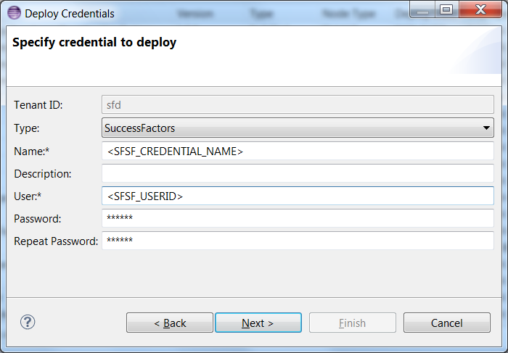
On the next screen, provide the Company ID.
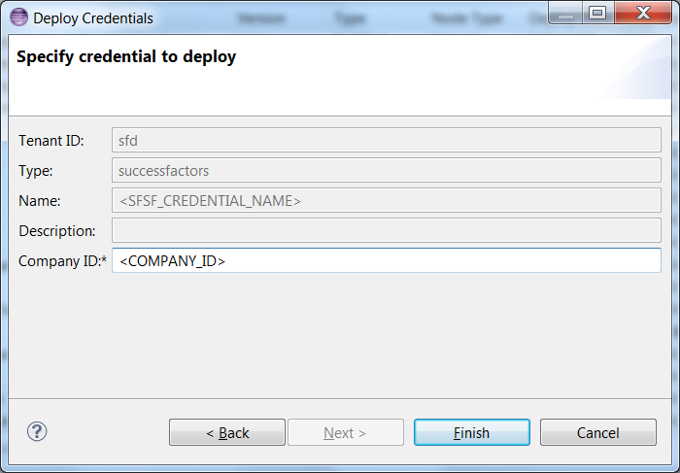

Finally click on the ‘Finish’ button and a success message like below should be displayed.

2.4 Value Mapping Maintenance

A value mapping project would be delivered along with the iFlows in this integration. It needs to be deployed in the customer landscape so that the iFlows can refer to them.
Refer the section 2.3 in this document http://help.sap.com/cloudintegration/SAP_HCI_DevGuide.pdf for general information about Value Mappings.
To edit an existing Value Mapping refer to section 2.3.2 in the above document.

3 Curriculum Catalog Synchronization
The following screens explain the steps needed to configure the Curriculum Catalog Synchronization iFlow before deploying on the customer landscape.
Open the iFlow in the eclipse HCI ‘Integration Designer’ perspective. By clicking anywhere on the iFlow screen, several tabs should appear below the diagrammatic representation of the iFlow. Here, choose the ‘Externalized Parameters’ tab as shown below.
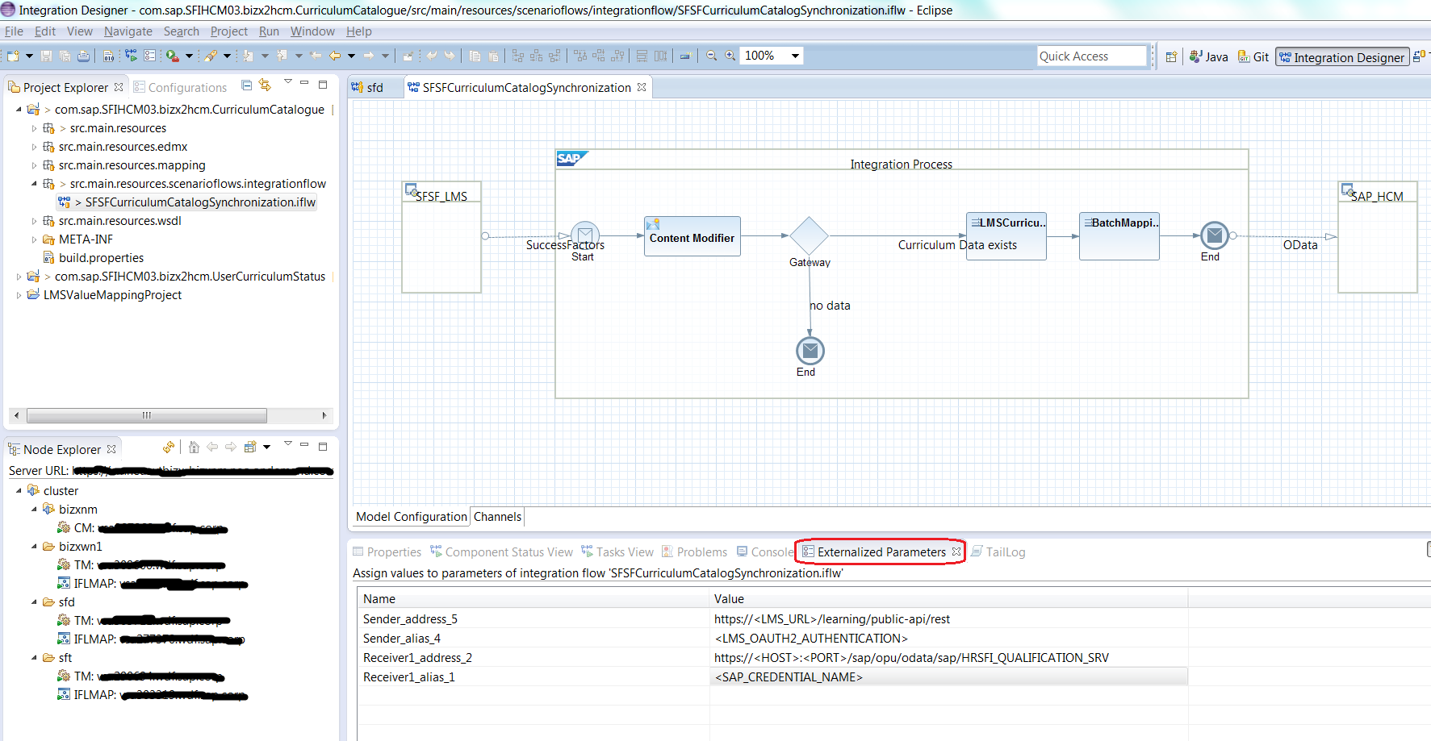

Here is a close-up view of the ‘Externalized Parameters’ tab.
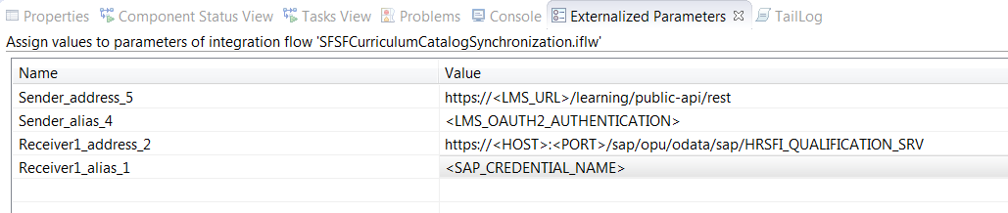
The parameters should be changed as per the customer landscape. The parameters are described as below –
<LMS_URL> - host name of the LMS system
<LMS_OAUTH2_AUTHENTICATION> - name of the OAuth2 Authentication credential created as described in this section of this document.
<HOST> - SAP HCM system host name
<PORT> - SAP HCM system port number
<SAP_CREDENTIAL_NAME> - name of the SAP Credential created as described in this section of this document.

Scheduling the iFlow

The following screens describe the steps needed to schedule iFlow.
Firstly, double-click on the source adapter (SuccessFactors, in this case), as highlighted below.
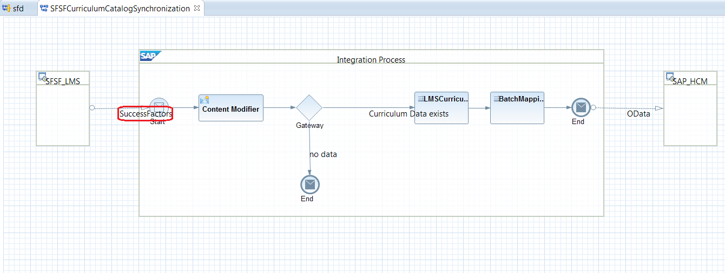
Click on the tab ‘Adapter Specific’, and the ‘Scheduler’ sub-tab. Here, the iFlow can be scheduled to run as per the requirements of the customer. For ex., On a specific date & a specific time, Daily, Weekly, etc.
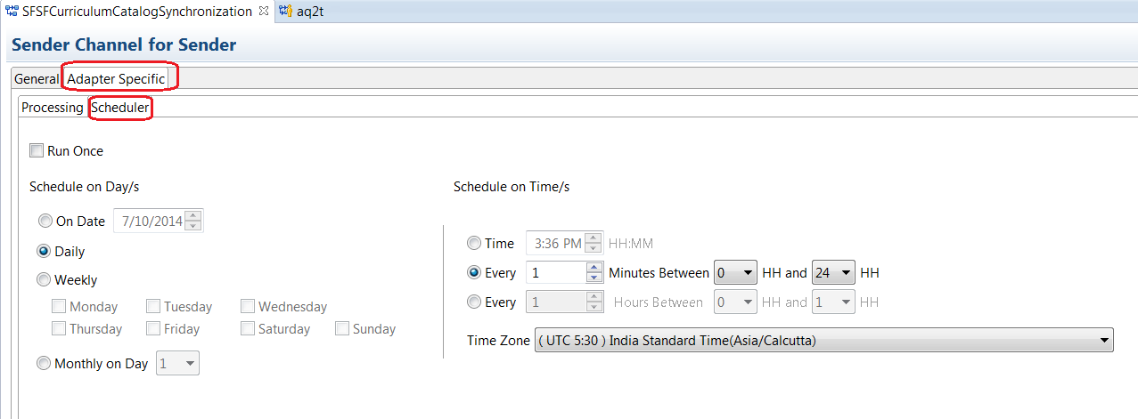

Parameter Settings:
The following parameters influence the runtime behavior of the iFlow. Click on the step ‘Content Modifier’ and click on the ‘Properties’ tab under the iFlow to view/ edit the parameters.
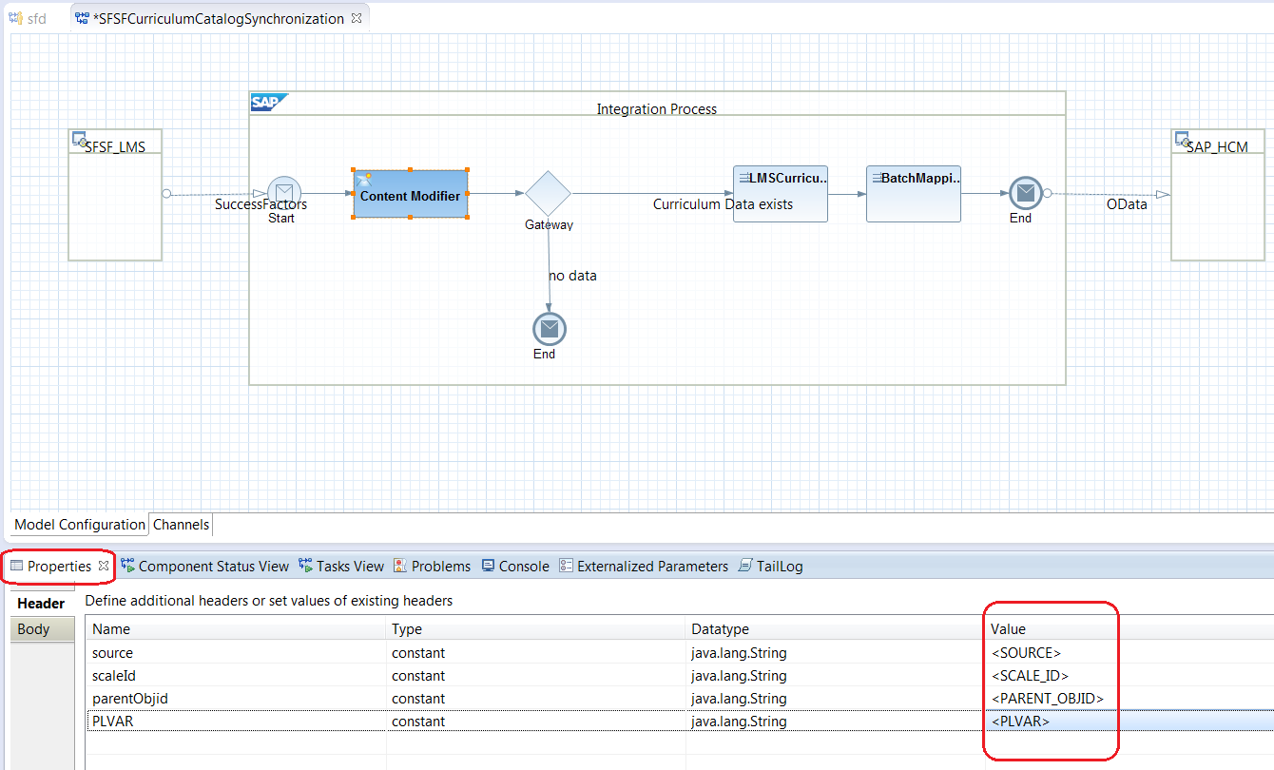
<SOURCE> - value of the QUAL_SOURCE that would be set in the source of the Qualification created/ updated
<SCALE_ID> - value of the SCALE_ID that would be set in the source of the Qualification created/ updated
<PARENT_OBJID> - value of the PARENT_OBJID that would be set in the source of the Qualification created/ updated, in case the curriculumType is BLANK in the source.
<PLVAR> - value of the PLVAR that would be set in the source of the Qualification created/ updated

Value mapping settings:
LMS locale to SAP HCM language mapping has been achieved through Value Mapping. A default Value Mapping project has been shipped along with this project.
The entries can be modified in this project to suit the needs of the customer. Refer to this section of this document for more details.
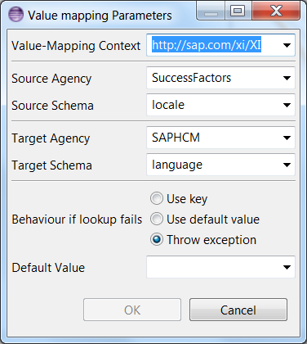

4 Curriculum Status Synchronization

The following screens explain the steps needed to configure the Curriculum Status Synchronization iFlow before deploying on the customer landscape.
Open the iFlow in the eclipse HCI ‘Integration Designer’ perspective. By clicking anywhere on the iFlow screen, several tabs should appear below the diagrammatic representation of the iFlow. Here, choose the ‘Externalized Parameters’ tab as shown below.

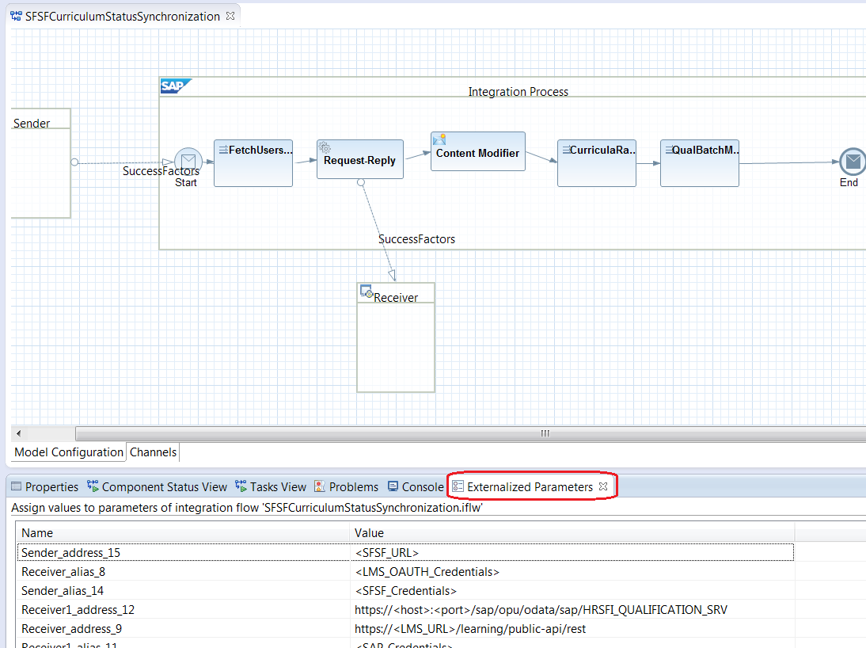
Here is a close-up view of the ‘Externalized Parameters’ tab.
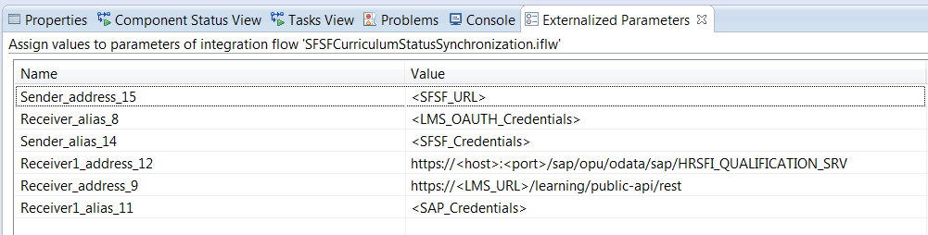
The parameters should be changed as per the customer landscape. The parameters are described as below –
<SFSF_URL> - the SuccessFactors URL, depending on the data center used by the customer. For ex., https://performancemanager4.successfactors.com.
<LMS_OAUTH_AUTHENTICATION> - name of the OAuth2 Authentication credential created as described in this section of this document.
<SFSF_Credentials> - name of the SFSF Credential created as described in this section of this document.
<LMS_URL> - host name of the LMS system
<HOST> - SAP HCM system host name
<PORT> - SAP HCM system port number
<SAP_Credentials> - name of the SAP Credential created as described in this section of this document.

Scheduling the iFlow

The following screens describe the steps needed to schedule iFlow.
Firstly, double-click on the source adapter (SuccessFactors, in this case), as highlighted below.

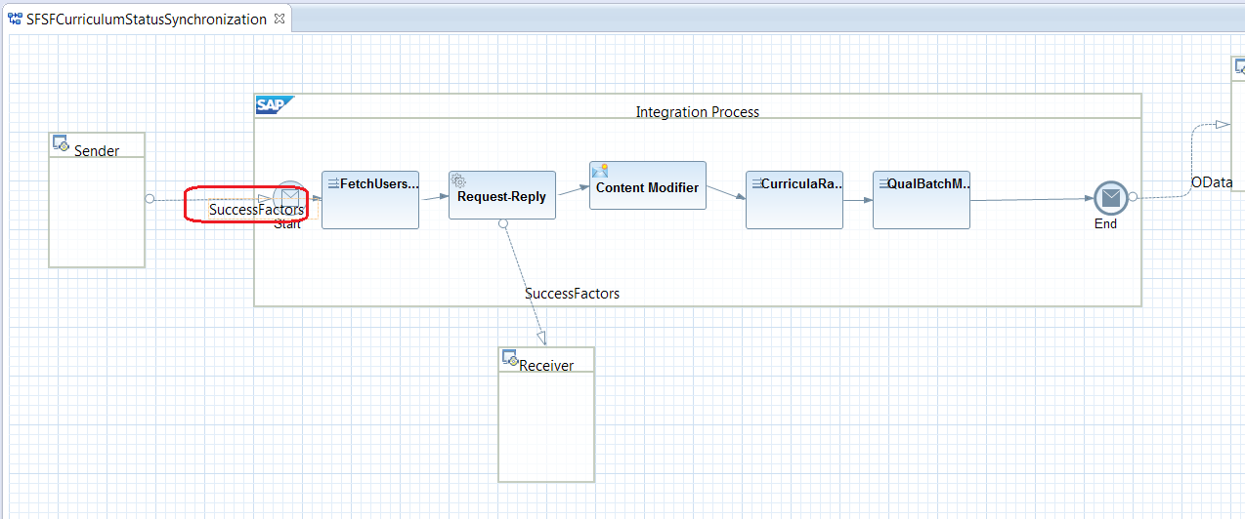
Click on the tab ‘Adapter Specific’, and the ‘Scheduler’ sub-tab. Here, the iFlow can be scheduled to run as per the requirements of the customer. For ex., On a specific date & a specific time, Daily, Weekly, etc.

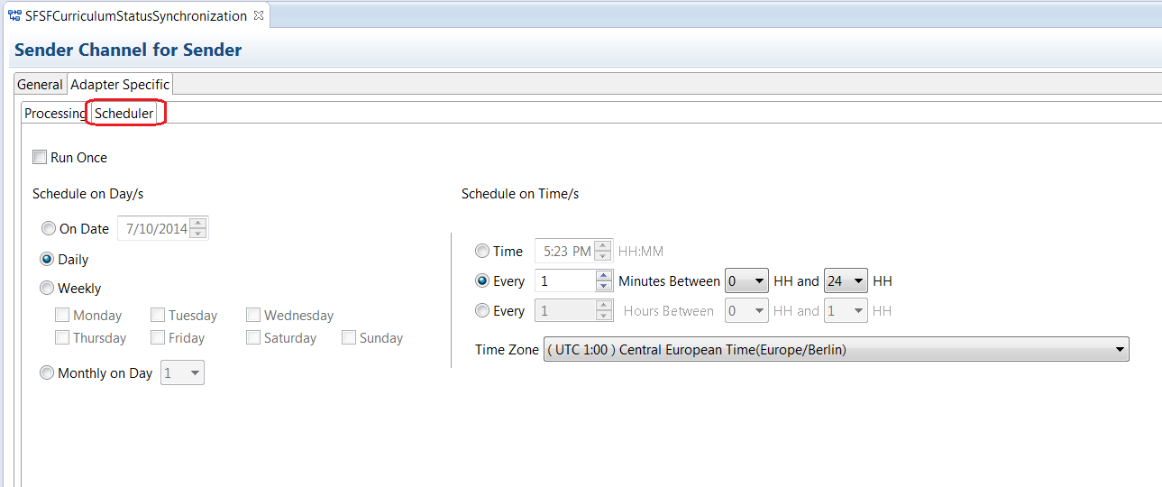

Parameter Settings:
The following parameters influence the runtime behavior of the iFlow.
Users Filtering: The iFlow by default runs for all the Users in the SFSF system. If this has to be filtered to run for a group of users only (for ex., HR department users), then, the iFlow needs to be modified. To do this, double-click on the source adapter (SuccessFactors, in this case), as highlighted below.

Click on the tab ‘Adapter Specific’, sub-tab ‘Processing’. Click on the ‘Model Operation…’ button to start a wizard.

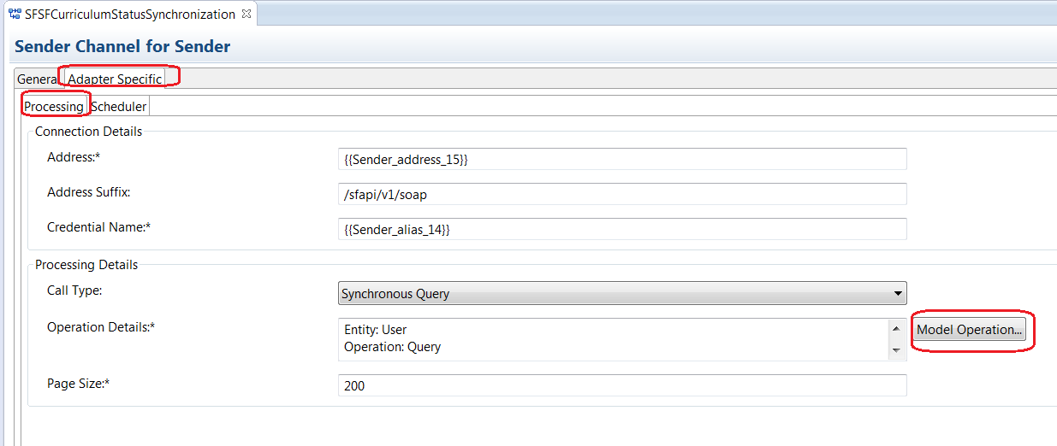
In the first screen of the wizard, provide the SFSF connection details like Address, Company ID, Username and Password. If a proxy is used, provide the same and click on ‘Next’.
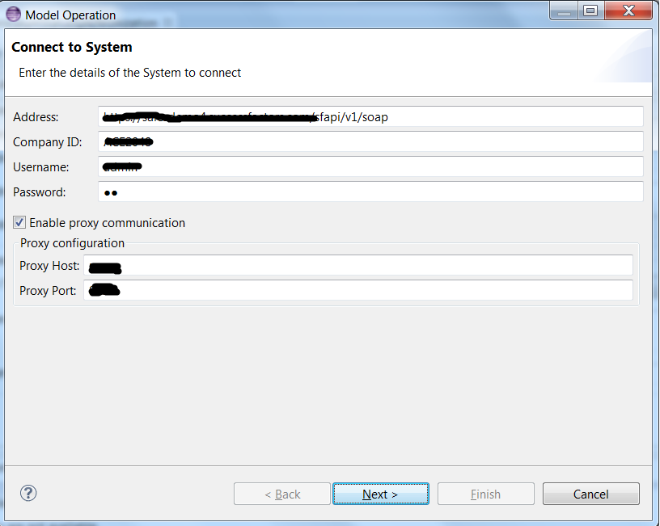
A list of entities would be displayed. The list can be filtered by typing in the text box as shown below. Select the entity ‘User’ as highlighted below and click on ‘Next’ button.
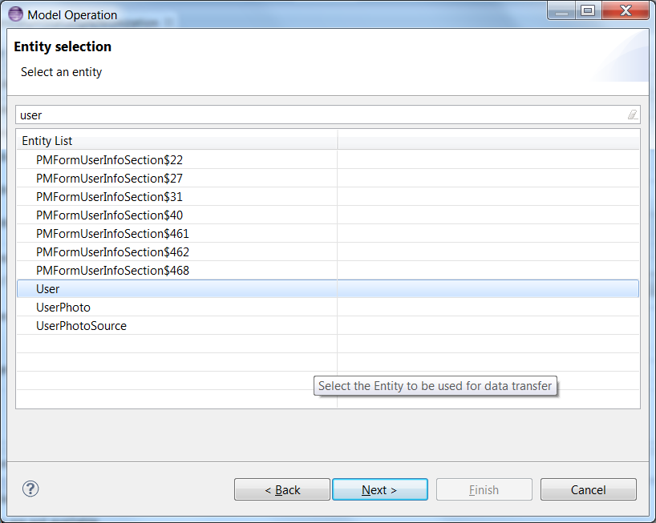
A list of fields in the ‘User’ entity would be displayed. Here search and select field ‘username’ and click on ‘Next’.
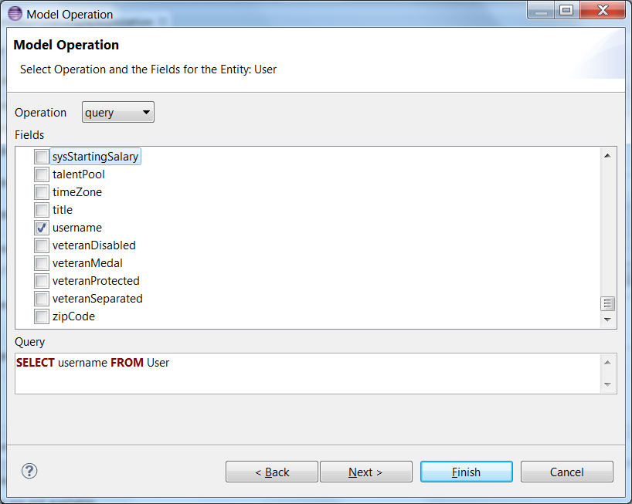

This is an IMPORTANT step in this setting because this is where we set the filter criteria. Select the filter field (for ex., department), operation as ‘=’, Input as Text and fill the value of the field as required (‘HR’ for ex,).
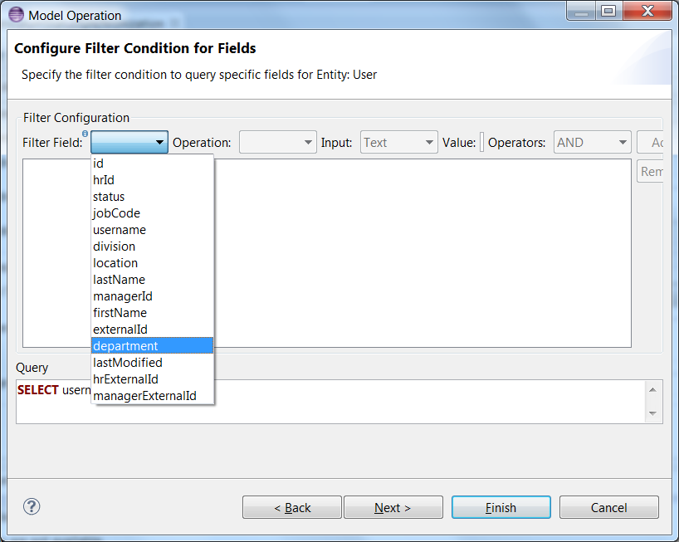

Click on Add button as shown below. Finally click on ‘Finish’ button.
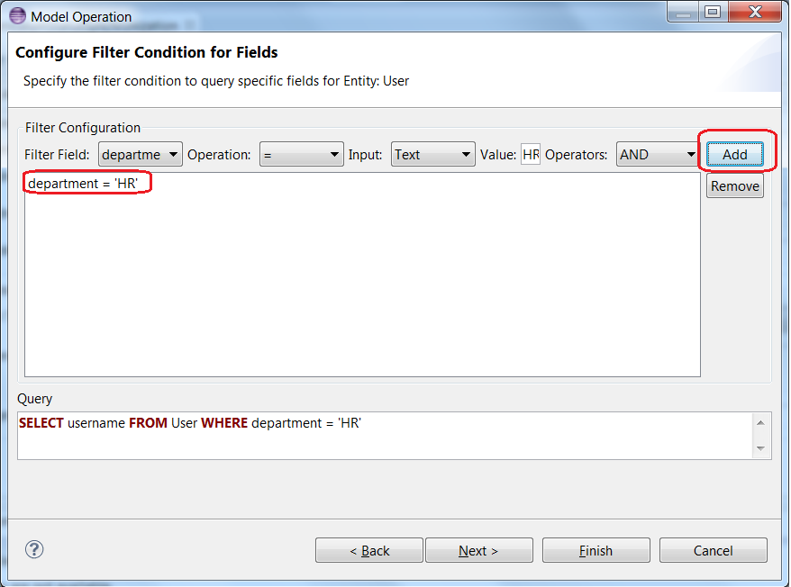

Click on the step ‘Content Modifier’ and click on the ‘Properties’ tab under the iFlow to view/ edit the parameters.

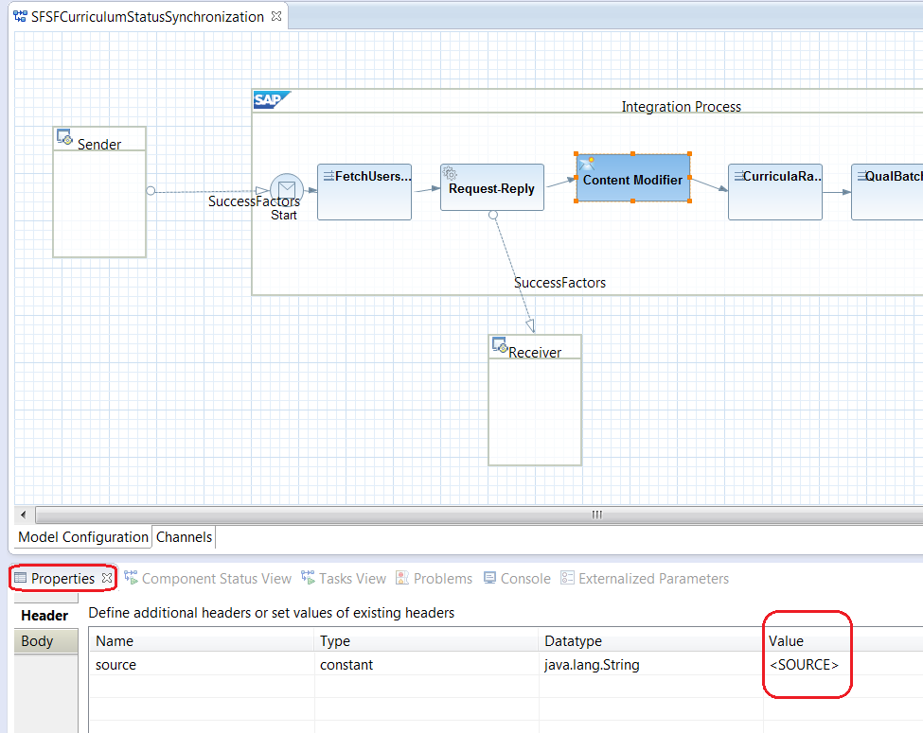
<SOURCE> - value of the QUAL_SOURCE that would be set in the source of the Qualification created/ updated

