

OpenText Supplier Invoice Integration with Email

Version | Description of change | Date | Author
1.0 | Initial version | 15.07.2021 | Kamran Akhtar
Date: 15/07/2021
Version: 1.0
Author: Kamran Akhtar

DOCUMENT CONTROL
Owner | Client contact |  | Status | Date issued
Kamran Akhtar | N/A | N/A |  | N/A
Version history log

TABLE OF CONTENTS

1 PURPOSE 3
2 OVERVIEW 4
3 PRE-REQUISITES 4
4 INTEGRATION FLOW CONFIGURATION 5
4.1 Configuration Parameters 5
5 THE IFLOW 6
6 TESTING THE IFLOW 7

PURPOSE

The purpose of this document is to describe the general configuration steps that are required to receive Supplier Invoice PDF files from Email Inbox(es) to the SAP S4 HANA Cloud System. The PDF Files are processed in the SAP CPI System and each attachment creates an individual entry in the Upload Supplier Invoice APP. This entry is created with the Attachment and the OpenText process allows the population of pre-defined fields using the file. The Interface is Capable or Extracting emails from multiple Email Inboxes with multiple Attachments.

OVERVIEW

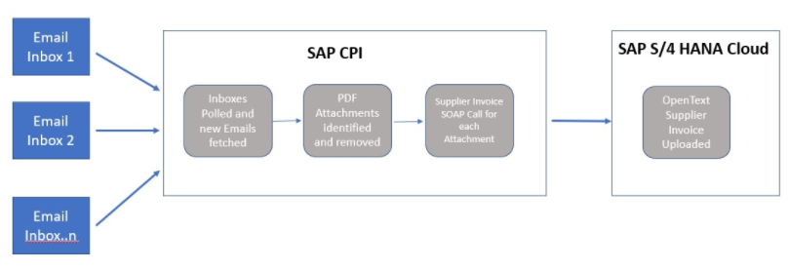
Step 1. Supplier Emails invoice attachment to specific email inbox.
Step 2. SAP CPI Polls the Inbox and fetches the new email ready to be processed.
Step 3. The iFlow then splits each PDF attachment and processes one by one in the iFlow.
Step 4. SOAP Call is made to S4 HANA Cloud system for each attachment. An entry is created with the PDF Attachment that was on the Original Email.

PRE-REQUISITES

Before configuring Integration Flow, please make sure the following prerequisites have been met:

- The SAP CPI Tenant is Configured and Operational.
- Supplier Email Inboxes need to be setup and are Active.
- Email Credentials and connection to the Email Server established by the SAP CPI Tenant.
- Communication Arrangement SAP_COM_0057 has been configured in the SAP S4 HANA Cloud Tenant. The Credentials from these are loaded in SAP CPI and are being used by the iFlow.
- Any Supplier Invoices & OpenText Configuration in the S4 HANA Cloud Tenant is completed.

INTEGRATION FLOW CONFIGURATION

Configuration Parameters

Externalized  Parameter Name | Description | Sample Value
Address  (Sender) | Email Server Address followed by Port | outlook.office365.com:143
Credential Name  (Sender) | Email Credentials to be used for Inbox Connectivity | OpenText_TestSupplier_GB
Address  (Receiver) | S4 HANA Cloud Tenant Address for SOAP Call | https://myxxxxxxx-api.s4hana.ondemand.com/sap/bc/srt/scs_ext/sap  /supplierinvoiceuploadrequest_i?
Credential Name  (Receiver) | User Credentials to be used for S4 HANA Cloud Connectivity | S4HC_Tech_User
EnableLogging | Set logging within iFlow | True

THE IFLOW
Send Supplier Invoice Email to S4HC Generic
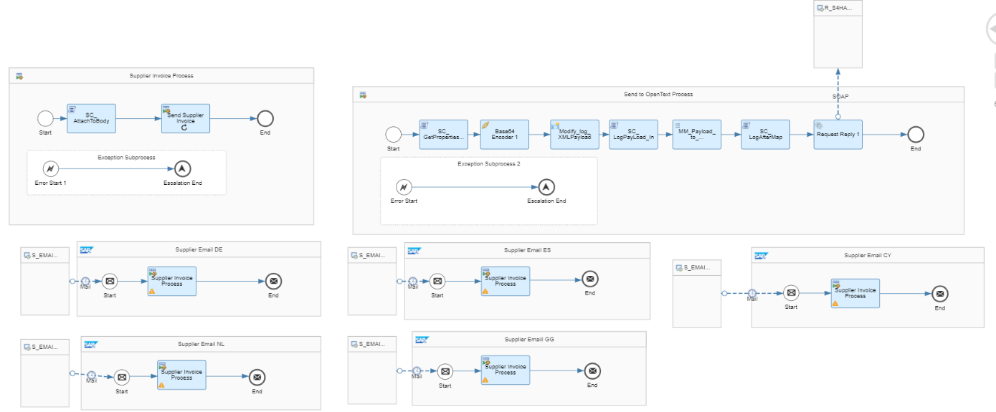

The Steps for the iFlow are detailed below:
Integration Processes created for each Email Inbox to be used in the Scenario. To add a new Email Inbox, the iFlow would need to be edited with another Integration Process added.
- Email Inbox Polled, Any new messages are extracted and loaded in the iFlow to process. Sent to Local Integration Process - Supplier Invoice Process.
- SC_AttachToBody - Script executed to make the email attachment the Main Body of the Message. PDF Attachment FileName from email extracted to be used later in the process. No of PDF Attachments identified and save in an array. The Filenames are also identified and save into another array.
- Looping Process call made for each attachment.
- SC_GetPropertiesAndSetBody – Properties set for the Attachment. Attachment set as the body of the message.
- Base64Encoder 1 - Message Encrypted to BASE64 which is the format the S/4 HANA Application expects
- Modify_log_XMLPayload - Content Modifier to set Logging Parameter. The Messages is encapsulated in XML fields.
- SC_LogPayLoad_In - Script to output the message before mapping. The Email Sender details are also logged as an attachment
- MM_Payload_to_SupplierUploadRequest - Mapping to transform message for the S/4 HANA Service supplierinvoiceuploadrequest_i
- SC_LogAfterMap - Script to output the message after mapping
- Request-Reply1 - SOAP Call made to send the message to the S/4 HANA System
The Exception Subprocess handles any errors. The message is completed and set to escalated status. The email is set to read to prevent CPI from extracting it again.

TESTING THE IFLOW

- Send an Email to the Supplier Invoice Email Account Setup. Ensure the message is sent with the Supplier Invoice as a PDF Attachment.
- Check SAP CPI Message Monitor for Message Processing
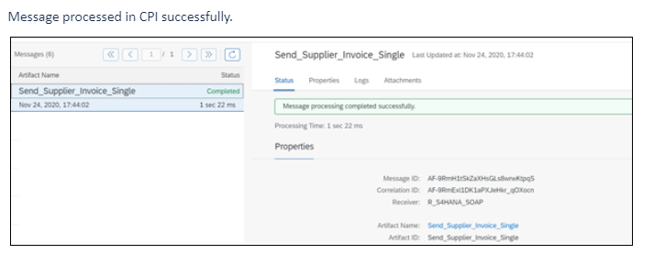
- A new Entry will uploaded in S4 HANA Cloud system in the Upload Supplier Invoice APP. This will contain the PDF Attachment from the Original Invoice.
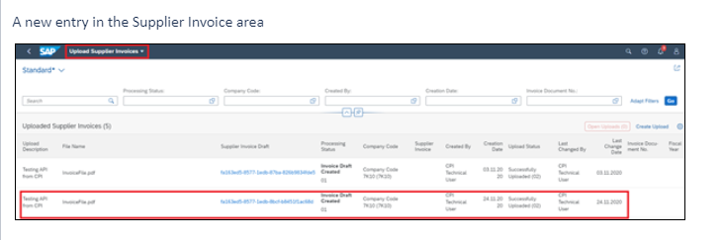
- Repeat Test by sending further Emails to the Inbox. Test with Multiple Attachments. You should get an entry for each attachment in the Upload Supplier Invoice APP.

