Motivation:
You want to Zip a message or file before transmitting.
Solution:
Cloud Platform Integration supports 2 ZIP formats to compress your message:
- ZIP Compression – Allows to compress the file using the standard zip algorithm
- GZIP Compression – Allows to compress the file using the GNU zip algorithm.

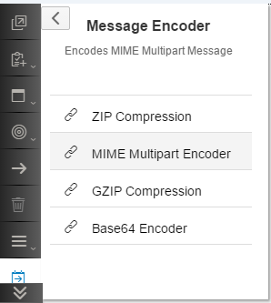
The ZIP/GZIP process step comes under:
Transformations Encoder ZIP Compression
Transformations Encoder GZIP Compression

These 2 process steps do not have any configuration properties.

Motivation:
You want to UnZip a message or file before processing.
Solution:
Cloud Platform Integration decompress 2 ZIP formats:
- ZIP Decompression – Allows to decompress the file/message that was compressed using the standard zip algorithm
- GZIP Decompression – Allows to decompress the file/message that was compressed using the GNU zip algorithm.

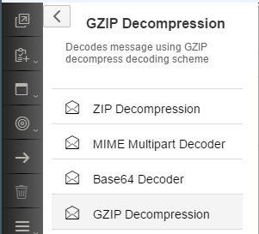
The ZIP/GZIP process step comes under:
Transformations Decoder ZIP Decompression
Transformations Decoder GZIP Decompression

These 2 process steps do not have any configuration properties.

Working Integration Flows can be found at:
WebUI Discover View Cloud Integration - Exemplars Artifacts Using ZIP-UnZIP and GZIP-UnGZIP – 2 integration flows are embedded here. The Subject of the outgoing mail will help you identify which mail belongs to which integration flow as both will get triggered when you deploy this flow.

