



Employee Personal Data Decrypt
Version 1.0

Date: 17th Jul 2025



RICEFW ID:
TD Created By: | Yogesh Wadakar
TD Reviewed By: | Krishna Kumar
TD Status:
TD Completion Date: | 17th Jul 2025
TD Approved Date:
Current TD Version: | 1.0

1

Usage guidelines and Specific Instructions:
- Document Flow- The flow of the document is generic. Specific changes to the flow will be required to be made by the client team to suit the client context.

- Document Content-The content explains the technical specification in a generic manner. Specific changes are required to be made to meet client requirements.

- Section 1 - The overall requirement summary, General technical Information,
assumptions, dependencies, and messages volume details need to be documented as a part of this section.

- Section 2 – This section caters to the detailed functional requirement. The technical flow diagram and description are to be compulsorily designed and documented here. This should also include each processing step details, Exception handling, Message
transformation and value mapping details.

- Section 3 – Finer details like Tenant Database area requirement like Data Store, variables and JMS queues requirement and specify the transport details.

- Section 4 - The section needs to cover all the key business test conditions and assembly test conditions that the enhancement must satisfy.

- Section 5 – All issues that have cropped up so far and their present status are to be highlighted in this section.

2

Revision History

Version No. | Change Date | Author | Revision Short Description | ITSM Ticket No
1.0 | 17th Jul 2025 | Yogesh Wadakar | Document prepared

Other Related Documents

Related Document | Comment

Document Approvals for all changes

Version No. | Author Name | Approver Name | Approver Role | Approve Date
1.0 | Yogesh Wadakar | Krishna Kumar | Delivery Lead | 18th Jul 2025

3

Contents
- DEVELOPMENT OVERVIEW 5
  - Requirements Summary with Process flow diagram 5
  - Cloud Integration – General Technical Details 5
  - Assumptions 5
  - Messages Volume 6
  - Messages Archival requirement 6
  - Integration Flow /process model Execution Details 7
  - Naming Convention Guidelines Details 8
  - Security, Integrity, and Controls (systems Authentication details) 8
- DETAILED TECHNICAL SPECIFICATIONS 9
  - Integration Flow / Process Model Flow Diagram including all sub processes and dependent
Integration Flows 9
  - Technical Flow Description for each Integration Process model wise 9
  - Channels Configurations 9
  - Externalization (Configuration) 10
- TESTING REQUIREMENTS 11
  - Test Body 9
  - Key Unit/Assembly Test Conditions 11

4

SAP
- Development Overview
  - Requirements Summary with Process flow diagram

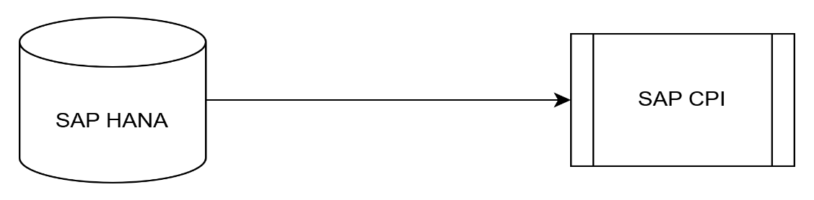

Using this integration, SAP HANA sends encrypted data in XML format (with multiple encrypted fields). In SAP CPI, a splitter is used to split the data, and decryption is applied to each part. After decryption, the data is aggregated, and a response is sent back to SAP HANA.
Cloud Integration – General Technical Details

Parameter | Description
Integration Scenario Technical Description | This integration used to decrypt the data.
Business Benefits | Securely decrypt personal data.
Process Owner | Krishna Kumar
Technical Owner | Krishna Kumar
Systems/Applications Involved | HANA 2.0
Integration Package Technical Name | SAPSFTPEmployeeDatawithPGPEncryptionDecryptiontoSAPHANA
Integration Package Name | SAP SFTP Employee Data with PGP Encryption-Decryption to SAP HANA
Integration Flow Technical name | Employee_Personal_Data_Decrypt
Integration Flow Name | Employee Personal Data Decrypt

  - Assumptions
The correct encrypted data (encrypted using the same private key) has been sent for decryption.

5

  - Messages Volume

Parameter | Description
Total Number of Messages per day | Dynamic
No of Messages per single Iflow/Process model execution | 1
Per message size in Bytes | 1KB

  - Messages Archival requirement

1. Messages Archival required? YES No
2 If YES to question 1:

- How long messages to be save in Archived area? days
- Please specify reason / explain the need for these data required? Please check all that applies.

Legal requirement:
Explain:

Business
Explain:

Tax
Explain:

Audit
Explain:

Others: Specify
Explain:

6

x

  - Integration Flow /process model Execution Details

Data Source/sender System: | HANA
Data Target  /Receiver System: | SAP CPI
Reference system for Direction below | Either sender or Receiver system mentioned above
Direction  (With respect to Source/sender system) |  |  | Inbound | Interface data flows inbound to Reference system
Direction  (With respect to Source/sender system) |  | x | Outbound | Interface data flows outbound from Reference system
Direction  (With respect to Source/sender system) |  |  | Other | Specify:
Interface Type | Batch  Near Real-Time Real-Time  File Upload  Other
Interface Frequency
Interface Frequency |  |  | Hourly | Details:
Interface Frequency |  |  | Daily | Details:
Interface Frequency |  |  | Weekly | Details:
Interface Frequency |  |  | Monthly | Details:
Interface Frequency |  |  | Quarterly | Details:
Interface Frequency |  |  | Yearly | Details:
Interface Frequency |  | X | On-Demand | How often: | As per request.
Interface Frequency |  |  | Other | Specify:
Type of Records Sent |  |  | Full record load | Send all records every time interface is executed
Type of Records Sent |  |  | Delta full records | Only send records where one or more fields have changed since previous execution
Type of Records Sent |  | x | Delta records | Only send fields (and keys) that changed since previous interface execution
Type of Records Sent |  |  | Other | Specify:
Quality of Legacy Data | x Good

7

 | Average Poor
Complexity of Legacy Data | x | Good Average Poor
Attachments | x | YES NO  Other | Specify: type and number of attachments Specify:

  - Naming Convention Guidelines Details

- Name of the package – 120 characters (Flexible based the involved product names)
- Short text of the package – 120 characters
- Description of the package – 1-3 paragraphs
- Name of the Artifact – 80 characters
- Integration Flow (Artifact) Description (Short Text): 120 Characters
  - Security, Integrity, and Controls (systems Authentication details)

System | Authentication Method | Cloud Integration (Security Artifact) | Type of Security Artifact | Version No | Created By | Status
SFTP | Basic Auth | <HANA Credential> | User  Credentials | 1.0 | - | Deployed
HANA | Basic Auth | <SFTP Credential> | User  Credentials | 1.0 | - | Deployed

8

- Detailed Technical Specifications
  - Integration Flow/Process Model Flow Diagram including all sub processes and dependent Integration Flows
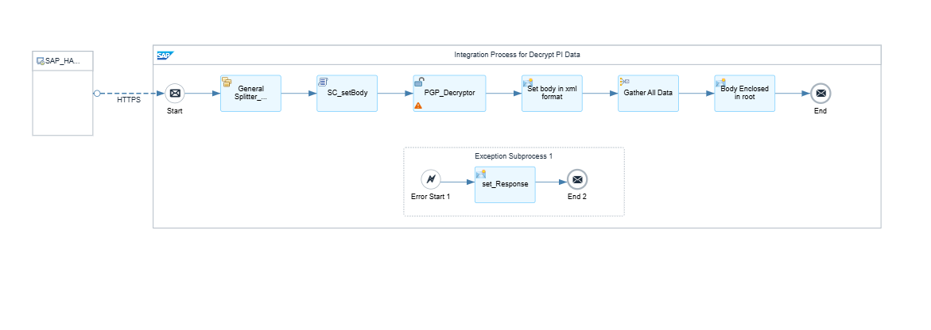

  - Technical Flow Description for each Integration Process model wise
The process flow involves the following steps:
- HTTPS Transfer: SAP HANA sends the encrypted body in XML format.
- General splitter: The general splitter splits the XML body into individual components.
- Data Decryption: Personal data is decrypted.
- Gather Data: The decrypted data is gathered and return in response body.

This flow ensures secure handling and transfer of sensitive data, maintaining data integrity throughout the process.

  - Channels Configurations

Step ID | Target system | Adapter Type | Security Artifact/Authnticati on | Trigger details (End points, HTTP method, file name, etc..)
Sender | HANA | HTTP | Username/Password | POST <Endpoint URL>

9

  - Externalization (Configuration)

Parameter | Value
Address | Enter the sender address.
Endpoint URL | Enter endpoint URL as per naming convention.

10

1
- Testing Requirements
  - Test Body

  - Key Unit/Assembly Test Conditions

Unit Test Log
Test Objective
Ste p No. | Date | Description | Expected Output/Re sults | Actual Output/Result s | Require ment ID | Sign-off
1 | 17th Jul 2025 | Verify Employee Data decrypt. | The HANA service receives the response in XML format without errors. | The HANA service receives the response in XML format without errors. |  | Tested  successfully
No tes

11

