Building block Configuration Guide  Connect to SAP Concur API  January 2022  English | Customer
Connect to SAP Concur API

Document History
Revision | Date | Author
0 | January, 2022 | Bertrand Henkel
Content
1 Prerequisites 5
2 Configuration steps on SAP Cloud Integration 6
2.1 Create OAuth2 Credentials 6
2.2 Configuration Steps - Connect to SAP Concur API 6

Prerequisites
Access/Information to the following systems:
- SAP Cloud Integration (Configuration Roles)
- SAP Concur (Access Credentials)

Configuration steps on SAP Cloud Integration
In this documentation an approach is explained in order to connect to an SAP Concur API. Please notice that you should edit this Iflow if more requirements need to be incorporate. This Iflow should only show you an easy way to connect to an SAP Concur API.

Create OAuth2 Credentials
Under the section Security Materials create an OAuth2 artefact with the necessary information:
- Token Service URL (https://<Concur Host//oauth2/v0/token>)
- Client ID
- Client Secret
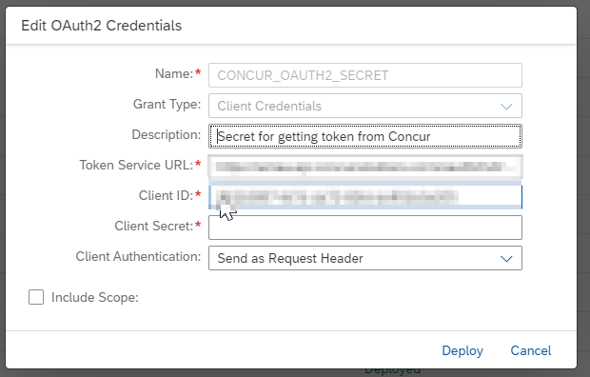

Configuration Steps - Connect to SAP Concur API
Timer:
Configure the Timer depending on the requirements.

Receiver
SAP Concur Authentication:
- Address: Enter the SAP Concur Authentication Endpoint (https://<SAP Concur Host/oauth2/v0/token>)

Receiver
SAP Concur API:
- Address: Enter the SAP Concur API Endpoint – Please also refer to SAP API Business Hub for more details on SAP Concur APIs.
- Query: Enter any query if necessary
- Method: Enter the HTTP request operation

More (Configure additional information)
- Concur Credentual Store: Set the SAP CI Oauth2 Credentials defined in chapter 2.1.
- Concur RefreshToken: Set the Refresh Token for this credentials provided by the SAP Concur team

