Motivation:
You have exposed a SOAP service on your tenant and now you want to retrieve the WSDL and the WSDL URL of the service.
You can get the WSDL URL or the WSDL directly from Ops UI in Eclipse:

Click on the worker node and then choose the Properties tab:
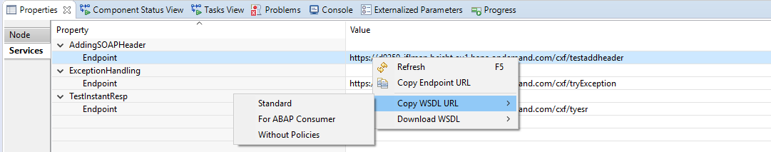

Here you find 2 options to choose from:
- Copy the WSDL URL
- Download the WSDL

- Choose “Standard” to use the default WSDL. In this case, the parameter abapConsumer is set to false and includePolicies to true
- Choose “For ABAP Consumer” if connecting to an ABAP system. In this case, both abapConsumer and includePolicies are set to true
- Choose “Without Policies” to switch off including policies.

Alternatively, the WSDL URL can also be constructed manually using the following format:
https://<tmnName>/Operations/api/WSDLDownload?artifactName=<Name of the integration flow>&servicePath=/<value of the address field in your SOAP Sender channel>&domainName=<Domain of the worker node>
The value of domain can be determined from the IFLMAP URL of the worker node. Just pick up the address after “iflmap.”.

