
PuBLIC
  - SAP SuccessFactors to Joule Promotion Analytics Integration Agent
  - Configuration & User Guide

Version: 1.0
Date: 2026-07-15

Contents
Overview 4
Business Value & Benefits 6
Prerequisites 6
Configuration Guide 7
Setup Business Technology Platform Cockpit 7
Services used: 8
Artifacts in the Agent: 8
Setup Content Package 9
Import Custom Joule Agent 9
Import Custom Joule Agent 9
Configuration & Modification 9
Release and Deploy the Project 10
Test the Joule Skills And Agent in SAP Build 10
Role of Cloud Integration…………………………………………………………………………………………………………………………………10
Support..................................................................................................................................................................17

This document contains 2 sections. Each section covers different information about this template content package.

- Overview: In this section, you will get quick overview of the use case, what are high-level components used and how the template works in nutshell. Prerequisite section provides information of different services of SAP Business Technology Platform that are required to use this template.

- Configuration Guide It contain sections which will guide you to setup your (a) SAP Business Technology Platform Account with destination, user roles etc., (b) Links and steps to set up Joule studio and Joule (c) Import and configure the template using SAP Build Process Automation - Joule studio

Note:
- Learning contents are published only for demo and reference purposes. We do not provide any support to learning / sample content.
- This documentation is not a detailed guide to setup SAP Business Technology Platform services. It assumes that IT admin who is setting the content is skilled with SAP Business Technology Platform environment. Configuration section must be followed.
- This template content is to accelerate your solution development. You must modify this template according to your requirements to achieve the desired business goal. To use this template content, you need to have basic knowledge and understanding of SAP Build Process Automation and its capabilities.

Overview
This document provides the technical configuration details required to enable and run the Promotion Analytics Assistant.
The primary audience for this document includes technical stakeholders such as IT administrators, developers, and functional consultants working with SAP Build, SAP CI, and SAP SuccessFactors.
The Promotion Analytics Assistant is designed to provide insights into employee promotion data through a conversational interface using Joule Studio. It enables users to retrieve promotion-related information without navigating complex backend systems.
The Promotion Analytics Assistant is designed to provide insights into employee promotion data in SAP SuccessFactors through a conversational AI interface using SAP Build and Joule Studio.
The agent enables HR users and administrators who have necessary authorization and roles to:
- Check employee promotion eligibility
- Retrieve latest promotion details
- Fetch complete promotion history
The agent interacts with backend systems via SAP Cloud Integration, which processes requests and retrieves data from SuccessFactors

Solution Flow:
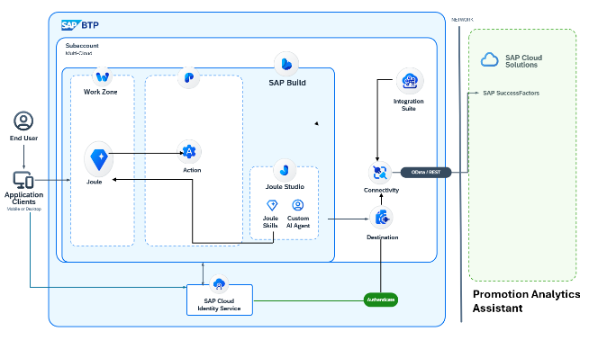
- The user (HR/Admin) interacts with the Promotion History Agent via Joule.
- The Agent understands the user intent and selects the appropriate Joule Skill:

The requester (HR user or administrator) interacts with the Promotion Analytics Assistant through Joule by providing natural language inputs such as requesting promotion eligibility or promotion details.
The agent understands the intent and triggers the appropriate Joule Skill. Based on the use case, the flow behaves as follows:
- For promotion eligibility, the agent evaluates whether the employee has completed the required tenure (minimum one year) or the list of eligible candidates before a certain date time as per the requirement.
- For latest promotion details, the agent retrieves the most recent promotion record.
- For promotion history, the agent fetches all available promotion records for the employee.
Each skill is linked to an action configured in SAP Build, which calls the respective Cloud Integartion endpoint. SAP Cloud Integartion processes the request, applies business logic, retrieves data from SAP SuccessFactors, and returns the response to Joule in a structured format.
The response from SuccessFactors is processed through Cloud Integartion and SAP Build and finally presented to the user in Joule.

Business Value & Benefits
The Promotion Analytics Assistant improves HR operations by enabling quick and intelligent access to employee promotion data.
- Provides real-time visibility into promotion details
- Reduces manual effort in retrieving employee data
- Enables faster and better decision-making
- Improves productivity through automation
- Ensures consistency and accuracy of HR data
- Improves HR productivity
- Enables AI-driven interaction without UI navigation
This solution helps HR teams avoid dependency on backend systems and simplifies data access using conversational AI.

Prerequisites
For this template to run successfully the following prerequisites are needed.
- Joule Studio in SAP Build
Follow the setup guide here based on your tenant configuration.
NOTE: If you need additional help with these prerequisites (such as setting up SAP Build Process Automation and SAP Build Work Zone), you can run the Discovery Center mission: Setup Joule Studio for a BTP Enterprise Account.

SAP Build Process Automation with Joule Studio enabled

SAP Cloud Integartion tenant configured

SAP SuccessFactors system access (Employee Central)

Destination configuration in SAP BTP cockpit

Required user roles and authorizations

Configuration Guide

Setup Business Technology Platform Cockpit
All required destinations and connectivity configurations must be created in the SAP BTP cockpit to enable communication between SAP Build, Cloud Integartion, and SuccessFactors.
To access the process automation capability of SAP Build, you can configure the destination. Please create destination as stated below:
Destination Property | Value
Name | Cloud Integartion Destination
Type | HTTP
URL  Username  paasword | XXXXXXXXXXXXXXXX-cpi018-rt.cfapps.eu10-003.hana.ondemand.com  YourTenateUsername  You Tenat Paasword
Proxy Type Internet | Internet
Authentication | BasicAuthentication
Add the property sap.processautomation.enabled as true to view the destination in the SAP Build Process Automation tenant. Please refer help document for more details.
NOTE: Make sure the API used in this template (see the below sections to get the API name) is exposed with the correct communication scenario to the communication user.

User Roles Configuration

Users must be assigned appropriate role collections in SAP Build to access Joule Studio, actions, and deployed agents. Required roles typically include access to SAP Build Process Automation and Joule capabilities. here

Services used:
There are two Action projects used in this implementation, both interacting with SAP Cloud Integartion to process Promotion Details data and integrate with SAP SuccessFactors.
Action Project Name | Service Used | Purpose
Promotion Eligibility | Cloud Integartion Endpoint → /http/eligibilityoneyear (GET) | Evaluates employee eligibility by calculating tenure using employment/job data from SuccessFactors and applying the one-year rule before returning eligibility status.
Latest Promotion Details | Cloud Integartion Endpoint → /http/promotionDetails (POST) | Retrieves the most recent promotion record by filtering job information based on effective date and extracting current and previous pay grade details.
Promotion History | CloudIntegartionEndpoint → /http/promotionHistoryEmp (POST) | Retrieves all promotion records by processing historical job data, identifying pay grade changes, and returning a structured list of promotion events.

Artifacts in the Agent:
Type | Name | Description
Joule Skill | Employee promotion eiligibility | Evaluates user requests related to promotion eligibility and determines whether the employee meets the required tenure condition based on the one-year rule. And also gets the list of employees eligible for promotion before a certain date period.
Joule Agent | promotionEligibilityAnalytics | Acts as the central controller that understands user intent, selects the appropriate skill, and ensures a smooth conversational flow across all promotion-related scenarios.
Joule Skill | Employee recent promotion data | Handles requests for the latest promotion information and presents the most recent promotion details of the employee in a structured and user-friendly format.
Joule Skill | Promotion history of employee | Manages requests to retrieve complete promotion history and displays all promotion records of the employee in a clear chronological sequence.

Setup Content Package

Import Custom Joule Agent
All imported custom agents are available in SAP Build Store. To know more about the SAP Build Store visit SAP Build Process Automation Store .
This template can be downloaded from the SAP Build Store:

Import Custom Joule Agent

The Promotion Analytics Assistant can be imported into SAP Build via the Build Store.

Navigate to SAP Build Lobby

Select the Store option

Filter by “Joule Agent and Skill”

Search for the “Promotion Analytics Assistant”

Click on “Create from Template”

Access the project from the lobby

Configuration & Modification
Once the agent is imported, it can be executed directly. However, modifications can be made to:
- Joule Skills (input/output schema)
- Agent instructions and behaviour
- Action configurations

Any customization should align with backend API structure and business rules defined in Cloud Integartion and SuccessFactors.
In order to understand the various capabilities of Joule Studio and work with them please refer to the link: Create AI Capabilities | SAP Help Portal

Release and Deploy the Project
Once the agent is verified by the user / modified based on user need, it has to be released and deployed into a shared environment.
- Refer to the link below to create/Share an Environment:
Environments | SAP Help Portal
- Refer to the link below to release a project:
Release a Project | SAP Help Portal
- Refer to the link below to deploy a project:
Deploy a Project | SAP Help Portal

Test the Joule Skills And Agent in SAP Build
- To access your projects, navigate to Control Tower ->Tenant Configuration->Environments.
- Select your environment.
- After deploying the project, the project should be seen in the Shared Environment.
- Click on the Tab, ’Joule’
- Click on the button ’Launch’
This will open the Joule launchpad where you can key in the below prompts in order to test the agent.
Prompt | Description
Check if employee [employee Id] is eligible for promotion | Checks if a certain employee is eligible for promotion as per the defined guidelines.
Get a list of employees who are eligible for promotion before the date [yyyy-MM-dd] | Presents the list of employees eligible for promotion before this date.
Get the latest promotion details of [Employee Id] | Retrieves the employee’s latest/most recent promotion information.
Get promotion history of employee [Employee Id] | Retrieves all the promotion history of the request employee.

NOTE:
1: Currently the Agent will be only deployed in the SAP Build environment and hence testing can also be done only in the Build Lobby. If you want to activate the Joule in other systems Eg: SAP S/4HANA or SAP Workzone, then click on the settings in ‘Control Tower->Environments-><Your Shared Environment that was created>->Joule’Here you have to switch the toggle on for ‘Share Environment Capabilities’.
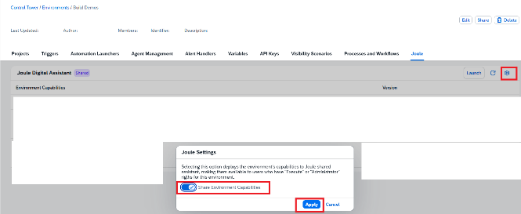

Role of SAP Cloud Integartion (Middleware)
SAP Cloud Integration acts as a middleware layer between SAP Build (Joule Agent) and SAP SuccessFactors.
Since Joule and SAP Build cannot directly interact with SuccessFactors APIs in a controlled and secure way, Cloud Integartion is used to:
- Receive requests from Joule (via SAP Build Actions)
- Process and validate the data
- Apply business rules
- Communicate with SAP SuccessFactors APIs
- Send response back to Joule
This ensures:
- Centralized logic handling
- Data validation before updating SuccessFactors
- Reusability and scalability of integration logic

Setup Integration Content Package
The Promotion Analytics solution includes a pre-built integration content package containing all required Cloud Integartion iFlows for promotion eligibility, latest promotion details, and promotion history.
Download the Integration Package
- Log in to SAP Integration Suite
- Navigate to the Discover section
- Search for “Promotion Analytics”
- Open the integration package
- Click on Download to get the ZIP file
Import the Integration Package
- Go to the Design section
- Click on Import
- Upload the downloaded ZIP file
- Open the package to view the iFlows

Integration Flows Included
- Eligibilityoneyear iFlow
- Employee Latest Promotion iFlow
- Employee Promotion History details iFlow

Cloud Integartion Integration Flows Used
Two Cloud Integartion iFlows are developed in this solution:
- Retrieve Employee Promotion Eligibility From SAP SuccessFactors
  - Method: GET
  - Endpoint:/eligibilityoneyear
Purpose:
This integration flow is responsible for evaluating whether an employee is eligible for promotion based on defined business rules.
  - Details:
The iFlow receives the employee identifier as input from SAP Build. It retrieves employee job and employment details from SAP SuccessFactors, particularly focusing on the employee’s start date or last promotion date.
  - Based on this data, Cloud Integartion calculates the employee’s tenure in the organization. The system then evaluates whether the employee has completed the minimum required duration of one year.
  - The response is returned with a clear eligibility status, indicating whether the employee is eligible or not eligible for promotion.

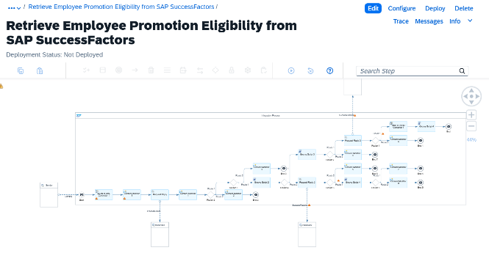

2. Retrieve Latest Employee Promotion from SAP SuccessFactors
- Method: GET
- Purpose:
This integration flow retrieves the most recent promotion details of an employee.
- Details:
The iFlow fetches employee job information records from SAP SuccessFactors and identifies the latest promotion entry based on the effective date.
It extracts key fields such as:
  - Effective Date
  - Current Pay Grade
  - Current Pay Grade Description
  - Previous Pay Grade
  - Previous Pay Grade Description
Cloud Integartion ensures that only the most recent record is selected and formats the response into a structured JSON output before sending it back to the agent.
3. Retrieve Employee Promotion History from SAP SuccessFactors
- Method: GET
- Purpose:
This integration flow retrieves the complete promotion history of an employee.
- Details:
The iFlow queries SAP SuccessFactors for all historical job records related to pay grade changes or promotions.
It processes multiple records and extracts relevant promotion data for each instance. The
response includes a list of promotion events, where each record contains:
- Effective Date
  - Current Pay Grade
  - Current Pay Grade Description
  - Previous Pay Grade
  - Previous Pay Grade Description
Cloud Integartion ensures that the records are sorted (typically by effective date) and returned in a structured list format, enabling the agent to display a clear promotion timeline.
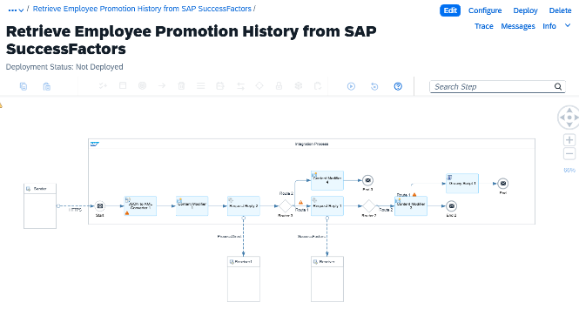
4 Validate Employee Promotion Access in SAP SuccessFactors
- Method: Process direct
- Purpose:
This integration flow validates weather the employee requesting the data is authorized to do so.
- Details:
The iFlow queries SAP SuccessFactors for all employee roles and validates it with required roles to access the current data.
It processes multiple records and extracts relevant promotion data for each instance. The
response includes a list of promotion events, where each record contains:
- authorization
Cloud Integartion ensures that the user trying to access the data is authorized to do it and prevent data leaks
and data security.
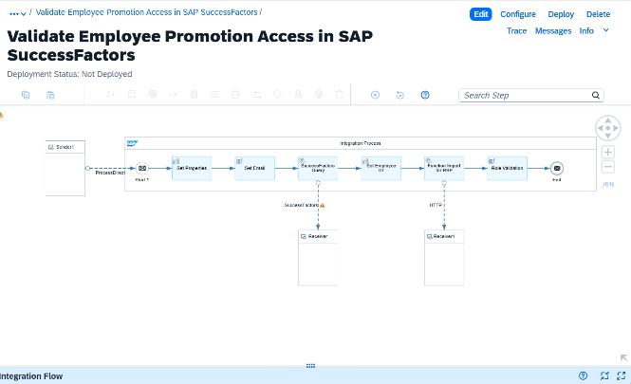

Business Rule: Promotion Eligibility and Data Handling
The system follows a structured approach while determining promotion eligibility and retrieving promotion data to ensure consistency and accuracy.
Eligibility Rule
- An employee must complete a minimum of one year in the organization to be eligible for promotion.
Behaviour
- If the employee has completed less than one year:
  - The system marks the employee as Not Eligible
- If the employee has completed one year or more:
  - The system marks the employee as Eligible

Promotion Data Handling Logic
- The system retrieves promotion-related data from job history (effective-dated records) in SAP SuccessFactors
- Promotion is identified based on change in pay grade across records

For Latest Promotion
- Cloud Integartion identifies the most recent effective-dated record
- Extracts:
  - Current pay grade
  - Previous pay grade
- Ensures only one latest record is returned

For Promotion History
- Cloud Integartion processes all historical job records
- Filters records where pay grade change occurred
- Sorts records based on effective date (chronological order)
- Returns a complete list of promotion events

This ensures
- Accurate identification of promotion events
- No duplication or incorrect records
- Proper chronological representation of employee growth
- Consistent and reliable data from SuccessFactors

Support
For any queries related to deployment, configuration, or artifacts associated with Promotion
Analytics Agent, please contact:
bpt.support@bpterp.com

