SAP BTP Incident Management System (IMS)
Configuration Guide

Vendor | Crave InfoTech
Version | 1.0
Creation Date | 09 August 2023
Modified Date

1. Overview 3
1.1 Introduction 3
1.2 Audience 3
1.3 Additional Documentation 3
2. Business Scenario 4
3. Prerequisites 5
4. Configuration 6
4.1 Incident Management System IFlow 6
5. About Us 7

1. Overview

Introduction

This Incident Management System (IMS) Notification package is developed and maintained by Crave Infotech. Incident Management System (IMS) application is developed using SAP’s Business Technology Platform (BTP) with the help of BTP services it streamlines incident handling process and BTP has integrated services that allow users to create, update, and delete incidents, ensuring a smooth workflow.
This iFlow triggers when a new employee is onboarded and an incident gets created in IMS application with incident details like title, description, category, priority, status etc. and it triggers an Email and Teams notification to the respective team members by ensuring the efficient record keeping.

Features:
- IMS Integration helps to take the right action at right time to resolve critical incidents.
- Incident Management is used across many industries like system failure or any event requiring the attention of any type of incident.
- Critical Maintenance of any business application.
- IMS improvise the communication and notification process.
- Efficient management of user data stored in database.

Audience

The SAP IMS Notification Configuration Guide is intended to be used by both technology and application consultants.

Additional Documentation

SAP Cloud Integration
https://help.sap.com/docs/cloud-integration
SAP Incident Management System (IMS)
Incident Management System

2. Business Scenario

To enable users to streamline the way, it notifies the business about the incidents in different business areas like in Healthcare, Oil & Gas Industry, Software Industry and so on...
Incident Management System below are few examples with different categories.

- A gas leak has been detected in the main processing unit of the refinery. Safety alarms have been triggered, and workers are being evacuated.

It sends notification with below details.

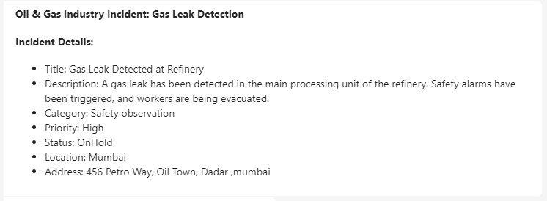

For Software Incident when a new employee is onboarded.

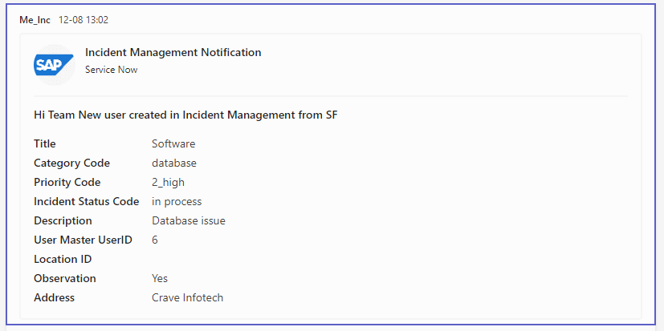

3. Prerequisites

- SAP Cloud Integration Subscription
- Email Subscription
- MS Teams Webhook configuration
- Security Material for all authentications:
  - Process Integration Runtime API authentication
  - Email authentication

4. Configuration

Incident Management System IFlow

Parameter | Description/Instruction
Sender System | IncidentManagement_Service
Sender Adapter | HTTPS
Receiver System1 | MS_OutlookEmail
Receiver Adapter | HTTPS
Connection Tab
Address | Address of your mail server
Proxy Type | Internet
Timeout | Default: 3000  You may change this value as needed.
Protection | Protection used to connect to your mail server.
Authentication | Type of authentication used to login to your mail server.
Credential Name | Credential created in Security Material for your mail server.
Processing Tab
From | Email address used to send the email
To | Enter To Email address.  You may change this value as needed.
Cc | Default: blank  You may change this value as needed.
Bcc | Default: blank  You may change this value as needed.
Subject | Default: Inc: New Emp Onboarded  You may change this value as needed.
Mail Body | ${in.body}
Body Mime-Type | Text/Plain
Body Encoding | UTF-8
Receiver System | MS_Teams
Receiver Adapter | HTTP
Teams Address | Provide Webhook URL
Proxy Type | On-Premise or Internet
Method | POST
Authentication | Client Certificate
Timeout (in ms) | 60000  You may change this value as needed.
More | All Parameters
Exchange Property:  ImageURL | https://banner2.cleanpng.com/20180419/yde/kisspng-sap-se-computer-icons-sap-erp-wtf-vector-5ad8de7cd6c141.9425303815241621728797.jpg  The above link has SAP Image in notification it will display the image with the incident details.  You may change this value as needed.

5. About Us

Product: Crave InfoTech
Contact Us: Crave InfoTech

