

Configuration Guide

Planon Financial Collection Integration with SAP S/4HANA Procurement for Purchase Requisition


App version: 1.0.0
Date: 25/03/2026 Author: Planon

Contents
1 Introduction 3
2 Prerequisites 4
2.1 Environment 4
2.2 Constraints 4
2.3 Assumptions 4
3 Features 5
4 How does it work? 6
5 Installation Process 7
5.1.1 Install by downloading from Discover 7
5.1.2 Manual installation 7
5.2 Settings 8
5.2.1 Description of settings 8
5.2.2 Activation 10
5.3 Planon configuration 11

- Introduction
This document describes the prerequisites, features and how to install the integration flow.

- Prerequisites
  - Environment
This solution is designed to work with Planon Live L125 and above.
  - Constraints
The design of this Integration Flow is based on the following constraints:
- SAP Business Technology Platform (BTP), SAP Cloud Integration (Public/Private Edition) and SAP Master Data Integration must be available and configured correctly.
- OData V4 API API_PURCHASEREQUISITION_2 is active and available
- ‘planonrealestatemanagementforsap’ is available from version 6.0.0 onwards.
- Additional Planon system configuration is required, see the Webhelp for details.
- Public Cloud version 2602 was verified
- Private Cloud (on-premise) 2025 FPS1
  - Assumptions
This design and functionality of the integration flow is based on the following assumptions:
- Source system appsettings are configured with companycode, logsys and instanceurl-options.

- Features
This chapter describes the features supported by this integration flow version.
- Create OData Purchase Requisitions for multiple destinations in a routed way
- Purchase Requisition Creation in S4/HANA (only POST method)
To enable the integration with SAP S/4HANA Procurement, you need to implement the solution process 2XD and require the SAP Real Estate and Facilities Management by Planon solution to be able to send the Purchase Request via the Financial Collection process.
Set-up:
In Planon, the standard object Requisition Line, which is a part of a Workorder, will trigger a Purchase Request in SAP S/4HANA. This Purchase Request then follows the regular SAP workflow to create (for each, or for all Requisition Items) one or more Purchase Orders. From the Requisition line in Planon, a deeplink can be used to view the status of the Purchase in SAP. The Workorder in Planon can be completed once the requested Services and/or Material are agreed or available.
When multiple CompanyCodes linked to the Real Estate objects in Planon require multiple back-end systems of SAP, the Purchase Request is routed to the right system, ensuring the right classification and follow-up proces.

- How does it work?
The integration flow enables the creation of Purchase Requisitions in SAP S/4HANA based on requests received from Planon. The integration is implemented using an iFlow deployed in SAP Integration Suite, which exposes a secure HTTPS endpoint that is configured in Planon.
The process works as follows:
- Trigger from Planon
When a Purchase Requisition needs to be created in SAP, Planon sends a request to the configured iFlow endpoint. The request payload contains the Purchase Requisition data including header and item details.
- Message Reception in SAP Integration Suite
The iFlow receives the incoming request through an HTTPS sender adapter. The message is then processed within the integration flow where necessary message headers and exchange properties are set.
- CSRF Token Retrieval
Before sending the Purchase Requisition request to SAP S/4HANA, the iFlow performs an initial HTTP call to the SAP OData service to retrieve a CSRF (Cross-Site Request Forgery) token.
This token is required by SAP S/4HANA for secure POST operations. The token and session cookies returned from this request are stored and used in the subsequent call.
- Purchase Requisition Creation in SAP
After retrieving the CSRF token, the iFlow sends a second HTTP request to the SAP S/4HANA Purchase Requisition API.
The request includes:
  - The CSRF token in the request header
  - Session cookies returned from the token call
  - The Purchase Requisition payload mapped to the structure expected by SAP
- SAP Processing
SAP S/4HANA processes the request and creates the Purchase Requisition in the system. The system then returns relevant details such as the created Purchase Requisition number.
- Response Handling
The iFlow receives the response from SAP S/4HANA and forwards the relevant response information back to Planon, indicating whether the Purchase Requisition was successfully created or if an error occurred.
- Monitoring and Error Handling
All messages processed by the integration flow can be monitored using the monitoring capabilities of SAP Integration Suite. Any processing errors are logged to support troubleshooting and operational monitoring.

- Installation Process
This chapter describes the steps required in order to install this integration flow on your Integration Suite environment.
    - Install by downloading from Discover
Integration flows can be downloaded from the Discovery-menu. Use ‘Copy’ to start with this available integration flow.
Example:
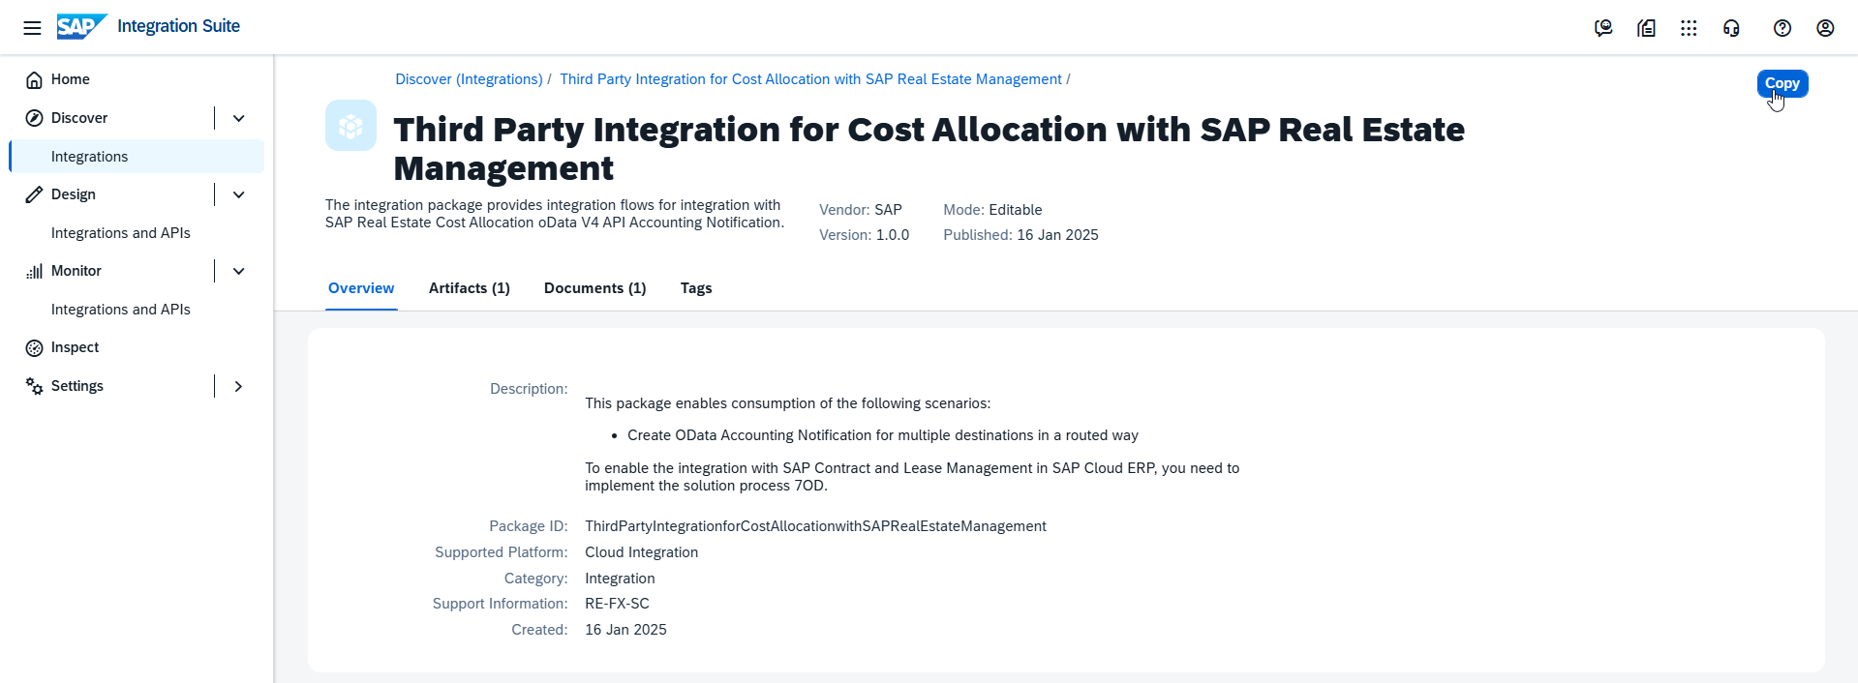
    - Manual installation

In this option, the Import option is recommended from the Design-menu.

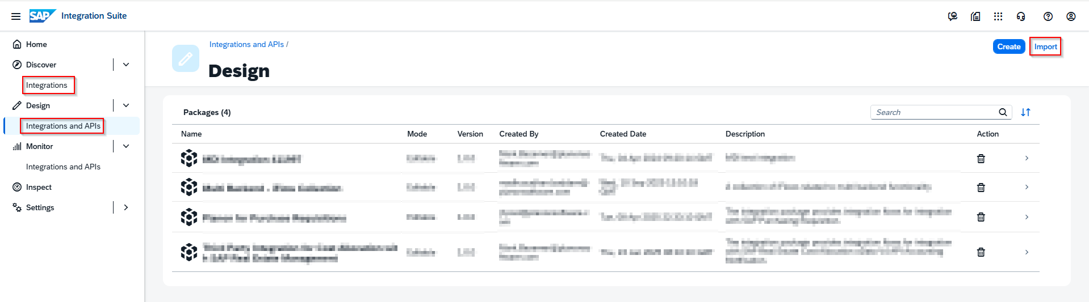
  - Settings
    - Description of settings

After the package is downloaded, it is required to adjust specific settings for each destination (one is a default) in the artifacts. All settings are part of the ‘Configure’ step.

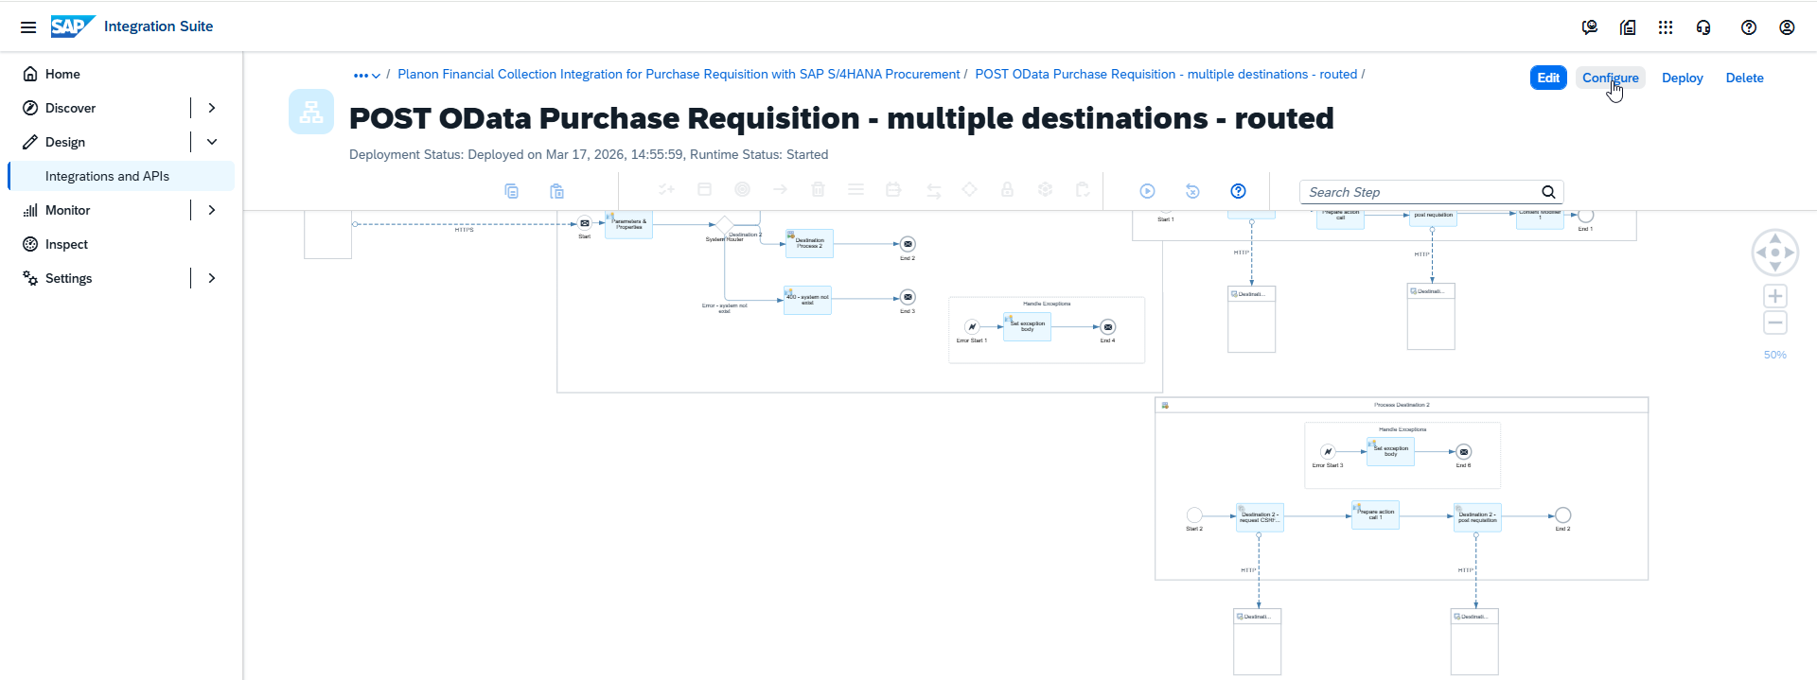
For the Sender-level, the authorization and User role have to be selected from the specific environment.

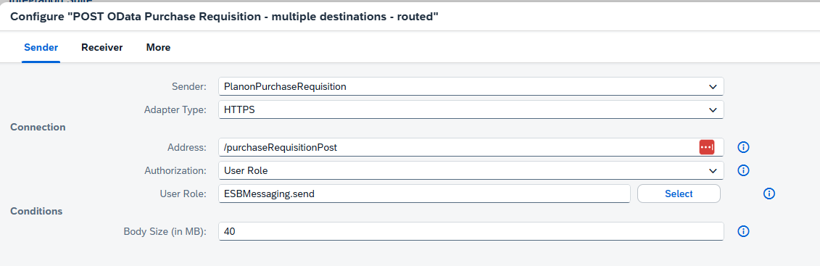

In the Receiver-level, for all Destinations (1 and 2) the URL should be copied from the API-documentation at the Business Accelerator Hub. As it might get changed or upgrade, it’s important to get it from this location instead of just copying it from this document. In this case, the following API is required: https://api.sap.com/api/CE_PURCHASEREQUISITION_0001

Run the POST option in the Sandbox to get the Request URL:

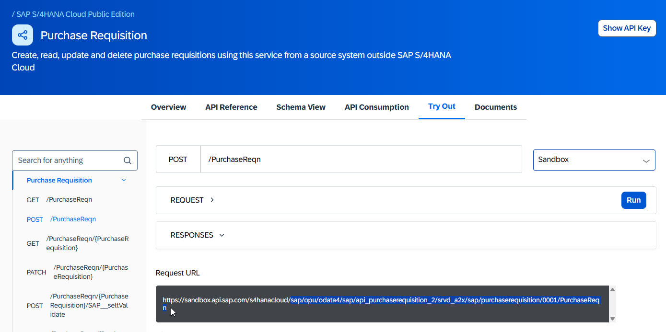

Copy the part in blue and past that at the connection_url for both Destination 1 and Destination 2.
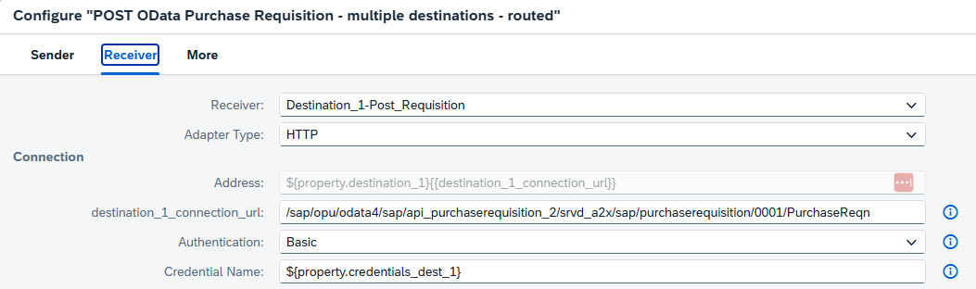

At the ‘More ‘step, the credentials, logsys and destination must be adjusted for your own system.
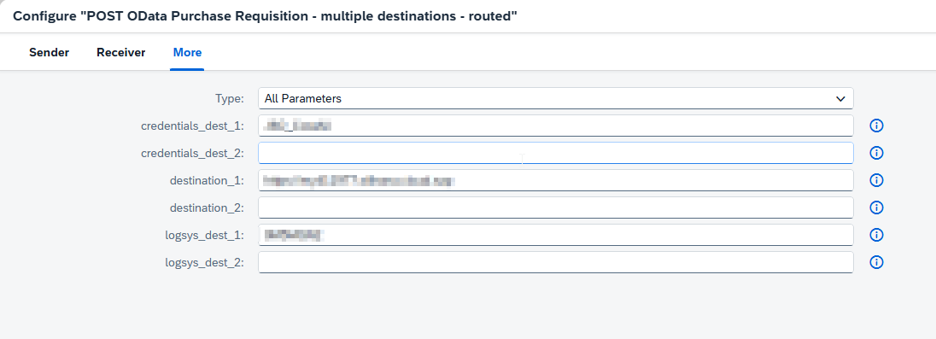
If more then two systems are required, copy/paste the Process Destination block.
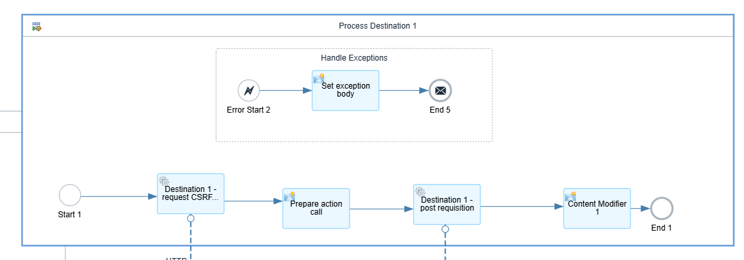
Enable this new Destination to the System router. Update the Content modifier.
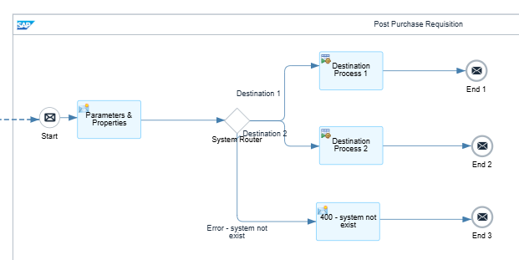

    - Activation

Once the artifact is configured, start to ‘Deploy’ to activate the integration flow. When the Integration Flow is deployed succesfully, copy the Endpoints to the Planon app-settings.

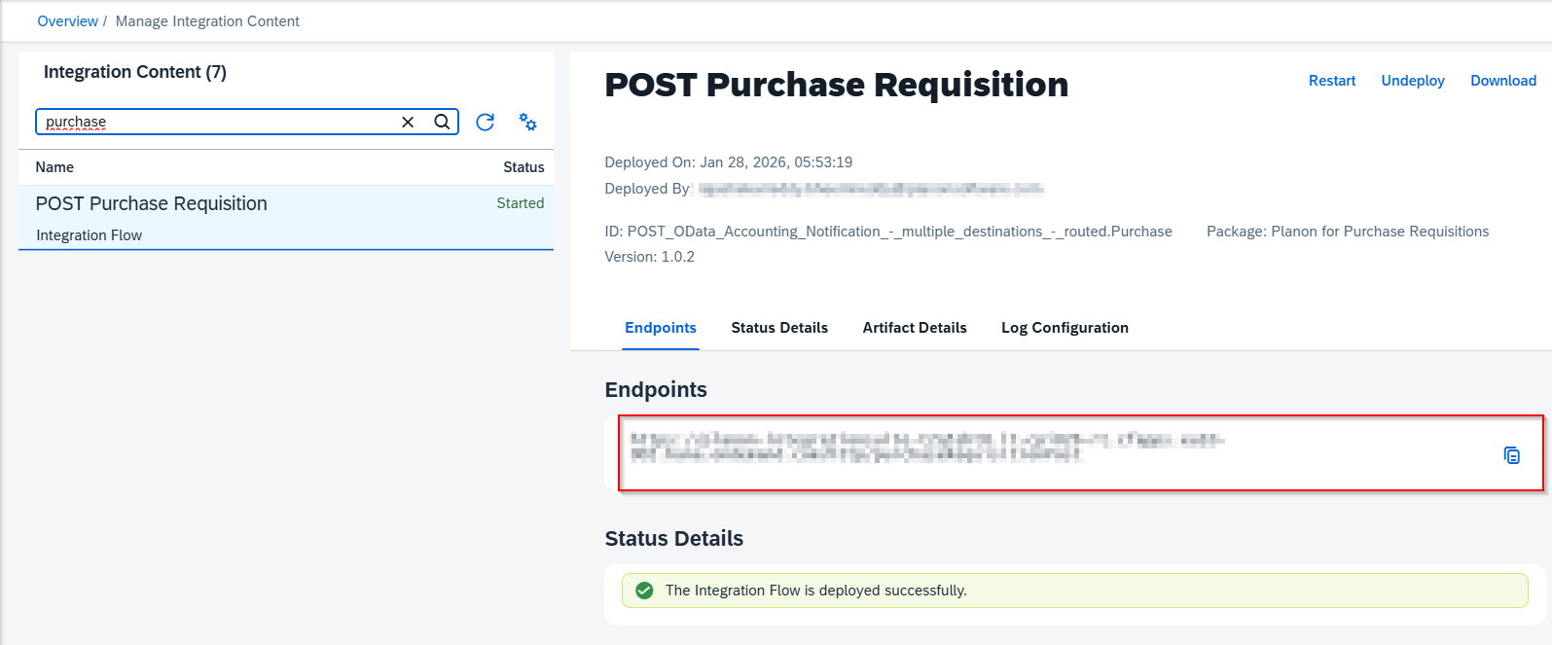

App-settings:

  - Planon configuration
Refer for this section to the planonrealestatemanagementforsap-appmanual. It includes the configuration of Requisition lines as part of Order Management, a batch-job to automatically collect the purchase requests in the Financial Collection and different kinds of masterdata which should be part of the message for SAP to be able to accept the message from Planon.

