Documentation
Synchronization of Provider, Applications & Interface Requests via SAP LeanIX and SAP Integration Suite
SAP Integration Package

20 August 2024 | Document Version 1.1.0
NTT Data Business Solutions AG

Contents
1. Overview & Introduction 4
2. iFlows and configuration in detail 5
2.1. Fullsync Integration Assessment Vendors 5
2.2. Fullsync Integration Assessment Applications 6
2.3. Create Integration Assessment Vendor 8
2.4. Create Integration Assessment Application 10
2.5. Create SAP LeanIX Interface FactSheet 13

Document history
Issue | Date | Comments | Pages Affected
1.00 | 02.09.2024 | Original | All
1.01 | 03.12.2024 | Added User Authorization Role Recommendation  Configuration of the iFlows is now visualized in Tables | All
1.10 | 08.12.2024 | Added new integration documentation ‘Create SAP LeanIX Interface FactSheet’ | All

Overview & Introduction
This integration package is designed to synchronize data between SAP LeanIX and Integration Assessment, focusing primarily on application and vendor (referred to as 'providers' in SAP LeanIX) information. Utilizing the powerful capabilities of the SAP Integration Suite, this synchronization process ensures a seamless, secure, and up-to-date data flow. This enhances the accuracy and efficiency of IT integration strategies, providing comprehensive insights for integration assessments.

Note: In this documentation, "Vendors" in Integration Assessment are equivalent to "Providers" in SAP LeanIX for simplicity and clarity.

The package comprises four distinct integrations, each serving unique functions and designed to operate independently. Users can select and deploy any iFlow according to their specific requirements and needs:

- Fullsync Integration Assessment Vendors: Synchronizes all vendors (providers) from SAP LeanIX to Integration Assessment. This interface is triggered manually and operates once per trigger.
- Fullsync Integration Assessment Applications: Synchronizes all applications from SAP LeanIX to Integration Assessment. This includes optional synchronization of application instances (on-premise/public-cloud/private-cloud). This interface is also manually triggered and operates once per trigger.
- Create Integration Assessment Vendor: Activated whenever a factsheet of type 'provider' is created in SAP LeanIX. This event triggers the creation of a new vendor in Integration Assessment, ensuring real-time data updates.
- Create Integration Assessment Application: Similar to the vendor creation interface, this is activated when a factsheet of type 'application' is created in SAP LeanIX. It triggers the creation of a new application in Integration Assessment, including the synchronization of application instances (on-premise/public-cloud/private-cloud) if applicable. This interface also requires manual triggering and operates once per trigger.
- Create SAP LeanIX Interface Factsheet: Generates a SAP LeanIX Interface Fact Sheet from Integration Assessment Interface Requests at a configurable interval. Applications selected in the Interface Request will also be referenced in the Fact Sheet, provided they have been synced by this package.
Each integration is designed to ensure that your IT integration strategies are supported by the most current and relevant data, fostering informed decision-making and efficient management of IT resources.

iFlows and configuration in detail

Fullsync Integration Assessment Vendors

This interface synchronizes all vendors from SAP LeanIX with Integration Assessment. In Integration Assessment, these entities are referred to as "vendors".
To initiate this integration, the following parameters must be configured in the iFlow:

Receiver: LeanIX

Address | Enter the SAP LeanIX API URL. The address should follow this pattern:  https://<customerdomain>.leanix.net/services/pathfinder/v1/graphql
Credential Name | Enter the credential name of a SAP LeanIX API user (OAuth2). To set this up, please create OAuth2 client credentials (refer to SAP LeanIX Developer Docs) and add these credentials as security material (OAuth2 Credentials) in the SAP Integration Suite. Then, enter the created credentials.

Receiver: SAP_Assessment

Address | Use the Integration Assessment Vendor URL, following this pattern:  https://<customerdomain>.hana.ondemand.com/intas/entities/v1/Vendor
Credential Name | Use your Integration Assessment Credentials (OAuth2). To set this up, create OAuth2 client credentials (see SAP HELP) and add these credentials as security material (OAuth2 Credentials) in the SAP Integration Suite. Then, enter the created credentials.

Please ensure that the client credentials are functioning correctly. To start the iFlow, deploy it. The integration will automatically commence (once) and the vendors will be synchronized. You can view all synchronized vendors in the monitoring section – an attachment with all status codes will be created.

Fullsync Integration Assessment Applications

This interface facilitates the synchronization of all applications from SAP LeanIX with Integration Assessment. Optionally, application instances (e.g., Public-Cloud/OnPremise) can also be synchronized.

Receiver: LeanIX

Address | Enter the SAP LeanIX API URL. The address should follow this pattern:  https://<customerdomain>.leanix.net/services/pathfinder/v1/graphql
Credential Name | Enter the credential name of a SAP LeanIX API user (OAuth2). To set this up, please create OAuth2 client credentials (refer to SAP LeanIX Developer Docs) and add these credentials as security material (OAuth2 Credentials) in the SAP Integration Suite. Then, enter the created credentials.

Receiver: SAP_Assessment_application_instances

Address | Use the Integration Assessment Vendor URL, following this pattern:  https://<customerdomain>.hana.ondemand.com/intas/entities/v1/ApplicationInstance
Credential Name | Use your Integration Assessment Credentials (OAuth2). To set this up, create OAuth2 client credentials (see SAP HELP) and add these credentials as security material (OAuth2 Credentials) in the SAP Integration Suite. Then, enter the created credentials.

Receiver: SAP_Assessment_deployment_model

Address | Use the Integration Assessment Vendor URL, following this pattern:  https://<customerdomain>.hana.ondemand.com/intas/entities/v1/DeploymentModel
Credential Name | Use your Integration Assessment Credentials (OAuth2). To set this up, create OAuth2 client credentials (see SAP HELP) and add these credentials as security material (OAuth2 Credentials) in the SAP Integration Suite. Then, enter the created credentials.

Receiver: SAP_Assessment_application

Address | Use the Integration Assessment Vendor URL, following this pattern:  https://<customerdomain>.hana.ondemand.com/intas/entities/v1/Application
Credential Name | Use your Integration Assessment Credentials (OAuth2). To set this up, create OAuth2 client credentials (see SAP HELP) and add these credentials as security material (OAuth2 Credentials) in the SAP Integration Suite. Then, enter the created credentials.

More: All Parameters

syncApplicationInstance | If this is set to false, only applications will be synchronized, and application instances will be ignored. Application instances can be manually created in Integration Assessment after synchronization. To synchronize application instances, set this value to “true” (in lower-case). It distinguishes between “cloud” and “onPremise”. If there is no value for the deployment instance in SAP LeanIX, “onPremise” will be used as a fallback.

Ensure the client credentials are functioning correctly.

To start the iFlow, deploy it. The integration will automatically commence (once), and the applications will be synchronized. You can view all synchronized applications in the monitoring section – an attachment with all status codes will be created.

Please note that starting from version 1.1.0, the internal FactSheet ID of SAP LeanIX will also be stored in the hidden 'APIHubId' field within Integration Assessment. This ID will then be reused when creating a FactSheet in SAP LeanIX by using the Interface “Create SAP LeanIX Interface FactSheet”, establishing a link between the application(s) and the interface.

Create Integration Assessment Vendor

This interface updates a single provider in Integration Assessment whenever a fact sheet of the type ‘provider’ is created in SAP LeanIX. To enable this functionality, an event must be created in SAP LeanIX Administration.
To deploy this integration, configure the following parameters in the iFlow:

Receiver: LeanIX

User Role | The necessary user role for invocation with Basic Auth is by default "ESBMessaging.send". However, since this role often has access to multiple flows in the Integration Suite, for security reasons, it is advisable to create a unique user role and assign it to the iFlow. In LeanIX, the Basic Auth user could be read out and used for the invocation of additional iFlows.  For more information regarding setup and other details, please refer to the documentation at SAP HELP
Address | Enter the SAP LeanIX API URL. The address should follow this pattern:  https://<customerdomain>.leanix.net/services/pathfinder/v1/graphql
Credential Name | Enter the credential name of a SAP LeanIX API user (OAuth2). To set this up, please create OAuth2 client credentials (refer to SAP LeanIX Developer Docs) and add these credentials as security material (OAuth2 Credentials) in the SAP Integration Suite. Then, enter the created credentials.

Receiver: SAP_Assessment

Address | Use the Integration Assessment Vendor URL, following this pattern:  https://<customerdomain>.hana.ondemand.com/intas/entities/v1/Vendor
Credential Name | Use your Integration Assessment Credentials (OAuth2). To set this up, create OAuth2 client credentials (see SAP HELP) and add these credentials as security material (OAuth2 Credentials) in the SAP Integration Suite. Then, enter the created credentials.

Ensure the client credentials are functioning correctly before deploying the iFlow.
After successful deployment, it is necessary to add an event in SAP LeanIX. This event will trigger whenever a fact sheet of the type ‘provider’ is created.

To set up the event in SAP LeanIX:

- Go to your SAP LeanIX instance and access the administration area. 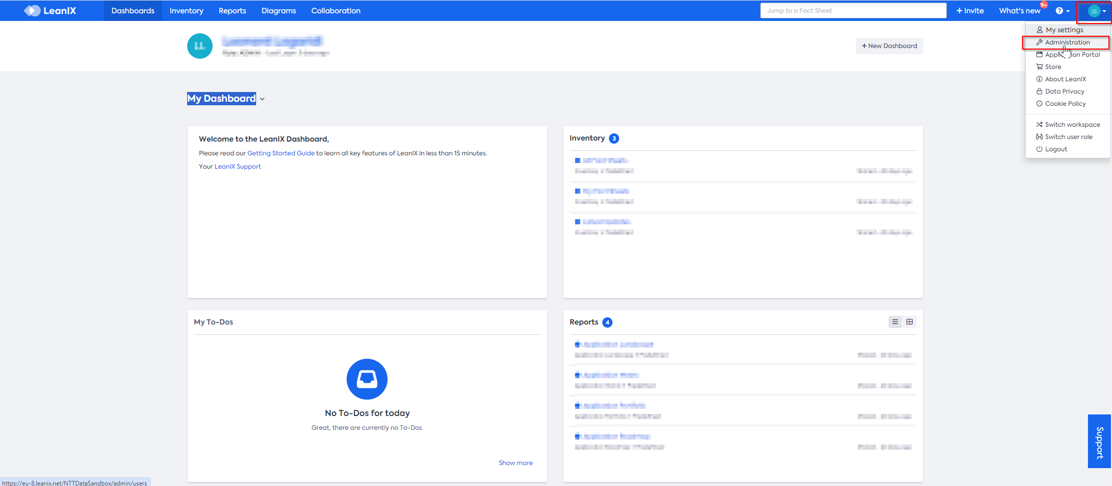
- Click on the last item on the left side, “webhooks”, and create a new webhook.
- Configure the webhook as follows:
Triggering Events | FACT_SHEET_CREATED
Managing User | Current User
Type | PUSH
Target URL (iFlow URL) | <your-SAP-Integration-Suite-instance>/http/integration-assessment/vendors
Authorization | <Add basic auth user for your SAP Integration Suite, which is authorized to call iflows>
Callback | delivery.active = false;  if (delivery.payload.factSheet.type == 'Provider' ) {  delivery.active = true;  }
Status | active

Once everything is set up correctly, a vendor should be automatically created in Integration Assessment whenever the specified event occurs in SAP LeanIX.

Create Integration Assessment Application

This interface updates a single application in Integration Assessment whenever a fact sheet of the type ‘provider is created in SAP LeanIX. To enable this functionality, an event must be created in SAP LeanIX Administration. Optionally, application instances can also be synchronized, but will always be set to onpremise.
To deploy this integration, configure the following parameters in the iFlow:

Receiver: LeanIX

User Role | The necessary user role for invocation with Basic Auth is by default "ESBMessaging.send". However, since this role often has access to multiple flows in the Integration Suite, for security reasons, it is advisable to create a unique user role and assign it to the iFlow. In LeanIX, the Basic Auth user could be read out and used for the invocation of additional iFlows.  For more information regarding setup and other details, please refer to the documentation at SAP HELP
Address | Enter the SAP LeanIX API URL. The address should follow this pattern:  https://<customerdomain>.leanix.net/services/pathfinder/v1/graphql
Credential Name | Enter the credential name of a SAP LeanIX API user (OAuth2). To set this up, please create OAuth2 client credentials (refer to SAP LeanIX Developer Docs) and add these credentials as security material (OAuth2 Credentials) in the SAP Integration Suite. Then, enter the created credentials.

Receiver: SAP_Assessment_application_instances

Address | Use the Integration Assessment Vendor URL, following this pattern:  https://<customerdomain>.hana.ondemand.com/intas/entities/v1/ApplicationInstance
Credential Name | Use your Integration Assessment Credentials (OAuth2). To set this up, create OAuth2 client credentials (see SAP HELP) and add these credentials as security material (OAuth2 Credentials) in the SAP Integration Suite. Then, enter the created credentials.

Receiver: SAP_Assessment_deployment_model

Address | Use the Integration Assessment Vendor URL, following this pattern:  https://<customerdomain>.hana.ondemand.com/intas/entities/v1/DeploymentModel
Credential Name | Use your Integration Assessment Credentials (OAuth2). To set this up, create OAuth2 client credentials (see SAP HELP) and add these credentials as security material (OAuth2 Credentials) in the SAP Integration Suite. Then, enter the created credentials.

Receiver: SAP_Assessment_application

Address | Use the Integration Assessment Vendor URL, following this pattern:  https://<customerdomain>.hana.ondemand.com/intas/entities/v1/Application
Credential Name | Use your Integration Assessment Credentials (OAuth2). To set this up, create OAuth2 client credentials (see SAP HELP) and add these credentials as security material (OAuth2 Credentials) in the SAP Integration Suite. Then, enter the created credentials.

More: All Parameters

syncApplicationInstance | If this is set to false, only applications will be synchronized, and application instances will be ignored. Application instances can be manually created in Integration Assessment after synchronization. To synchronize application instances, set this value to “true” (in lower-case). It distinguishes between “cloud” and “onPremise”. If there is no value for the deployment instance in SAP LeanIX, “onPremise” will be used as a fallback.

Ensure the client credentials are functioning correctly before deploying the iFlow.

After successful deployment, it is necessary to add an event in SAP LeanIX. This event will trigger whenever a fact sheet of the type ‘provider’ is created.

To set up the event in SAP LeanIX:

- Go to your SAP LeanIX instance and access the administration area.
- Click on the last item on the left side, “webhooks”, and create a new webhook.
- Configure the webhook as follows:
Triggering Events | FACT_SHEET_CREATED
Managing User | Current User
Type | PUSH
Target URL (iFlow URL) | <your-SAP-Integration-Suite-instance>/http/integration-assessment/application
Authorization | <Add basic auth user for your SAP Integration Suite, which is authorized to call iflows>
Callback | delivery.active = false;  if (delivery.payload.factSheet.type == 'Application' ) {  delivery.active = true;  }
Status | active

Once everything is set up correctly, a vendor should be automatically created in Integration Assessment whenever the specified event occurs in SAP LeanIX.

Please note that starting from version 1.1.0, the internal FactSheet ID of SAP LeanIX will also be stored in the hidden 'APIHubId' field within Integration Assessment. This ID will then be reused when creating a FactSheet in SAP LeanIX by using the Interface “Create SAP LeanIX Interface”, establishing a link between the application(s) and the interface.

Create SAP LeanIX Interface FactSheet

This integration synchronizes interface requests from Integration Assessment to SAP LeanIX. Whenever an interface request is created in Integration Assessment, it will periodically (configurable) generate a Fact Sheet of the 'integration' type in SAP LeanIX.
The Source System (only one can be selected; if multiple are present, the integration will choose one) and Target System(s) (can be 1 or more) will also be referenced in SAP LeanIX, provided that the applications have been synced using the 'Fullsync Integration Assessment Applications' and/or 'Create Integration Assessment Application' integrations.

To initiate this integration, the following parameters must be configured in the iFlow:

Timer: Start Timer [StartEvent_4]

Schedule to Recur | - Set to ‘Daily’  - Set to ‘Every X hours’ Between ’00:00’ and ’24:00’  Replace X with the desired frequency, ensuring it matches the time set in the "More" tab under "All Parameters." For example, if it’s set to 2 hours, “timeOffsetInMinutes” must be set to ‘120’ minutes. The default value is 2 hours.  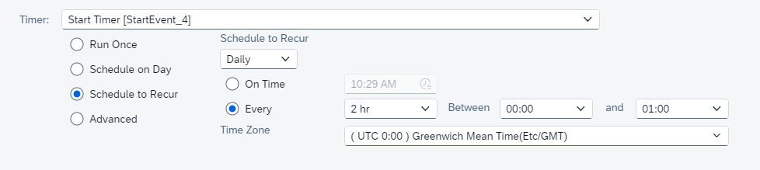

Receiver: LeanIX

Address | Enter the SAP LeanIX API URL. The address should follow this pattern:  https://<customerdomain>.leanix.net/services/pathfinder/v1/graphql
Credential Name | Enter the credential name of a SAP LeanIX API user (OAuth2). To set this up, please create OAuth2 client credentials (refer to SAP LeanIX Developer Docs) and add these credentials as security material (OAuth2 Credentials) in the SAP Integration Suite. Then, enter the created credentials.

Receiver: Integration_Assessment

Address | Use the Integration Assessment Vendor URL, following this pattern:  https://<customerdomain>.hana.ondemand.com/intas/entities/v1/IntegrationFlow
Credential Name | Use your Integration Assessment Credentials (OAuth2). To set this up, create OAuth2 client credentials (see SAP HELP) and add these credentials as security material (OAuth2 Credentials) in the SAP Integration Suite. Then, enter the created credentials.

Please ensure that the client credentials are functioning correctly. To start the iFlow, deploy it. The integration will automatically run every 2 hours unless configured otherwise, and the interfaces will be synchronized. You can view all synchronized interfaces in the monitoring section, where an attachment with all status codes will be generated.

