Set-Up Instructions  English | Customer
Cloud Integration for
Document Information Extraction Service

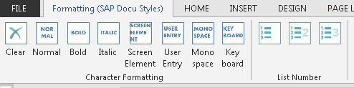

Enable the Formatting ribbon with the SAP Styles by adding the template file SAP_styles.dotm (download here) to your Microsoft Templates folder.
C:\Users\<user ID>\AppData\Roaming\Microsoft\Templates

To add the template, go to Developer > Document Template > Attach
Make sure that macros are enabled.

To view the template instructions, turn on Paragraph Marks.
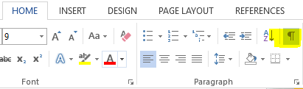
Make sure to use the appropriate style in order to facilitate the efficient, error-free migration to the DITA CMS.

- For user Interface texts use SAP_ScreenElement
- For user input, use SAP_UserEntry.
- For subheadings (Use, Procedure), apply the SAP_KeyblockTitle style
- For tables, use the SAP_StandardTable table format.
- Do not merge cells in tables.
- Do not nest a table within another table.

Typographic Conventions
Type Style | Description
Example | Words or characters quoted from the screen. These include field names, screen titles, pushbuttons labels, menu names, menu paths, and menu options.  Textual cross-references to other documents.
Example | Emphasized words or expressions.
EXAMPLE | Technical names of system objects. These include report names, program names, transaction codes, table names, and key concepts of a programming language when they are surrounded by body text, for example, SELECT and INCLUDE.
Example | Output on the screen. This includes file and directory names and their paths, messages, names of variables and parameters, source text, and names of installation, upgrade and database tools.
Example | Exact user entry. These are words or characters that you enter in the system exactly as they appear in the documentation.
<Example> | Variable user entry. Angle brackets indicate that you replace these words and characters with appropriate entries to make entries in the system.
EXAMPLE | Keys on the keyboard, for example, F2 or ENTER.
Document History
Revision | Date | Change
1.0.0 | 2020-11-17 | Initial Draft
1.0.1 | 2021-07-13 | Rebranding to Cloud Integration, amendment in section 3.4.1.1
Table of Contents
1 Purpose 5
2 Prerequisites 6
3 Configuration 7
3.1 User Credentials Setup 7
3.2 Integration Flow Config 9
3.3 Integration Flow Config Mailbox 10
3.4 Integration Flow Config Document Information Extraction Service 11
4 Appendix 12
4.1 Ticket Component 12

Purpose
The purpose of this document is to describe the steps that customer can configure Cloud Integration (CI) for SAP AI Business Service Document Information Extraction for integrating a mail server.

Prerequisites
The customer has purchased the license of Document Information Extraction Service and Cloud Integration Platform.

Configuration

User Credentials Setup
Use
This step needs you to access Manage Security Material in order to create new User credentails for Document Information Extraction Service integration.
Procedure
- Go to Manage Security Material section of Cloud Integration.
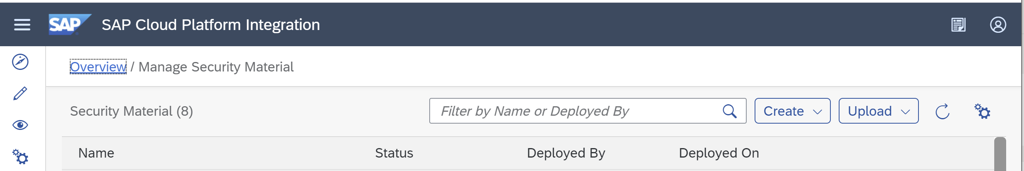

- Click Create and select User Credentials
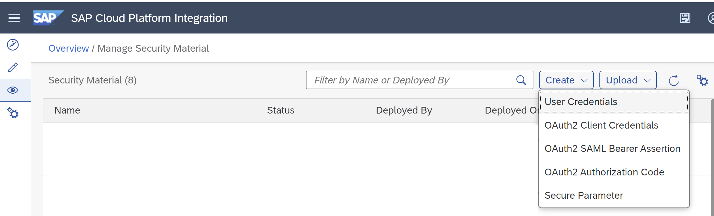.

- Add User Credentials with the following settings and click Deploy
  - Input Name as DOX_USER.
  - Select Type as User Credentials.
  - Input User with <clientid> from Document Information Extraction service key JSON file.
  - Input Password with <clientsecret> from Document Information Extraction service key JSON file.

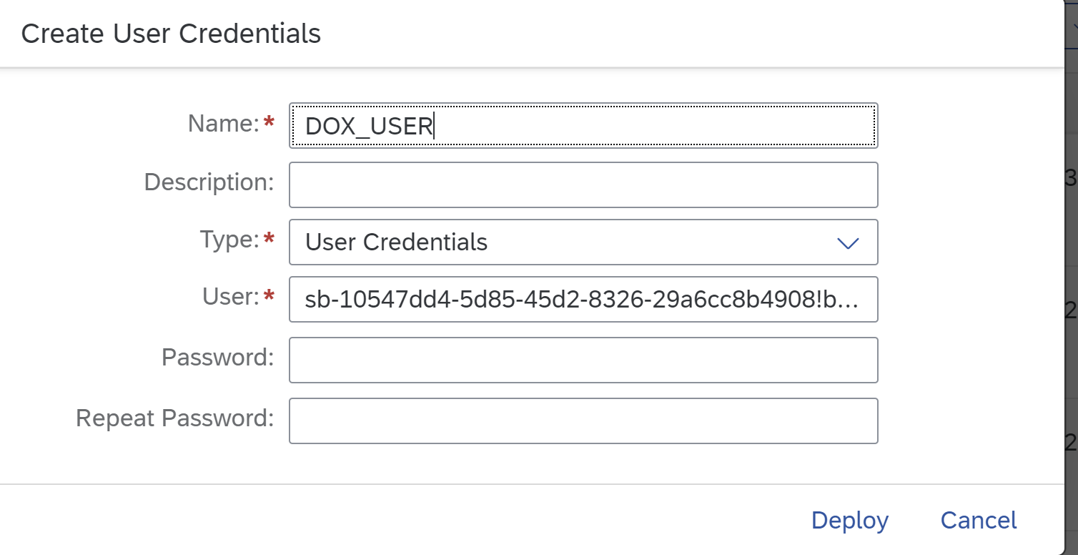

Integration Flow Config
Use
Once OAuth2 Credentials is created, SAP AI Business Service Document Information Extraction Integration with Email Server can further configured.
Procedure
- In Discover section of Cloud Integration and go to Search and write SAP AI Business Service Document Information Extraction and copy the package with name SAP AI Business Service Document Information Extraction Integration with Email Server

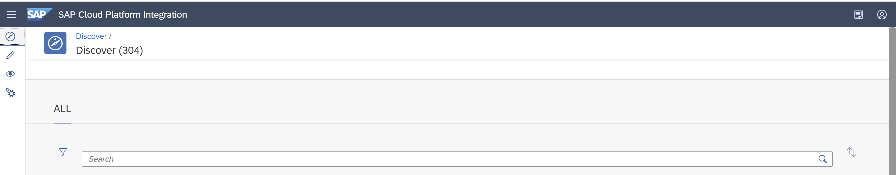

- Once the package is copied, search for Document and select SAP AI Business Service Document Information Extraction Integration with Email Server.

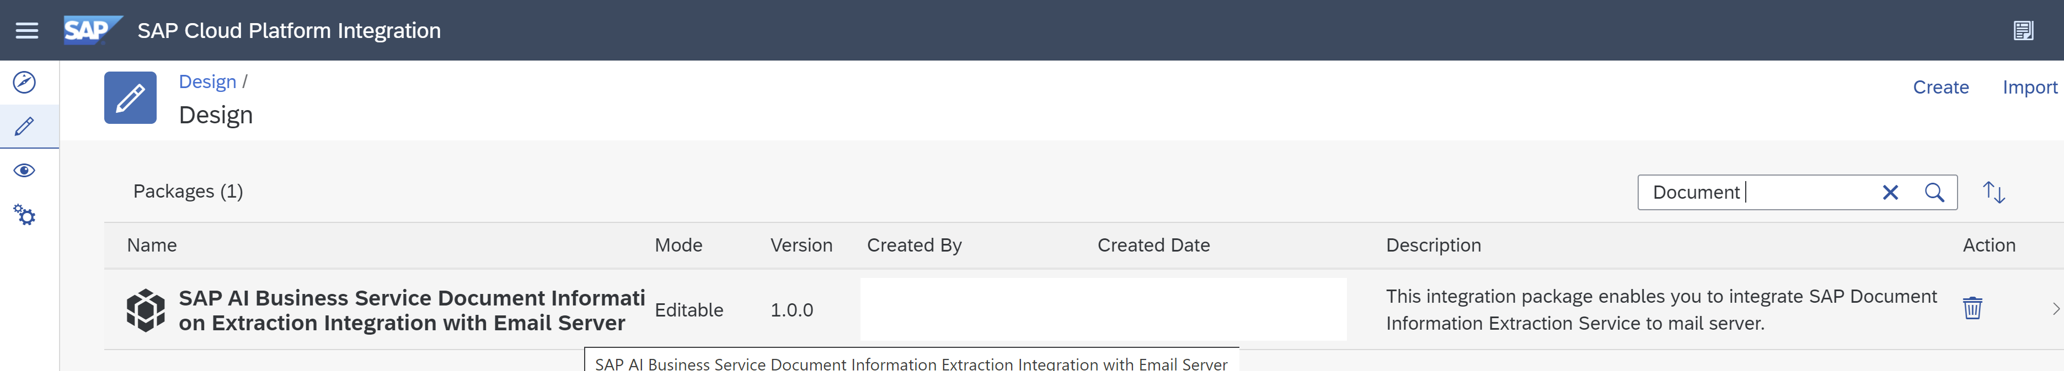

- In package SAP AI Business Service Document Information Extraction Integration with Email Server, you should be able to see 1 integration flow artifacts.

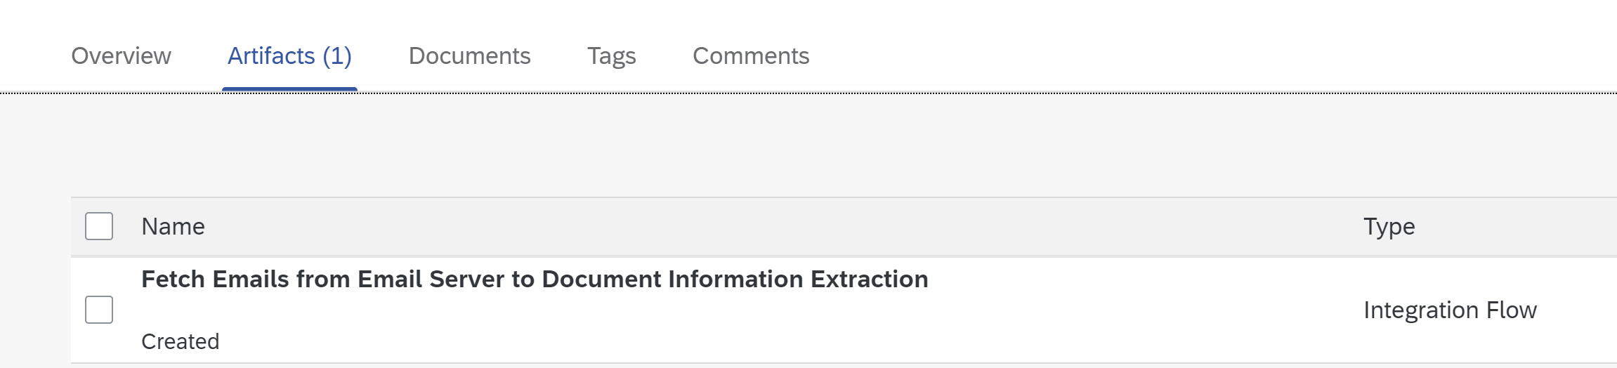
- Select Configure
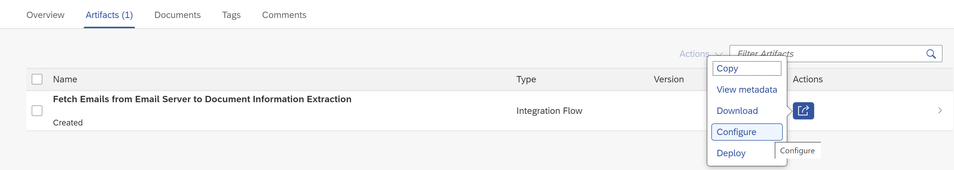

Integration Flow Config Mailbox

  - In the Sender section configure your email box setting, where the emails come
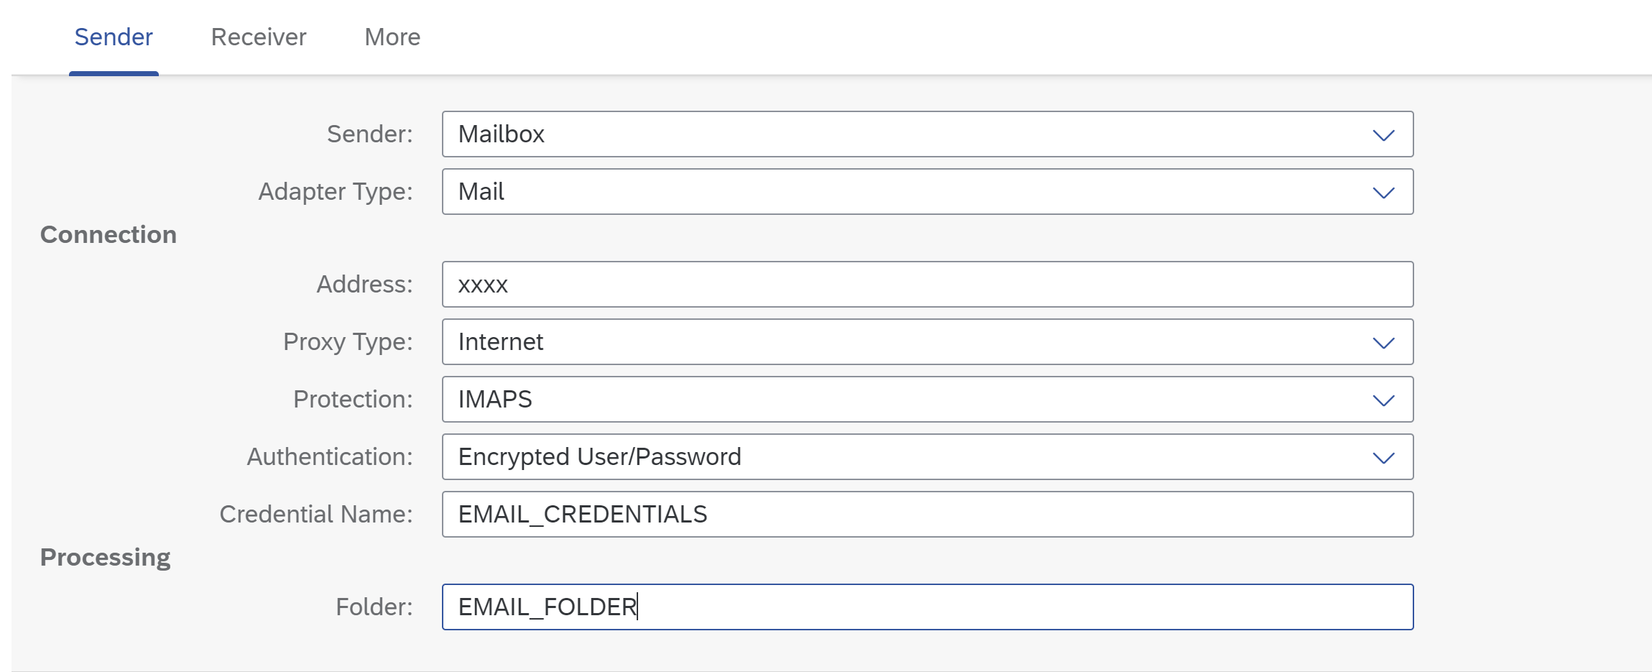
  - In the Receiver section configure the FinalStatusEmail, UnsupportedAttachmentMail and ProcessFailedMail
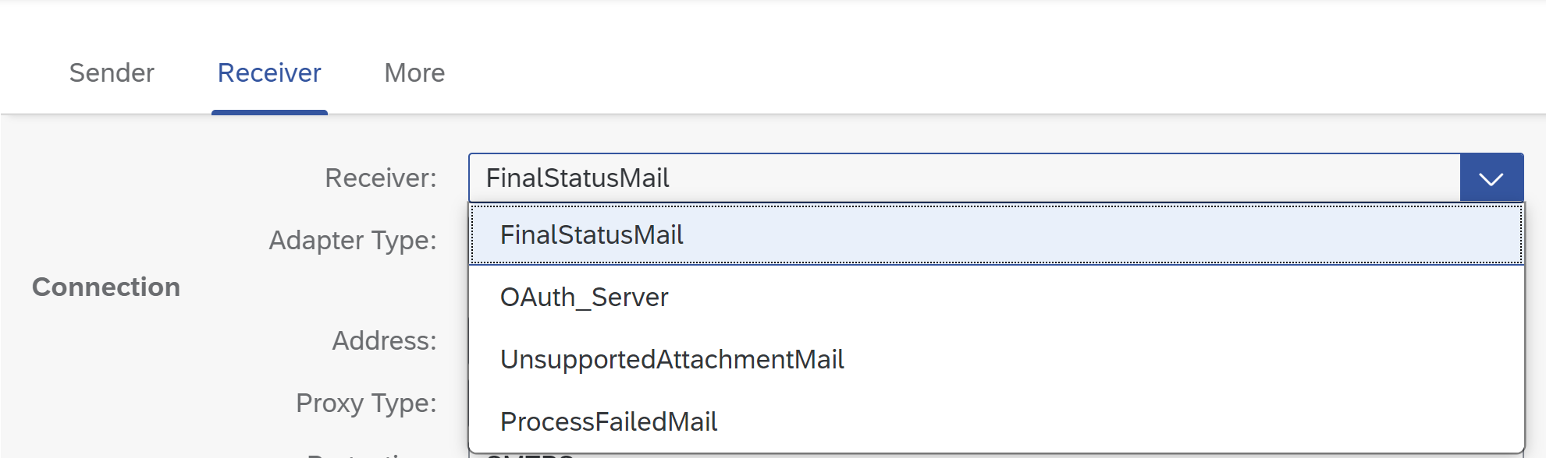

Integration Flow Config Document Information Extraction Service

- In the Receiver section configure the OAuth_Server
    - Input Address as url from uaa section from Document Information Extraction service key JSON file and append /oauth/token.
    - Input Query grant_type=client_credentials.
    - Input Credential Name with DOX_USER, the credentials name created 3.1.
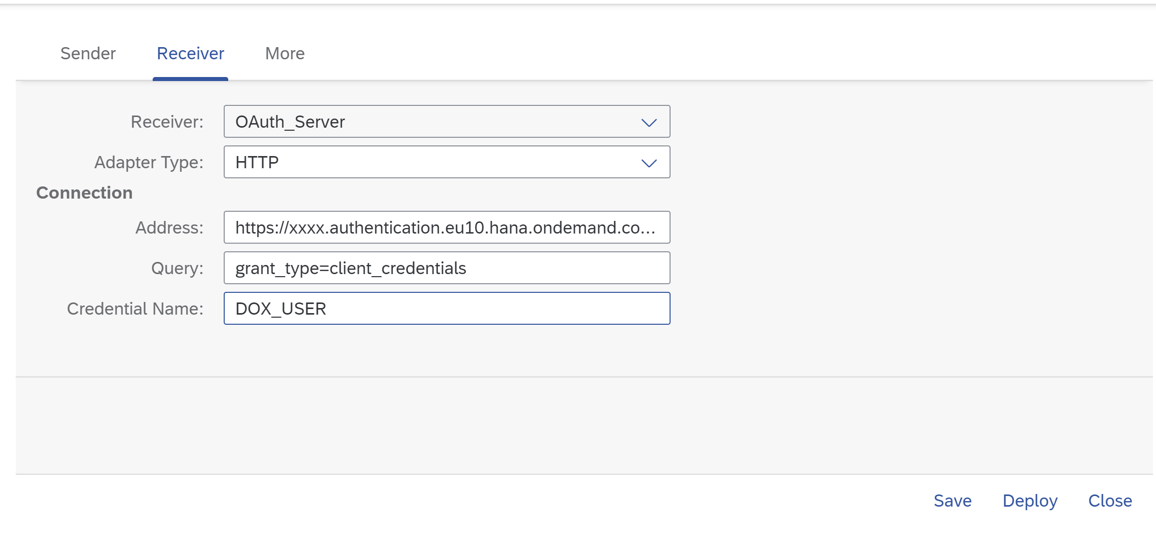

- In the More section configure the Parameters
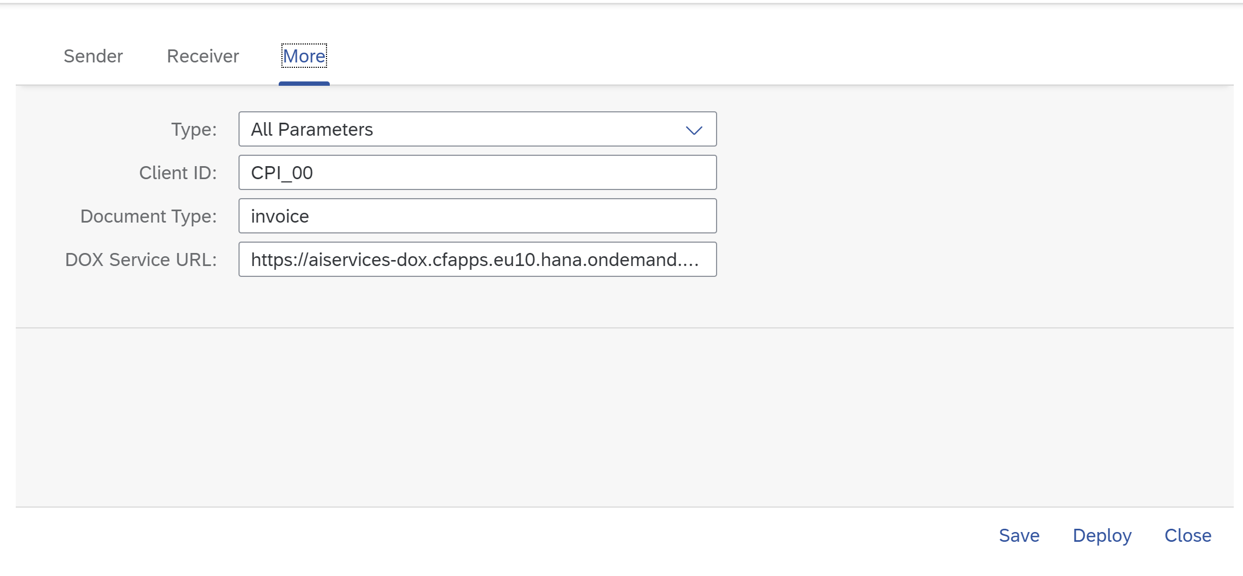

    - Input Client ID as client ID you would like to use from Document Information Extraction service, if you have not created a client in DOX service, you can create one by Client API of Document Information Extraction Service. Please check on help.sap.com the Client API description.
    - Input Document Type as the document type you would like to process. Please check on help.sap.com the available document types that Document Information Extraction Service can process.
    - Input DOX Service URL as url from Document Information Extraction service key JSON file and add /document-information-extraction/v1 at the end

Appendix

Ticket Component
In case of issues during the configuration, open an SAP support ticket for the following component.
Implementation Step | Component | Comment
3.1 ,3.2, 3.3 | LOD-HCI-PI-OPS | SAP Cloud Integration Operations
3.4 | CA-ML-DOX | Document Information Extraction

www.sap.com/contactsap
© 2019 SAP SE or an SAP affiliate company. All rights reserved.
No part of this publication may be reproduced or transmitted in any form or for any purpose without the express permission of SAP SE or an SAP affiliate company.
SAP and other SAP products and services mentioned herein as well as their respective logos are trademarks or registered trademarks of SAP SE (or an SAP affiliate company) in Germany and other countries. Please see http://global.sap.com/corporate-en/legal/copyright/index.epx#trademark for additional trademark information and notices.
Some software products marketed by SAP SE and its distributors contain proprietary software components of other software vendors.
National product specifications may vary.
These materials are provided by SAP SE or an SAP affiliate company for informational purposes only, without representation or warranty of any kind, and SAP SE or its affiliated companies shall not be liable for errors or omissions with respect to the materials. The only warranties for SAP SE or SAP affiliate company products and
services are those that are set forth in the express warranty statements accompanying such products and services, if any. Nothing herein should be construed as constituting an additional warranty.
In particular, SAP SE or its affiliated companies have no obligation to pursue any course of business outlined in this document or any related presentation, or to develop or release any functionality mentioned therein. This document, or any related presentation, and SAP SE’s or its affiliated companies’ strategy and possible future developments, products, and/or platform directions and functionality are all subject to change and may be changed by SAP SE or its affiliated companies at any time for any reason without notice. The information in this document is not a commitment, promise, or legal obligation to deliver any material, code, or functionality. All forward-looking statements are subject to various risks and uncertainties that could cause actual results to differ materially from expectations. Readers are cautioned not to place undue reliance on these forward-looking statements, which speak only as of their dates, and they should not be relied upon in making purchasing decisions.

