

SAP S/4HANA integration with Oracle Primavera
Installation and operation manual
SAP API HUB version 1.0
May 29, 2020
Commondo d.o.o. – Restricted Access
This document and confidential information it contains shall only be used, distributed, routed or made available to authorized persons and not to any third party without the prior written consent of Commondo d.o.o.

This is a controlled document and shall not be reproduced unless the copy is prominently marked “This is not a Controlled Copy”. If you receive a revised version of this document, you shall prominently mark this version “Superseded” or destroy it.

Doc: SAP S/4HANA integration with Atlassian JIRA - Demo
Ver. | Date | Description | P | R | A
1.0 | 29-05-2020 | First version | CM | CM | CM

Statuses:
P = prepared
R = reviewed
A = approved

Worked out by:
- Commondo (CM)

Content Page

1 Introduction 4
1.1 Purpose of this document 4
2 System Prerequisites 5
2.1 Acronyms and Terms 5
3 Integration Overview 6
4 System Configuration 7
4.1 System preparation 7
4.2 Installation and configuration of Integration flows 8
5 Application execution 9
5.1 Basic workflow trigger 9
5.2 Commondo Fiori Trigger 11
6 Usual business scenarios 12
6.1 Management driven project execution 12
6.2 External project plan proposal 12
6.3 Import subcontractor data 13

Introduction

This package delivers standalone sample Integration Flows for SAP S/4HANA PPM and Oracle Primavera integration which are also used as key components in Commondo® ePPM.

Commondo® ePPM Suite is a set of solutions for the seamless integration of external project management tools like Oracle Primavera P6, Microsoft Project Server, Atlassian JIRA, etc. into SAP driven business processes. The technical data exchange is facilitated by SAP CPI and an array of Integration Flows – some of which are delivered as standalone content within this package.
For more details visit our web page: www.commondo.eu or contact us via sales@commondo.eu.

SAP S/4HANA – Oracle Primavera integration helps to compare planned, scheduled or executed hours and connect them with SAP finances automating reports delivery, helping project timeline analysis or connecting tasks with financial data points. Integration can be used to compare project data on either platform, helping each step of the project execution and analysis.

Available sample Integration Flows in this package:

- SAP Project and Portfolio Management to Oracle Primavera Task
This is PPM to Primavera Task Transfer integration flow which updates project data from SAP to Primavera. It creates project on Primavera system and maintain it based on the changes on the SAP side. It also creates a new WBS object on Primavera side based on a Task from SAP PPM system.
- Oracle Primavera to SAP Project and Portfolio Management Task
This is Primavera to PPM Task Transfer integration flow which updates project data from primavera to SAP. The main goal of the workflow is to update planned and actual data, as well as some important scheduling data, aggregated on Oracle Primavera and transfer it to SAP PPM Task.

This package delivers standalone sample Integration Flows for SAP S/4HANA PPM and Oracle Primavera integration which are also used as key components in Commondo® ePPM.

Purpose of this document
This manual enables customer to install and configure workflows that will enable integration between SAP PPM and Oracle Primavera.

Customer will get first insight in concepts and features provided in Commondo ePPM Suite.
It also empowers customer to use simple integration scenarios for their purposes and allow them to extend workflows wits some customer’s specific needs.

System Prerequisites

Customer/user must fulfill following prerequisites in order to install and run delivered integration flows:

- SAP S/4HANA 1909 on-premises system installed
- SAP PPM module configured and installed
- SAP CPI subscription (account)
- Oracle Primavera P6 system installed
- Oracle Primavera P6 Web Services installed and enabled
- enable PPM and Primavera for integration
  - enable Cloud Connector on S4HANA and SAP Cloud Platform
  - create technical user on SAP (this user is used in CPI destination to access SAP system, see 7, configuration in Cloud cockpit)
  - create Primavera technical user (this user is used in CPI flow in https adapter in form of credentials, see 7, configuration in Cloud cockpit)
- enable respective Roles for existing user who will trigger workflows in CPI or create new one (e.g. technical user). User credentials are used for application execute (chapter 5)

Acronyms and Terms

BAPI: Business API
ePPM Suite: Comprehensive integration suite provided by Commondo® LTD
EPPM: Enterprise Project Portfolio Management
RFC: Remote function call
SAP CPI: Cloud Platform Integration

Integration Overview

Integration flows provided in this package are standalone and enable user to use them without any limitation. However, the flows must be triggered from customer’s application or any other comparable mechanism which is not a part of delivered package.

As shown in system overview below, integration flows are installed on Cloud Platform Integration and could be triggered by:

- any external frontend application with HTTPS request option
  - like Commondo Fiori application described in chapter 5.2

- any job scheduler, for example S4/HANA background job scheduler
- any browser URI request like
  - Testing tools (example with Postman described in chapter 5)

Main function of this integration is to map, aggregate and synchronize relevant project data between SAP PPM and Oracle Primavera systems. As stated in chapter 1 Commondo® ePPM Suite covers comprehensive set of integration scenarios. Scenarios (integration flows) provided in this package cover typical transfers between SAP and Oracle Primavera. It is described in chapter 6.

Integration flows provided in the package are prepared and tested with S4/HANA on-premises solution and Oracle Primavera on-premises installation.

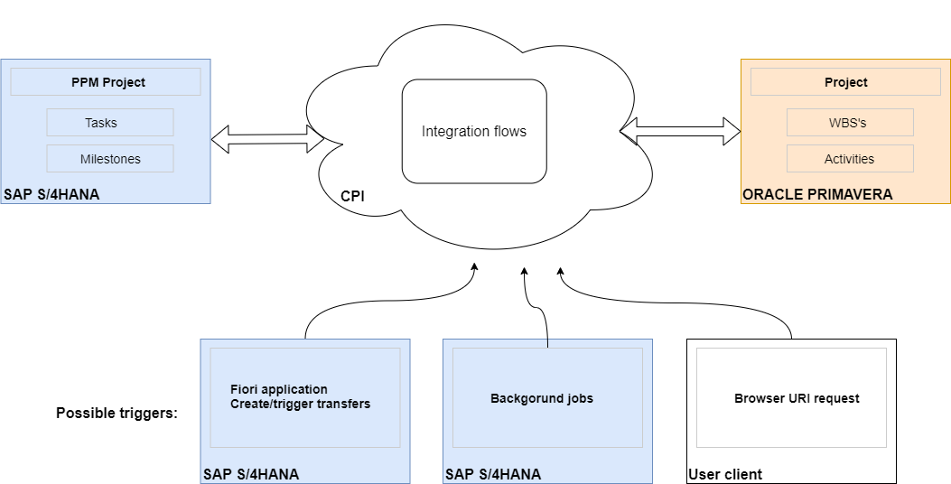
Figure 1- Architecture overview

System Configuration

System preparation
Some workflow specific configurations are required to run this integration flows. Before you start please prepare and configure S4/HANA, Oracle Primavera system and SAP Cloud platform as described below.

Configuration on S4/HANA:
- Import custom BAPI “Z_COMMEPC_BAPI_BUS2175_CHANGE” provided by Commondo in this document. This BAPI is simple extension (wrap) of SAP standard BAPI_BUS which includes committing.
Note:
  - keep exact name of custom BAPI (“Z_COMMEPC_BAPI_BUS2175_CHANGE”)
  - BAPI needs to be Remote Enabled

- Import custom BAPI “Z_COMMEPC_BAPI_BUS2175_GET_DET” provided by Commondo in this document. This BAPI is simple extension (wrap) of SAP standard BAPI_BUS which includes committing.
Note:
  - keep exact name of custom BAPI (“Z_COMMEPC_BAPI_BUS2175_GET_DET”)
  - BAPI needs to be Remote Enabled

Configuration on Oracle Primavera:
- Expose API port on Oracle Primavera system to SAP CPI (CPI is Cloud based service)

Configuration in SAP Cloud Platform:
Using SAP Cloud Cockpit:
- Create destination e.g. “MyRFCDstinationToCPI” to S4/HANA
(Note: the same name must be used in CPI workflow)
- Create credentials for JIRA access e.g. “CommondoPrimavera”
(Note: the same must be used in http adapter in respective workflow)

Installation and configuration of Integration flows
Please copy and install Commondo flows from API HUB using Discover option in SAP Cloud Platform Integration and perform configuration of external parameters.

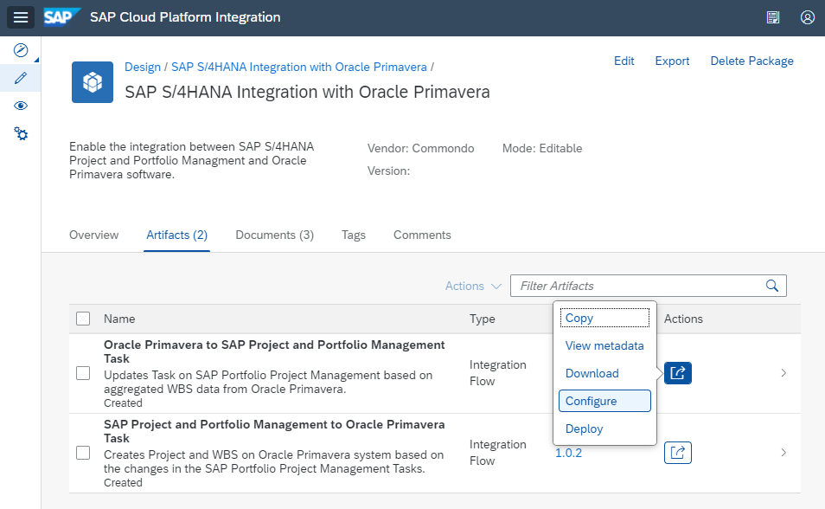
Figure 2: Configure workflow

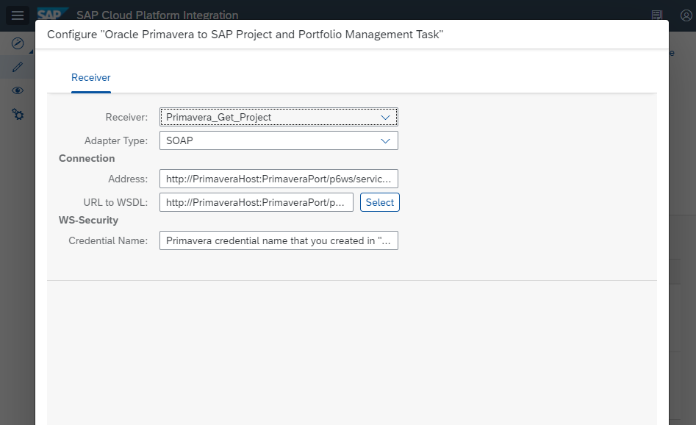
Figure 3: Entering values for external parameters

Configuration is performed using standard CPI feature – Externalized Parameters. Default values provided in flows are describing what type of content parameter should contain. User is required to change config parameters values with correct data for Users local environment.

Application execution

SAP CPI workflows are triggered with REST (HTTP) request to workflow URI.
Any REST client or application can be used for triggering. You might use some testing tools (Postman, SOAPUI etc.) for test purposes. In production you will probably use some other mechanism as described in chapter 3: your custom application, Fiori application, SAP extensions, batch jobs etc.

Basic workflow trigger
This is a standard option which is available immediately after workflow deploy.
URI for calling workflow is automatically provided by CPI after workflow is deployed. In our example there are two workflows:
- https://<tenant>-iflmp.hcisbp,eu.hana.ondemand.com/http/PPMtoPrimaveraTask
- https:// <tenant>-iflmp.hcisbp,eu.hana.ondemand.com/http/PrimaveratoPPMTask

This offers some advantages:

- No additional code of configurations required
- Any REST client can be used
- Easy to run from any machine

But it is more usable for testing purposes by technical people because:

- it could be complex for high level users
- there is no GUI interaction
- there is only one action at the time
- it doesn’t enable “On response” action

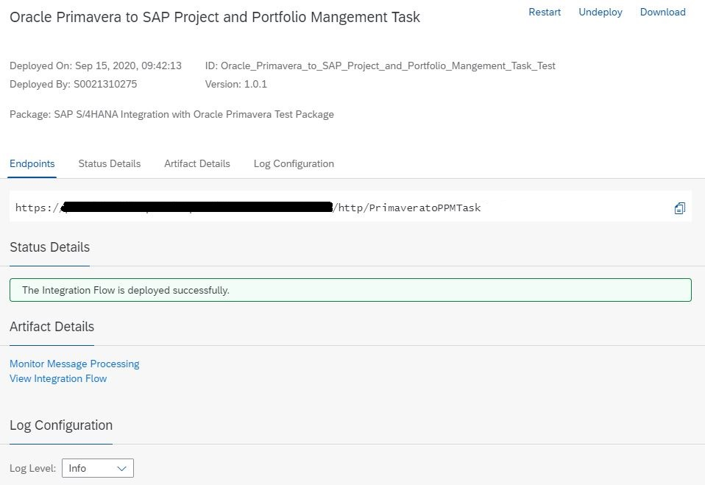
Figure 10: Deployed workflow
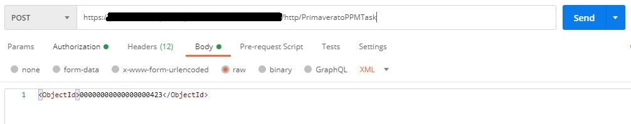
Figure 11: Calling CPI workflow from Postman

Commondo Fiori Trigger
More usable way to trigger flows is usage of some custom application or extensions in your SAP and/or external project management systems. Depending on your end-to-end process integration flows are only one segment in whole process. Typically, project budgeting and project decision process happens in S4/HANA. Once the project is approved and released transfer of basic project data will be transferred from S4/HANA into external project system e.g. Primavera.

It means integration flows for SAP -> Primavera transfer will be triggered. Of course user is allowed and enabled to trigger the transfer manually as described in previous chapter. But more efficient way is to do that directly from SAP. In figure bellow you find My Tasks Fiori application extended by Commondo which enables user to trigger the transfer. Fiori application is not part of delivered package, please contact Commondo for support in that regard.

Furthermore, after project data is transferred to Primavera, other operational departments can review and use it.
Usually this data consists of planned hours, planned work, schedule or costs. Operational users now have frame with planned data and can use it for project execution and input of actual values.
This data can be summarized and sent back to PPM for high company levels to review it.

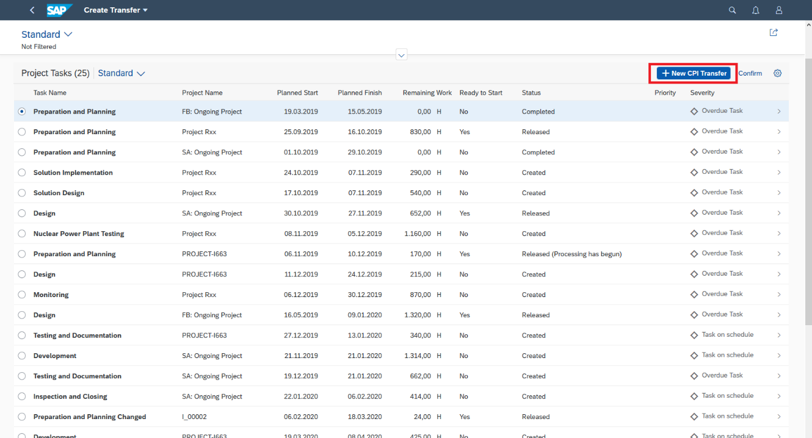
Figure 12: New function in My Tasks Fiori app

Usual business scenarios

Commondo trough years of experience has acquired know-how for usual business scenarios with this kind of integration. Workflows in this package enables typical scenarios that we found reliable and effective for our clients needs.

Management driven project execution
High level project planning is usual and natural way for company management to plan efforts and schedule. Project duration, work and costs are determined and next step is provide that data to operational departments. They require more details data about plan and usually ask management to provide it using project management tools. This is not easy task and project management tools often struggle to provide easy to use features that can produce both high level and low level data.

Solution is to use two project management tools, one for high level planning, other for low level planning and execution.
With connecting SAP PPM and Oracle Primavera, Commondo ePPM suite makes this task easier.

- Management creates project in PPM and determines required Task structure and cost allocation
- Project is transferred to Primavera
- Project is executed in Primavera and filled with new planned and actual data
- Aggregating actual or plan data from Primavera and transferring to PPM

External project plan proposal
Operational department can create their own project plan in external system (Primavera).
Next step is to propose it to management.
For management to evaluate that project plan, other aspects of project need to be check to determine if the plan is suitable.
Doing this manually can produce unintentional error that can reflect on whole project.

With connection SAP PPM and Oracle Primavera, plan and actual efforts can be imported to PPM project. With all data in project, it’s easy to schedule and review if proposed plan is suitable. Plan can be adjusted and returned to Primavera for operational execution.

- Create plan hours and schedule in Primavera
- Transfer to PPM Task
- Edit plan values and schedule
- Transfers to Primavera WBS
- Working in Primavera with plan provided by management, submitting actual hours
- Transfer to PPM Task
- Generate reports to compare plan and actual hours

Import subcontractor data
Enterprise companies are cooperating with many subcontractors on most of projects.
Subcontractors project management systems often differs from companies.
Manual export and import of data is often possible but for daily/weekly data exchange this is hard task to execute.
Commondo ePPM enables automatic daily/weekly data exchange with subcontractors.

- Subcontractor provides a file or connection to system
- File is imported to Primavera
- Data from Primavera project is imported to PPM
- Reports can be generated with new data
Restate, in summary form, statements from prior project documentation such as the project charter and the vision and scope report. Reconfirm the understanding of project objectives and state any clarification needed for those statements that may be required due to the passage of time.
In the form of a matrix, highlight the results of the business analysis.

