

[Interactions Reconciliation From SAP Marketing Cloud To ThirdPartySftp]

Date: 10/03/2020
Version: 1.0
Author: Oleg Veliks

DOCUMENT CONTROL
Owner | Client contact |  | Status | Date issued
Oleg Veliks | N/A | N/A |  | N/A
Version history log
Version | Description of change | Date | Author
1.0 | Initial version | 10.03.2020 | Oleg Veliks

TABLE OF CONTENTS
1 PURPOSE 3
2 OVERVIEW 4
3 PRE-REQUISITES 5
4 INTEGRATION FLOW CONFIGURATION 6
4.1 Configuration Parameters 6
5 HANA RECNCILIATION SQL SCRIPT 8
6 STEPS FOR TESTING THE IFLOW 10

PURPOSE
This document provides configuration steps of the integration flow to extract the loaded interactions from SAP Marketing Cloud via OData and transforms them as AWS S3 files to reconcile data between SAP Marketing Cloud and third party systems. The output files are then fed to other SAP Cloud Integration Data Service Flows to load SAP C/4 Marketing Cloud System data into Staging DB and compare interactions loaded into SAP Marketing Cloud with Legacy Data in Staging DB. We used SCP HANA DB in our scenario but you can use any staging DB that SAP Cloud Integration DS or PI supports.

OVERVIEW
This IFLOW is used to reconcile the interaction data between SAP Marketing Cloud Systems and Source Systems. The output files are then fed to SAP Cloud Integration Data Services Flows to compare interactions loaded into SAP Marketing Cloud with Source Data Staging DB.
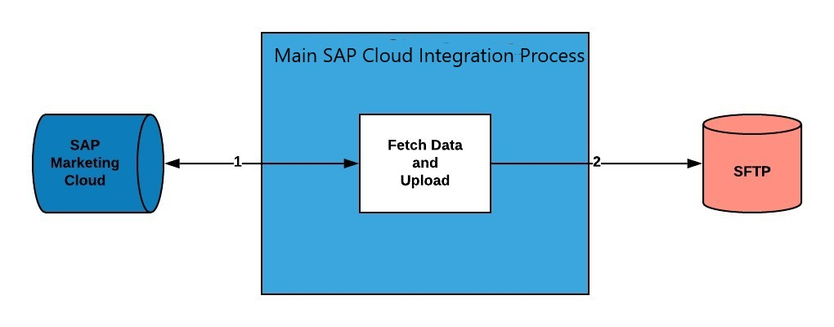
Step 1. Fetch interaction records via OData call in pages from SAP Marketing Cloud. This process will repeat until there are no records to be fetched.
Step 2. Convert the interaction records retrieved via OData call for each 5k page from SAP Marketing Cloud into CSV format and save it as separate files under SFTP directory.

PRE-REQUISITES
Before configuring Integration Flow, please make sure the following prerequisites have been met:

- SAP Marketing Cloud API for fetching Contact data is enabled and up and running.
- Amazon Web Services account is enabled. S3 bucket is created and SFTP Transfer server is up and running. S3 bucket is a root directory of SFTP.
- SFTP server is configured and connectivity between SAP Cloud Integration tenant and SFTP is established.
- SFTP user having permissions to create and update folders and files.

INTEGRATION FLOW CONFIGURATION

Configuration Parameters

Externalized  Parameter Name | Description | Sample Value
Receiver -  C4M(Address) | Host address of SAP Marketing Cloud API for fetching Interactions | https://myxxx.s4hana.ondemand.com/sap/opu/ odata/sap/API_MKT_INTERACTION_SRV
Receiver - C4M  (Credential  Name) | Credential name to connect to the system as deployed in the tenant. | KAPIUSER
Receiver - C4M (Page Size) | Specify page  size to retrieve required number of  records from  C4M | 4900
Receiver - C4M  (Timeout in min) | Maximum  time the system wait before operation is terminated. | 10
Receiver -  SFTP(Directory) | File path from where log files should be written. | DevelopmentLoads/LoadFiles/Interactions/Reco nciliation
Receiver - SFTP(File  Name) | Name of the file name to be written. | Interactions_Reprocess_C4M.csv
Receiver -  SFTP(Address) | Host name or IP address and port of the SFTP server. | xxx.server.transfer.eu-west-2.amazonaws.com
Receiver -  SFTP(User Name) | ID of the user performing file transfer. | CPI_USER_PROD

Receiver -  SFTP(Timeout) | Maximum  waiting time to contact the FTP server while establishing connection or performing a write operation. | 10000
Receiver -  SFTP(Maximum reconnect attempts) | Maximum  numbers of reconnect attempts allow to reconnect  SFTP server. | 3
Receiver -  SFTP(Reconnect delay in ms) | Time period to wait before attempting to reconnect to the remote FTP server. | 1000
Receiver -  SFTP(Buffer size) | Write file content using the mentioned buffer size. | 128
More (Path to XSD of XML Converter) | Specify Xpath of the record identifier. Used in XML to CSV. | /INTERACTIONS_RECONCILIATION/Records

HANA RECNCILIATION SQL SCRIPT

This step assumes that you loaded the SAP C/4 marketing cloud data into HANA DB that you extracted into AWS S3 files via SAP Cloud Integration Data Service flows. You can use the following HANA SQL script to reconcile legacy system interactions data with SAP C/4 Marketing Cloud System.
//Creation of missing Marketing Interactions:
Description of Query: selecting customer data from table “INTERACTIONS OF TYPE MARKETING INTERACTIONS” (Legacy Data) which is not present in table “ INTERACTION_RECONCILIATION” and inserting them into new table “INTERACTIONS_RECONCILIATION_C4M_Temp_Others”.
create column table prod_hana_ds.INTERACTIONS_RECONCILIATION_Temp_Others as ( SELECT INTERACTIONCONTACTID,INTERACTIONTIMESTAMPUTC,INTERACTIONTYPE
FROM (SELECT
INTERACTIONCONTACTID,INTERACTIONTIMESTAMPUTC,INTERACTIONTYPE FROM prod_hana_ds.INTERACTIONS where interactiontype not in
('SHOP_CHECKOUT_SUCCES','SALES_ORDER','LOYALTY_VOUCHER') except SELECT INTERACTIONCONTACTID,INTERACTIONTIMESTAMPUTC,INTERACTIONTYPE FROM prod_hana_ds.INTERACTIONS_RECONCILIATION where interactiontype not in ('SHOP_CHECKOUT_SUCCES','SALES_ORDER','LOYALTY_VOUCHER')));

//Creation of missing Orders line items-
Description of Query: selecting customer data from table “INTERACTIONS OF TYPE
ORDERS” (Legacy Data) which is not present in table “ INTERACTION_RECONCILIATION” and inserting them into new table “INTERACTIONS_RECONCILIATION_C4M_Temp_ORDERS”.
create column table prod_hana_ds.INTERACTIONS_RECONCILIATION_Temp_ORDERS as ( SELECT
INTERACTIONCONTACTID,INTERACTIONTYPE,INTERACTIONTIMESTAMPUTC,INTERACTION
SOURCEOBJECT FROM (SELECT
INTERACTIONCONTACTID,INTERACTIONTYPE,INTERACTIONTIMESTAMPUTC,INTERACTION
SOURCEOBJECT FROM prod_hana_ds.INTERACTIONS where interactiontype in ('SHOP_CHECKOUT_SUCCES','SALES_ORDER') except SELECT
INTERACTIONCONTACTID,INTERACTIONTYPE,INTERACTIONTIMESTAMPUTC,INTERACTION SOURCEOBJECT FROM prod_hana_ds.INTERACTIONS_RECONCILIATION where interactiontype in ('SHOP_CHECKOUT_SUCCES','SALES_ORDER')));

//Creation of missing Vouchers-
Description of Query: selecting customer data from table “ INTERACTIONS OF TYPE
VOUCHERS” (Legacy Data) which is not present in table “ INTERACTION_RECONCILIATION” and inserting them into new table “INTERACTIONS_RECONCILIATION_C4M_Temp_VOUCHERS”.
create column table prod_hana_ds.INTERACTIONS_RECONCILIATION_Temp_Vouchers as ( SELECT
INTERACTIONCONTACTID,INTERACTIONTYPE,INTERACTIONTIMESTAMPUTC,YY1_LOYBEN
EFITCODE_MIA FROM (SELECT
INTERACTIONCONTACTID,INTERACTIONTYPE,INTERACTIONTIMESTAMPUTC,YY1_LOYBEN
EFITCODE_MIA FROM prod_hana_ds.INTERACTIONS where interactiontype in
('LOYALTY_VOUCHER') except SELECT
INTERACTIONCONTACTID,INTERACTIONTYPE,INTERACTIONTIMESTAMPUTC,YY1_LOYBEN EFITCODE_MIA FROM prod_hana_ds.INTERACTIONS_RECONCILIATION where interactiontype in ('LOYALTY_VOUCHER')));

STEPS FOR TESTING THE IFLOW
Step 1. Deploy iflow and wait until it is finished. iflow Components:
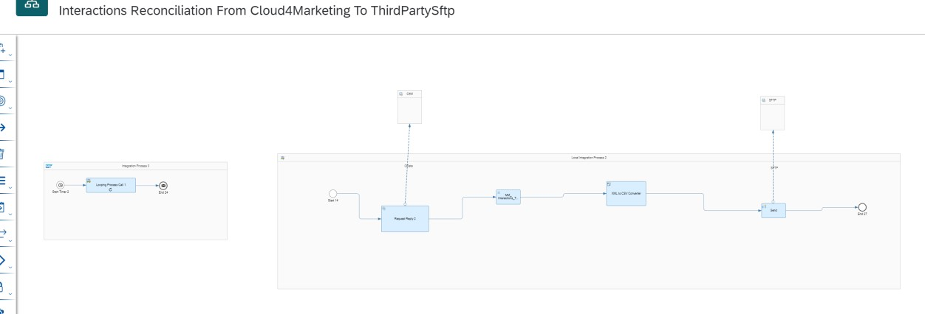
Status of the message is successful.
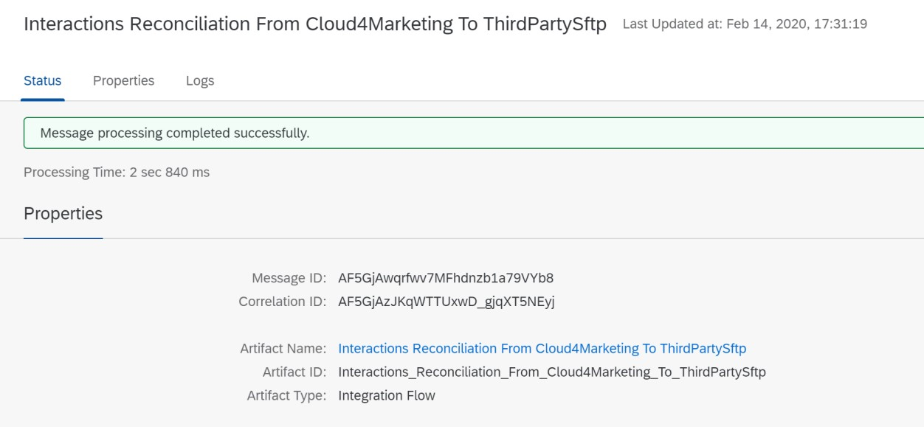
Overview of Message Trace Logs.
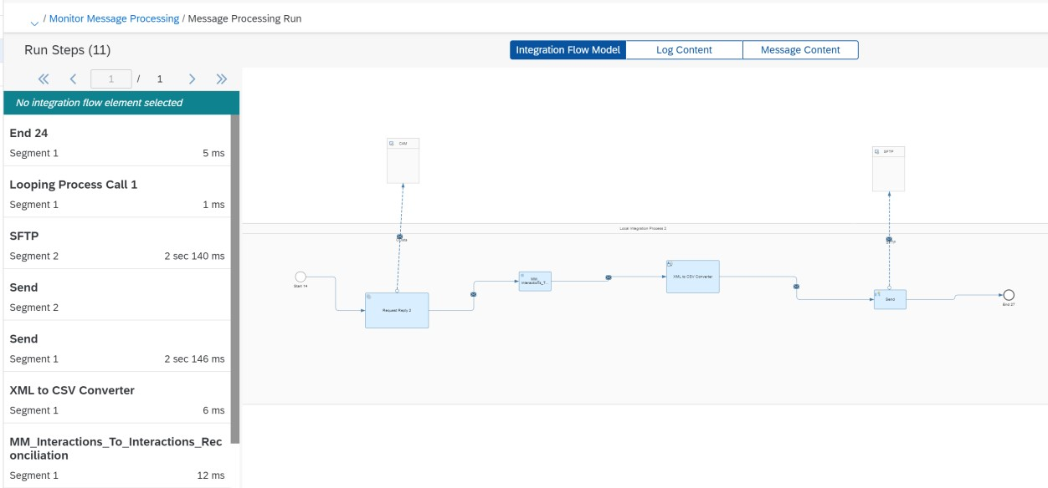
Step 2. Explore SFTP directory specified in "Receiver - SFTP(Address)" and make sure all interactions which are satisfying OData filter and exist in SAP Marketing Cloud appear in file Receiver - SFTP(File Name)
