Motivation:
How can I control if the exception getting generated in Cloud Platform Integration is transmitted back to the sender?

Solution:
For security reasons, we introduced a feature in Cloud Platform Integration that prevents errors that occur during the processing in Cloud Platform Integration or while transferring messages to a receiver system, back to the SOAP sender. Reason: the exceptions might also include system information that may allow attackers to find a way to break into the system. With the new mechanism, the sender receives instead a generic error message containing the MPL ID (in case Message Processing Log is enabled at all).
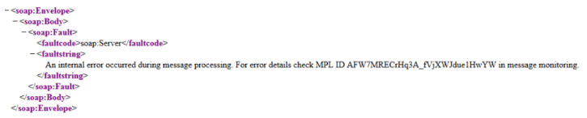
This ID can to searched via Cloud Platform Integration monitoring for the error details:
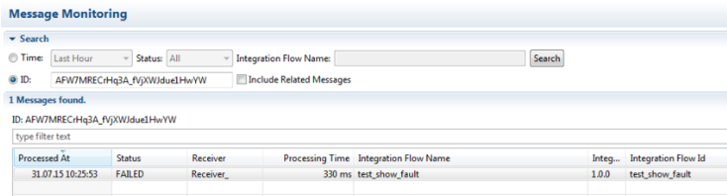

The same applies to the WebUI:
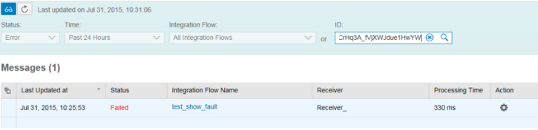

You can find the details of the exception in the detailed logs:
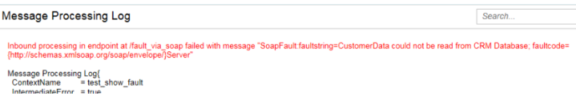

However, there might be cases where the SOAP sender wants to see the error on its side. In order to enable this, we can use a flag that shall return the exceptions back to the sender. The flag is under "Error Configuration" section of the integration flow:
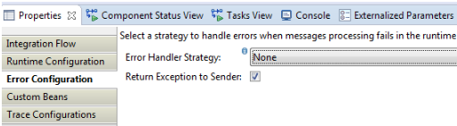

After re-deploying the integration flow a SOAP call to this service would return:
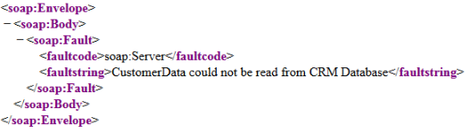

It is now up to the integration flow developer if errors shall be returned to the sender system or if they shall only be visible inside Cloud Platform Integration.

