Motivation:
Renaming integration artifact or document or package in the WebUI

Solution:

Edit Package Name:
Goto the Design view of the WebUI and open the Package whose name needs to be updated:

Click on Edit on the top right side:
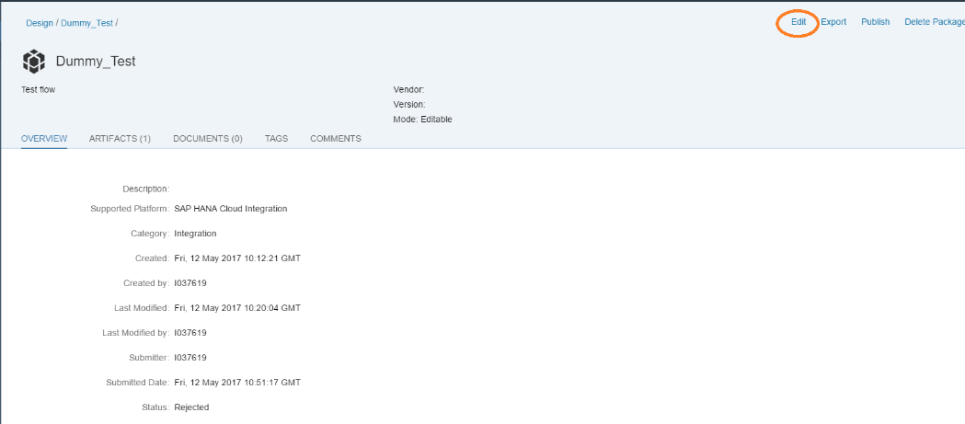

Goto the Header tab.
Now add the new name in the Name field. Note that the technical name cannot be changed. The Technical name can only be defined when you are either creating a new package or copying it from the Discover view:

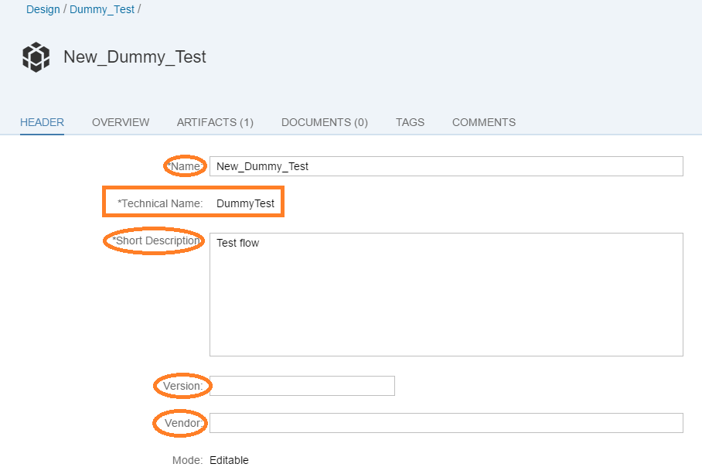

Other fields that you can change are: Short description, Version and Vendor.
You can move to the other tabs, like Overview and Tags to change the corresponding fields:

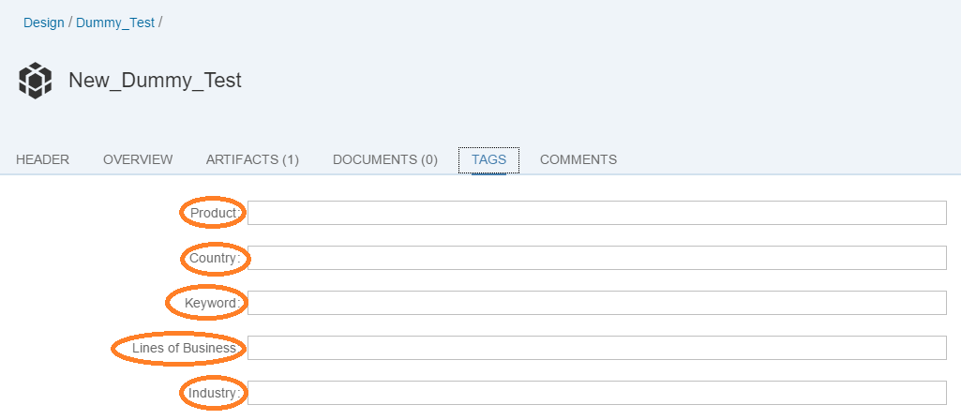
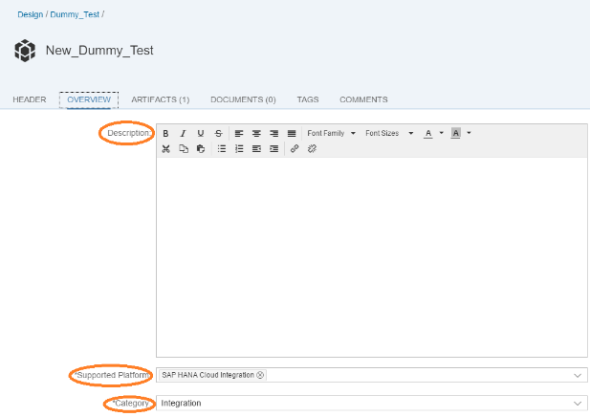

Change the details and click on Save on the top right:
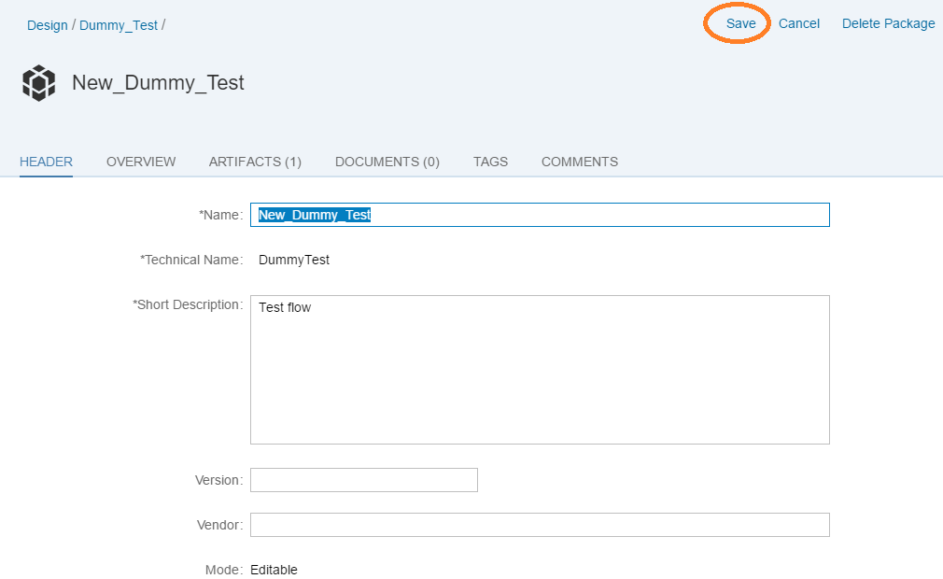

Editing a Document or Artifact Name:
Goto the Design view of the WebUI and open the Package whose document or artifact’s name needs to be updated:

Click on Edit on the top right side:

Goto the Artifacts or Documents tab:
Click on the button under Actions for the Artifact whose name needs to be changed. Now click on View Metadata.
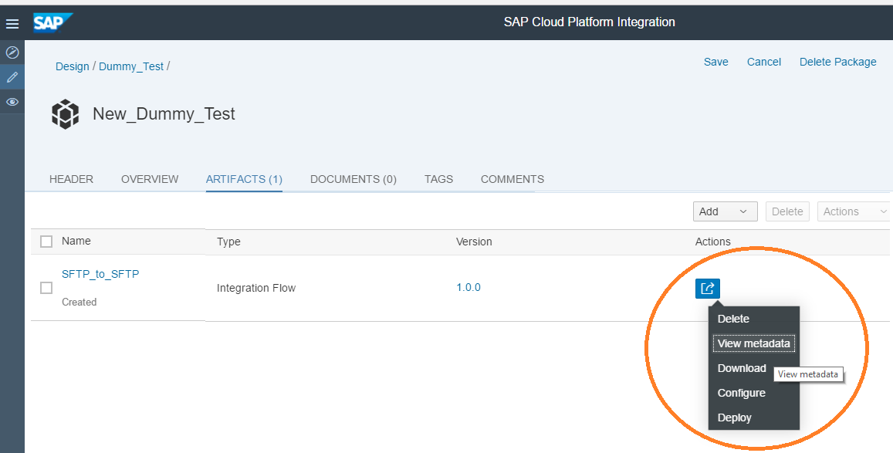

Now click on Edit on the bottom right:
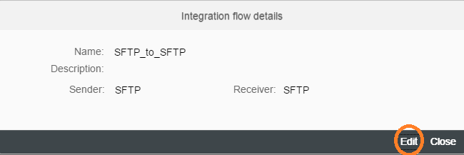

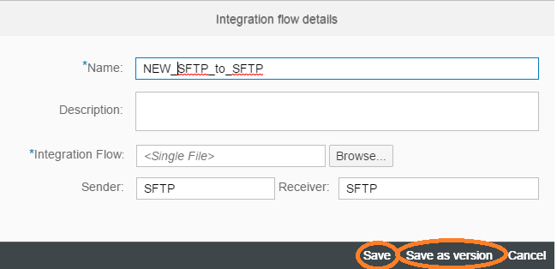

Here you can change the Name, Description, Sender and Receiver.
You can also upload a new Artifact.

Finally you can either choose to Save or Save as version.
The corresponding fields shall be changed:

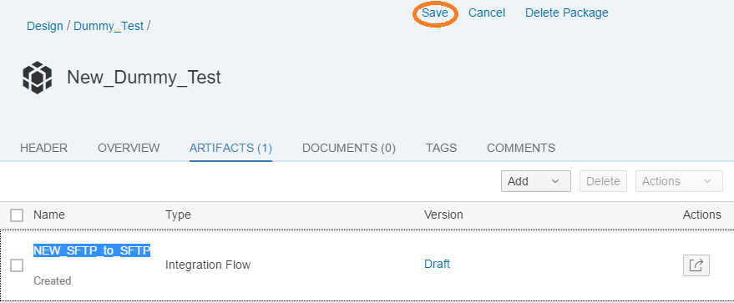

Finally Save the package by clicking on the Save button on the top right.

