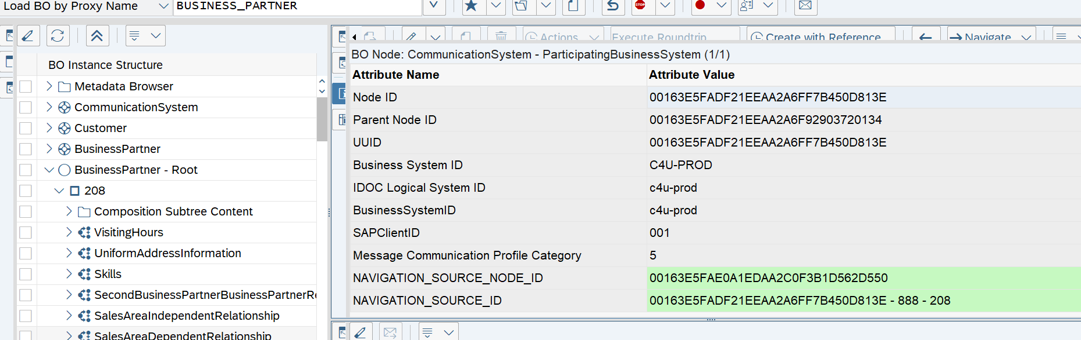
March 2021  Version 2.0  English | Internal
SAP Cloud for Utilities Basic Integration setup using SAP Cloud Integration

Document History
Revision | Date | Change
1.0 | Sep, 2020 | Initial Draft
2.0 | March 26.2021 | Brand Name changes incorporated

1 Purpose 4
2 Connection set up between SAP Cloud for Customer and SAP S/4HANA 5
2.1 Overview 5
2.2 Configuration in C4C 6
2.2.1 Define Communication System 6
2.2.2 Configure Communication Arrangement 8
2.3 Configuration in SAP Cloud Integration 14
2.4 Configuration in SAP S/4HANA 17
2.4.1 Maintain Endpoints for Services 17
2.4.2 Logical port creation for outbound services 18

Purpose
The purpose of this document is to describe the general configuration steps required to manually set up the Configuration within the system landscape that has already been installed.
This document describes the procedure to configure the Basic Integration between SAP S/4HANA, Cloud for Customer(C4C), and SAP Cloud Integration.
Network Security team takes the responsibility of preparing the network environment across different systems and its security aspects.

Important:
If you have any queries or feedback on this document, please create a ticket for the component IS-U-C4U

Connection set up between SAP Cloud for Customer and SAP S/4HANA

Overview
This section provides an overview of the required connection setup for the solution package. Certificates are installed in the SAP Cloud Integration and SAP C4C Systems.
Between the SAP Cloud Integration Service and SAP S/4HANA the message can be routed via reverse proxy or a cloud connector based on the customer infrastructure setup.

SAP Cloud Integration
S/4HANA
C4C

Configuration in C4C
To establish the connection of C4C follow the steps.
Note: This configuration does not require any scoping and ID mapping set up.

Define Communication System
To define the communication system, follow the steps:
- Navigate to Administrator General Settings Integration Communication Systems.
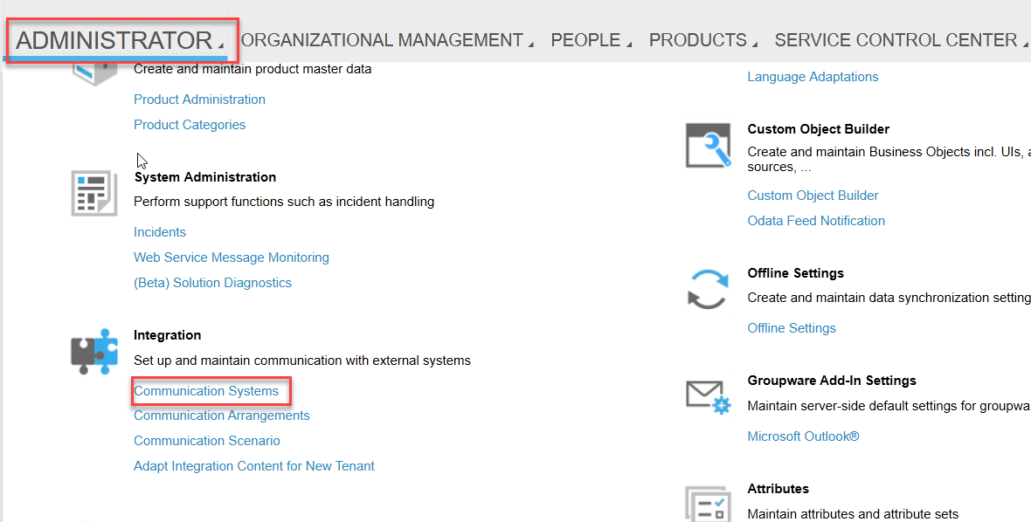
- Select New to define Communication System.
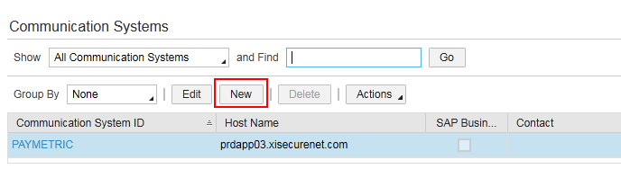
- Enter the fields as shown in the table.
Field | Value | Comment
ID | <SID> | SAP back-end system’s ID
SAP Business Suite | Check
Host Name |  | Host Name is the value SAP Cloud Integration Worker Node without prefix Https://
System Access Type | Internet
INTERNAL COMMENT |  | Optional
System Instance ID | <S/4HANA Logical System Name> example: <SIDCLNTXXX> | SID is the system ID and XXX is the Client number of the SAP Backend System
Business System ID | <S/4HANA Logical System Name> example: <SIDCLNTXXX>
IDoc Logical System ID | <S/4HANA Logical System Name> example: <SIDCLNTXXX>
SAP Client | <Client Number> example:XXX
Preferred Application Protocol | 5-Web Service
- Provide the contact details in the TECHNICAL CONTACT.
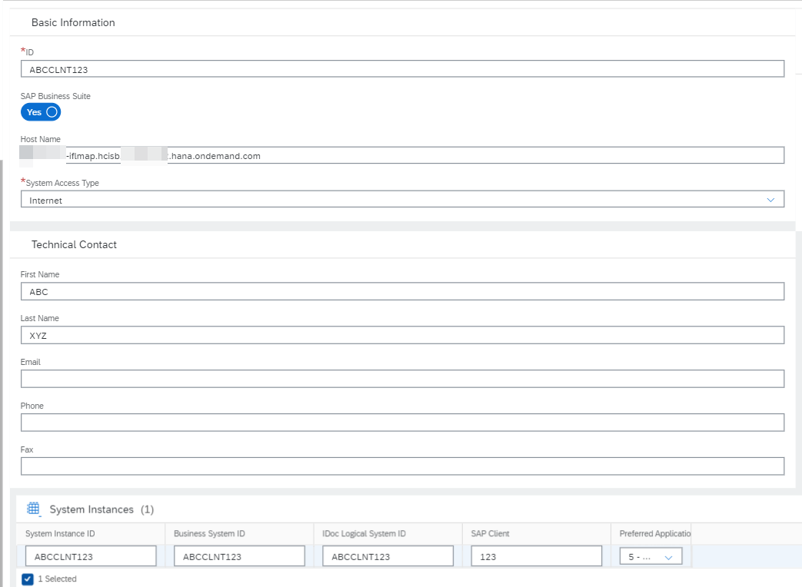
- Click Save and then select ActionsSet to Active.
- Click Close.

Configure Communication Arrangement
The communication scenarios mentioned in the table are relevant for your project scope, create them one after the other:

Communication Scenarios | Communication Services
Communication Scenarios | Inbound | Outbound
Cloud for Utilities Integration | - not relevant | - Contains all the Utilities Transactional data services
Utilities Contract Account Replication | - Replicate Contract Account data from S/4HANA(Master Data) | - not relevant
Utilities Technical Master Data Replication | - Replicate Technical Master Data from S/4HANA (Master Data) | - not relevant
Note: In case you do not see any of the configuration scenarios, re-check the project scoping to add the necessary scoping elements.

To configure the communication arrangements, follow the steps:
- Navigate to Administrator General Settings Integration Communication Arrangements.
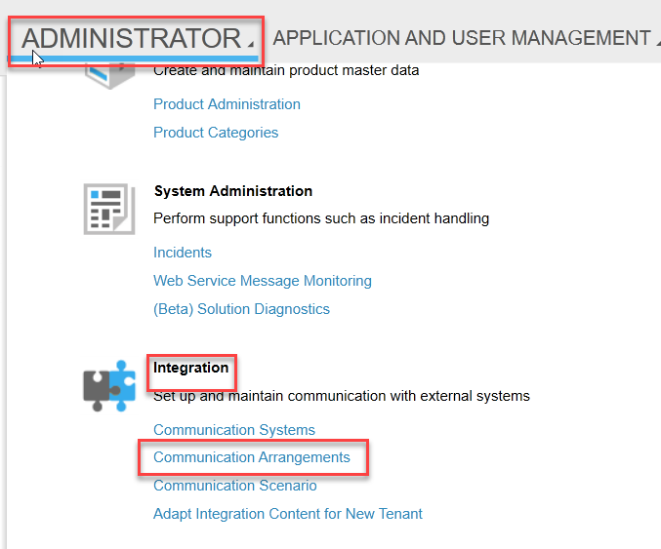
- Select New to create a new communication arrangement.
- From Communication Scenarios table, select the Communication Scenario Cloud for Utilities Integration

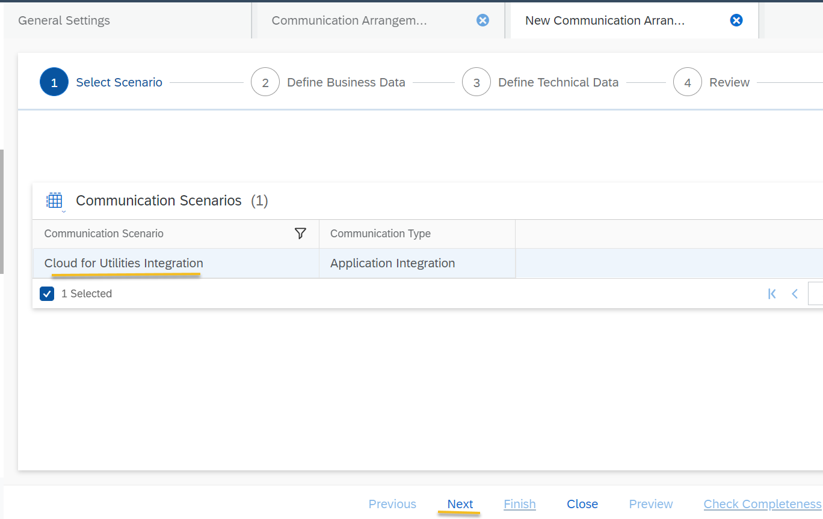
- Click Next.
- Select System Instance ID from the value help. This communication system ID is created in the Define Communication System section.
- Make a note of the My System ID, displayed under MY COMMUNICATION DATA. This is used in S/4HANA system while setting up the communication system.
- Select Code List Mapping as SAP On-Premise Integration.
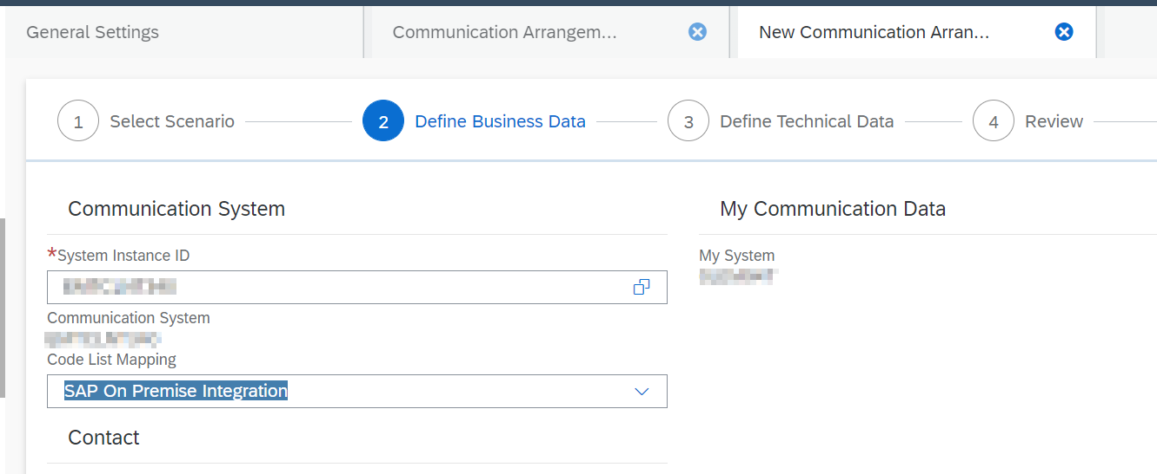
- Click Next.
- For OUTBOUND COMMUNICATION BASIC SETTINGS, select the Application Protocol as Web Service and Authentication Method as SSL Client Certificate or User ID and Password.
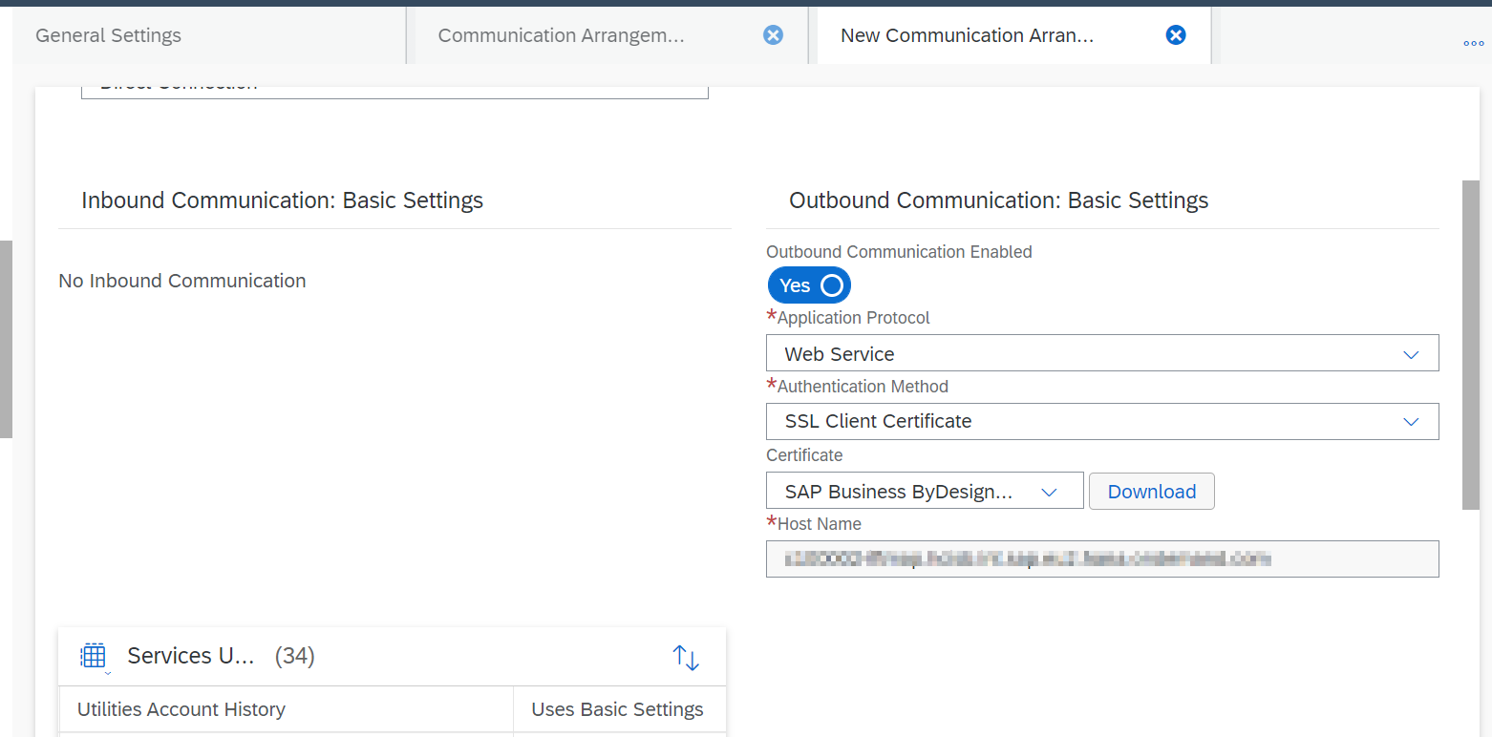
- If SSL client certificate is selected as Authentication method, download the certificate and upload in the sender communication channel/Adapter in SAP Cloud Integration.
- If User ID and Password is selected as Authentication method, provide SAP Cloud Integration credentials to connect.
Note: Inbound Communication Basic Settings is not applicable for Cloud for Utilities Integration scenario.
- Click Next and Finish.
- Edit the communication arrangement that you created
- Click View All Technical Data Edit advance settings and enter the SAP Cloud Integration end point URL.
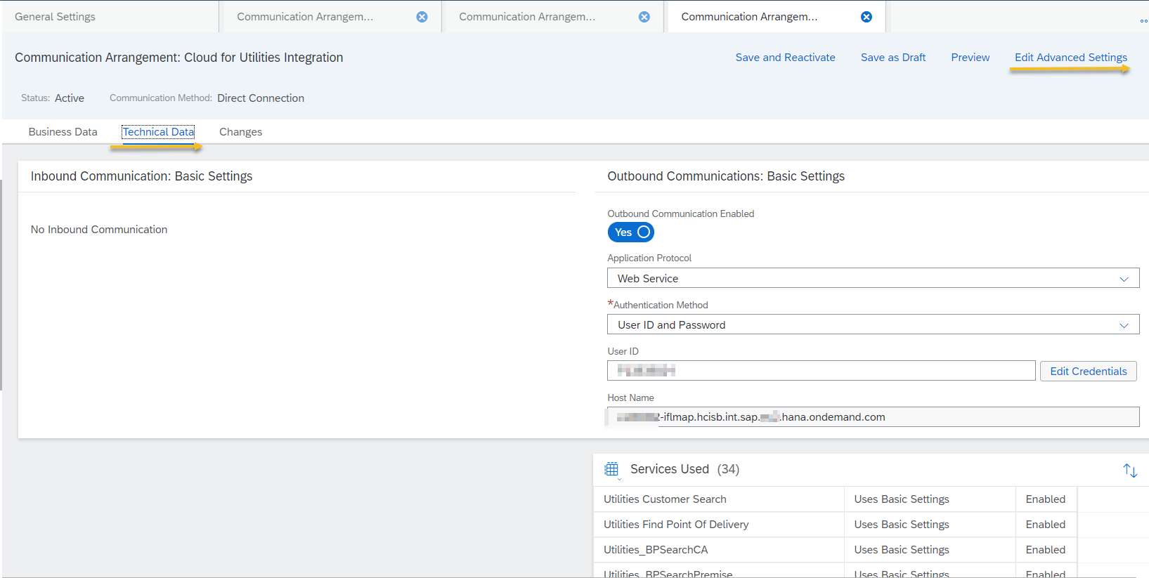
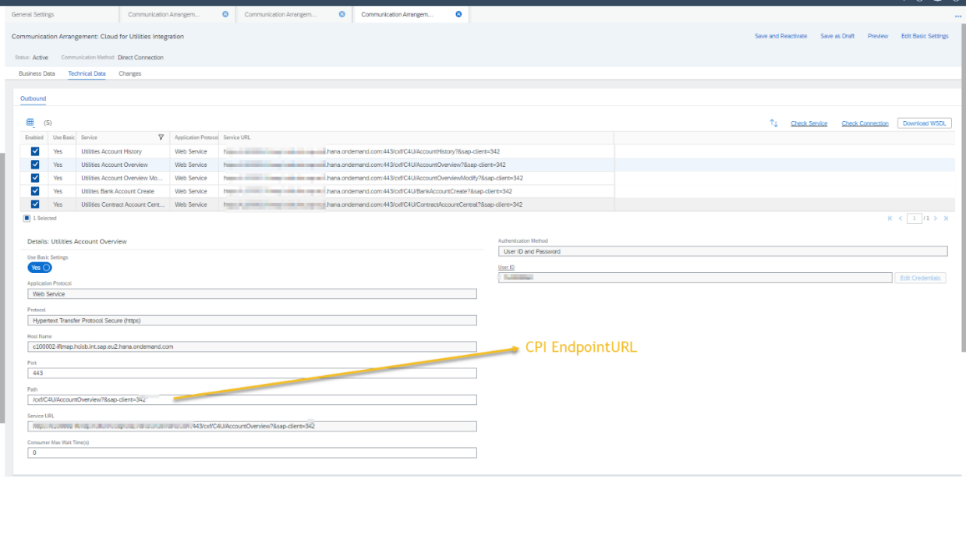
Note: Example for PATH field: Login to SAP Cloud Integration Web UI and go to corresponding CLOUD INTEGRATION iFlow for your package content. In configure tab and copy the Address path. Add prefix /cxf and suffix ?sap-client= (Client number) to the copied path.
Ex: /cxf/C4U/AccountOverview?sap-client=000

- In the similar way, configure for Utilities Technical Master Data Replication and Utilities Contract Account Replication.
- For inbound Communication: Basic setting, if Authentication method is selected as SSL Client Certificate.
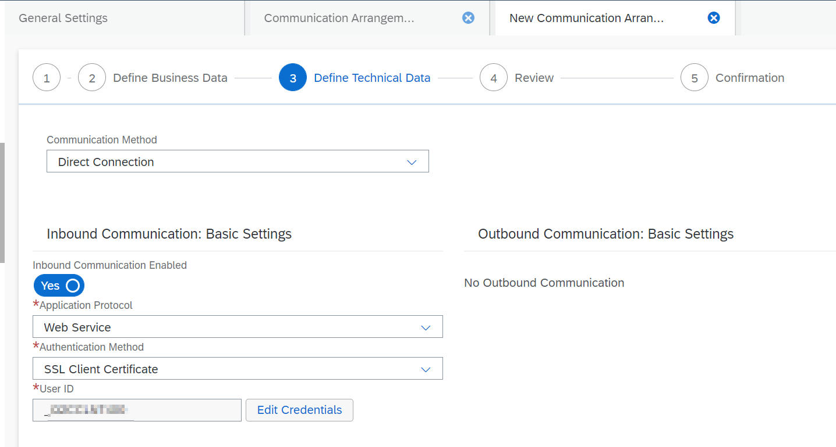
- Click Edit Credentials.
- In the Certificate tab, under Upload Certificate select CLOUD INTEGRATION Client Certificate.
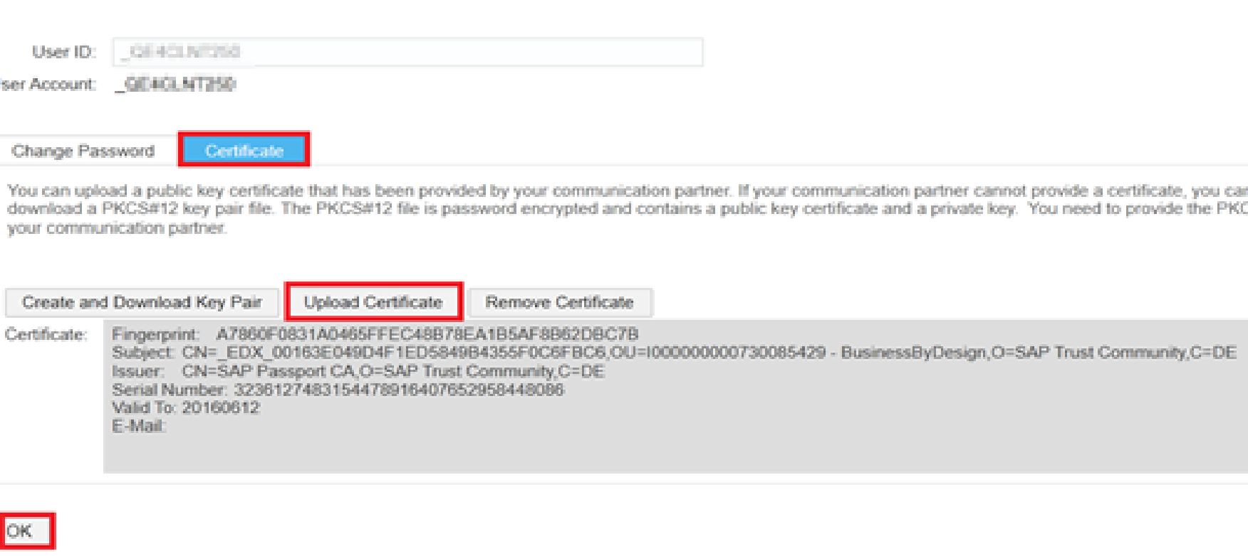
- Click OK.
For more information refer Communication Arrangement quick guide: https://help.sap.com/viewer/abfba1342cfb4832ab722fa041f6c4b7/1702/en-US/de63ea8996514f518d251f5ae188fb11.html

Configuration in CLOUD INTEGRATION
To configure the SAP Cloud Integration, follow the steps:
- Access the SAP Cloud Integration web UI URL in the format https://<SAP Cloud IntegrationTenant>.ondemand.com/ itspaces.
- Log in to the tenant with relevant credentials.
- Select the package SAP Cloud for Utilities for Customer Service Solution Integration with SAP S/4HANA from Discover tab.
- Click Copy button to get the package to Design tab.
- Navigate to Design tab and click the package, where you can perform all the relevant configurations.
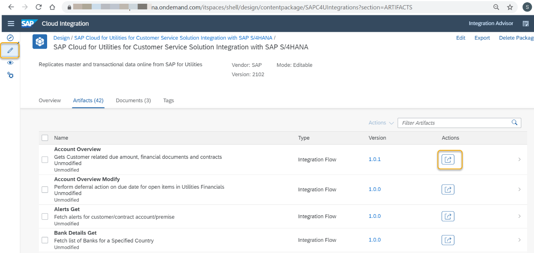
- Go to Artifacts tab -> click Actions button -> select Configure.
- In the Sender tab, upload the client certificate for Authorization is Client Certificate.
- In the Receiver tab, enter the Private key for Authorization is Client Certificate.

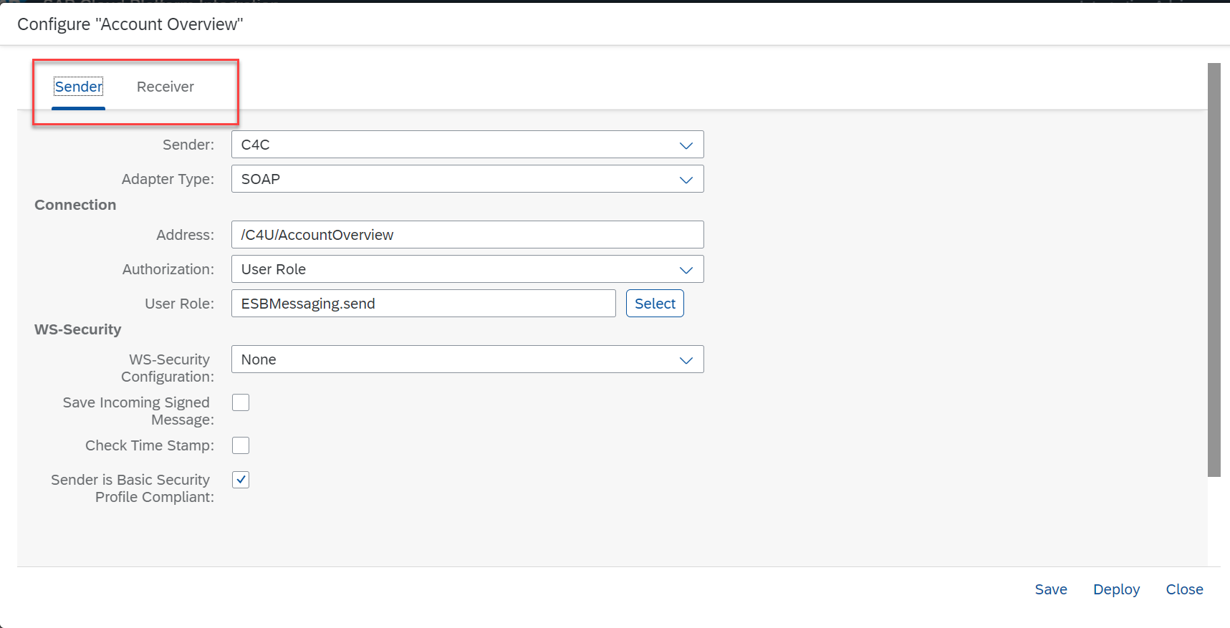
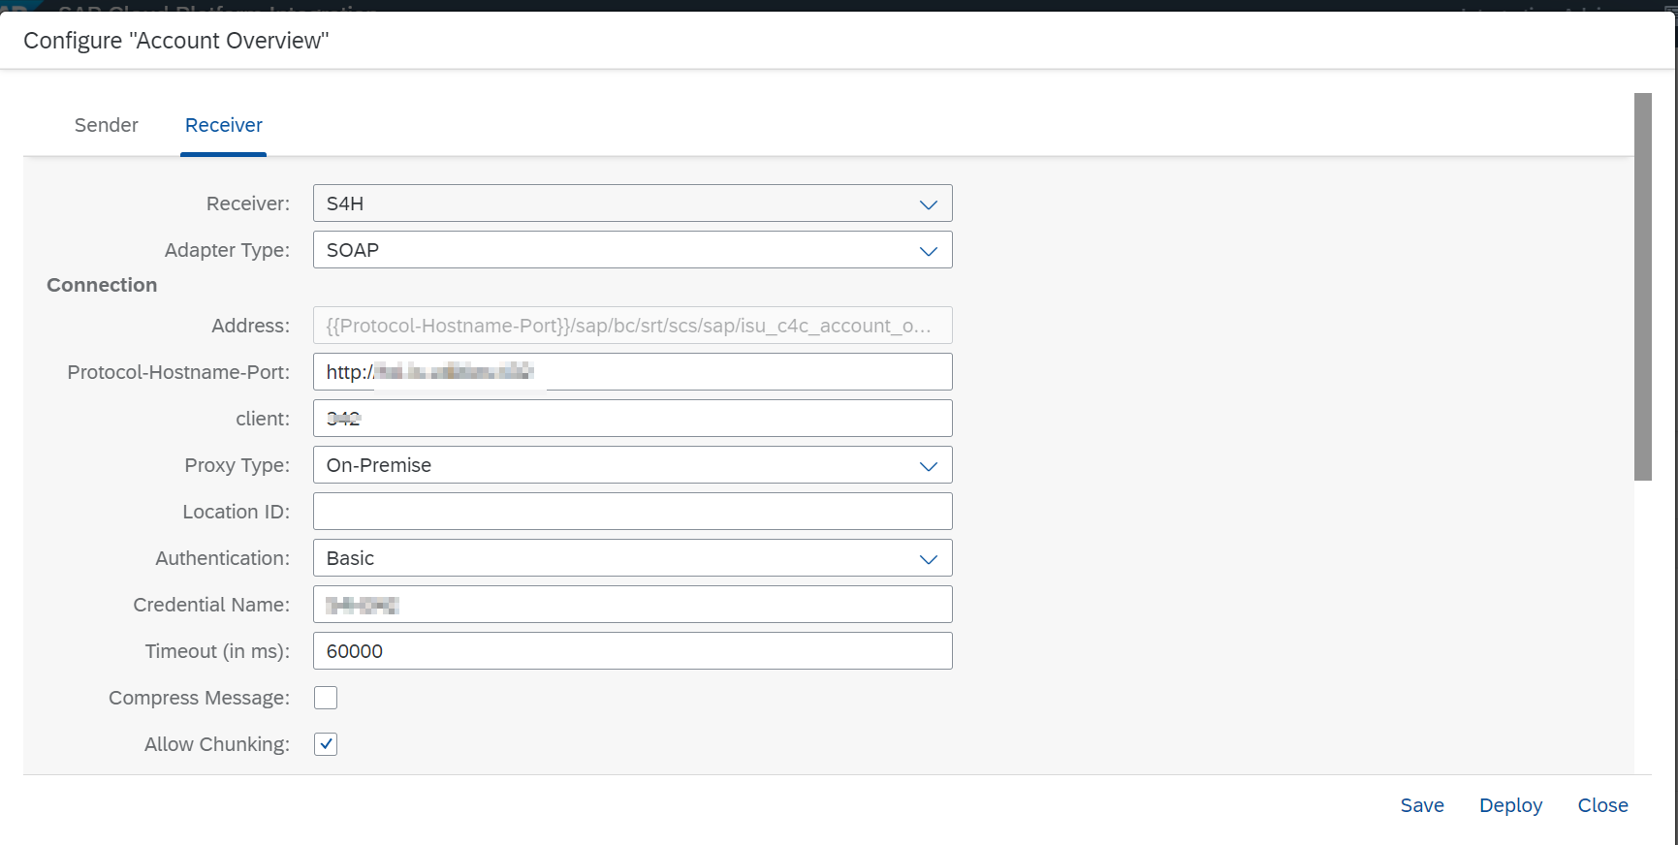
- During Replication Utilities Technical Master Data Artifact configuration, under More tab enter the values in Sender and Receiver system parameters with S4H and C4C business system IDs.
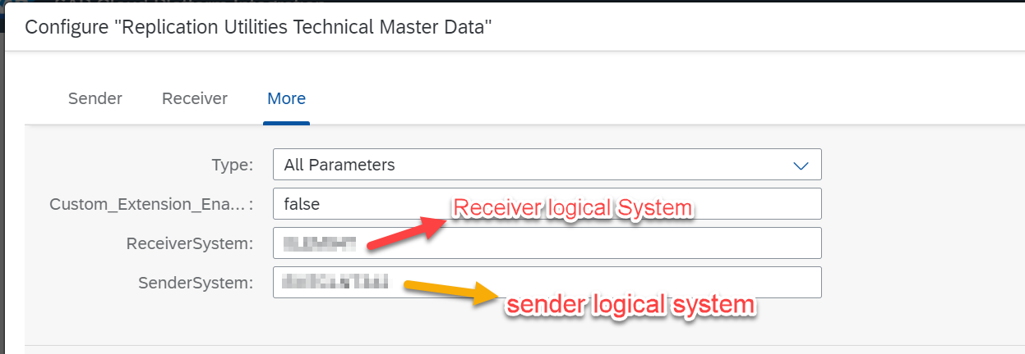
- Click Save and Deploy
- Check the deploy status in Monitoring-Manage Integration.
- Under Operation view, create S/4HANA or C4C credentials and deploy.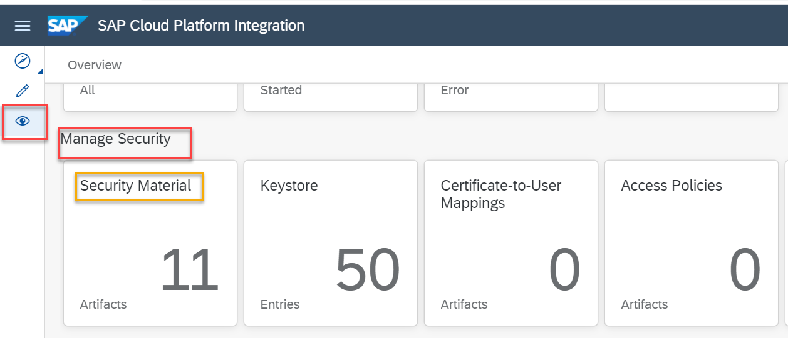
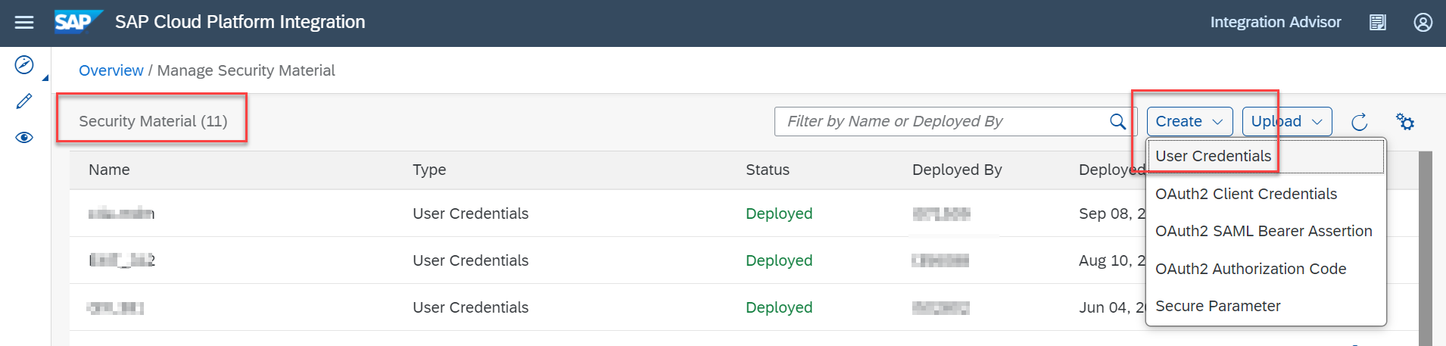

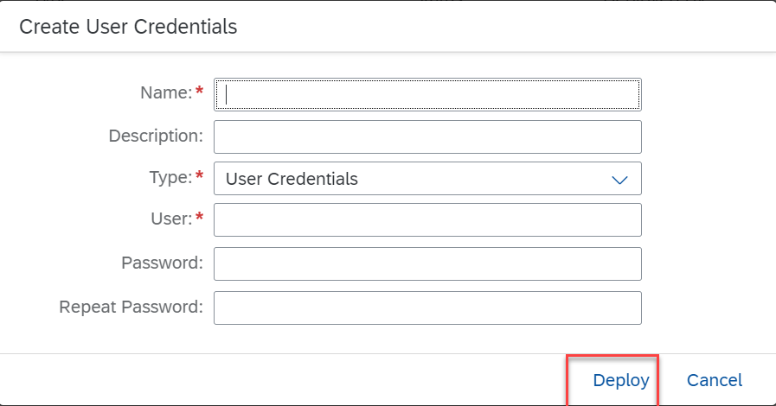

Configuration in SAP S/4HANA

Maintain Endpoints for Services
To configure inbound web service for synchronous call from C4C to S/4HANA system follow the steps:
- In the system enter Transaction code – SOAMANGER.
- Select Simplified Web Service Configuration under Service Administration.
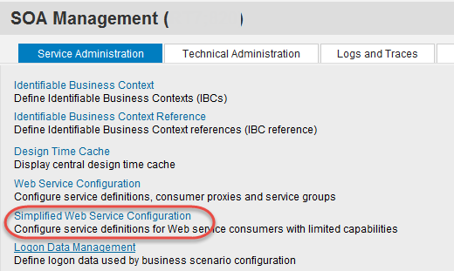
- Search for the object name ISU_C4C_ACCOUNT_OVERVIEW in Search Service Definitions.
- Click Go.
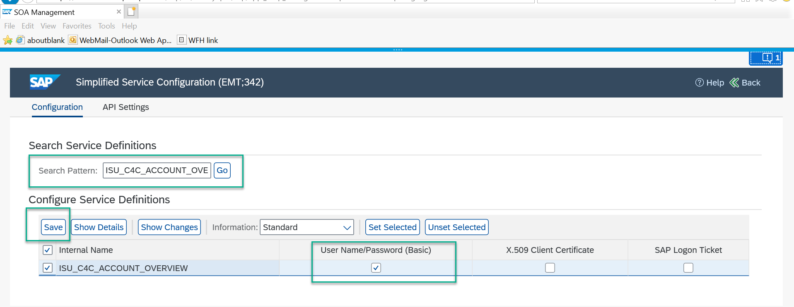
- Select the object entry and click Username /Password check box and click Save.
- Click Show Details tab to see the generated URL.
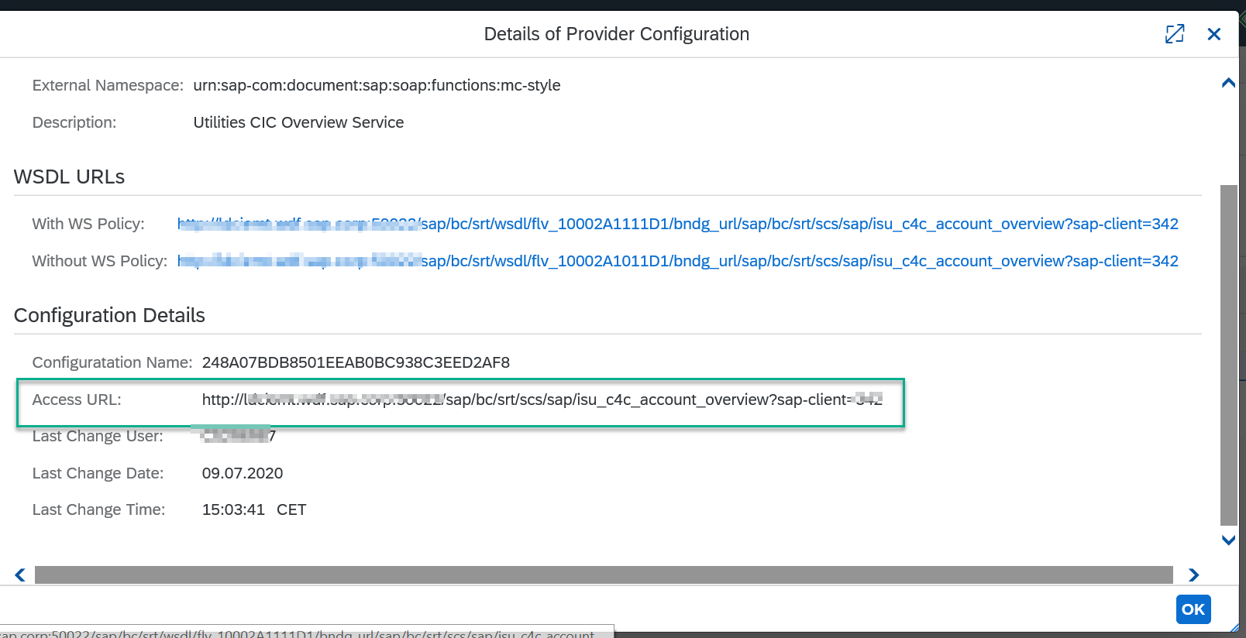
- This URL is already maintained in the receiver channel of SAP Cloud Integration as S/4HANA end point URL.
Note: Repeat the Configurations for all the synchronous services

Logical port creation for outbound services
Create the logical ports for the Asynchronous/Outbound services.
The Outbound services are as follows:
- CO_FKK_MDG_CONTRACT_ACCOUNT_BU (Contract Account Replication)
- CO_UTILITIES_TECHINICAL_OBJEST (Technical Object Replication)

- In the system enter Transaction code – SOAMANGER,
- Select Web Service configuration under the Service Administration.
- Select for object name CO_UTILITIES_TECHINICAL_OBJEST and click search.
- Click Manual Configuration for the selected service.

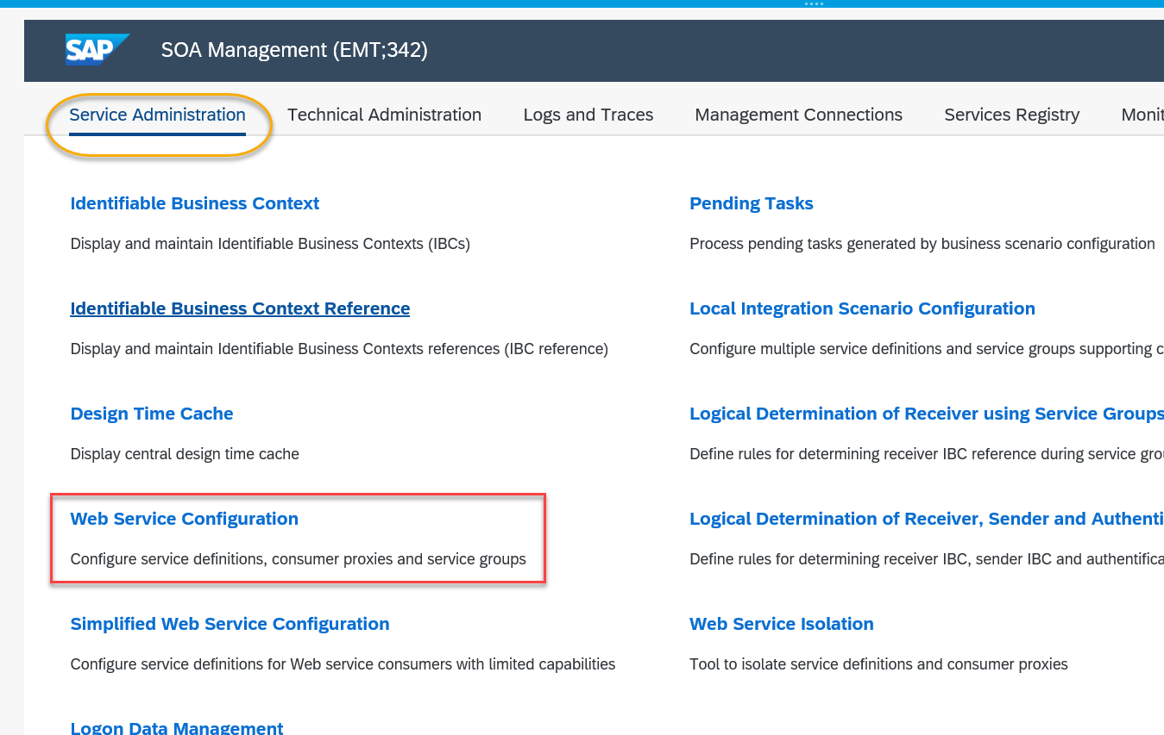

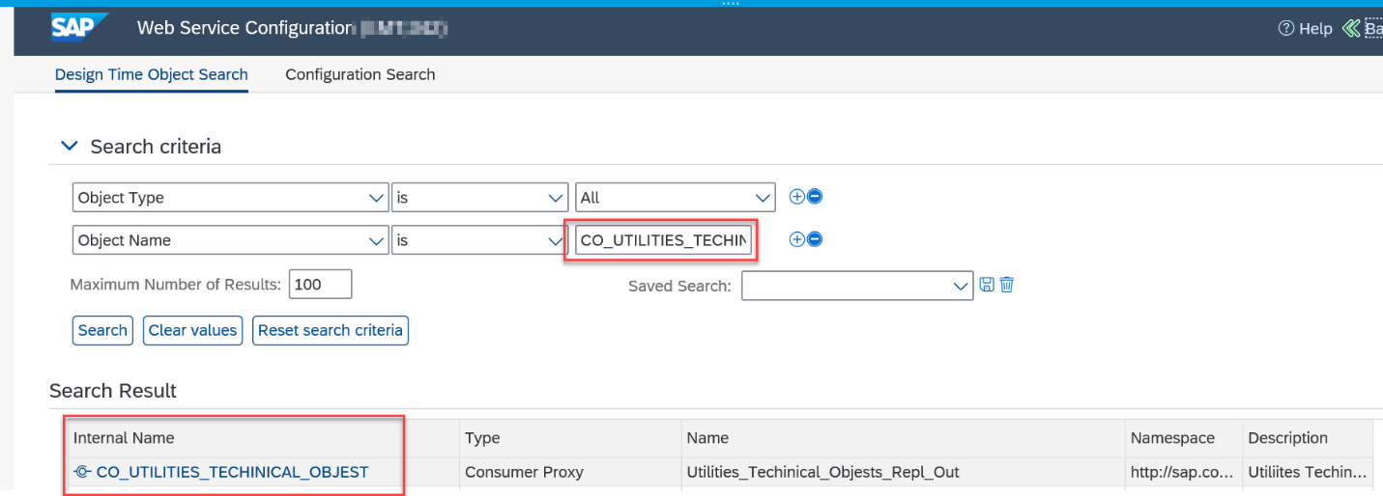

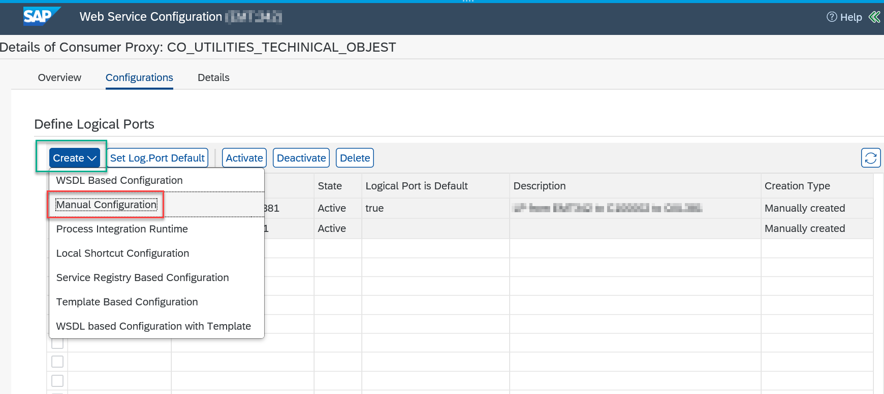
- Under Consumer Security tab, provide the required details.
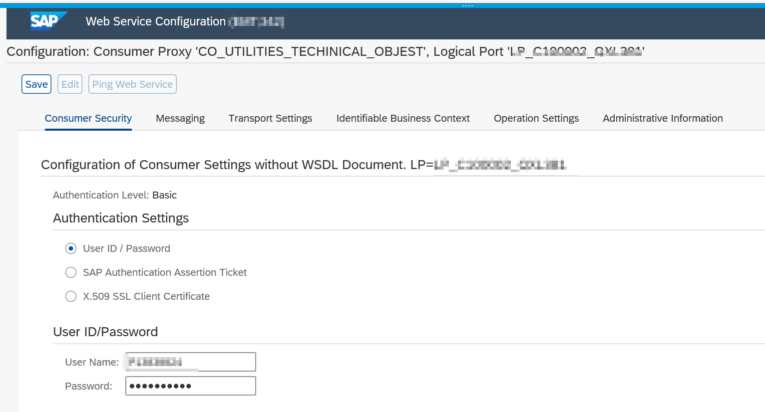
- Under Messaging tab, provide the required details.
  - RM Protocol – SAP RM
  - Message ID - SAP Message ID
  - Data Transfer Scope – Basic Data Transfer
  - Transfer Protocol – Transfer via SOAP Header
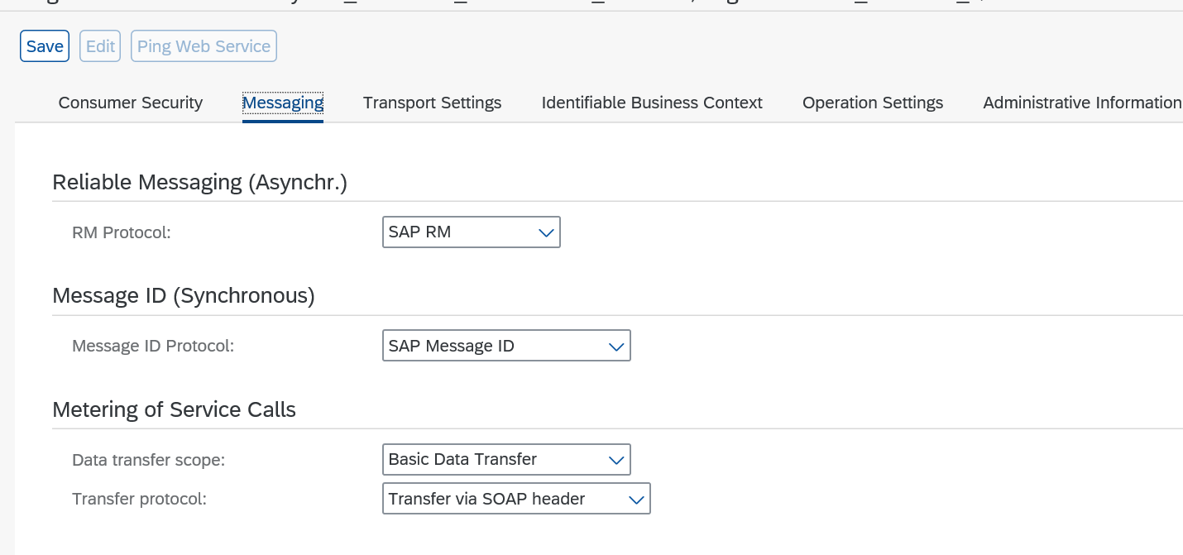
- Under Transport Settings tab, provide the required details.
    - Enter the SAP Cloud Integration end point URL which is deployed.
    - Click Next and Finish.
    - Click Ping web service to test the connection from S/4HANA to SAP Cloud Integration.
