

[Content Based Split From ThirdPartySftp To
ThirdPartySftp]

Version | Description of change | Date | Author
1.0 | Initial version | 10.03.2020 | Oleg Veliks
Date: 10/03/2020
Version: 1.0
Author: Oleg Veliks

DOCUMENT CONTROL
Owner | Client contact |  | Status | Date issued
Oleg Veliks | N/A | N/A |  | N/A
Version history log
TABLE OF CONTENTS

1 PURPOSE 3
2 OVERVIEW 4
3 PRE-REQUISITES 5
4 INTEGRATION FLOW CONFIGURATION 6
4.1 Configuration Parameters 6
5 STEPS FOR TESTING THE IFLOW 9

PURPOSE
The purpose of this document is to describe the general configuration steps that are required to split Interactions files with type Orders before loading to SAP Marketing Cloud. This Integration flow is used to group orders by customer ID & split order files of 1 Million records into 100K files without splitting the customer orders between two different 100k files i.e. if the legacy source system 1 million file has 101,000th record with same customer and order number as 100,000th record then file is split at 101k record instead of 100,000k record.
If the file is not split to ensure that the all items of the same order number are in one file then SAP Marketing Cloud system creates two interactions for the same order and splits the order items between 2 interactions i.e. an order in legacy source system will have 2 order interactions in SAP C/4 Marketing Cloud System.

OVERVIEW
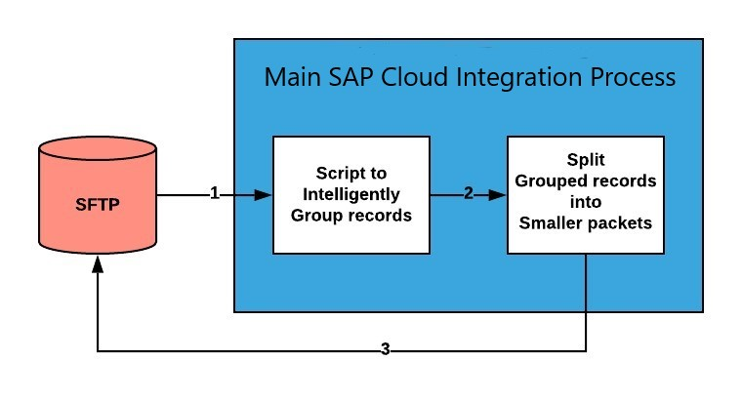
Step 1. Order files of 1 million records are placed in AWS S3 buckets via SFTP.
Step 2. SAP Cloud Integration splits the file into 100k records each without splitting the customer orders between multiple 100k files i.e. if the source 1 million file has 101,000th record with same customer and order number as 100,000th record then file is split at 101k record instead of 100,000k record..
Step 3. SAP Cloud Integration saves 100k files into SFTP folder without splitting the orders of the same customer between multiple 100k files and the preserves the legacy source file name.

PRE-REQUISITES

Before configuring Integration Flow, please make sure the following prerequisites have been met:

1. The SAP HANA Cloud Platform Integration has been delivered.
a. SAP HANA Cloud Platform Integration - https://www.sap.com/products/hana-cloud-integration.html https://cloudplatform.sap.com/index.html
- Amazon Web Services account is enabled. S3 bucket is created and SFTP Transfer server is up and running. S3 bucket is a root directory of SFTP.
- SFTP server is configured and connectivity between SAP Cloud Integration tenant and SFTP is established.
SFTP user having permissions to create and update folders and files.
- AWS S3 1million files are sorted by Customer Number Order Number and Customer Number should be the first column of the file.

INTEGRATION FLOW CONFIGURATION

Configuration Parameters

Externalized  Parameter Name | Description | Sample Value
Sender (Directory) | Root SFTP directory. A source directory of  SFTP server. | DevelopmentLoads/LoadFiles/Interactions/Orde rs/BeforeSplit_DS
Sender (FileName) | Source File Name on SFTP server. A file from where to load data. | Orders_Split.csv
Sender (Address) | SFTP server host name. | xxx.server.transfer.eu-west-2.amazonaws.com
Sender (User  Name) | SFTP User Name. SFTP user which has access to SFTP directories. | CPI_USER_PROD
Sender (Timeout) | Maximum waiting time to contact the  FTP server  while establishing connection or performing a read operation. | 10000
Sender (Maximum  Reconnect  Attempts) | Maximum reconnect  attempts  allowed to reconnect. | 10
Sender  (Reconnect Delay  in ms) | Time period to wait before attempting to reconnect to the remote FTP server. | 1000
Sender Processing (Lock Timeout) | How long to wait before | 20

 | trying to process the file again.
Sender (Change  Directories  Stepwise) | Changes  directory levels one at a time | true
Sender (Post-  Processing) | Controls which actions should be done after file processing. | Move File
Sender (Buffer size) | Write the file content using the mentioned buffer size. | 128
Sender (Max.  Messages per Poll) | Maximum number of messages to gather for each poll. | 100
Receiver (Address) | Host name or IP address and port of the  SFTP server. | xxx.server.transfer.eu-west-2.amazonaws.com
Receiver (User Name) | ID of the user performing file transfer. | CPI_USER_PROD
Receiver (Timeout) | Maximum waiting time to contact the  FTP server  while establishing connection or performing a read operation. | 10000
Receiver  (Maximum  Reconnect  Attempts) | Maximum reconnect  attempts  allowed to reconnect. | 3
Receiver  (Reconnect Delay  (in ms) | Time period to wait before attempting to reconnect to | 1000
 | the remote FTP server.
Receiver (Create  Directories) | Automatically creates missing directory levels. | true
Receiver  (Handling for  Existing Files) | If file already exist. | Fail
More (Splitter  Grouping) | Specify the group size into which the  composite message should be split. | 1
More (Splitter  Xpath Expression) | Xpath expression to navigate to the split item using absolute path. | //properties

STEPS FOR TESTING THE IFLOW
Step 1. Configure and deploy iflow.
Content Based Split Iflow Components:
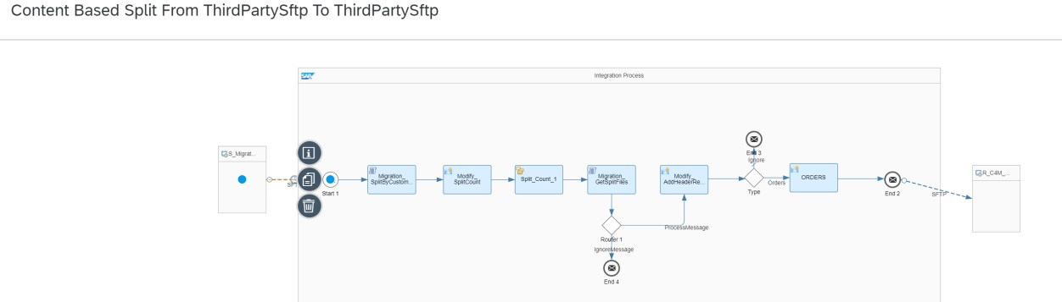
Step 2. Login to AWS and Upload Orders file into Source folder
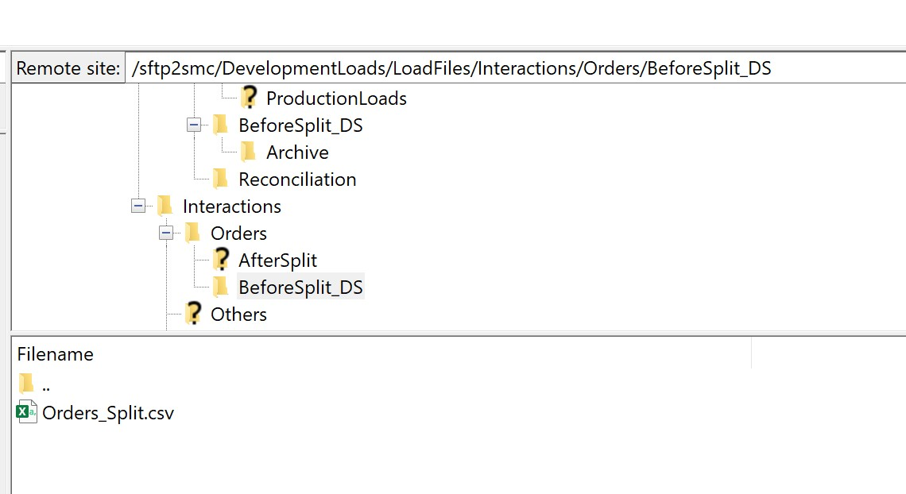
Step 3. Make sure iflow has been executed successfully.
Status of message is successful.

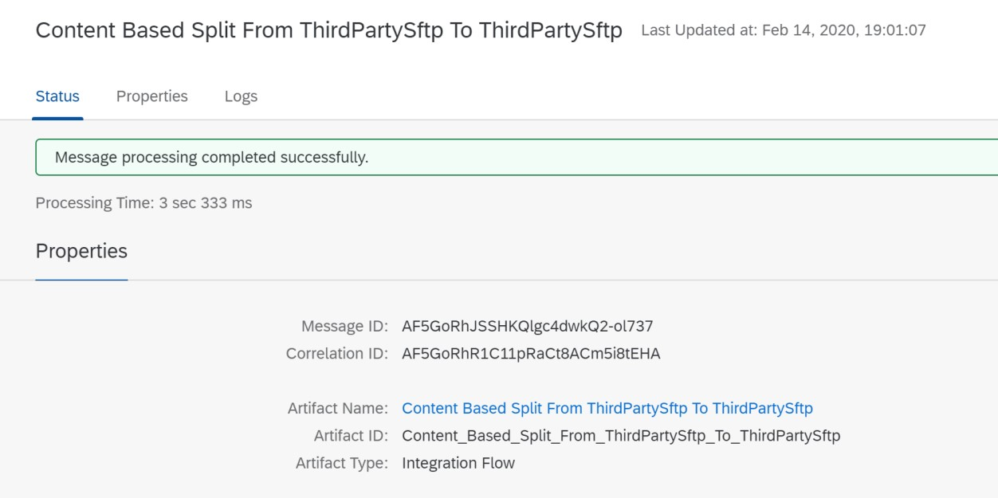
Step 4. Make sure all steps were performed and there are no errors in between.
This can be done by increasing log level to debug.
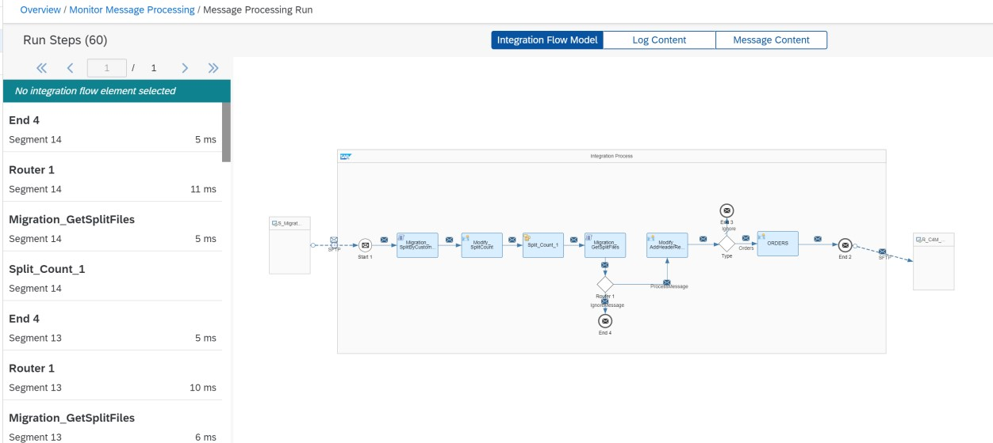
Step 5. Review results by navigating to SFTP folter. Split files in target folder:
Page 10 of
11
