
PuBLIC

SAP Build Process Automation

Employee Onboarding
  - Configuration and User Guide

Contents

Overview 3

Prerequisites 4

Configuration Guide 4

Setup SAP Business Technology Platform Cockpit 4

User Roles Configuration 5

SAP Build Process Automation 5

Import Content 5

Configuration & Modification 5

Configure Process 5

Configure Destination Settings 5

Release and Deploy Content 5

Configure SAP SuccessFactors 6

Configure SAP Work Zone 6

User Guide 7

Capabilities 7

Support 8

This document contains 3 sections. Each section covers different information about this template content package.

- Overview: In this section, you will get quick overview of the use case, what are high-level components used and how the template works in nutshell. Prerequisite section provides information of different services of SAP BTP that are required to use this template.

- Configuration Guide: It contains sections which will guide you to (a) set up your SAP BTP Account with destination, user roles etc, (b) import and configure the template using SAP Build Process Automation design studio and (c) set up SAP Work Zone to access the SAP Build Process Automation templates.

- User Guide: This section provides details about different artefacts that are used in this template like process definition, action project details etc. to better understand how different capabilities are used in this template.
Note: This documentation is not a detailed guide to setup SAP BTP services. It assumes that IT admin who is setting the content is skilled with SAP BTP environment.

Note: This template content is to accelerate your solution development. You must modify this template according to your requirements to achieve the desired business goal. To use this template content, you need to have basic knowledge and understanding of SAP Build Process Automation and its capabilities.

Overview
This document provides information about setting up the SAP Business Technology Platform account to consume the SAP Build Process Automation Employee Onboarding template. The main audience of this document are technical IT/system administrators.
Our template aims to onboard external new hires with a wizard-like predefined process, which provides the Low-Code and No-Code solutions for you to easily configure the guided experience via UI, after selecting the the SAP Build Process Automation template. All steps of this wizard are split to individual cards so that you can do the configurations based on the card level. Again, all UI texts are editable.
This template contains guided process, subprocess, enabling customers to flexibly configure stages and steps in a low code / no code approach. When a new hire clicks “Start” button in SAP Work Zone wizard, the guided process gets started at the backend. Then one branch goes to “Before Your First Day” stage, the other goes to a subprocess “Fetch Hire Date”. Within the subprocess, three action projects run sequentially to get the new hire’s hire date which will be returned to the main process as a reference date for a timer event. After the new hire reaches the hire date, “Your First Day” stage and “Your First Three Months” stage will be enabled.

Features of the content package
- Create guided process as new artefact in SAP Build Process Automation
- Add (parallel) stages and steps with SAP Work Zone (widgets, cards, …) as step UI
- Select guided process as template for wizard layout (new) or create empty one (existing) in SAP Work Zone
- Add wizard layout to any workpage, and widgets and UI cards to each step
- Save user progress on SAP Work Zone for gradual completion
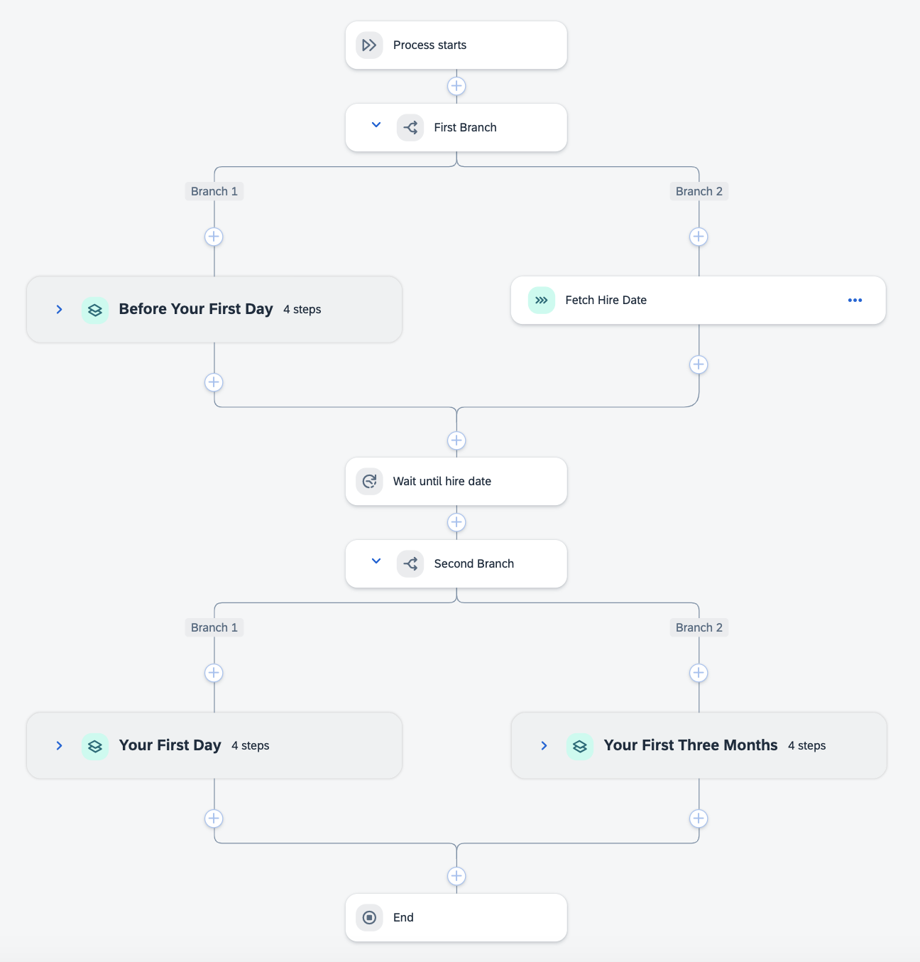

Prerequisites
Ensure identity authentication service has been configured.
- https://help.sap.com/docs/SAP_SUCCESSFACTORS_WORK_ZONE/04877e17a5da4908a6fea94949e160b5/cc0aae759f3f460f9d244a5acfb7fee4.html
Your organization has a license for SAP SuccessFactors Onboarding.

This Employee Onboarding template is intended to be used for human resources and requires the following services in SAP Business Technology Platform.
- SAP Build Process Automation to orchestrate the process.
- SAP Work Zone to access the apps that are involved in the process.

Configuration Guide

Employee Onboarding template requires SAP Build Process Automation subscription or CPEA contract. Follow the setup and configuration section.

Setup SAP Business Technology Platform Cockpit
Ensure the SuccessFactors destination has been configured.
- https://help.sap.com/docs/SAP_SUCCESSFACTORS_WORK_ZONE/04877e17a5da4908a6fea94949e160b5/c12996ba62d34dfba5ae042fb925add2.html

User Roles Configuration

- To access this template, the business user will need these roles:
  - ProcessAutomationParticipant

Role Name | Purpose
ProcessAutomationParticipant | Starts a new workflow instance

SAP Build Process Automation

Import Content
This template can be downloaded from the Store:
1) Navigate to the Store in your SAP Build Process Automation application.
2) Select the Project Type filter as “Process”.
3) In the search bar type “Employee Onboarding with SAP SuccessFactors”
4) Select the “Create from Template” button to add the template into your lobby.
5) After successfully adding the template, navigate back to the lobby to find the “Employee Onboarding with SAP SuccessFactors” project available for use.

Configuration & Modification
Once you have added the content to your lobby, you will find the project in your project list. Adapt the
content template based on your requirements(change names or step orders), and then release and deploy from the lobby.

Configure Process
This package contains the “Fetch Hire Date” subprocess and it does not need to be
explicitly configured. It can be directly utilized after successful deployment.

Configure Destination Settings
Actual destinations that are created in SAP BTP cockpit will be required when you deploy the process. This actual destination will be mapped the destination environment variables during deployment.
For this package a destination needs to be present in the SAP BTP cockpit:
• SuccessFactors_API
Then you should go to the SAP Build Process Automation Control Tower, add the SuccessFactors_API destination: click “Add” button, select the SuccessFactors_API destination and associate your environment.
Besides, please ensure sap_process_automation_service_user_access destination also exists in the SAP BTP cockpit. The property “HTML5.DynamicDestination” of sap_process_automation_service_user_access should be true.

Create an Environment
Employee Onboarding contains a “guided process” artifact, which can only be deployed in a shared environment. So you need to create a shared environment. Please refer to
https://help.sap.com/docs/build-process-automation/sap-build-process-automation/create-environment?version=Cloud

Configure Environment Permissions
The created environment needs to be shared with members and groups. Environment permissions should be given to the target users or user groups. For Employee Onboarding, “Execute” authorization should be selected. Please refer to https://help.sap.com/docs/build-process-automation/sap-build-process-automation/share-environment?version=Cloud

Release and Deploy Content
After configuring your process, it’s time to publish, test and run it. To run a process, you must first release
and deploy it.

Release - This locks the version of your process, meaning that no further edits can be made to that
version. At this stage, the process can’t be run and isn’t available to participants yet.
To release a version of your process,
• first ensure that the status is listed as ‘Editable’.
• Then click ‘Release’:
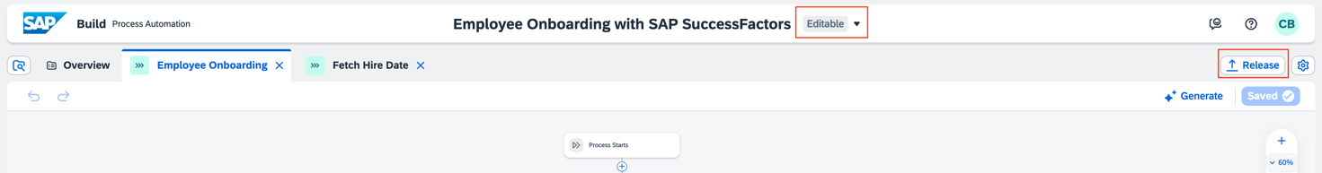
If this is the first time you’ve released the process, a version labelled 1.0.0 is released. For
subsequent releases, you’re prompted to select a version type before the process is released.

Deploy – This takes a released version of a process and enables it to be actively run and monitored.
A deployed version of this guided process gets started when a new hire clicks “Start” button in SAP Work Zone wizard.
To deploy a released version of your process,
• first ensure that the status is listed as ‘Released’.
• Then click ‘‘Deploy’.
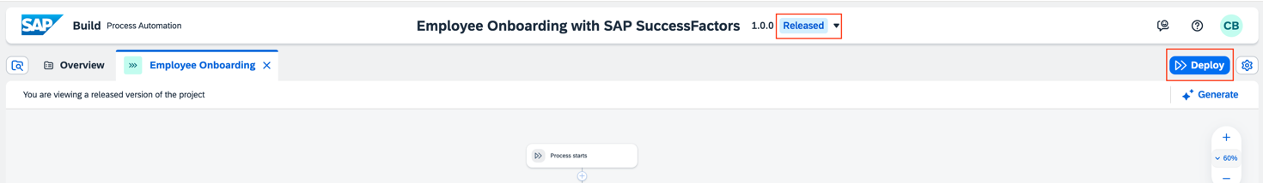
• To deploy your project, you need to choose an environment with permissions granted. Then you will be prompted to provide a following environment variables for
connection to the SuccessFactors system for action projects: SuccessFactors_API

Configure SAP SuccessFactors
You've completed the following configurations for new hires in SAP SuccessFactors Onboarding:
- Personal paperwork. See Personal Data Collection Configuration.
- Grant the View permissions of Employment Details MSS and Hire Date under User Permissions > Employee Data > Employment Details to new hires.

Configure SAP Work Zone
- You've completed the conversion of SAP SuccessFactors Work Zone from SAP SuccessFactors HCM Core to SAP Cloud Identity Services.
- You've installed the content package from SAP SuccessFactors in SAP Work Zone. Please refer to the help doc.
- Your organization has a Qualtrics license and have installed the card Qualtrics Survey before embedding surveys during this onboarding process.
- You have the permissions to edit contents for the guided experience.
- Create your cross boarding guided experience with wizard and widgets configured.
  - Create a workspace where you want to add the Employee Onboarding wizard. See details in How to Create a Workspace and make sure you select a Employee Onboarding template deployed in the SAP Build Process Automation lobby.
  - In the workspace, edit your workpage using the workpage designer icon to edit your workpage.
  - Hover over the existing wizard area and choose the Edit Wizard icon.
  - In Edit Wizard dialogue, define the wizard properties according to How to Create a Wizard.
  - Choose Save to apply changes to your wizard.
  - Select the step that you want to make changes to, then hover over the step area. You can choose Add Widget to add certain widgets needed. Choose the Edit Widget icon to configure widget settings and save changes.
  - Choose Publish to release your workpage.
- Sync the employee data of new hires from SAP SuccessFactors to SAP SuccessFactors Work Zone based on the topics listed in Working with Onboarding Guided Experience and Onboarding Guided Experience (Wizard Version).
- Invite new hires to the workspace you just created for using the cross boarding guided experience. See Managing Imported User Lists.

User Guide

Capabilities
This template consists of following capabilities.
Please refer help documentation about these different artifacts.

Name | Description
Employee Onboarding | This is the main process which defines the layout and steps for cross boarding guided experience. It gets started when a new hire clicks “Start” button in SAP Work Zone wizard.
Fetch Hire Date | It is a subprocess and fetches a new hire’s hire date by calling SuccessFactors APIs.
Action for Employments in SAP SuccessFactors | It is an action project of the subprocess, which gets multiple employments from SuccessFactors.
Action for Employment Information in SAP SuccessFactors | It is an action project of the subprocess, which gets a hire date via employments from SuccessFactors.

Support

There is no support available for template content. If you experience general issues with SAP Build Process Automation, please follow the links below:
- Troubleshoot Support Guided Answer
- Test an Automation Help portal Article
- Test an Application Help portal Article
- Get traces Support Guided Answer
If the issue persists, please raise an incident via SAP Support Portal on LOD-SF-EAS-WZC component.

This template can be modified using SAP Process Automation: change names or step orders. Support is only available if you do not modify or modify your project as per the guidance in the configuration guide. Refer Help Portal for more details.

www.sap.com

