Joule Agent Publishing Guide for Partners
This guide describes the required information and supporting materials for partners submitting custom Joule Agents built using Joule Studio (Agent Builder) for publishing.
SAP SuccessFactors to Joule Promotion Analytics Integration– Publishing Guide
1. General Information
This document provides the necessary information required to publish and deploy the Promotion Analytics Assistant developed using SAP Build Process Automation and Joule Studio.
The Promotion Analytics Assistant enables users to retrieve and analyze employee promotion data in SAP SuccessFactors through conversational interaction using Joule. The agent supports key functionalities such as checking promotion eligibility, retrieving latest promotion details, and accessing complete promotion history.
This guide is intended for developers, administrators, and functional consultants responsible for publishing and maintaining the solution within SAP Business Technology Platform (BTP).

Name *
SAP SuccessFactors to Joule Promotion Analytics Integration
Summary *
This Joule agent enables users to retrieve and analyze employee promotion data in SAP SuccessFactors using natural language interaction. It allows users to check promotion eligibility, view latest promotion details, and access complete promotion history in a simple and efficient manner.

Description *
The Promotion Analytics Assistant is designed to simplify access to employee promotion data by providing a conversational interface powered by Joule.
In many organizations, retrieving promotion-related information such as eligibility status, latest promotion details, and historical promotion records requires navigating multiple systems and complex reports. This solution addresses these challenges by enabling users to access this information using natural language queries.
The agent integrates with SAP SuccessFactors as the backend system, where employee job and promotion data is maintained. SAP Cloud Integration acts as the middleware layer to handle request processing, data transformation, and communication between SAP Build and SuccessFactors.
When a user interacts with the agent, Joule interprets the request and determines the appropriate action to perform. Based on the user’s intent, the agent invokes specific Joule Skills responsible for handling different promotion-related scenarios.
The agent supports the following key capabilities:
- Checking whether an employee is eligible for promotion based on tenure rules
- Retrieving the latest promotion details, including pay grade changes
- Fetching complete promotion history with all relevant records
The solution ensures that defined business rules are applied, such as validating eligibility based on minimum tenure and correctly identifying promotion events from job history data.
The architecture leverages SAP Build Process Automation for agent and skill configuration, SAP Cloud Integration for backend integration and business logic handling, and SAP SuccessFactors as the primary data source. This ensures secure, scalable, and efficient processing of user requests.
Overall, the Promotion Analytics Assistant improves user experience by reducing manual effort, providing faster access to promotion insights, and enabling better HR decision-making through an intuitive conversational interface.

2. Solution Context
The Promotion Analytics Assistant is designed as an AI-driven orchestration layer that leverages Joule capabilities to interpret user intent and trigger backend operations through predefined skills and actions.
User interactions are processed by the Joule Agent, which dynamically selects the appropriate Joule Skill based on the identified intent. Each skill is associated with an action configured in SAP Build Process Automation.
These actions invoke APIs exposed through SAP Cloud Integration, where data transformation, validation, and business logic are applied before forwarding the request to SAP SuccessFactors.
The backend system processes the request using employee job information and related entities, and the response is returned through CI and SAP Build to Joule for presentation to the user in a structured format.

Line of Business *
Human Resources

Industries *
This solution is applicable across multiple industries where employee lifecycle and promotion management is relevant.
Recommended selections:
- Information Technology
- Healthcare
- Higher Education and Research
- Manufacturing
- Professional Services

Products *
- SAP SuccessFactors Employee Central
- SAP Build Process Automation
- SAP Integration Suite

3. Media
This section provides supporting assets to help users understand, configure, and use the Promotion Analytics Assistant effectively.
The included media assets demonstrate the overall solution architecture, agent behavior, and integration flow between SAP Build, SAP Cloud Integration, and SAP SuccessFactors.

Gallery
Upload images illustrating the solution.
Examples:
• Architecture Diagram
• Integration Flow (Cloud Integration iFlows)
• Joule Agent Workflow
Architecture diagram:
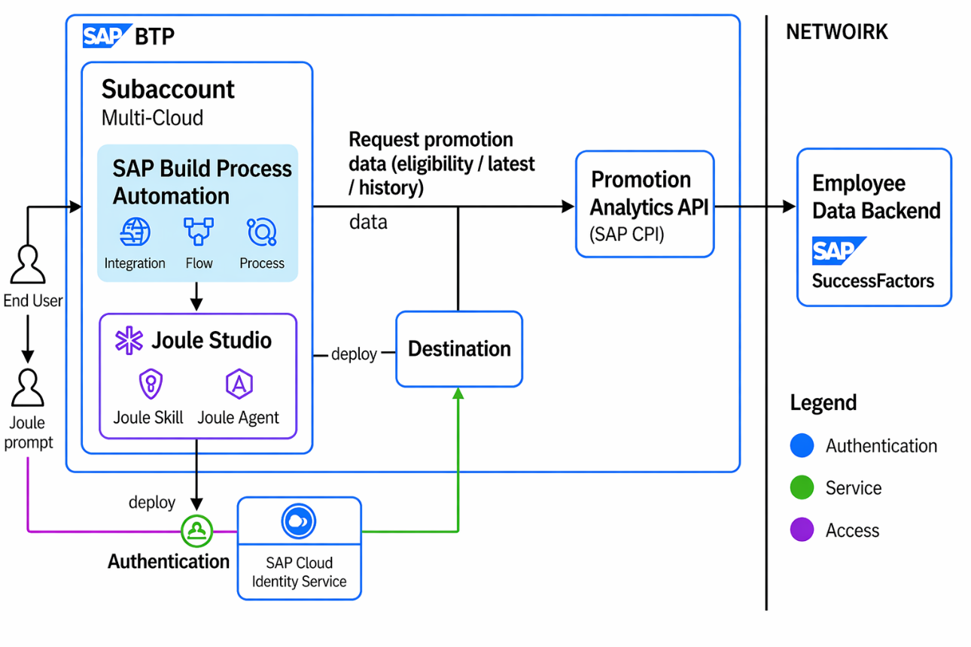
Agent Workflow
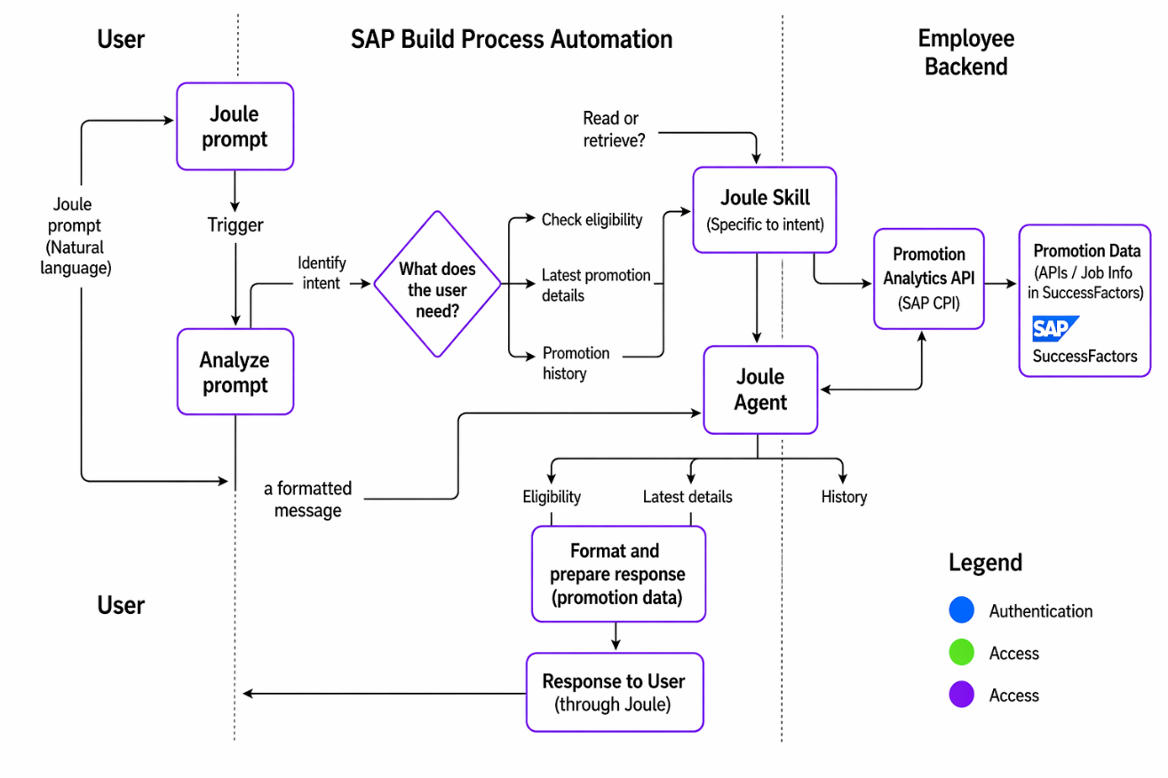
Integration flow :
1. Promotion Analytics Iflow
Purpose:
This integration flow is responsible for evaluating whether an employee is eligible for promotion based on defined business rules.
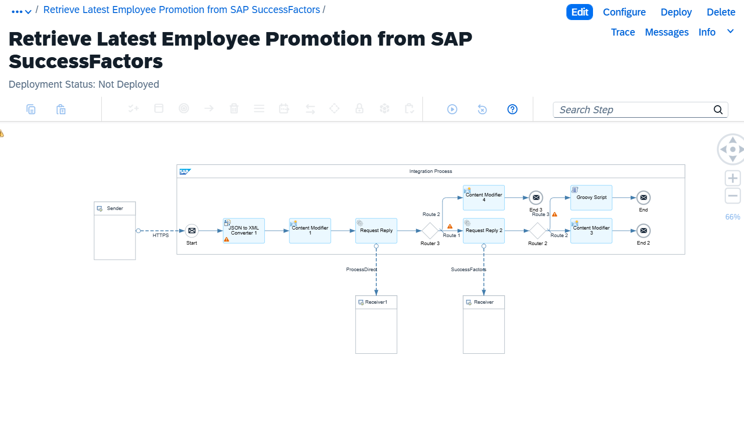
2.Latest Promotion Details Iflow
Purpose
This integration flow retrieves the most recent promotion details of an employee.
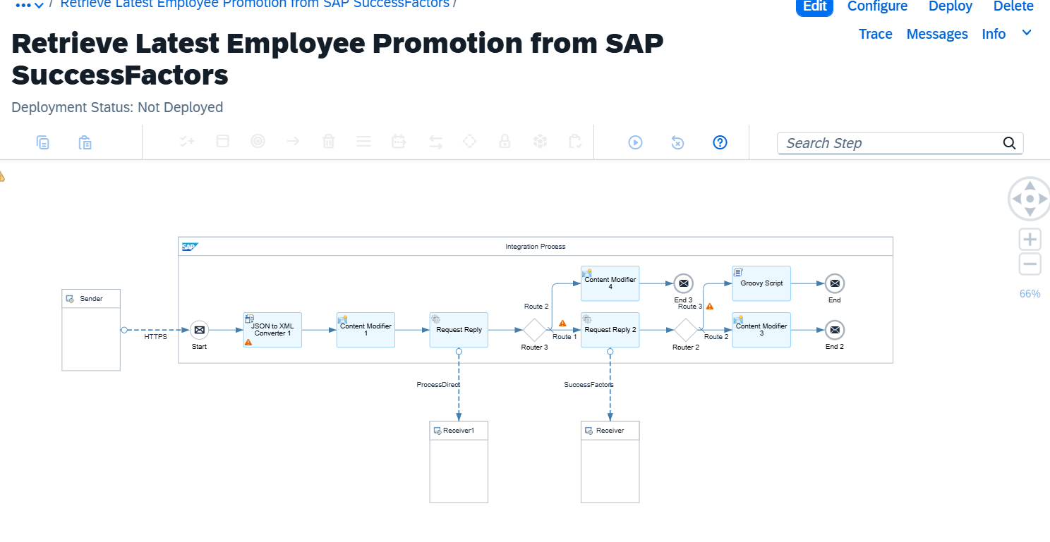
3. Promotion History Iflow
Purpose:
This integration flow retrieves the complete promotion history of an employee.
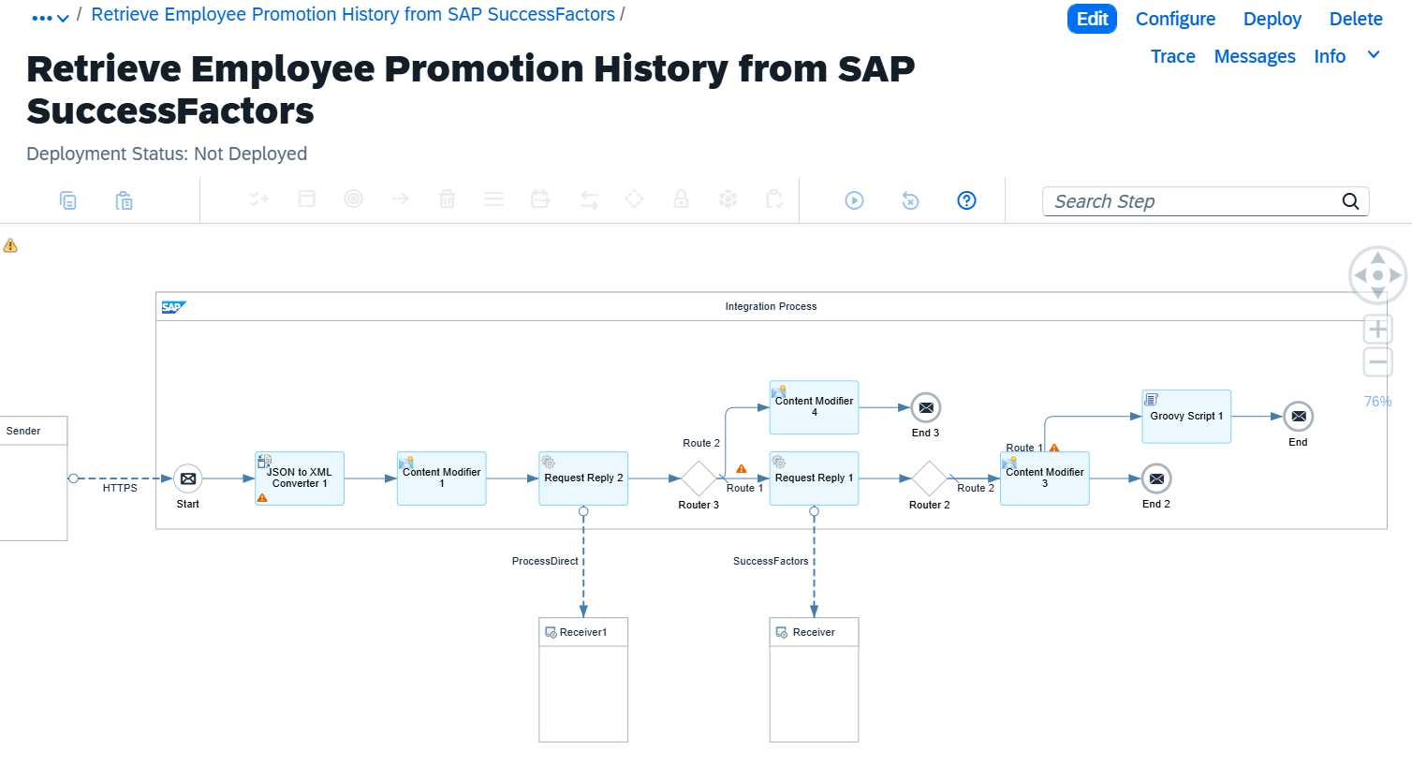
4. Validate Employee Promotion Access in SAP SuccessFactors
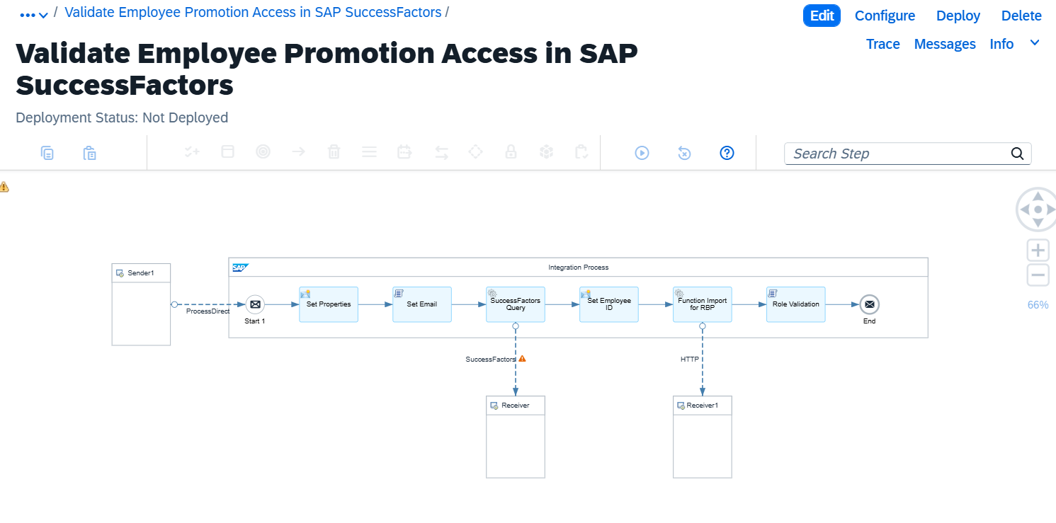
Title *
SAP SuccessFactors to Joule Promotion Analytics Integration
Description *
This guide explains how to configure, deploy, and use the Promotion Analytics Assistant built using SAP Build Process Automation and Joule Studio. It includes setup steps for SAP Business Technology Platform, destination configuration, integration with SAP Cloud Integration, and interaction with SAP SuccessFactors.
The document also provides details on agent behavior, skills, actions, and testing procedures required to retrieve promotion eligibility, latest promotion details, and promotion history effectively.

Links
1. SAP Help – Joule Studio
- URL: https://help.sap.com/docs/build-process-automation/joule-studio
- Title: Joule Studio – SAP Help Documentation

Support
If any issues are encountered during configuration or execution, please raise an incident through the appropriate support channels.
For any queries related to deployment, configuration, or artifacts associated with the Promotion Analytics Assistant, please contact:
bpt.support@bpterp.com

