New Zealand Inland Revenue Reporting for Payroll
SAP Cloud Integration Configuration Document
Public


Integration Package Version 2

Version | Date | Comment
1.0.0 | 02/02/2021 | Phase 2 release. Contains four artifacts for OAUTH Token and four artifacts each for create, update, terminate and pay date reporting.
1.0.1 | 12/03/2021 | In this version Sender Client Certificate is enabled for configuration.
1.0.2 | 26/03/2021 | In this version the correct user token is used while sending the files.
1.0.3 | 29/03/2021 | This version contains the correction for iflow OAUTH Token V2 and update the name of the Logical Port name for Terminate in Section 6.1
1.1.0 | 07/02/2023 | This version contains the changes made for integrating with START IAM which handles Authorisation Tokens. Configurable Receiver  Connection Addresses are changed for OAUTH iFlows, as mentioned in section 5.2
1.1.1 | 07/03/2023 | Corrected client secret of version 1.1.0
1.1.2 | 09/01/2025 | Simple Parser Exception after Upgrade to Camel Runtime 3.14


1

TABLE OF CONTENTS
- OVERVIEW 3
- TECHNICAL SOLUTION IN MORE DETAIL 4
  - SAP Cloud Integration (SCI) 5
  - Process Overview 5
    - Obtaining the OAUTH Token 5
    - Submitting Data 6
- SOLUTION INSTRUCTION 7
- PREREQUISITES 7
  - SAP Notes 7
  - Set up Tenant 8
  - Check the SAP Cloud Integration Certificate for Umlauts 8
  - User Authorisations 9
  - Ensure CA Signed Certificate installed in STRUST of Payroll System 10
- SETUP STEPS IN SAP CLOUD INTEGRATION 11
  - Copy Published Package into Your Package 12
  - Configure Integration Flow for OAUTH token services 13
    - OAUTH Token V2 14
    - OAUTH Token Validation V2 15
    - OAUTH Token Revoke V2 18
    - OAUTH Token Validation Backend V2 21
  - Configure Integration Flow for XML file communication 22
    - Employee Services: Create V2 22
    - Employee Services: Update V2 24
    - Employee Services: Terminate V2 25
    - Employment Information: Pay Date File V2 27
- SETUP STEPS IN SAP ERP OR SAP S/4HANA 28
  - Create the logical ports in SOAMANAGER 28
- SENDER CHANNEL CONNECTION AUTHORIZATION 33
  - Certificate based authorization for HTTP sender channel 33
    - Download the public certificate from the browser 34
    - Assign the public certificate for authorization 37
- REGISTER YOUR SAP CLOUD INTEGRATION DETAILS WITH INLAND REVENUE 38
- MAINTENANCE 39

OVERVIEW
In New Zealand information about employees and their payments must be sent to Inland Revenue each pay date. This information needs to be submitted directly from the SAP payroll system to Inland Revenue. The communication part of this process is taken care of by SAP Cloud Integration.
There are multiple types of files that can be sent to Inland Revenue and each of these has their own ‘iflows’ created in SAP Cloud Integration. However, before the files can be sent the appropriate authorization credentials must be established with Inland Revenue and an OAUTH token received. This token can be validated or revoked and each of these ‘services’ is also an ‘iflows’ in SAP Cloud Integration.

In order to set up SAP Cloud Integration for these processes, there are some required configuration steps in both the SAP payroll system and the SAP Cloud Integration tenant. This document details that configuration. These steps are typically taken care of by an SAP Cloud Integration consultant or SAP Basis person who is responsible for configuring the SAP ERP - SAP Cloud Integration connection and maintaining the integration content and certificates/credentials on the SAP Cloud Integration tenant.

Note that the Inland Revenue server currently has no ability to accept test files, so the following assumes that all configuration is set for the production system.
For a full overview of the Pay Date Reporting process refer to SAP Note 2672190.
Version 1.0.0
Initial Version for Phase 2 release Version 1.0.1
This version is to enable the fields for Sender Client Certificate for configuration. These are the i- flows updated:
- Employee Services - Create V2 (Version - 1.0.1)
- Employee Services - Terminate V2 (Version - 1.0.1)
- Employee Services - Update V2 (Version - 1.0.1)
- Employment Information - Pay Date File V2 (Version - 1.0.1) Version 1.0.2
This version is to enable the fields for Sender Client Certificate for configuration. These are the i- flows updated:
- Employee Services - Create V2 (Version - 1.0.2)
- Employee Services - Terminate V2 (Version - 1.0.2)
- Employee Services - Update V2 (Version - 1.0.2)
- Employment Information - Pay Date File V2 (Version - 1.0.2)
- OAUTH Token V2 (Version - 1.0.1) Version 1.0.3
In this version section 6.1 is updated for the document “New Zealand Inland Revenue Reporting for Payroll”. The name of the logical port name LP_CO_HRNZ_IDRED_TERMINATE_CPI is updated to LP_CO_HRNZ_IRDED_TERMINATE_CPI.
This version is to correct the variable creation of while getting the token with Global scope. The i- flow updated:
- OAUTH Token V2 (Version - 1.0.2) Version 1.1.0
This version contains the changes made for integrating with START IAM which handles Authorisation Tokens. These are the i-flows updated:
Cosmetic Improvements for the below four:
- Employee Services - Create V2 (Version - 1.0.3)
- Employee Services - Terminate V2 (Version - 1.0.3
- Employee Services - Update V2 (Version - 1.0.3)
- Employment Information - Pay Date File V2 (Version - 1.0.3)
Changes made for new START IAM endpoint and API signature for the below four:

- OAUTH Token V2 (Version - 1.1.0)
- OAUTH Token Revoke V2 (Version - 1.1.0)
- OAUTH Token Validation V2 (Version - 1.1.0)
- OAUTH Token Validation Backend V2 (Version - 1.1.0)

Version 1.1.1
Corrected client secret of version 1.1.0

Kindly go to latest version of Integration package “New Zealand Inland Revenue Reporting for Payroll Version 2 “(Version 1.1.1) and copy the updated i-flows maintained above. Once updated, reconfigure the i-flows as per the package implementation instructions. Please note that no additional new configuration fields are introduced.

Version 1.1.2
This version includes the changes made to address the Simple Parser Exception after upgrading to Camel Runtime 3.14. These are the i-flows updated:
Employee Services - Create V2 (Version - 1.0.4) Employee Services - Terminate V2 (Version - 1.0.4) Employee Services - Update V2 (Version - 1.0.4)
Employment Information - Pay Date File V2 (Version - 1.0.4) OAUTH Token V2 (Version - 1.1.2)
OAUTH Token Revoke V2 (Version - 1.1.2) OAUTH Token Validation V2 (Version - 1.1.2)
OAUTH Token Validation Backend V2 (Version - 1.1.2)

TECHNICAL SOLUTION IN MORE DETAIL
In order to facilitate the electronic submission of data Inland Revenue have established a protected service referred to as the Inland Revenue “Gateway” and have defined specifications for how software providers can communicate with that Gateway in a secure manner. (Note that this Gateway is also used for non-payroll related functions as well, e.g. GST reporting.)

Each software provider that uses this Gateway has to follow the guidelines issued by Inland Revenue and have to have performed a number of predefined tests to ensure that the information can be sent correctly. Only once that is successfully completed can that software provider’s customers use the Gateway for filing.
The process as defined by Inland Revenue is as follows:
- The user interacts with their software system and it accesses the protected service provided by IR (the Gateway)
- The software system invokes an authorization API to get an authorization code and the user is directed to an IR log on page.
- The user logs on and is authenticated.
- IR issues an authorization code that is sent back to the software system.
- The software invokes IR’s token service to redeem the authorization code for an OAUTH Access Token. (The token has a finite life.)
- The software then invokes the Gateway to file information with the OAUTH Access token in the header.
This process ensures that it is secure and that only MyIR users who are authorized to submit data for an organisation can send information. Data is submitted in XML format.

SAP Cloud Integration (SCI)
In SAP’s case the communication between the payroll and Inland Revenue’s Gateway is managed by SAP Cloud Integration (SCI).

Process Overview

In order to perform the process of sending the files, Inland Revenue’s Gateway needs to know where to send response codes to and to be able to ‘trust’ that system. A registration process must therefore be completed before you can commence filing with Inland Revenue. That process involves supplying a return URL (an address where responses are sent to) and a security certificate to Inland Revenue for your employer IRD number(s). This can only be done once SCI has been set up for NZ Pay Day Reporting and you will find details about the registration process in the SCI Configuration Guide for registration (refer to the details later in this document).
Once Inland Revenue has this information loaded in their system you can commencer Pay Day filing through the Gateway. The filing processing is essentially split into two steps:
- Obtaining the OAUTH token
- Submitting Data

Obtaining the OAUTH Token

The process to obtain a token is as follows:
      - The user clicks a button in the B2A Manager transaction within the payroll system. This will route the user to a MyIR log on screen at Inland Revenue.
      - The user is authenticated by Inland Revenue (there is an option to enable dual verification).
      - The Gateway then returns an OAUTH code to the return_url held in their system, (i.e. your SCI system).
      - SCI then uses this OAUTH code to send a request to the Gateway for an OAUTH Token.
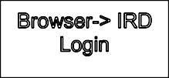
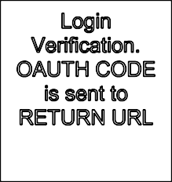
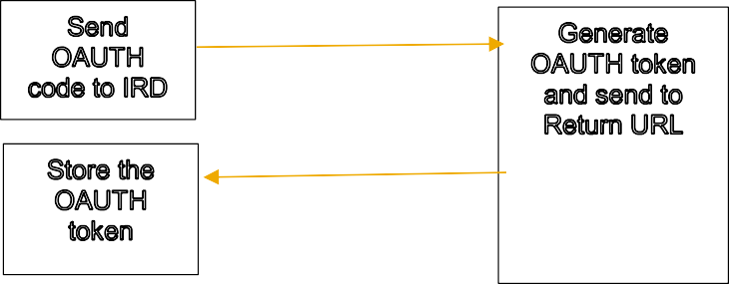
      - The token is sent back to SCI and held there.
•
•
•
•
•
•
•
•
•
•
•

Submitting Data

A valid OAUTH token must be obtained before files can be sent to Inland Revenue as that token is contained in the header information. The above process, therefore, acts as a prerequisite to this process. To submit data:
      - A user runs HCM reports to extract relevant data and create the necessary files. These files are per legal entity and are managed in the payroll system in the B2A Manager. (Within B2A Manager the user is able to view the data contained in the files in XML format.)
      - Within B2A Manager the user selects the file(s) to be sent and selects execute.
      - B2A Manager sends the files to SCI where the XML pay load is formed according to the Inland Revenue requirements (including inserting the token into the header).
      - SCI sends the data to Inland Revenue.
      - Inland Revenue sends a response code to SCI. This shows whether the file was successfully or what type of error has occurred.
      - SCI modifies that response into an understandable format for the payroll system and the user is able to view the result in B2A Manager.

When the data is sent from the payroll system to SAP Cloud Integration. it is done through the SOAP channel created in SOAMANAGER. Each SOAP channel refers to the corresponding proxy (interfaces) created in SPROXY. The proxies also have the response structures included and wait for the response to come from SCI after the data is sent.
The communication channel from SCI to Inland Revenue’s Gateway (and the return response) is SOAP 1.2 which is configured as the receiver channel in the IFLOWS contained within SAP Cloud Integration. The authentication at Inland Revenue is done using the security certificate (MUTUAL TLS method). The private key for this is stored in the key store within SAP Cloud Integration and the public key is given to Inland Revenue as part of the registration process. This public key is then used in the SOAP channel.
Diagrammatically this process is as follows:
SCI
SAP R/3
Proxy(In terface) for each file type
SOAP
Channel created for each proxy in SOAMA NGER
User authenticated using security certificate: SOAP channel

SAP R/3
B2A
Manager
SCI
SOAP 1.2
channel. Data authenticated using security certificate
6
ersion 2
DATA
IRD

IR File service
XML DATA +
Header containing Authorisation

SOLUTION INSTRUCTION
Inland Revenue introduced a version 2 of both Pay Day files with a mandatory date of 01 April 2021. Version 2 can be used earlier but, at the latest, it must be used for pay dates on or after 01 April 2021. The date is controlled in SAP ERP via sub-application PDVR (Pay Day Filing Version 2) in V_T596C. Files created prior to this date will be directed to version 1 iflows. After this date the version 2 iflows will be used.

For customers who are already live with payday filing on 01 April 2021 and are transitioning to version 2 a summary of the required changes is as follows:
- all existing 8 artifacts from version 1 are replaced with new artifacts and will need to be downloaded from the package configured in a similar manner to version 1.
- All new iflows will need unique URL’s so generally V2 has been added in the new urls. The exception is the OAUT TOKEN V2 iflow for which, the URL should remain as previous because this forms the return_url that is already registered with IRD. This means that this iflow cannot be deployed until the version 1 equivalent iflow is deactivated.
- V_T50BK will need to be updated for 2 parameters “RTOKE” and “VTOKE” based on the new url’s assigned
- SOAMANAGER will need to be updated with new proxies.
Note that the new iflows cannot be used productively until the prerequisite notes are in the production SAP ERP system and hence, they should not be deployed until these are present. Once the notes are in production the iflows can be deployed and this can be earlier than 1 April 2021 as the system will decide which set is relevant based on the PDVR date. After 01 April 2021 the version 1 iflows can be deactivated. The effective date of the T50BK changes should be the date that you intend to start filing your various 2 files,
i.e. it will be the same as the PDVR date. However, note that T50BK functionality is based on system date. This could make a difference if your SCI system is held in a different time zone. E.g. if you are filing from NZ on the morning of 1st April and your SCI system is based in Europe then the system may think it is
still 31st March. In this case the first filing should be done after the system thinks it is 1st April or change the effective date of T50BK to 31 March.

PREREQUISITES
Before you start with the activities described in this document, ensure that the following prerequisites are met in SAP Payroll system and SCI.

SAP Notes
Check that the following notes have been applied in the SAP payroll system:
- Notes relevant for Pay Day Filing with Version 1:
  - SAP Note 2672190 – this note is the original note for pay day filing and delivers new proxies for pay date reporting. The proxies are used to send the data from SAP payroll system to

SCI. Section 4 document discusses the steps for configuring the logical ports in the SOA manager for which this note must be installed in the system.
  - SAP Note 2727831 – this note makes enhancements to the MyIR logon routine and is a pre- requisite for version 1.0.2 of the SCI package. Without this Note the user will get an error in the B2A Manager transaction that the token has expired (even though a valid token is held).
  - SAP Notes 2745334 and 2748113 – these notes are not a prerequisite for package version
1.0.02 but if the functionality described in these notes is required then package version
1.0.02 is required.
- Notes relevant for Pay Day Filing with Version 2:
  - SAP Note 2939166 - This note is the original note for 2nd phase of Pay Date Filling and delivers new proxies for Employee Details service reporting. The proxies are used to send the data from SAP payroll system to SCI. Section 4 document discusses the steps for configuring the logical ports in the SOA manager for which this note must be installed in the system.
  - SAP Note 3000464 - This note is the original note for 2nd phase of Pay Date Filling and delivers new proxies for Employment Information service reporting. The proxies are used to send the data from SAP payroll system to SCI. Section 4 document discusses the steps for configuring the logical ports in the SOA manager for which this note must be installed in the system.
  - SAP Note 3016365 – This Note is the correction note for 2nd phase of Pay Date Filling and also contains the correction to token changes. These token changes will enable the User dependent token in SCI system. Which means, each user can have one token at a time in an instance. This also means, there can be more than one tokens in an SCI instance at a time depending on User if required.
- Notes relevant for Pay Day Filing with Version 2, package version 1.1:
  - SAP Note 3230681 – This Note contains the ERP change required to adapt with new Identity Access Management (IAM) solution of Inland revenue department (IRD). IRD implemented new START IAM solution for the token generation and authorization process in October 2022. SAP iFlows updated to match this new process; along with this - IRD API endpoints need to be updated in SAP system as guided in this Note.

Set up Tenant

If this is your first use of SAP Cloud Integration (SCI) refer to the Welcome Kit that you should receive when your tenant is first provisioned. This Kit contains a link to the SCI Customer Success Portal ( https://help.sap.com/viewer/p/SCP_CUSTOMER_SUCCESS_PORTAL/) where you can access a wide range of SCI related resources.

You will also receive a “SAP Cloud Integration Onboarding Guide’ to guide you through the initial setup to get your tenant up and running.
For the subsequent configuration of SAP ERP, note down the URL of the tenant (it is the TMN URL which you received when the tenant was provisioned).

  - Check of the SAP Cloud Integration Certificate for Umlauts is no more required (since Oct 2021)

The public key of the security certificate issued for your tenant will be shared with Inland Revenue. Initially they were unable to accept security certificates with special characters like the umlaut (a ‘u’ with dots above it) as shown in the screen shot below. However, since October 2021 Inland Revenue is now able to accept these.

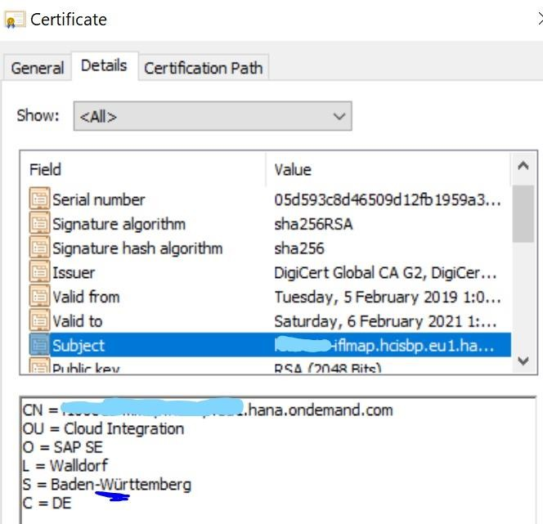
  - User Authorisations Administrator Access
Ensure that admin users in the tenant have enough rights and privileges to copy the NZ integration package and to configure and deploy the integration flow.
To deploy the security content, the required role is ‘AuthGroup.Administrator’.

End User Access
End users are the ones who are essentially sending the files from the payroll system. The end users are to be added in SCI tenant as members and assigned the role “ESBMessaging.send”. Only with this role the users will be able to send the files to Inland Revenue. The end users can either use their SCI User credentials or can use a single sign on certificate to send a message through SCI.
Note: End user id (who send the files from payroll system) should not contain any special character, only alphanumeric values are accepted.
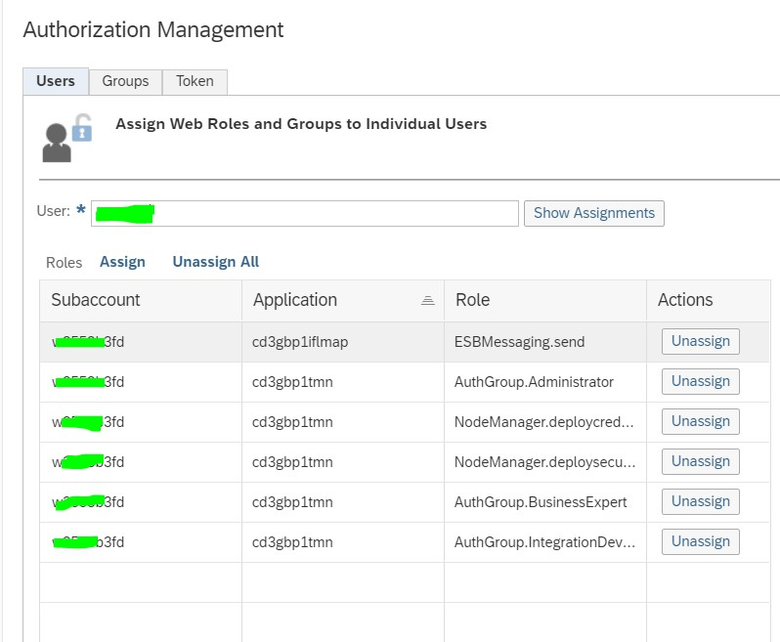

Ensure CA Signed Certificate installed in STRUST of Payroll System

The recommended communication method between the SAP payroll system and SCI is certificate-based authentication. (User name and password is possible but not recommended for usability reasons as the user would need to enter their details multiple times). In order to facilitate this a CA signed certificate is required from the SAP Payroll system which is then installed in STRUST and the public key noted in the relevant iflows. (Note that the key pair will only be accepted by the SAP Load Balancer if it is signed by an SAP approved CA.)
If you do not already have a CA signed certificate available, follow these steps:

- Go to STRUST transaction
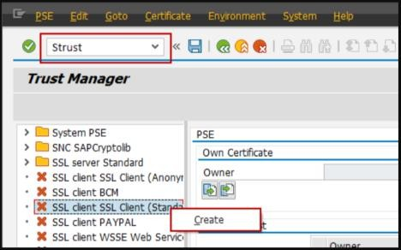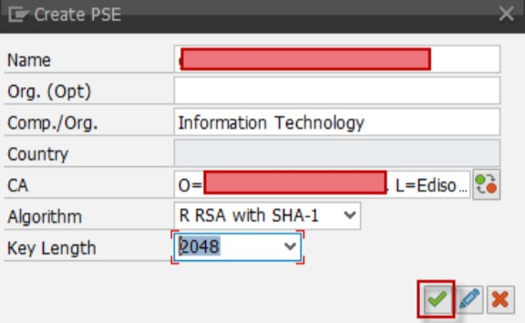
- Below is the example show DN of the certificate:
DN = CN=erpc.externaldomain.com, OU=Information Technology, O=mycompany Inc, L=Location, S=State, C=Country
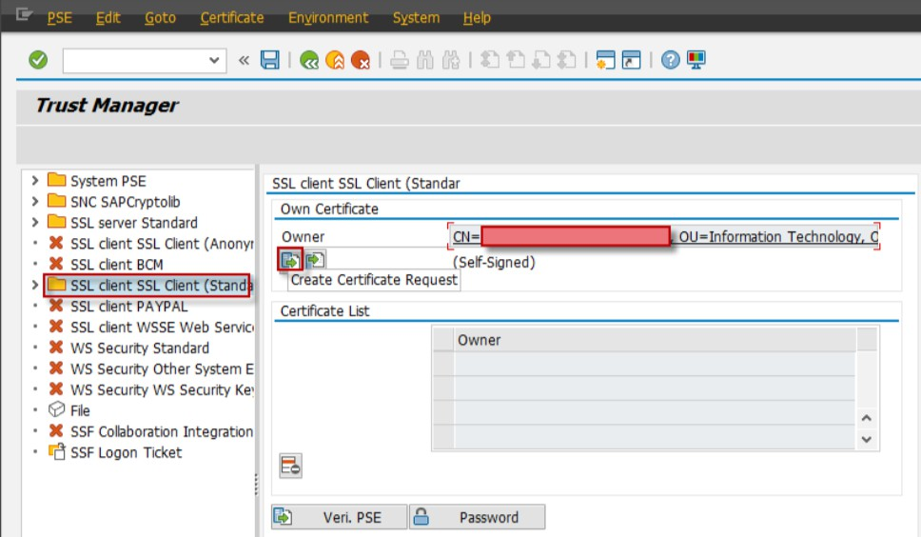

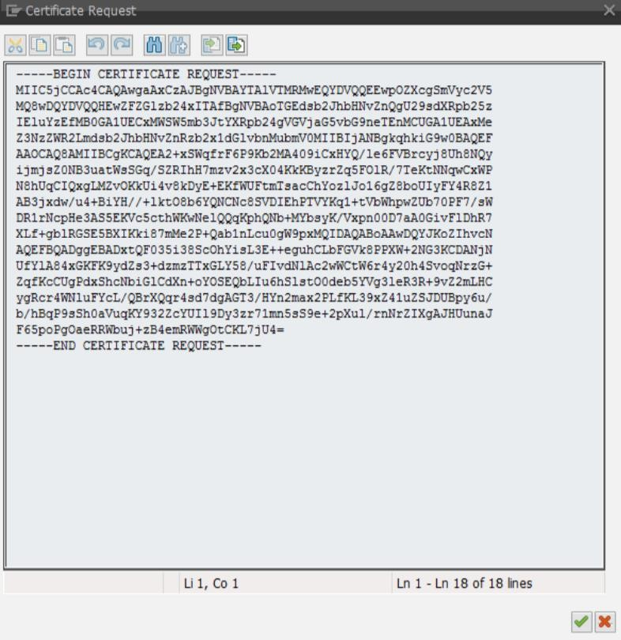
- This is the CSR. Copy the CSR and get it signed by a Certificate Authority.
Note: CA should be in the Trust list of SCI. Please check for the latest SCI trust list here.
- Import the certificate response in STRUST.

- Take note of the directory where the certificate is stored as this will referenced when the logical ports are configured (section 5).
More help on PSE/certificate can be found in the link https://help.sap.com/saphelp_nw73ehp1/helpdata/en/59/6b653a0c52425fe10000000a114084/frameset.htm

SETUP STEPS IN SAP CLOUD INTEGRATION
As part of the initial (Version 1) release, there were eight SCI artifacts delivered. For Version 1 details, kindly refer to latest document for Version 1 attached in the SCI Integration Package ‘New Zealand Inland Revenue Reporting for Payroll’.
All customers should now be on version 2 as this version was mandatory from 1 April 2021. For Version 2 release, there are 8 new SCI artifacts are delivered in a new Integration Package ‘New Zealand Inland Revenue Reporting for Payroll Version 2’.

Four artifacts are related to authentication token.

IFLOW Name | Description
OAUTH Token V2 | Iflow used for obtaining OAUTH token.
OAUTH Token Validation V2 | Iflow used to validate the OAUTH token.
OAUTH Token Revoke V2 | Iflow used to revoke the OAUTH token at Inland Revenue server
OAUTH Token Validation Backend V2 | Iflow is called from the B2A manager while sending the payload to Inland Revenue.

Four artifacts relate to the four types of XML files which are sent to Inland Revenue.

IFLOW Name | Description

Employee Services – Create V2 | Iflow sends the details of employees who are hired in a pay period.
Employee Services – Update V2 | Iflow sends the details of employees who have had an update to master data in a pay period that should be reported
Employee Services – Terminate V2 | Iflow sends the details employees who were terminated in a pay period.
Employment Information - Pay Date File V2 | Iflow sends the payment information of employees for a pay date.

The three buttons in B2A manager namely “Get Token”, “Validate Token” and “Revoke Token” uses the below three IFLOWS respectively and these three IFLOWS uses HTTP as sender channel.

OAUTH Token V2
OAUTH Token Validation V2
OAUTH Token Revoke V2ss
The authorisation for HTTP calls are either made by entering the user SCI credentials manually or the user can use the single sign on certificate (Certified by SAP authorised CA), e.g. SAP Passport.
In case the user wants to use the single sign on (SSO) certificate, the key pair of the certificate should be installed in the local machine/PC from where user will send the file. Once the certificate is installed, user must configure the public certificate of the SSO in SCI. This step is described in the section 6 of this document.

The other five IFLOWS are the once whose calls are routed through the payroll system server using SOAP. The Authorisation for these five IFLOWS are to be set at the logical ports created in the transaction SOAMANAGER. For SOAP endpoint the authorisation can be set to User credentials or X.509 SSL certificate installed in STRUST of the payroll system. The step is explained in section 4.4 of this document.

Employee Services – Create V2
Employee Services – Update V2
Employee Services – Terminate V2
Employment Information - Pay Date File V2
OAUTH Token Validation Backend V2
To set up these iflows follow the details in the following steps:

  - Copy Published Package into Your Package
Go to the ‘Discover’ chapter of your tenant and find the package ‘New Zealand Inland Revenue Reporting for Payroll Version 2’
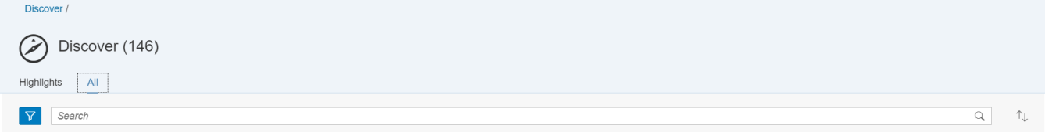

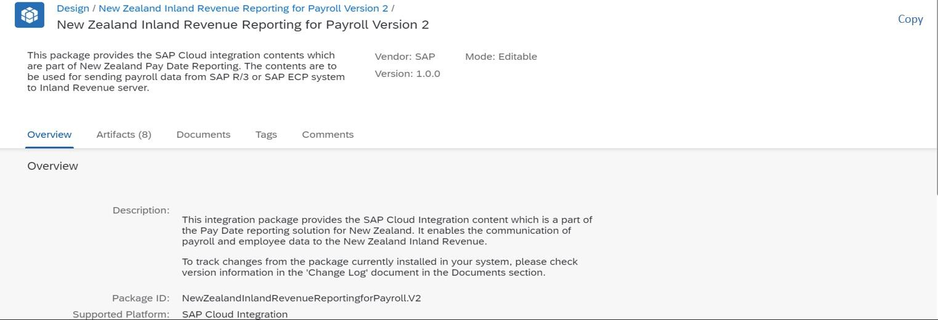

Click on package name, then click ‘Copy’ in the upper right corner:
Note: the package version on the screenshot may differ from the one shown above.

  - Configure Integration Flow for OAUTH token services
There are four artifacts which are delivered to process the OAUTH token and three out of them have HTTP as sender channel and one have SOAP as sender channel. The certificate-based authorization for sender channel will differ for HTTP and SOAP.
Important Information for those converting from version 1 to version 2:
Please consider below point carefully, before Configure/Deploy these changes in your production environment if you already have version 1 iflows in place.
- Availability of SCI objects are independent of SAP ERP/ECP objects. So, you can download the published package and start configuration for iflows. But must not Deploy until the required SAP Note (3016365) is applied in respective backend (SAP ERP/ECP) system.
- You can configure new version (V2) iflows without Undeploying old version (V1) iflows.
- You must Undeploy “OAUTH Token” iflow before Deploying “OAUTH Token V2” iflow considering the URL for both are same, as they are registered with IRD for RETURN_URL. Once the “OAUTH Token V2” iflow is Active, the old version (V1) iflows will not be functionable even if they are active.
- While delimiting T50BK table entry with generated URL in section-5.2.2 and 5.2.3 of this document, please use the correct date from which you intend to start using these iflows.
- You can Undeploy all old version of iflows after 01.04.2021.

Important Information for those updating the V2 package to version 1.1.0.
Version 1.1.0 is released to coincide with OAUTH changes being made by Inland Revenue that impact the OAUTH token related iflows. The iflows need to be updated to the latest version and configured as per the details below. In particular note that the Inland Revenue URLs are changed.
- The new iflows and URL’s can be used any time after 10 October 2022 but MUST be in productive use by Oct 2023 at the absolute latest. You can choose the date that best fits your organisation but SAP recommends around 1 April 2023 for the start of the new tax year.
- The iflows must be deployed in line with the date configurated in V_T50BK for parameter OAUTH as per SAP Note 3230681.

- All four OAUTH related iflows those are impacted should be undeployed, updated and then configured as per details below (and re-depolyed when configuration complete).

    - OAUTH Token V2
This integration flow is used to get the OAUTH token. Steps:
- Go to the integration package that was copied from the original ‘New Zealand Inland Revenue Reporting for Payroll Version 2’
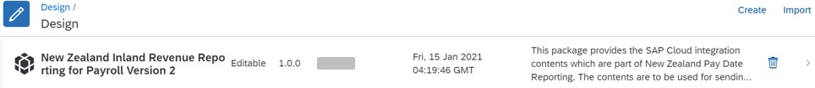
- Click on the Artifacts tab
- Click on action button that corresponds to integration flow ‘OAUTH Token V2’.
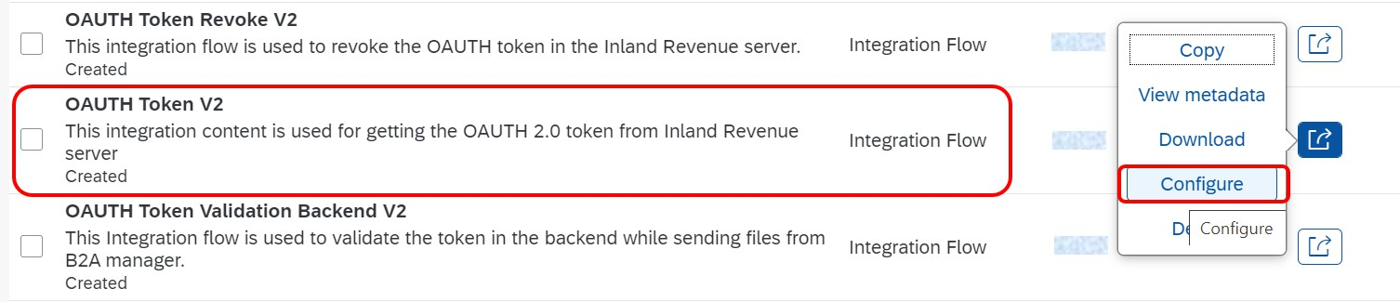
Note: the version of the integration on the screenshot may differ from the current one.
- Choose Configure and maintain the following configuration parameters:

Sender Tab

The sender for this scenario is the Inland Revenue server. The Inland Revenue server will be routing the OAUTH Authorisation code which will be processed in this IFLOW and then sent to OAUTH server to get the OAUTH token.

  - Update the connection address in the format “/XXXX”, where XXXX will be any meaningful name for return URL.
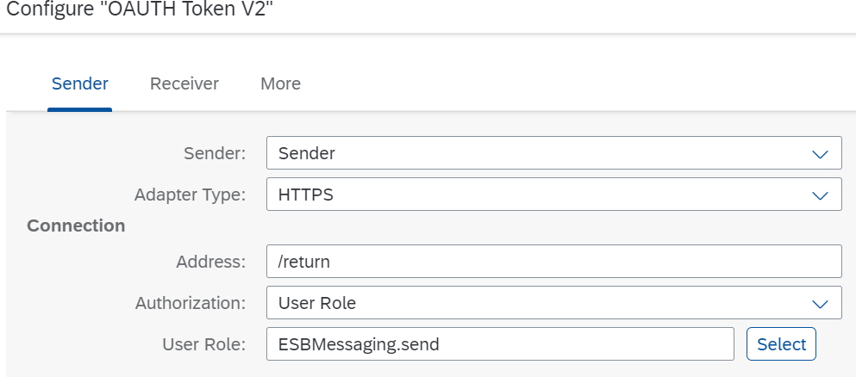
Note: The address configured here will be the suffix used to form the RETURN_URL for OAUTH 2.0 token which is referred to later in this document. This URL is registered with IRD token server. But the connection address must be unique. So, you must keep the URL same as earlier (version 1

iflow). As you have already Version 1 OAUTH Token available with same URL (*** /return), Kindly Undeploy the OAUTH Token (Version 1) iflow before deploying OAUTH Token V2 (Version 2) iflow.

  - For the HTTP sender channel set the ‘Authorisation’ field to ‘User Role’ and the ‘User Role’ to ESBMessaging.send’ regardless of whether the end user will be identified by a username and password or via a certificate. (refer to section 6 for configuring authorisations).

Receiver Tab
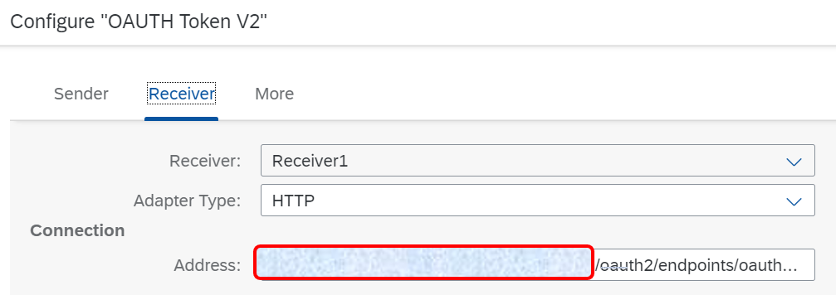
Address: Enter the following OAUTH production server URL. https://services.ird.govt.nz/gateway3/oauth/token
More Tab
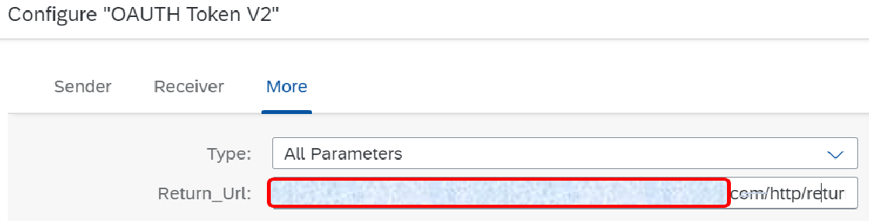

Return_URI: Enter the return URI which will be registered with Inland Revenue (refer to the registration section at the end of this document to link to the documentation detailing how this is formed, in short it is a combination of the tenant http URL and the address parameter specified on the Sender tab).
- Select Save and Deploy to save your configuration and to deploy it actively to server, respectively.

Note: you may get warning message while saving this and other artifacts but this ok.
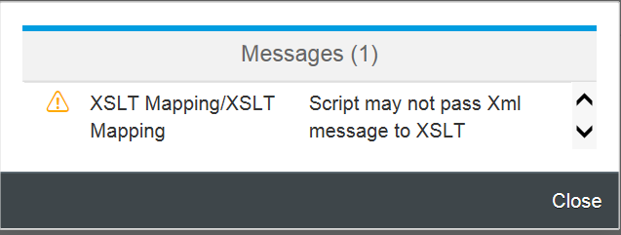

OAUTH Token Validation V2
This integration flow is used to validate the OAUTH token issued by the Inland Revenue server. A user can use this service to determine if the token is still active or whether they need to obtain a new one.

Steps:
- Go to the integration package that was copied from the original ‘New Zealand Inland Revenue Reporting for Payroll Version 2’
- Click on the Artifacts tab
- Click on action button that corresponds to integration flow ‘OAUTH Token Validation V2’.
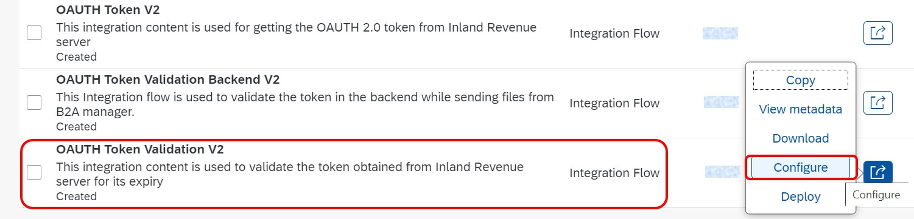
- Choose Configure and maintain the following configuration parameters:
Sender Tab

The sender for this scenario is the HTTP request invoked by the end user from the B2A Manager transaction in SAP ERP/ECP (T-Code - PB2A) using “Validate Token” button. The request is then sent to the Inland Revenue server and a response is shown to the end user in HTML format.

  - Update the connection address in the format “/XXXXX”, where XXXXX can be any meaningful word for validating the token.
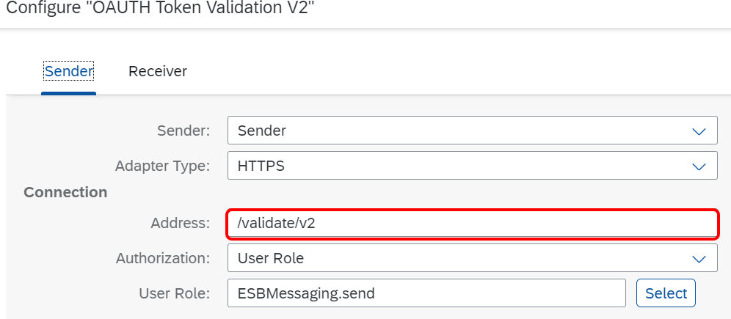

Note: The connection address must be unique within a tenant.

  - For the HTTP sender channel set the ‘Authorisation’ field to ‘User Role’ and the ‘User Role’ to ESBMessaging.send’ regardless of whether the end user will be identified by a user name and password or via a certificate. (refer to section 6 for configuring authorisations).

Receiver Tab

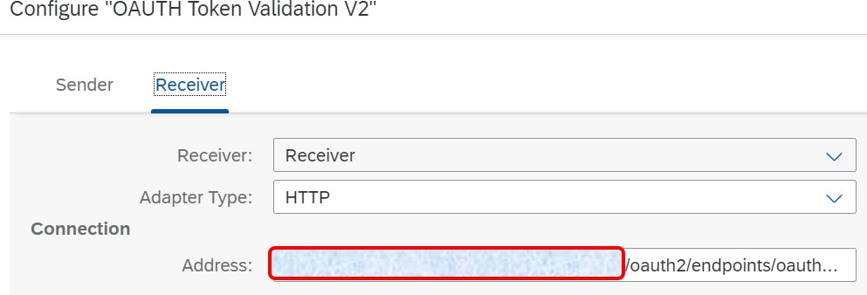

Address: Enter the following OAUTH production server URL. https://services.ird.govt.nz/gateway3/oauth/introspect
- Select Save and Deploy to save your configuration and to deploy it actively to server, respectively.

- Configure view V_T50BK.
- Copy the generated URL of Deployed iflow.
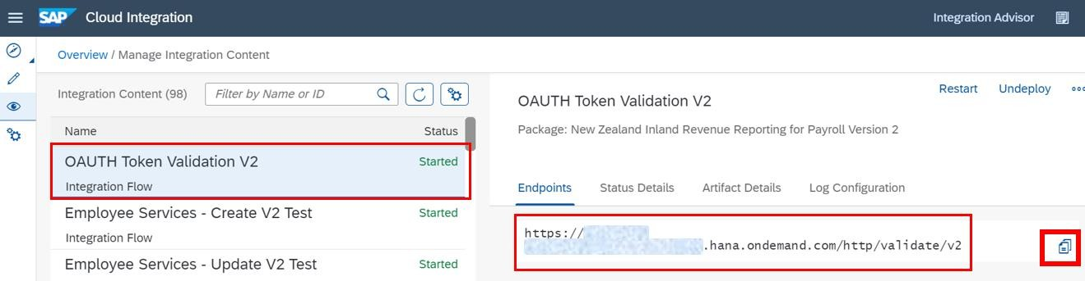
- Logon to backend SAP ERP/EC system.
- Open T-Code SM30. Edit View V_T50BK.
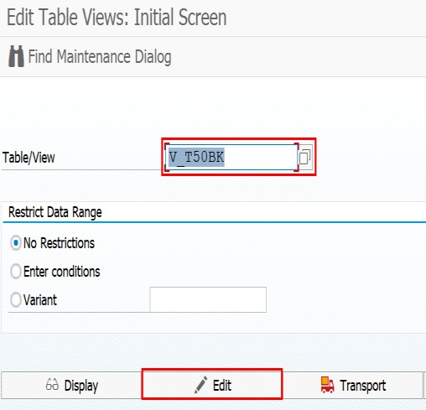

- Select “Country Grouping” as “43”, Click on “Ok”.
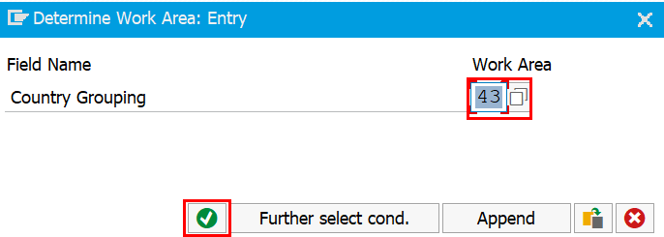

- Select the entry with Constant “VTOKE” and click on “Delimit”.

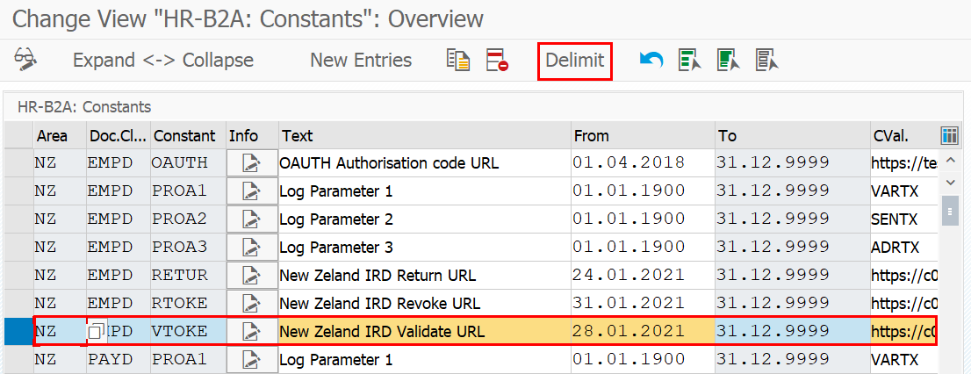

- Provide a date from when you want to start using this iflow for that system and Click on “Ok”
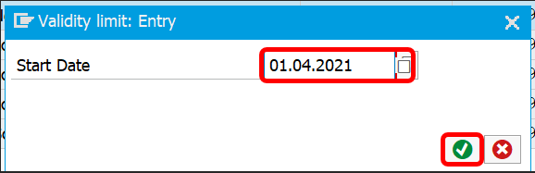

- Paste the copied URL in CVal field.
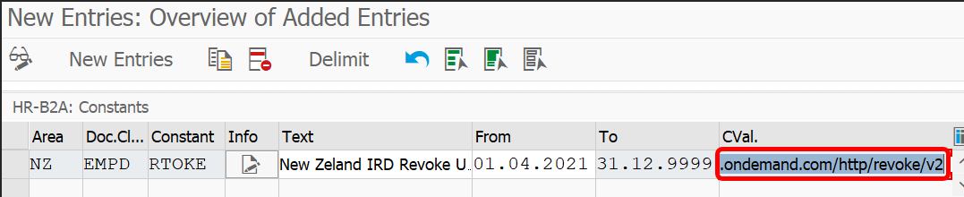
- Save your changes.

    - OAUTH Token Revoke V2
This integration flow is used to revoke the OAUTH token issued by the Inland Revenue server. Once the token has been revoked communication with the Inland Revenue server ceases and a user must retrieve a new token for further communication.
Steps:
- Go to the integration package that was copied from the original ‘New Zealand Inland Revenue Reporting for Payroll Version 2’
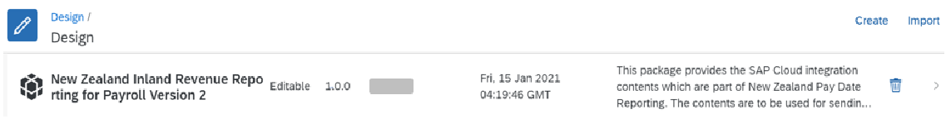
- Click on the Artifacts tab
- Click on action button that corresponds to integration flow ‘OAUTH Token Revoke V2’.

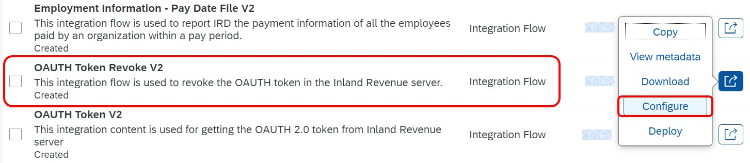

- Choose Configure and maintain the following configuration parameters:
Sender Tab
The sender for this scenario is the HTTP request invoked by the end user from the B2A Manager transaction in SAP ERP/ECP (T-Code - PB2A) using “Revoke Token” button. The request is then sent to the Inland Revenue server and a response is shown to the end user in HTML format.

  - Update the connection address in the format “/XXXXX”, where XXXXX can be any meaningful word for revoking the token in Inland Revenue server.
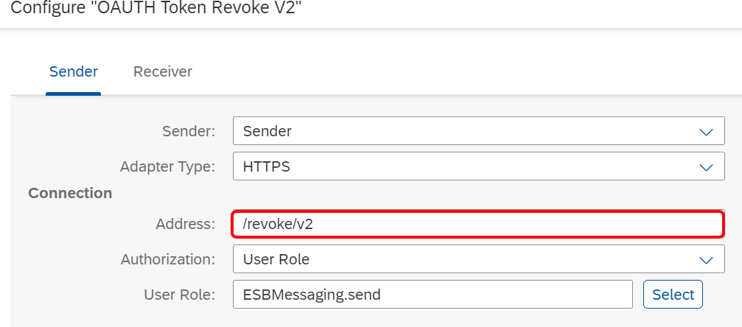
Note: The connection address must be unique within a tenant.

  - For the HTTP sender channel set the ‘Authorisation’ field to ‘User Role’ and the ‘User Role’ to ESBMessaging.send’ regardless of whether the end user will be identified by a user name and password or via a certificate. (refer to section 6 for configuring authorisations).

Receiver Tab
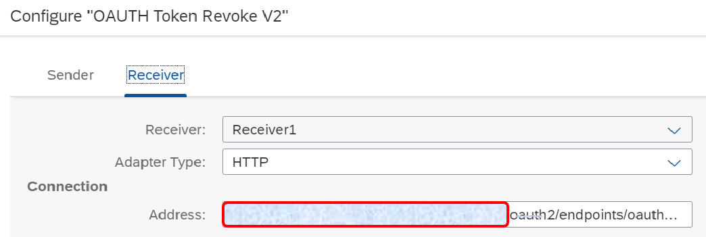
Address: Enter the following OAUTH production server URL. https://services.ird.govt.nz/gateway3/oauth/revoke
- Select Save and Deploy to save your configuration and to deploy it actively to server, respectively.

- Configure view V_T50BK.

- Copy the generated URL of Deployed iflow.
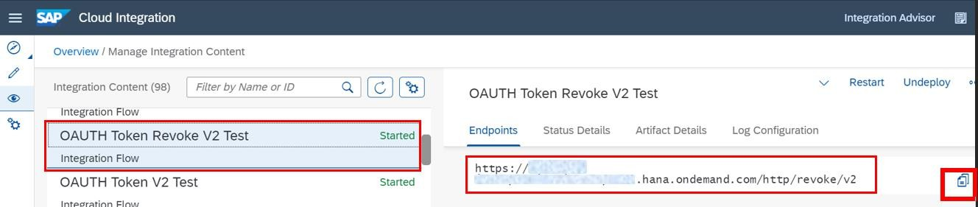
- Logon to backend SAP ERP/EC system.
- Open T-Code SM30. Edit View V_T50BK.

- Select “Country Grouping” as “43”, Click on “Ok”.

- Select the entry with Constant “RTOKE” and click on “Delimit”.
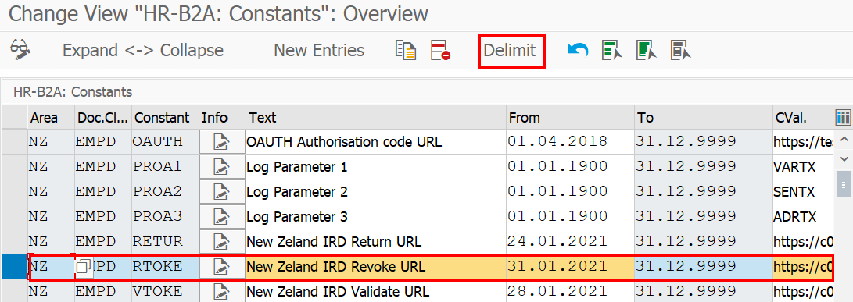

- Provide a date from when you want to start using this iflow for that system and Click on “Ok”

- Paste the copied URL in CVal field.

- Save your changes.

    - OAUTH Token Validation Backend V2
This Integration flow is used to validate the token. The call to this IFLOW is made while sending the payload from the backend system so that the token is verified before sending the actual payload to Inland Revenue. This uses SOAP to communicate between payroll system and SCI.
Steps:
- Go to the integration package that was copied from the original ‘New Zealand Inland Revenue Reporting for Payroll Version 2’
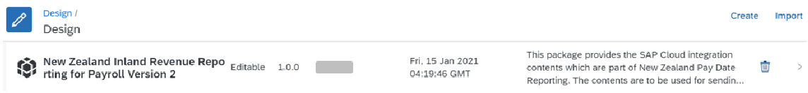
- Click on the Artifacts tab
- Click on action button that corresponds to integration flow ‘OAUTH Token Validation Backend’.
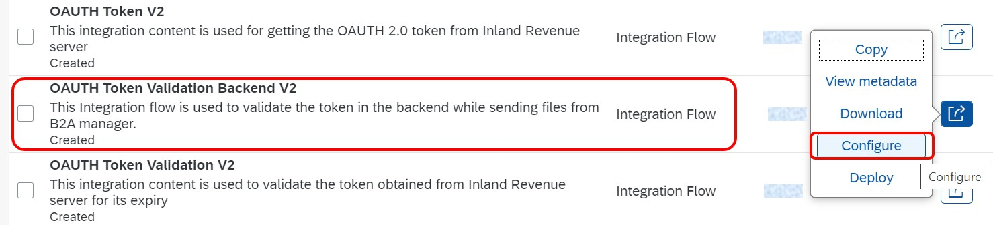

- Choose Configure and maintain the following configuration parameters:

Sender Tab

The sender for this scenario is the SAP R/3 or SAP ECP system. The communication protocol for this connection used is SOAP. The connection is established in SAP R/3 or SAP ECP using SOA manager.

  - Update the connection address in the format “/XXXXX”, where XXXXX can be any meaningful word for validating the token from backend system.

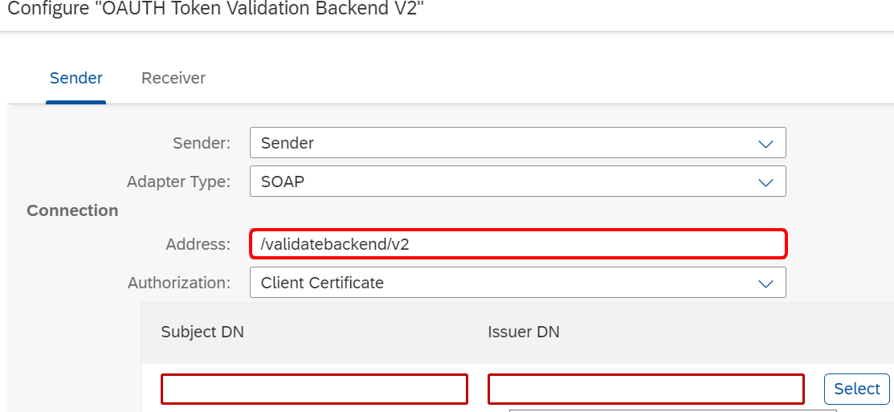
Note: The connection address must be unique within a tenant.

  - In the Authorization field enter ‘client certificate’ and enter the public key of the certificate stored in STRUST referenced in prerequisite step 3.5.

Receiver Tab
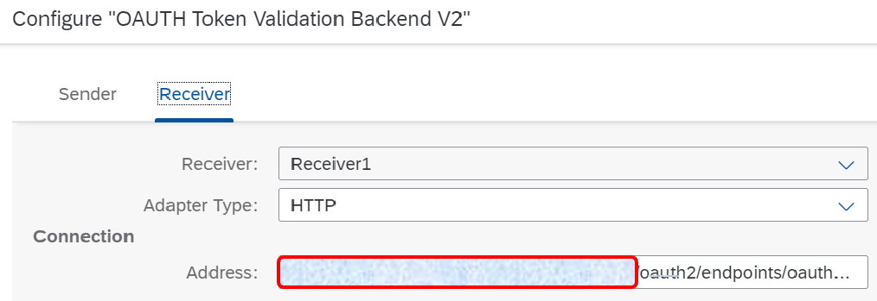
Address: The OAUTH production server URL. https://services.ird.govt.nz/gateway3/oauth/introspect
- Select Save and Deploy to save your configuration and to deploy it actively to server, respectively.

  - Configure Integration Flow for XML file communication
You will be configuring the Iflows which are specific to employee and payment files.
- Employee Services: Create, Update, Terminate
- Employment Information: Pay Date reporting

The Iflows used for the scenarios uses certificate Alias which is the security certificate going to be registered with Inland Revenue.

    - Employee Services: Create V2
This integration flow is used to update Inland Revenue with details of each new employee who was hired in a pay period.

Steps:

- Go to the integration package that was copied from the original ‘New Zealand Inland Revenue Reporting for Payroll Version 2’
- Click on the Artifacts tab
- Click on action button that corresponds to integration flow ‘Employee Services – Create V2’.
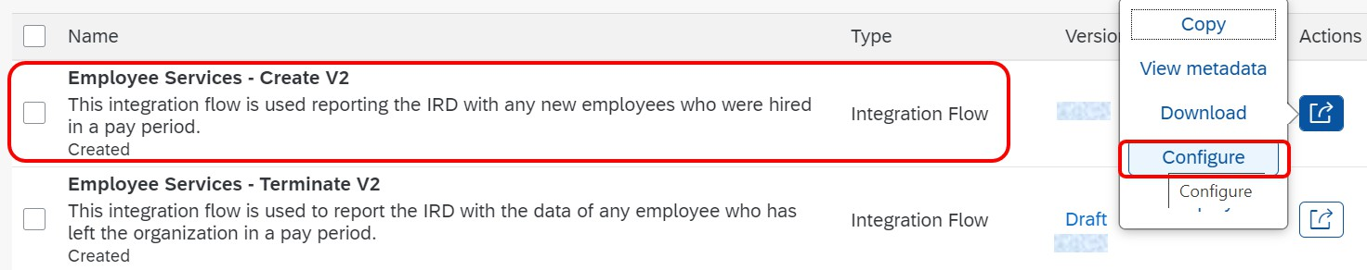

- Choose Configure and maintain the following configuration parameters:

Sender Tab

The sender for this scenario is the SAP payroll system. The communication protocol for this connection used is SOAP. The connection is established in SAP payroll system using SOA manager.

  - Update the connection address in the format “/XXXXX”, where XXXXX can be any meaningful word for Inland Revenue ES create service.
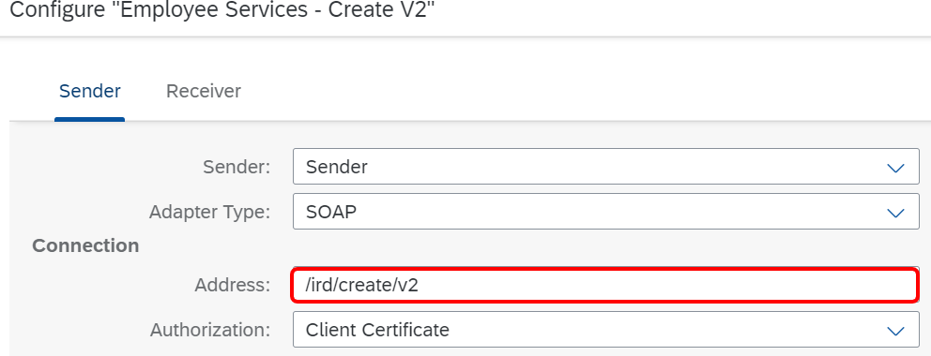
Note: The connection address must be unique within a tenant.

  - In the Authorization field enter ‘client certificate’ and enter the public key of the certificate stored in STRUST referenced in prerequisite step 3.5.

Receiver Tab

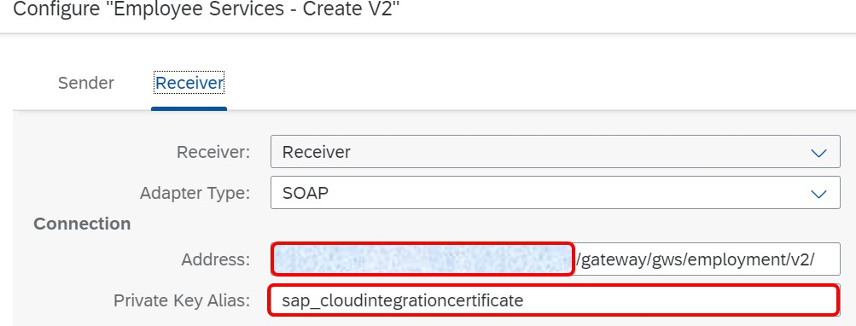
Address: Enter the following production Inland Revenue Employee Service URL address
https://services.ird.govt.nz:4046/gateway/gws/employment/v2/

Private Key Alias: Enter the Alias of the certificate which will be registered with Inland Revenue.
- Select Save and Deploy to save your configuration and to deploy it actively to server, respectively

    - Employee Services: Update V2
This integration flow is used to update Inland Revenue when an existing employee has changes to KiwiSaver (e.g. opts out or joins) or has a change in personal details such as a tax code change or a name change.
Steps:
- Go to the integration package that was copied from the original ‘New Zealand Inland Revenue Reporting for Payroll Version 2’
- Click on the Artifacts tab
- Click on action button that corresponds to integration flow ‘Employee Services – Update V2’.
s
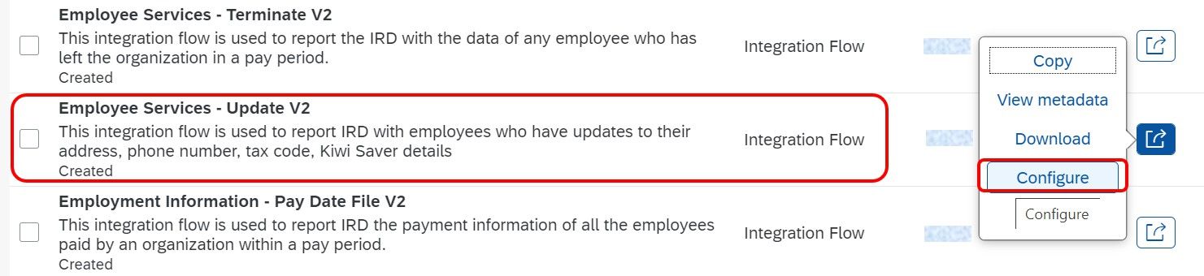

- Choose Configure and maintain the following configuration parameters:
Sender Tab

The sender for this scenario is the SAP payroll system. The communication protocol for this connection used is SOAP. The connection is established in SAP payroll system using SOA manager.

  - Update the connection address in the format “/XXXXX”, where XXXXX can be any meaningful word for Inland Revenue ES Update service.

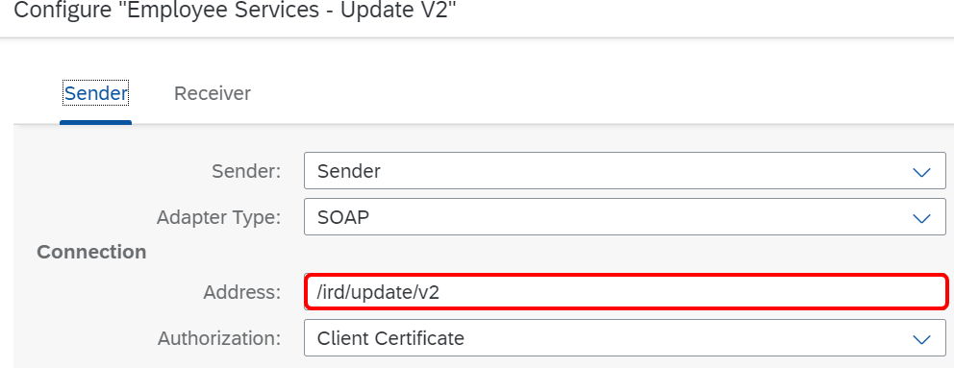
Note: The connection address must be unique within a tenant.

  - In the Authorization field enter ‘client certificate’ and enter the public key of the certificate stored in STRUST referenced in prerequisite step 3.5.

Receiver Tab
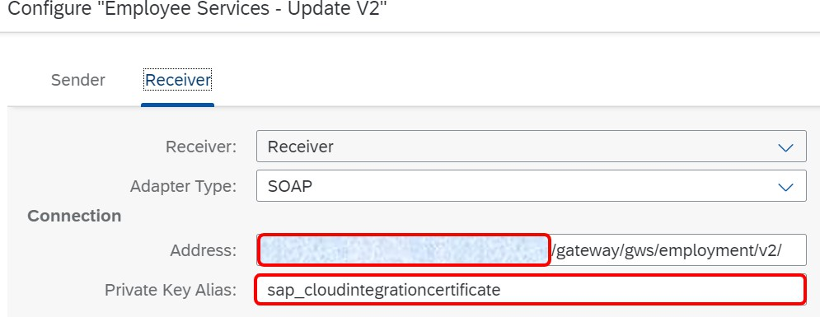
Address: Enter the following production Inland Revenue Employee Service URL address
https://services.ird.govt.nz:4046/gateway/gws/employment/v2/
Private Key Alias: Enter the Alias of the certificate which was be registered with Inland Revenue.
- Select Save and Deploy to save your configuration and to deploy it actively to server, respectively.

    - Employee Services: Terminate V2
This integration flow is used to report any employees that are terminating employment. Steps:
- Go to the integration package that was copied from the original ‘New Zealand Inland Revenue
Reporting for Payroll Version 2’
- Click on the Artifacts tab
- Click on action button that corresponds to integration flow ‘Employee Services – Terminate V2’

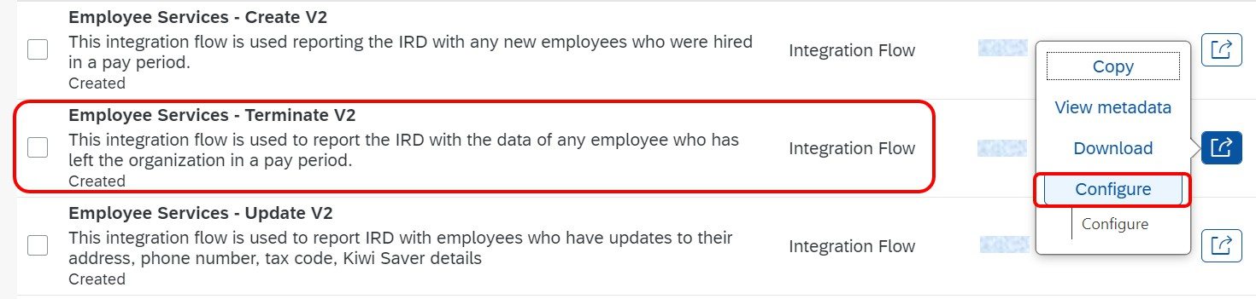

- Choose Configure and maintain the following configuration parameters:

Sender Tab

The sender for this scenario is the SAP R/3 or SAP ECP system. The communication protocol for this connection used is SOAP. The connection is established in SAP R/3 or SAP ECP using SOA manager.

  - Update the connection address in the format “/XXXXX”, where XXXXX can be any meaningful word for Inland Revenue ES terminate service.
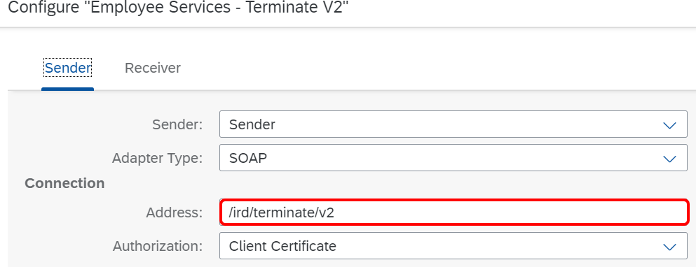
Note: The connection address must be unique within a tenant.

  - In the Authorization field enter ‘client certificate’ and enter the public key of the certificate stored in STRUST referenced in prerequisite step 3.5.

Receiver Tab

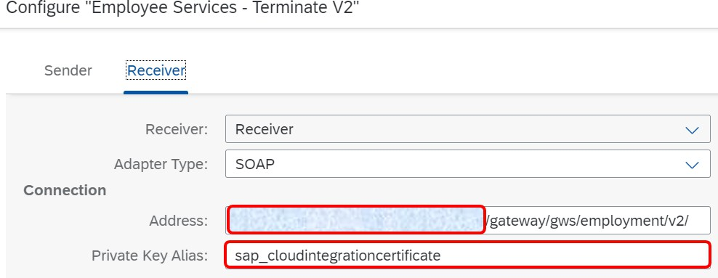
Address: Enter the following production Inland Revenue Employee Service URL address
https://services.ird.govt.nz:4046/gateway/gws/employment/v2/

Private Key Alias: Enter the Alias of the certificate which will be registered with Inland Revenue.

- Select Save and Deploy to save your configuration and to deploy it actively to server, respectively.

    - Employment Information: Pay Date File V2
This integration flow is used to update the Inland Revenue with any new employee who was hired in a pay period.
Steps:
- Go to the integration package that was copied from the original ‘New Zealand Inland Revenue Reporting for Payroll Version 2’
- Click on the Artifacts tab
- Click on action button that corresponds to integration flow ‘Employment Information - Pay Date File V2.
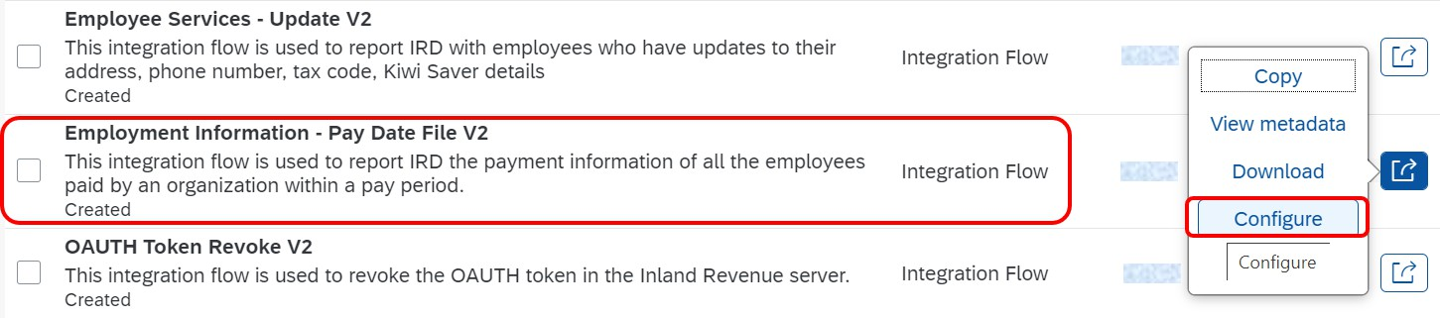

- Choose Configure and maintain the following configuration parameters:
Sender Tab

The sender for this scenario is the SAP R/3 or SAP ECP system. The communication protocol for this connection used is SOAP. The connection is established in SAP R/3 or SAP ECP using SOA manager.

  - Update the connection address in the format “/XXXXX”, where XXXXX can be any meaningful word for Inland Revenue EI service for Payment reporting.
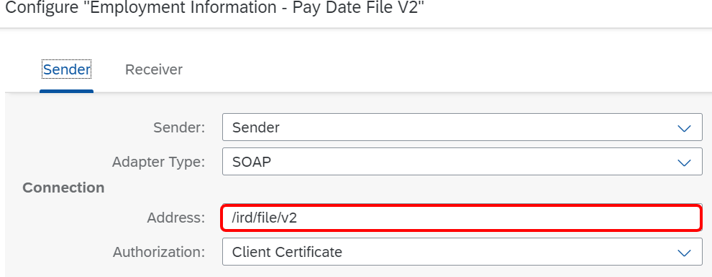
Note: The connection address must be unique within a tenant.

  - In the Authorization field enter ‘client certificate’ and enter the public key of the certificate stored in STRUST referenced in prerequisite step 3.5.

Receiver Tab
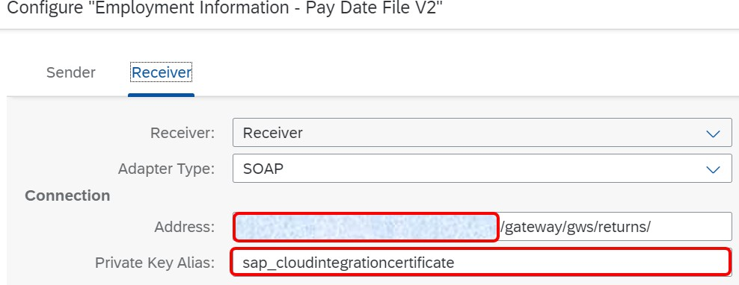
Address: Enter the following the production Inland Revenue Employment Information service URL https://services.ird.govt.nz:4046/gateway/gws/returns/
Private Key Alias: Enter the Alias of the certificate which will be registered with Inland Revenue.

- Select Save and Deploy to save your configuration and to deploy it actively to server, respectively.

SETUP STEPS IN SAP ERP OR SAP S/4HANA
The connection between SAP Payroll system and SCI needs to be established for communication purpose.

  - Create the logical ports in SOAMANAGER
The proxies must be connected to the SAP CLOUD INTEGRATION tenant via logical ports. In the productive SAP ERP or SAP ECP system, the logical ports are configured to connect to the productive SAP CLOUD INTEGRATION tenant.
Note: the look and feel of the screens in your system may differ from the screenshot below, depending on your release.

- In your SAP ERP/ECP system, go to transaction SOAMANAGER.
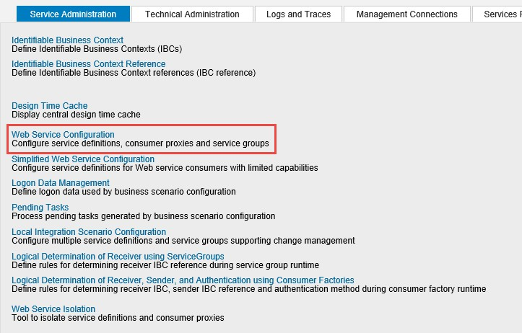

- Select Web Service Configuration and find the proxies created for New Zealand Pay Date reporting. (Note that these will only be available if SAP Note 2939166 and 3000464 are implemented.)
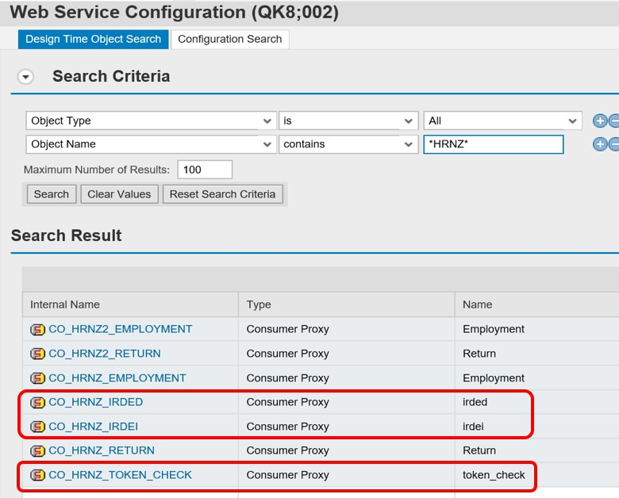
- Create logical port(s) for CO_HRNZ_IRDED and CO_HRNZ_IRDEI proxy and modify logical port CO_HRNZ_TOKEN_CHECK proxy with updated URL.
The logical ports you will be creating are:
Proxy: CO_HRNZ_TOKEN_CHECK (modify URL)

Logical Port Name | Description | Corresponding  IFLOW | Example CXF path
LP_CO_HRNZ_TOKEN_CHECK_HCI | LP for OAUTH token validation  backend | OAUTH Token Validation  Backend | /cxf/validatebackend/v2
Proxy: CO_HRNZ_IRDED

Logical Port Name | Description | Correspondi  ng IFLOW | Example CXF path
LP_CO_HRNZ_IRDED_CREATE_CPI | LP for Employee Service: Create File | Employee Service -  Create | /cxf/ird/create/v2
LP_CO_HRNZ_IRDED_UPDATE_CPI | LP for Employee Service: Update File | Employee Service -  Update | /cxf/ird/update/v2
LP_CO_HRNZ_IRDED_TERMINATE_CPI | LP for Employee Service: Terminate  File | Employee Services -  Terminate | /cxf/ird/terminate/v2
Proxy: CO_HRNZ_IRDEI

Logical Port Name | Description | Corresponding  IFLOW | Example CXF  path
LP_CO_HRNZ_IRDEI_FILE_CPI | LP for Employment Information: Return  File | Employment Information - Pay  Date File | /cxf/ird/file/v2

The steps are the same for all the logical ports.

This document has the example for “LP_CO_HRNZ_IRDED_CREATE_CPI” and this can be used as an example to create each separate port.
  - Click on the Create button and choose “Manual Configuration”.
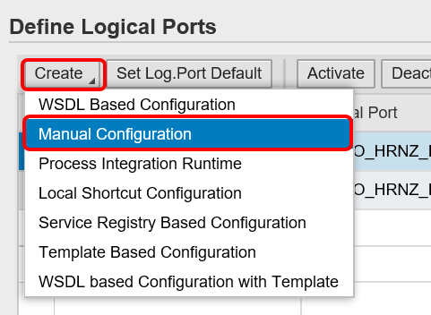
  - Enter the Logical Port name and description

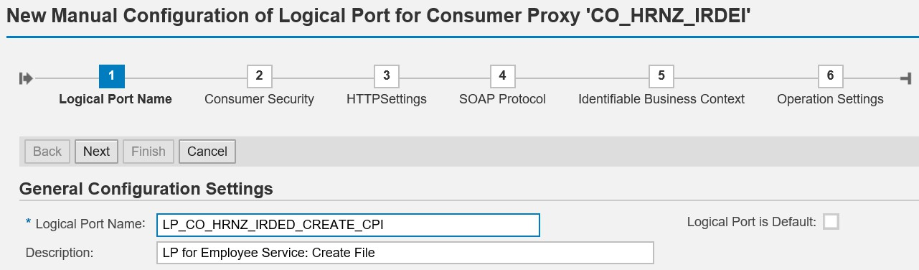

  - The Consumer Security tab page specifies the authentication method used for communication between SAP ERP/ECP and SCI.
    - In the ‘Authentication Settings’ select the X.509 SSL Client Certificate radio button.
    - In the “SSL Client PSE of transaction STRUST” field, use the drop down to find the certificate stored in STRUST as part of prerequisite step 3.5.

Note: if you do not see this radio button or cannot select it, please refer to notes 2368112 “Outgoing HTTPS connection does not work in AS ABAP” and 510007 “Setting up SSL on Application Server ABAP”.
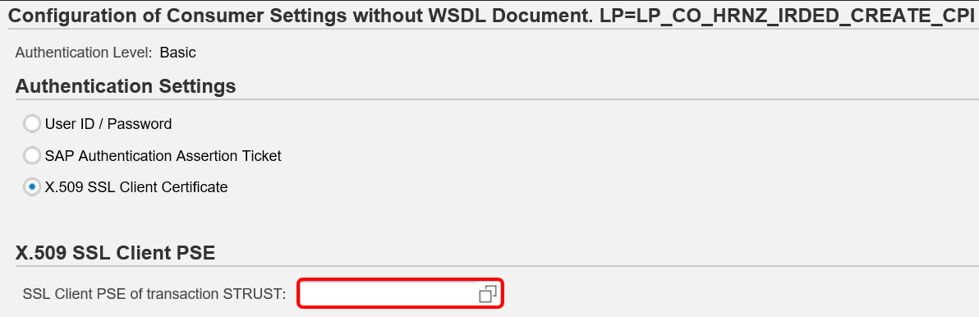
Note: the solution will support User ID/Password authentication between SAP ERP and SCI but this is not recommended for usability reasons in a productive environment. If you decide to use this method the authorization method referred to in the previous section for the iflows (OAUTH Token V2, Validation Backend V2, Create V2, Update V2, Terminate V2 and Pay Date File V2) will need to be changed to ‘User’ and the user role set to ‘ESBMessaging.send’.
  - On the HTTP Settings tab page, make the following entries: Note: the screenshots may look slightly different in your system depending on the release, but all the required fields should be available.

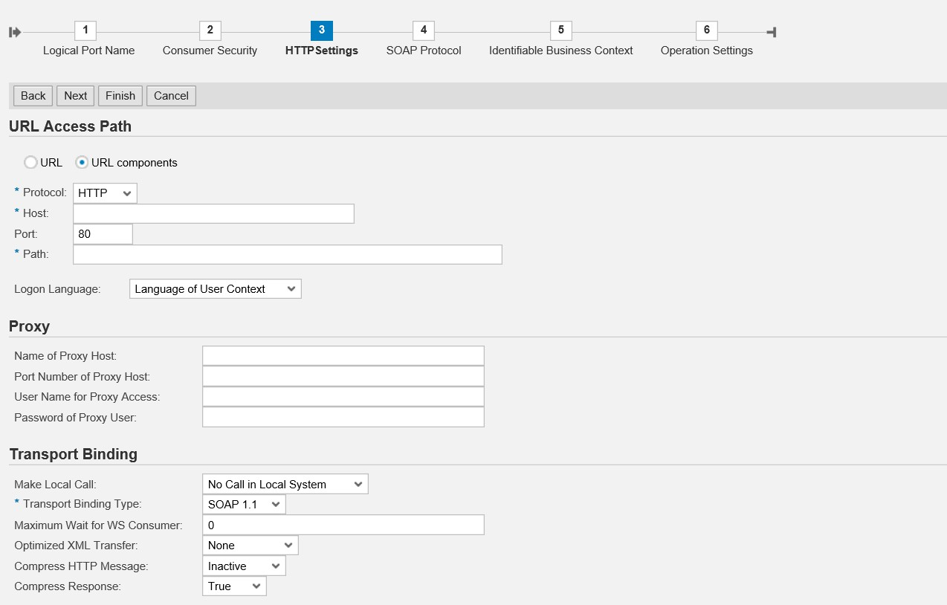
Get the HOST URL from the SCPI WEB UI – refer to details below

CXF path deployed artifacts in SCPI – refer to details below
Proxy settings of your network

Note that in older version the above screen may look different, but the fields will still be present, for example:
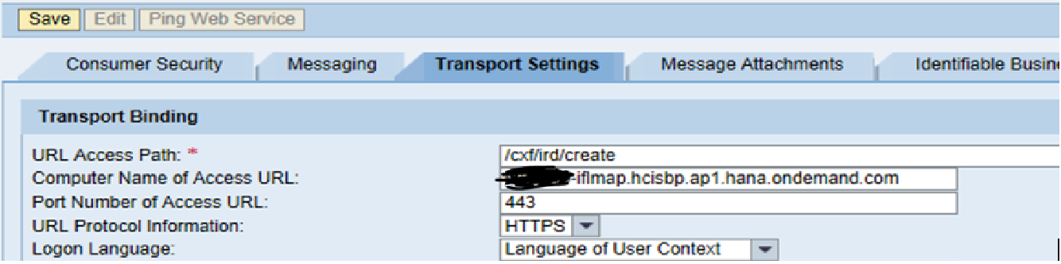


The computer Name of access URL is the first part of an URL without the forward slash ‘/’. The URL access path is part of an url which starts from forward slash ‘/’.
For e.g., URL = https://cdf-iflmap.hcisb.int.sap.hana.ondemand.com/cxf/ird/create Computer name: cdf-iflmap.hcisb.int.sap.hana.ondemand.com Access path: /cxf/ird/create

  - Get HOST URL & CXF path from SCI WEB UI
To find the Host, go to Cloud Integration Web UI, choose Monitor and under Managed Integration Content go to All. Use the search to find your integration flow as in the screenshot below:

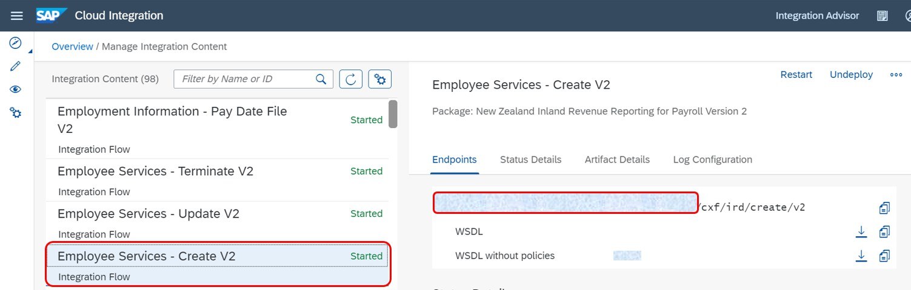
The URL found under the Endpoints section has the HOST URL and the CXF path.
Host url = xxxxxxxxxx.sap.hana.ondemand.com CXF path = /cxf/ird/create/v2
Update the information in the HTTP settings section.
Note that the entries for the Proxy fields depend on your company’s network settings. The proxy server is needed to enable the connection to the internet through the firewall.
  - On the SOAP Protocol tab page, set Message ID Protocol to Suppress ID Transfer
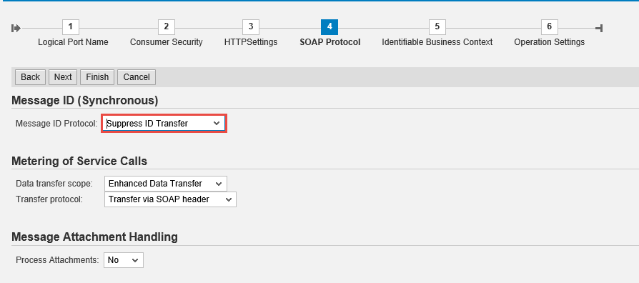
  - No settings required in the tabs Identifiable Business Context and Operation Settings. Just select Next
and then Finish.
NOTE: In case you want to test your configuration, do not use WebService Ping, as it is not supported by SAP Cloud Integration. But you can setup a HTTP connection in transaction SM59. Maintain the host and port of SAP Cloud Integration service (e.g., for path /cxf/ird/create/v2) and execute a connection test. In case of a successful connection you will receive an error with HTTP return code 500.

SENDER CHANNEL CONNECTION AUTHORIZATION

Certificate based authorization for HTTP sender channel

The Iflows, OAUTH Token V2, OAUTH Token Validation V2 & OAUTH Token Revoke V2 have HTTP as the sender channel. These iflows are invoked through a browser. If you want to configure the authorization by Certificate (rather than use name and password), then you will have to use the client certificate which is installed in the user’s PC to identify the user. The SAP Passport certificate that users receive when they receive an SAP “S” number can be used for this purpose. The steps to download and assign the certificates is as follows.

Note: if you wish these iflows to use user name/password as the authentication method no further additional steps are required.

    - Download the public certificate from the browser. Below example steps are given for Chrome in Windows OS:
- From top right corner menu, go to “Settings” -> then choose “Privacy and security” -> and go to “Security” -> Then select “Manage Certificates”
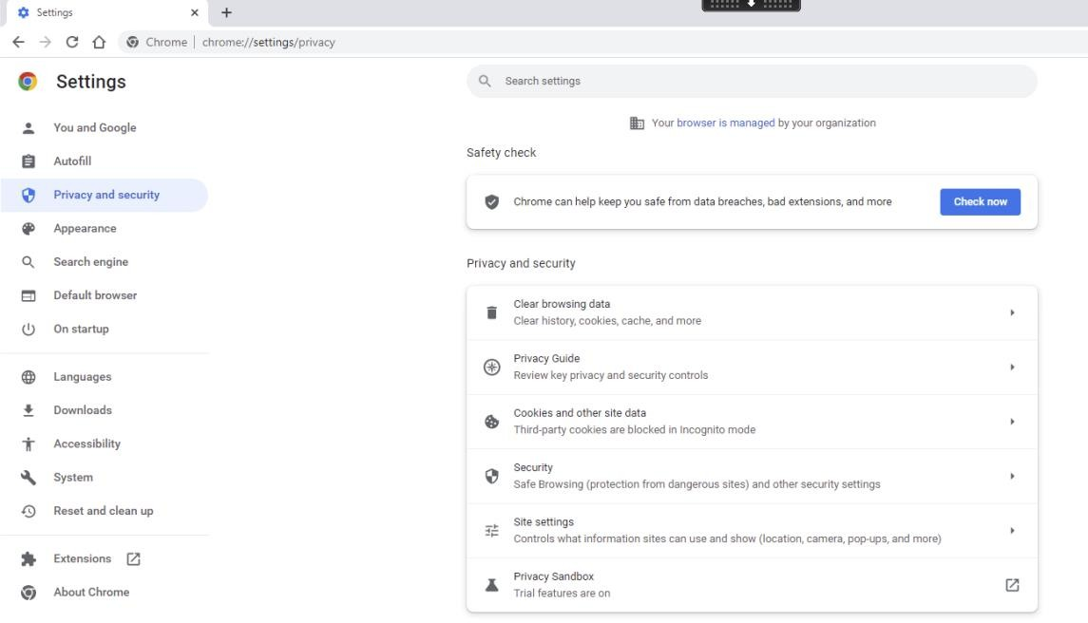

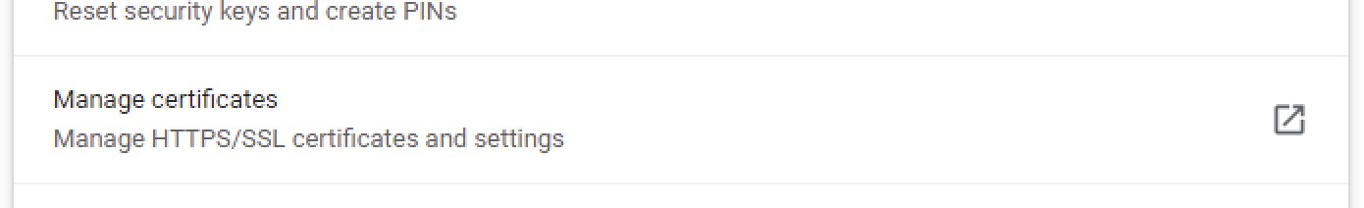

- In Personal tab, select the certificate which you wish to use for authenticating the user and then click “Export” button.

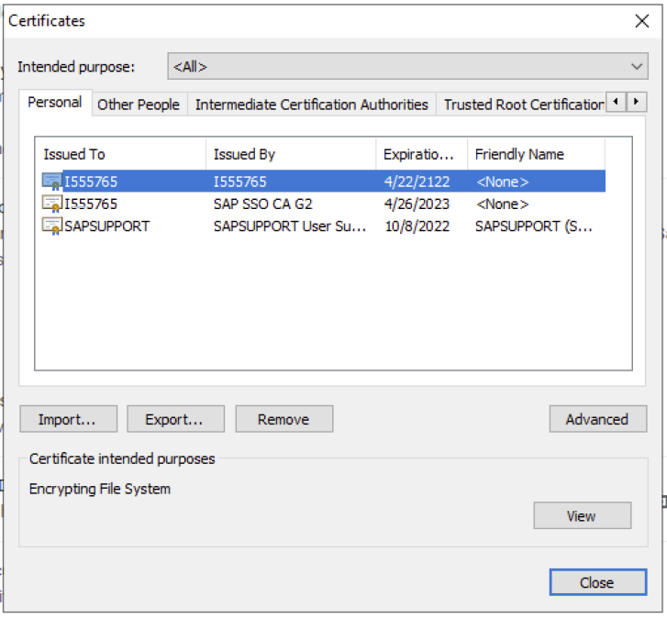

- Proceed with certificate export wizard.
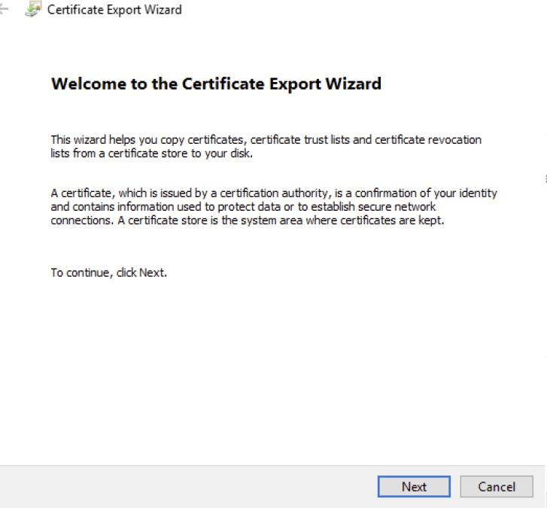

- Select “No, do not export the private key”

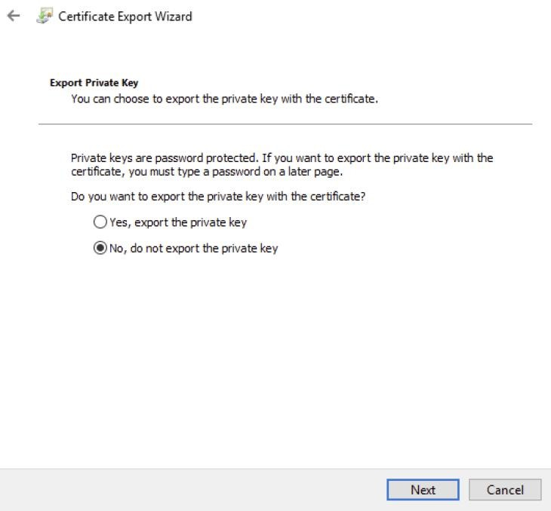

- Select “Base-64 encoded” option and
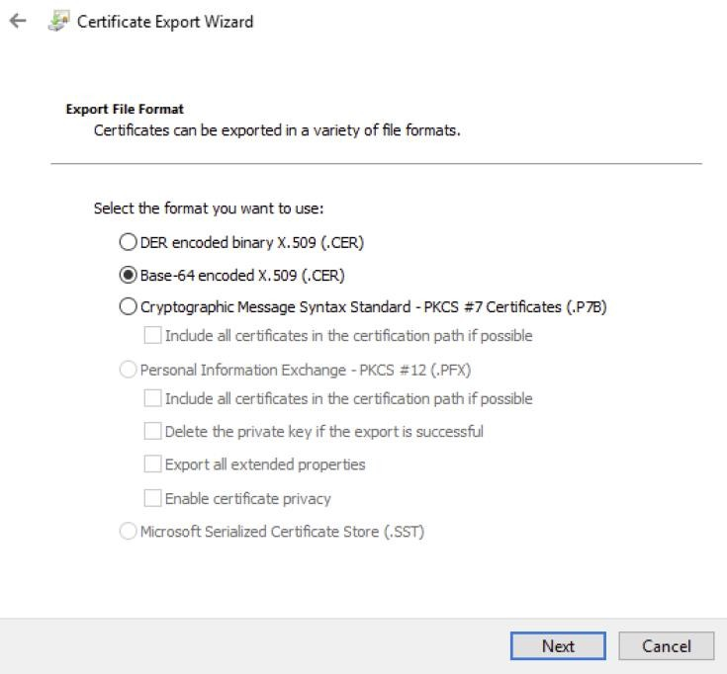

- Save the certificate with “.cer” extension and complete the wizard.

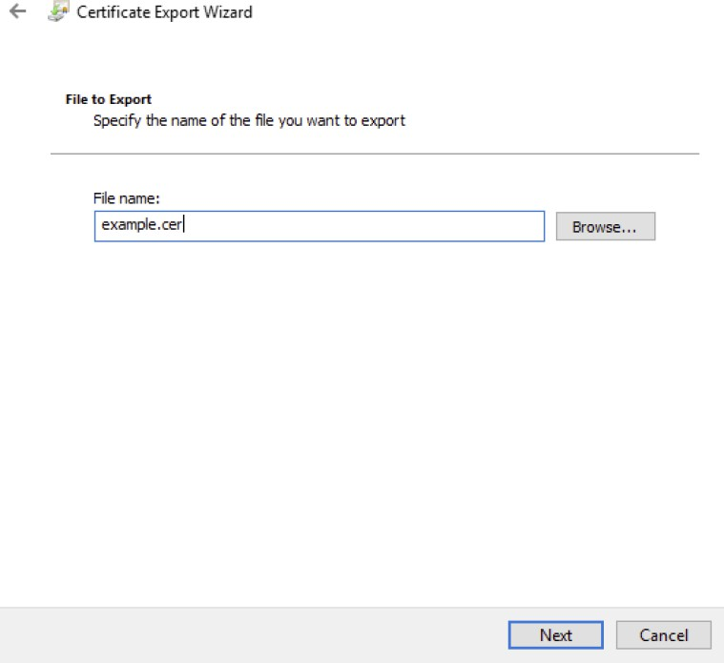
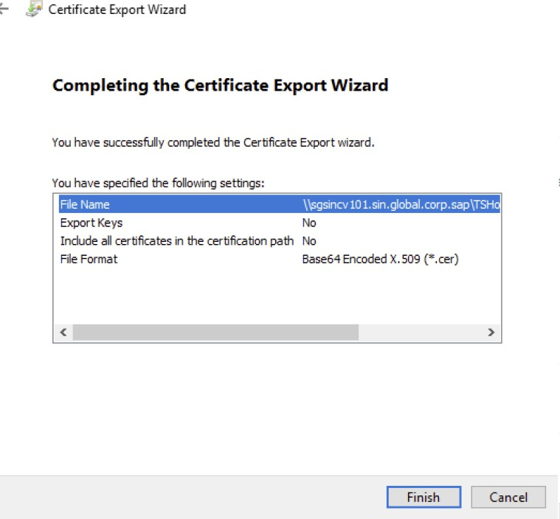

Assign the public certificate for authorization

The certificate then needs to be associated to the SCI user id and it is recommended that this be done through the ‘certificate-to-user mapping’ settings. (Note: It is technically possible to assign the user’s certificate directly to the corresponding iflows but this is not recommended as only one use can be assigned and it is recommended that at least two users have the ability to file in case one user is absent.)

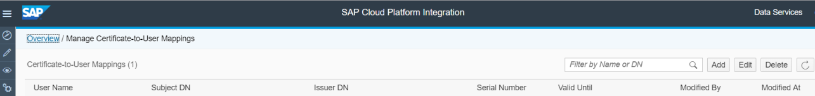

Note that all users should have the authorisation role “ESBMessaging.send” assigned to them so that they are able to invoke the iflows.

- Go to SAP Cloud Integration-> Overview ->Certificate-to-User Mappings.
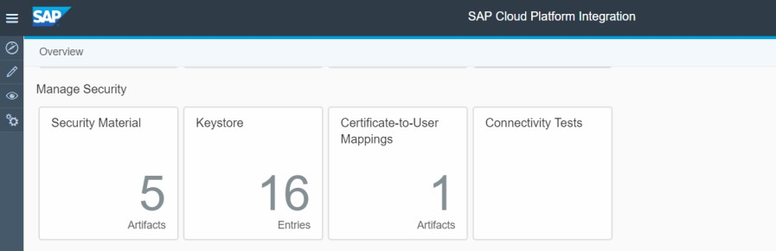
- Press button Add

- Enter a user name with “ESBMessaging.send role”, upload the SSL certificate
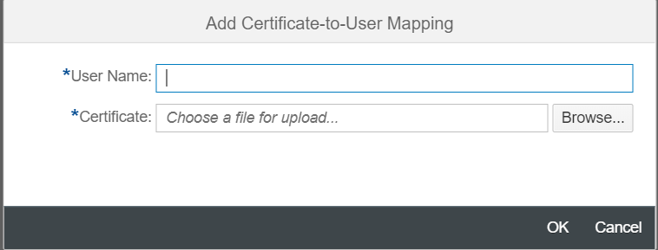

- REGISTER YOUR SAP CLOUD INTEGRATION DETAILS WITH INLAND REVENUE

SAP Cloud Integration (SCI) uses a client certificate to authenticate the communication with external systems. At the Inland Revenue server, the authentication is done using MUTUAL TLS method. The public key of a key pair which is installed in SCI tenant needs to be downloaded and then given to Inland Revenue for them to install in their server. This is part of the registration process that must be followed before you can fully test the connection to Inland Revenue.

Please refer to the document “New Zealand Inland Revenue- Registering for Payroll Services” for more information about the registration process.

- MAINTENANCE

Take note of the expiry date of all certificates used in the solution and put in processes so that these are renewed before they expire, and the configuration updated accordingly with the new details.
Each time the CPI certificate is updated, check that the certificate common name (CN) is the same. If this name is changed you will need to reregister the certificate with Inland Revenue. This can be done by raising a message with SAP under component PY-NZ. Ensure that there is at least a week’s notice before you need to file.

www.sap.com/contactsap

© 2018 SAP SE or an SAP affiliate company. All rights reserved.
No part of this publication may be reproduced or transmitted in any form or for any purpose without the express permission of SAP SE or an SAP affiliate company.

The information contained herein may be changed without prior notice. Some software products marketed by SAP SE and its distributors contain proprietary software components of other software vendors. National product specifications may vary.

These materials are provided by SAP SE or an SAP affiliate company for informational purposes only, without representation or warranty of any kind, and SAP or its affiliated companies shall not be liable for errors or omissions with respect to the materials. The only warranties for SAP or SAP affiliate company products and services are those that are set forth in the express warranty statements accompanying such products and services, if any. Nothing herein should be construed as constituting an additional warranty.

In particular, SAP SE or its affiliated companies have no obligation to pursue any course of business outlined in this document or any related presentation, or to develop or release any functionality mentioned therein. This document, or any related presentation, and SAP SE’s or its affiliated companies’ strategy and possible future developments, products, and/or platform directions and functionality are all subject to change and may be changed by SAP SE or its affiliated companies at any time for any reason without notice. The information in this document is not a commitment, promise, or legal obligation to deliver any material, code, or functionality. All forward-looking statements are subject to various risks and uncertainties that could cause actual results to differ materially from expectations. Readers are cautioned not to place undue reliance on these forward-looking statements, and they should not be relied upon in making purchasing decisions.
SAP and other SAP products and services mentioned herein as well as their respective logos are trademarks or registered trademarks of SAP SE (or an SAP affiliate company) in Germany and other countries. All other product and service names mentioned are the trademarks of their respective companies. See http://www.sap.com/corporate-en/legal/copyright/index.epx for additional trademark information and notices.

