
PuBLIC

SAP Build Process Automation

Asset Maintenance
  - Configuration and User Guide

Contents

Overview 3

Prerequisites 3

Capabilities 4

Procedure 5

Setup SAP Business Technology Platform Cockpit 5

Destination Configuration 5

SAP Build Process Automation 5

Import Content 5

Configuration & Modification 6

Configure Process 6

Configure Trigger 6

Revised Maintenance Plan Approval for ACME Plant - Q2, 2023 6

Approval Workflow 7

Read Mail Automation 7

Process Input File Automation 9

Read excel file Automation 9

Release and Deploy your Process 11

Release 11

Deploy 12

Trigger the Automation 12

Support 13

Overview
This document provides information about setting up the Asset maintenance sample. The main audience of this document are technical IT/system administrators.
The Asset Maintenance sample content enables customers to automate the receipt of the maintenance plans from service providers and send for necessary approval of the plan for execution.
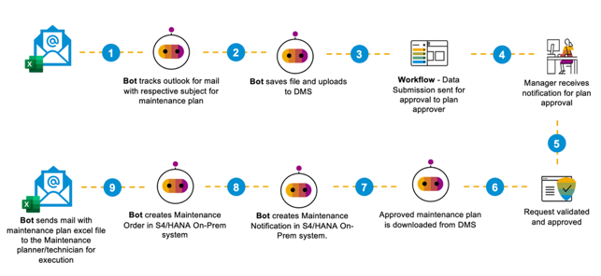
The following steps are included as part of this sample:
- Service provider sends maintenance plan in an excel file attachment in email to the manufacturer.
- On the Manufacturer’s side, Microsoft Outlook is monitored constantly for such incoming email with attachment and search criteria defined to download such attachment and upload to the SAP BTP Document Management Service and create a public share link for the attachment.
- Approval Workflow is called to get the approval of the maintenance plan from the manager on the manufacturer’s side.
- Approver(s) accesses My Inbox to view the task, review the document and choose one of the following decisions.
  - Approve: Upon selecting “Approve” option, the maintenance notification and maintenance order creation starts and is appended to the excel sheet by the bot
  - Reject: Upon selecting “Reject” option, Requester (and Watcher if specified) are notified via email about rejection of the request and the process is terminated.
- Once the entire excel sheet is processed the “Execution Complete” mail is sent to the service provider.

Prerequisites
This asset maintenance sample is intended to be used for collaboration between vendors, operators and service providers and requires the following services in SAP Business Technology Platform:
- SAP Build Process Automation to run the automation and workflow approval process
- SAP Document Management Service to create a repository to store and retrieve maintenance plan
- SAP Business Network Asset Collaboration to collaborate with manufacturers, service providers and operators
- S/4HANA 2021 FPS02 On-Premise system to create maintenance notifications and maintenance orders

Capabilities
This sample consists of following capabilities.
Icon | Type | Name | Description
 | Automation | Read mail Auto | Read email and call the sub-automation to send the file to approval workflow
 | Process | Approval Workflow | Get the decision for the maintenance plan excel file and call sub-automation to process the input file
 | Automation | Create Maintenance Notification | Call S/4HANA API to create Maintenance Notification
 | Automation | Create Shared Folder | Create a shared folder in SAP BTP DMS
 | Form | Maintenance Plan Approval for ACME Plant - Q2, 2023 | Approval Form for maintenance plan
 | Application | MaintenanceOrderWithNotification | UI screen recording of SAP GUI to create Maintenance Order in S/4HANA On-Premise system
 | Automation | MaintenanceOrderWithNotification Automation | UI Automation to create Maintenance Order in S/4HANA On-Premise system
 | Automation | Preventive Maintenance - Initial | Save the excel file attachment and call sub-automation to create a shared folder on SAP BTP DMS and Upload document
 | Automation | processInputFile | Download the excel file and call sub-automation to read the file and create the shared folder in SAP BTP DMS and upload the document
 | Automation | Read excel file | Read data from excel file and call the sub automations to create maintenance notification and maintenance order
 | Automation | Upload document | Upload document to SAP BTP DMS

Please refer help documentation about these different artifacts.

Procedure
Asset Maintenance sample requires SAP Build Process Automation subscription or CPEA contract. Follow the setup and configuration section.

Setup SAP Business Technology Platform Cockpit

Destination Configuration
- Configure SAP Build Process Automation Email Destination
Configure email destination. For more information on configuring destination, see Configure a SMTP Mail Destination.
- Configure Document Management Service Repository
If not available already, to create and configure root Document Management Service repository please follow the steps described in Configure SAP Document Management Service for Process Attachments
For more information refer to Create HTTP Destinations and OAuth User Token Exchange Authentication.
User Roles Configuration
● To access this template, the business user will need these roles:
Role Name | Purpose
“SDM_Admin” or “SDM_User” | To give access for File Upload
ProcessAutomationDeveloper | To fully use this content package, you need to have an active user entitled to this role to use SAP Build Process Automation
For more information about SAP Build Process Automation roles, see Authorizations.

SAP Build Process Automation

Import Content
This sample can be downloaded from the Store:
- 1) Navigate to the Store in your SBPA tenant.
- 2) Select the Project Type filter as “Process Automation”
- 3) In the Search bar type “Asset Maintenance Sample”
- 4) Select the “Add” button to add the template into you lobby.
- 5) After successfully adding the sample, navigate back to the lobby to find the “Asset Maintenance Sample” available for use.
Note: Be sure to select the Project Type as “Process Automation” in the filters.

Configuration & Modification
Once you have added the content to your lobby, you will find the project in your project list. Before you can deploy and use it, you can configure it or adjust it to your own needs.

Configure Process
The process “Approval Workflow” does not need to be explicitly configured.

Configure Trigger
Workflow Trigger: Process Trigger
This is the trigger to the Process which will start the workflow, this trigger accepts the given payload.
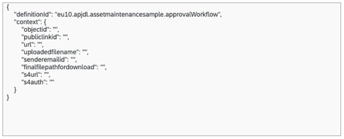

Revised Maintenance Plan Approval for ACME Plant - Q2, 2023
This form contains the Plant Details, Service Provider Details, Link to Maintenance Plan Document.
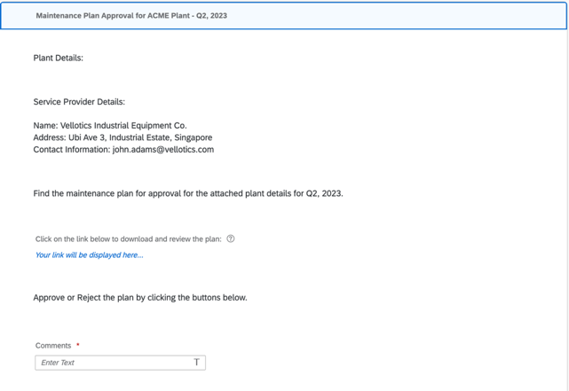
General Settings – These allow you to configure how the approval tasks are displayed in an inbox and to which users or groups of users should receive them.
Recipients – In this template , the recipient of the approval form are the people defined in the MAINTENANCE_PLAN_APPROVER User Group.

Approval Workflow
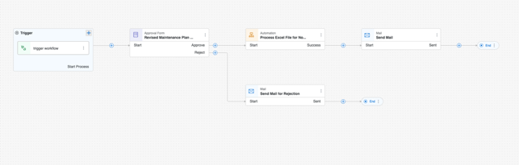

Read Mail Automation
There can be addition of refined search criteria based on your project needs which can be added to the list to give email filtering to suit your needs.
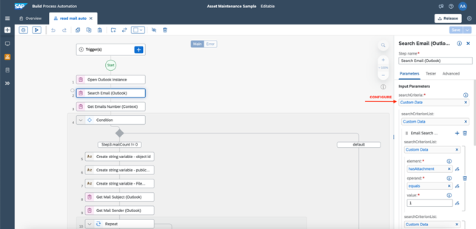
The condition to check the email subject in this automation could also be changed as per your project needs to check for some other specific information in the email content.
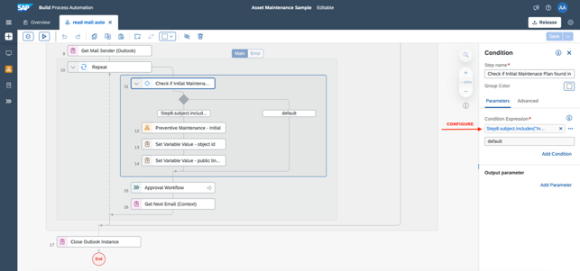
Configure the DMS repository url to your own repository url:
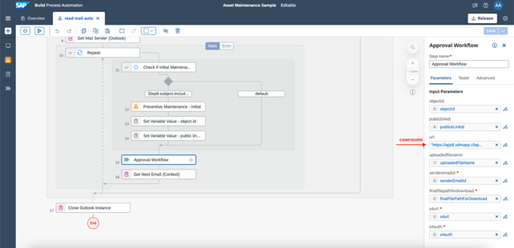

Process Input File Automation
Configure the DMS repository url to your own repository url:
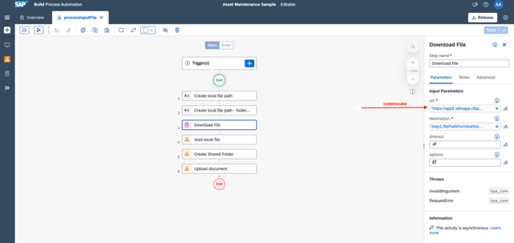

Read excel file Automation
Here the excel sheet sample is used for a particular range definition. This can be updated and used for your specific project needs depending upon your use case and the sample excel sheet used. According to the excel sheet used the start row also can be changed.
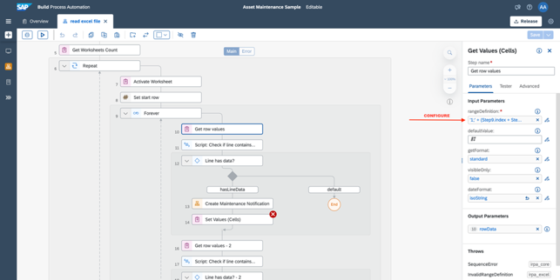
Depending on the project need the call for different S/4HANA On-Premise system APIs could be added/removed in this project.
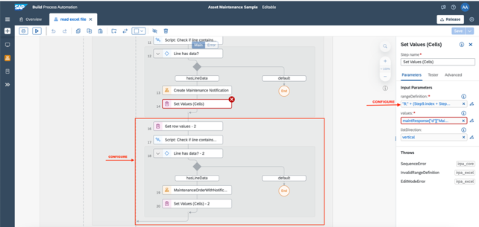
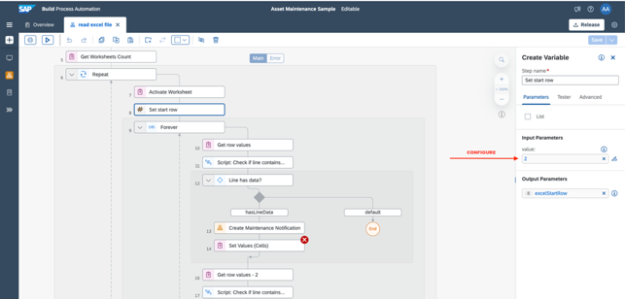

Release and Deploy your Process
After configuring your process, it’s time to publish, test and run it. To run a process you must first release and deploy it.

Release
This locks the version of your process, meaning that no further edits can be made to that version. At this stage, the process can’t be run and isn’t available to participants yet.
To release a version of your process, first ensure that the status is listed as ‘Editable’. The click ‘Release’:
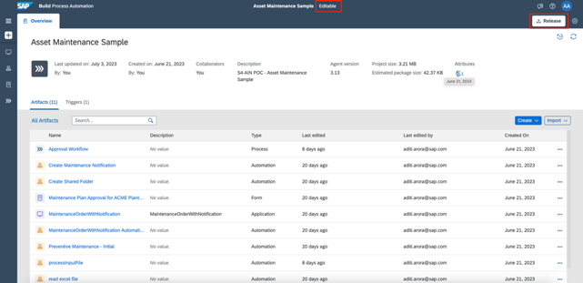
If this is the first time you’ve released the process, a version labelled 1.0.0 is released. For subsequent releases, you’re prompted to select a version type before the process is released.

Deploy
This takes a released version of a process and enables it to be actively run and monitored. A deployed version of this approval process unlocks the request form, allowing participants to submit requests and the approvers to view items in their inbox.
To deploy a released version of your process, first ensure that the status is listed as ‘Released’. The click Deploy:
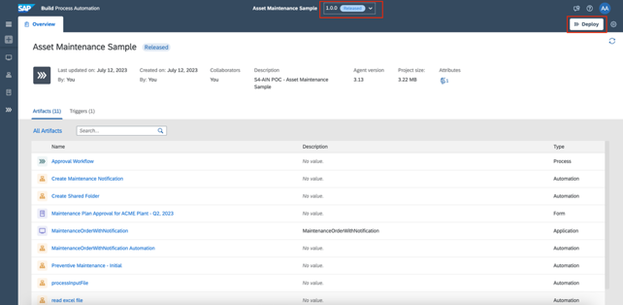

Trigger the Automation
Once you have deployed the automation you can go to Monitor->Triggers and create a trigger for starting the automation ‘read mail auto’ by providing the input parameters for the automation as described below:
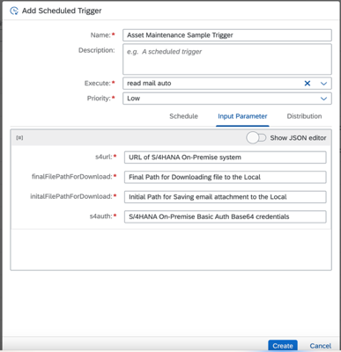

Support
There is no support available for sample content. If you experience general issues with SAP Build Process Automation, raise an incident via SAP Support Portal on BPI-PA component.
Conclusion
For more information on the details of the scenario and implementation check out this blog post:
https://blogs.sap.com/2023/05/23/unlocking-seamless-maintenance-planning-using-sap-s-4hana-on-prem-sap-business-network-asset-collaboration-and-sap-build-process-automation/

This sample can be modified using SAP Process Automation. For example: add business rules to determine the approver based on a certain business logic or add any other required information for the maintenance plan in the excel sheet. Refer Help Portal for more details.

www.sap.com

