SAP Best Practices for Intelligent Automation for SAP Business ByDesign
May 2022
English
 | Creation of Closing Cockpit
SAP SE  Dietmar-Hopp-Allee 16  69190 Walldorf  Germany | Technical Specifications

Copyright

© 2022 SAP SE or an SAP affiliate company. All rights reserved.
No part of this publication may be reproduced or transmitted in any form or for any purpose without the express permission of SAP SE or an SAP affiliate company.
SAP and other SAP products and services mentioned herein as well as their respective logos are trademarks or registered trademarks of SAP SE (or an SAP affiliate company) in Germany and other countries. Please see http://global.sap.com/corporate-en/legal/copyright/index.epx#trademark for additional trademark information and notices.
Some software products marketed by SAP SE and its distributors contain proprietary software components of other software vendors.
National product specifications may vary.
These materials are provided by SAP SE or an SAP affiliate company for informational purposes only, without representation or warranty of any kind, and SAP SE or its affiliated companies shall not be liable for errors or omissions with respect to the materials. The only warranties for SAP SE or SAP affiliate company products and services are those that are set forth in the express warranty statements accompanying such products and services, if any. Nothing herein should be construed as constituting an additional warranty.
In particular, SAP SE or its affiliated companies have no obligation to pursue any course of business outlined in this document or any related presentation, or to develop or release any functionality mentioned therein. This document, or any related presentation, and SAP SE’s or its affiliated companies’ strategy and possible future developments, products, and/or platform directions and functionality are all subject to change and may be changed by SAP SE or its affiliated companies at any time for any reason without notice. The information in this document is not a commitment, promise, or legal obligation to deliver any material, code, or functionality. All forward-looking statements are subject to various risks and uncertainties that could cause actual results to differ materially from expectations. Readers are cautioned not to place undue reliance on these forward-looking statements, which speak only as of their dates, and they should not be relied upon in making purchasing decisions.

Document History
Revision | Change Date | Description
1 | 17-05-2022 | Initial version of document

Contents
1 Purpose 5
2 Content and Strategic Intent 5
3 Technical Details 5
3.1 Overview 5
3.2 Type 5
3.3 Public API 5
3.4 Applications/Pages (Screen Scrapping) 6
3.5 Input/output 6
3.5.1 Input 6
3.5.2 Output 7
3.6 Validations 7
3.7 Components 7
3.8 Flow Variations 8
4 Configurations 8
5 Constraints 9
6 Security 9
6.1 Protecting user credentials 9
7 Software 9

Purpose
The SAP Automated Creation of Closing Cockpit for all Company Codes and Set of Books IRPA bot is an SAP Business ByDesign product. It fetches the local agent credentials and performs a log-in to the SAP Business ByDesign portal, navigates to the Closing Cockpit view, and creates a New Period-End Close with Reference for each Company Code and Set of Books combination that is defined by the user in the configuration Excel file. The bot captures any errors that occur while trying to save the New Period-End Close with Reference, logs the errors that are issued by the SAP Business ByDesign system and stores them in the log file.

Content and Strategic Intent
Creating a New Period-End Close with Reference for a huge number of records is a manually intensive, time-consuming, and error-prone process. It adds unnecessary manual effort and poses potential risks to the business. By automating this process using the Automated Creation of Closing Cockpit for Company Codes and Set of Books bot, these drawdowns are avoided, valuable employee time is freed up, and error rates are reduced.

Technical Details

3.1 Overview
This bot can be set up in attended mode using the Intelligent Robotic Process Automation Cloud Factory.
The bot can create a New Period-End Close with Reference and log the progress into a log file for user reference.

3.2 Type

Cloud Edition | On Premise | Attended | Unattended | Screen Scrapping
Yes | No | Yes | No | No

3.3 Public API
N/A

3.4 Applications/Pages (Screen Scrapping)
N/A

3.5 Input/output

3.5.1 Input
Before executing the bot, you must create a root folder containing a configuration Excel file. The configuration Excel file contains a combination of Company Codes and Set of Books along with the different parameters necessary for populating the entry fields. You must enter this data into the configuration file before running the bot. You can choose the name of the configuration file and you must specify this name in the Cloud Factory variable “ConfigExcelFileName”.
You can choose either “Chrome” or “Edge” to run the bot. In case of any other input, Edge will be taken as the default browser.
Example Configuration File
Variable Name | Type | Sample Value | Description
RootFolderPath | Text | C:\Users\Desktop\RPA | Location, where the configuration file and the template log file are placed.
ConfigExcelFileName | Text | Config.xlsx | File, where the rules for creation of Closing Cockpit are present.
ByDCredEntryName | Text | EntryName | Name of the local agent credentials.
TenantURL | Text | https://myxxxxxx.sapbydesign.com/ | SAP Business ByDesign login portal.
BrowserName | Text | Chrome | Browser, through which the bot should run.
Cloud Factory Trigger Parameters

3.5.2 Output
For each rule in the configuration Excel, the required folders are created in the root folder specified in the input. The New Period-End Close with Reference is created by the bot for all the rules specified in the configuration Excel file.
The actions of the bot are logged and can be found in the created Logs file.

3.6 Validations
- Configuration file exists or not - The bot stops with appropriate logging if the file does not exist.
- Local agent credential exists or not – The bot stops with appropriate logging in the log file.
- General Ledger exists or not - The bot stops with appropriate logging in the log file.
- Unable to create and save the New Period-End Close with Reference - The bot stops with appropriate logging in the log file.

3.7 Components
The following table describes the list of Components or Libraries that are used.
Library | Type | Comments
Excel | Read | Used to get input data from the end user
Excel | Write | Used to write/create/modify files during the bot’s execution
Web | N/A | Used to steer the SAP Business ByDesign portal.
Sapui5 | N/A | Used to perform tasks on SAPUI5 buttons.

3.8 Flow Variations
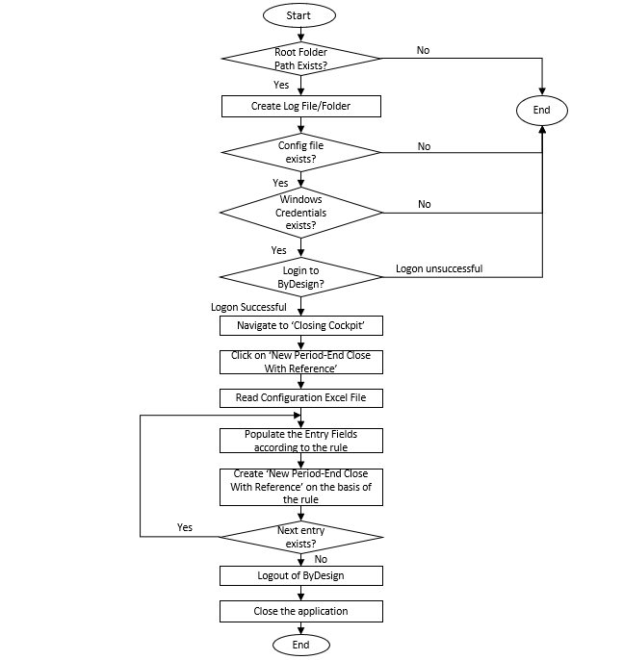

4 Configurations
- Root Folder
- SAP Business ByDesign Credential Name
- Excel Configuration File name
- Tenant URL

5 Constraints
- This bot can work only in Windows OS.
- All required software must be installed.
- The SAP Business ByDesign Credentials must exist in the user system.
- The Root Folder Path and Configuration File must exist in the user system.
- The Date format of ‘Close Period By’ in the SAP Business ByDesign must be in the format ‘DD.MM.YYYY’.
- This bot doesn’t close the application if the incorrect tenant URL is provided.

6 Security

6.1 Protecting user credentials
In certain configuration scenarios, a technical user is required. In such cases, every natural person needs a separate technical user (for example, a separate communication arrangement).
The user must not share their credentials with any other natural person.

7 Software
- IRPA Cloud Studio 2.0.22.59
- IRPA Desktop Agent 2.0.22.59
- Microsoft Excel

