
EXTERNAL
Schedule Report Refresh
Technical Specifications

Table of ContentS
Technical Overview 3
Prerequisites 3
Software Requirements 4
Bot Setup 5
Output and Logs 5
Constraints 5
Security 5
Appendix 6

Technical Overview
The SAP Schedule Report Refresh bot is an SAP Business ByDesign product. It automates the process of refreshing the SAP Business ByDesign Excel reports with the latest data.
It is an independent bot.

Cloud Edition | On Premise Edition | Attended | Unattended | Screen Scrapping
Yes | No | No | Yes | Yes

Prerequisites

- Root folder: A folder with an arbitrary name must be created anywhere in the local system that will function as the root folder for the automation. This folder must contain the configuration file that is attached to the bot in the Intelligent Robotic Process Automation (iRPA) Store and another folder for storing the excel reports. The bot will use this root folder to
  - create a log folder where log files will be stored.

- Configuration File: Download the configuration file from the attachments of this bot in the iRPA Store and place it inside the root folder.
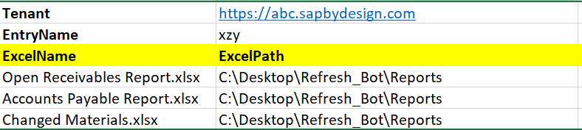

The file includes the report names along with their path and credential information.

- The user must enter the ByD tenant URL in the field name Tenant.
- The user must maintain an entry name for the tenant credentials in the Windows Credential Manager and update the field EntryName of the configuration file. For more details, please check how to setup Windows generic credentials.
- The user must include report names under ExcelName and provide their path under ExcelPath.

- Ensure that the “Refresh Automatically” option in the Excel report is disabled for all the reports.

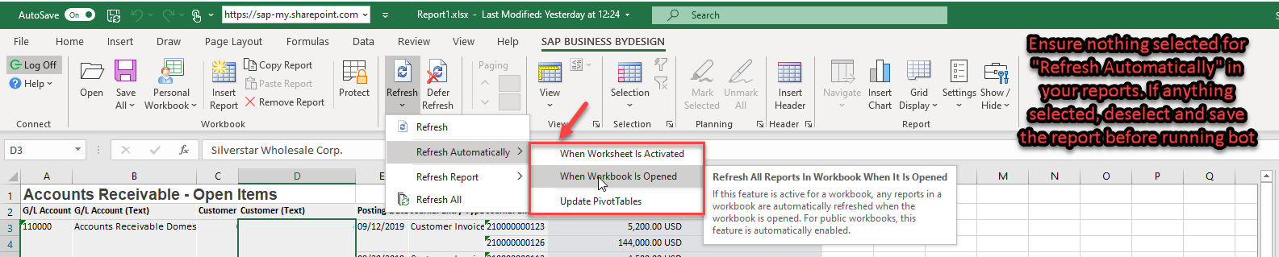
- Make sure to pin the ribbon in Excel before saving it. If the ribbon is not pinned, the bot fails to locate the logon button. Please refer to the screenshot below.

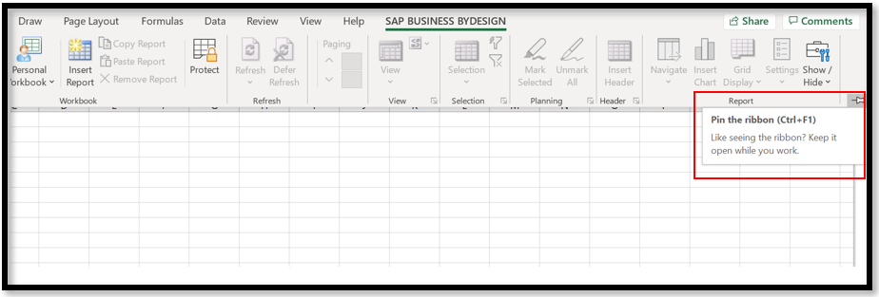

- No other Excel instance should be open during the run of the bot.
- The bot currently only works with Excel set to the English language. You can of course reuse the bot package and customize it to your needs to work for your own language.

- Applications/Pages (Screen Scrapping)

- Microsoft Excel

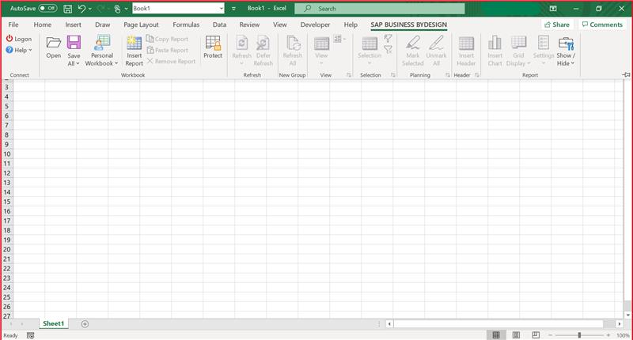
- SAP Business ByDesign Logon

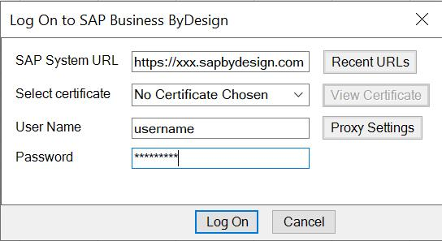

Software Requirements
- IRPA Cloud Studio 2.0.8 or higher
- IRPA Desktop Agent 2.0.8 or higher
- Microsoft Excel

Bot Setup

- Acquire the package from the iRPA Store. (iRPA Help)
- Create an environment in the iRPA Cloud Factory. (iRPA Help)
  - Add the Desktop Agent to the environment.
  - Add the bot package to the environment.
  - Create a scheduled trigger for the bot package in the environment. Insert the needed input information in the trigger variables as per the table below.
- Wait for the scheduled trigger or start a bot run immediately by triggering it via the Options menu of the trigger and the “Run Now” option. (“Next Steps” in iRPA Help)
This example video demonstrates how to set up a bot in the Cloud Factory.

Cloud Factory Trigger Variables
The following table provides details on the Cloud Factory trigger variables required for executing the bot.
Trigger Variable Name | Type | Sample Value | Description
rootFolderPath | Text | C:\Users\Desktop\RPA | Location of the configuration file.
configExcelFilename | Text | Config.xlsx | File that contains information on the report Excel files to be refreshed.

BOT WORKFLOW
For the bot workflow, please refer to the attached flowchart in the Appendix.

Output and Logs

- The bot refreshes all the SAP Business ByDesign Excel reports with the latest data of files that are mentioned in the config file.
- Logs: If it doesn’t exist, the bot creates a folder names “Logs” inside the root folder. There, the log files of each bot run will be stored.
 Log files should not be opened during the bot execution.

Constraints
1. This bot can work only in Windows OS.
2. All required software plugins must be installed beforehand.

Security

In certain configuration scenarios, a technical user is required. In such cases, every natural person needs a separate technical user (for example, a separate communication arrangement).
The user must not share their credentials with any other natural person

Appendix

- Components:

Library | Type | Comments
Excel | Read | Used to get input data from the end user.
Excel | Write | Used to write/create/modify files during the bot’s execution
Excel | SAP Business ByDesign Excel Plugin | Used to integrate SAP Business ByDesign tenant to the Excel.

- Bot Workflow:

