SAP S/4HANA – Shopify
Automated order & customer creation

Action | Name / Owner | Date
Documentation v1 | Flexso | 01.11.2023

Table of contents
Table of contents 2
1. Interface overview 3
2. Pre-requisites 4
3. Integration flow configuration 5
3.1 Shopify to SAP S4HANA Cloud Orders 5
3.1.1 SAP S/4HANA Data Mapping Configuration 5
3.1.2 Integration Flow Configuration 6
3.1.3 Extension capability 7
3.2 Shopify to SAP S4HANA Cloud Customer 8
3.2.1 SAP S/4HANA Data Mapping Configuration 8
3.2.2 Integration Flow Configuration 9
3.2.3 Extension capability 9

Interface overview

The integration seamlessly links Shopify with SAP S/4HANA, enabling a fluid order process. Upon a Shopify order placement, a message with order and customer details is sent to the SAP Integration Suite. This data is then converted and mapped to a sales order and a business partner in SAP S/4HANA, ensuring real-time integration.
The below diagram clarifies the flow of the integration:
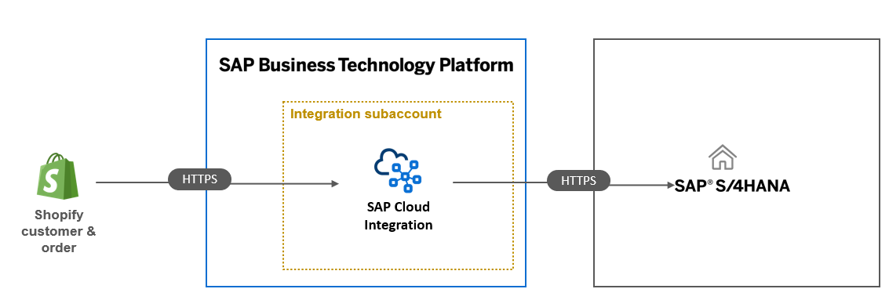
Both SAP S/4HANA & SAP S/4HANA Cloud are supported as target systems.

Pre-requisites

On the SAP S/4HANA system the following OData services need to be activated:
- Sales Order Integration(SAP_COM_0109, Sales Order (A2X))
  - Allows the automated creation of salesorders
- Business Partner Integration (SAP_COM_0008, Business Partner (A2X))
  - Allows the automated creation of business partners

Within Shopify a webhook needs to be created to capture the ‘order creation event’ and transfer it to SAP Integration Suite. Documentation on this activity can be found on the following url:
- https://help.shopify.com/en/manual/orders/notifications/webhooks
The integration requires an enhancement to the standard Sales Order API through the 'Custom Fields & Logic' app. A designated custom field named 'YY1_ShopifyReference' should be created to store the Shopify salesorder id.

Integration flow configuration

Shopify to SAP S4HANA Cloud Orders

SAP S/4HANA Data Mapping Configuration
The integration flow harnesses Shopify data to accurately map and convert orders into SAP S/4HANA sales orders. The following externalized configuration parameters can be customized to define the creation of the sales order in the target system:
Externalized Parameter Name | Sample Value
Prop_CustomerPurchaseOrder | 0000
Prop_DistributionChannel | 00
Prop_IncoTermsClassification | DDP
Prop_IncotermsVersion | 0000
Prop_OrganizationDivision | 00
Prop_PricingConditionType | PPR0
Prop_SalesOrderType | OR
Prop_SalesOrganization | 0000
Prop_ShippingCondition | 01
OneTimeShipTo | 9000000000

Integration Flow Configuration

This section details the technical setup of the integration flow, including its extensibility features. We have externalized a set of parameters for flexible configuration as follows:

Externalized Parameter Name | Sample Value
AllowedHeaders | x-shopify-allow
BusinessObjectIdentifier | /order/id
FetchAdditionalDataForOrder | false
PerformMapping | true
Failed_Datastore_Name | SHOP_Salesorder_Failed
ApplicationID | /order/id
MessageType | Salesorder
Sender | Shopify
Webhook_URL | /Shopify/OrderCreate
CPI_Additional_Data_Order_Endpoint | /Shopify/FetchAdditionalData
Automated_Retry | Run Once
S4HANA_OData_Host_SalesOrder | OData URL
S4HANA_Client_Cert | Certificate

Description of integration configuration parameters:
- AllowedHeaders: Specifies permissible headers for data transmission from Shopify to SAP Cloud Integration.
- BusinessObjectIdentifier: Designates a unique identifier for each incoming business object.
- FetchAdditionalDataForOrder: Enables an integration extension to acquire supplementary data prior to order creation.
- PerformMapping: Determines the use of the standard mapping versus custom-defined mappings.
- Failed_Datastore_Name: Identifies CPI's local datastore that holds sales orders requiring manual resolution post failed creation.
- ApplicationID, MessageType, Sender: These SAP standard parameters configure the monitoring ID, define the message type, and identify the message originator, respectively.
- Webhook_URL: Specifies the URL endpoint that intercepts and processes events from Shopify
- Automated_Retry: Sets the retry interval for re-attempting the processing of sales orders that initially failed.

Extension capability

Prior to order creation, an extension/pre-exit feature is provided. This facilitates the acquisition of extra data and allows for the execution of complex mapping should the standard mapping prove inadequate.
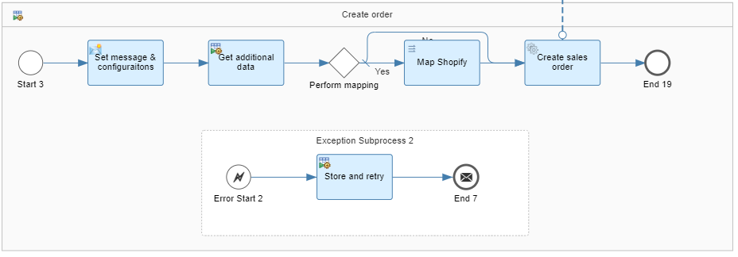

Shopify to SAP S4HANA Cloud Customer

SAP S/4HANA Data Mapping Configuration

The integration flow harnesses Shopify data to accurately map and convert customers into SAP S/4HANA business partners. The following externalized configuration parameters can be customized to define the creation of the business partners in the target system:
Externalized Parameter Name | Sample Value
Prop_APARToleranceGroup | ZXXX
Prop_BPIdentificationType | XXXX
Prop_BusinessPartnerCategory | 1
Prop_BusinessPartnerGrouping | Z1
Prop_BusinessPartnerRole | FLCU00
Prop_CompanyCode | 0000
Prop_CompleteDeliveryIsDefined | true
Prop_CustomerGroup | 0
Prop_CustomerPaymentTerms | XX00
Prop_CustomerTaxCategory | TTX1
Prop_DepartureCountry | XX
Prop_DistributionChannel | 00
Prop_Division | 0
Prop_DunningBlock | X
Prop_DunningProcedure | Z00X
Prop_IncotermsClassification | DDP
Prop_IncotermsVersion | 0000
Prop_OrderCombinationIsAllowed | false
Prop_PartialDeliveryIsAllowed | C
Prop_PartnerFunction | XX
Prop_PaymentMethodsList | X
Prop_PaymentTerms | XXXX
Prop_PriceListType | 00
Prop_ReconciliationAccount | 10000000
Prop_SalesOrganization | 0000
Prop_ShippingCondition | 1
Prop_CarrierPartner | 1000000

Integration Flow Configuration
This section details the technical setup of the integration flow, including its extensibility features. We have externalized a set of parameters for flexible configuration as follows:

Externalized Parameter Name | Sample Value
Custom_Mapping_BusinessPartner | false
Custom_Update_BusinessPartner | false
ApplicationID | /order/customer/id
MessageType | BusinessPartner
Sender | Shopify
CPI_Custom_Mapping_Endpoint | /mapBPForShopify
CPI_Customer_URL | /Shopify/Customer
CPI_Update_BusinessPartner_Endpoint | /updateBPForShopify
S4HANA_HOST | https://S4HANAHOST
S4HANA_Certificate | certificate

In the integration flow configuration, we offer the capability to extend business partner data updates and customize the mapping process for business partner creation. This flexibility allows for tailored adaptations to specific business needs, ensuring seamless integration and accurate data handling.

Extension capability

Prior to business partner creation, an extension/pre-exit feature is provided. This facilitates the acquisition of extra data and allows for the execution of complex mapping should the standard mapping prove inadequate.
In case the business partner already exists when verifying the emailadress as a unique identifier, an extension/pre-exit feature is provided to support the update functionality. This facilitates the acquisition of extra data and allows for the execution of complex mapping for the update of business partner data.
