Filter:
A Filter step is used to retrieve a part of the message. After the filter steps, only the retrieved data is available on the pipeline. The rest of the message is lost.

Configuring the Aggregator:
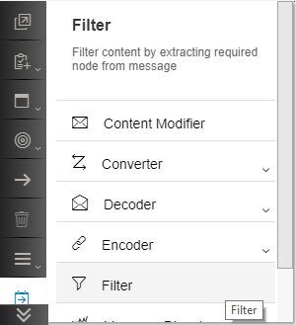
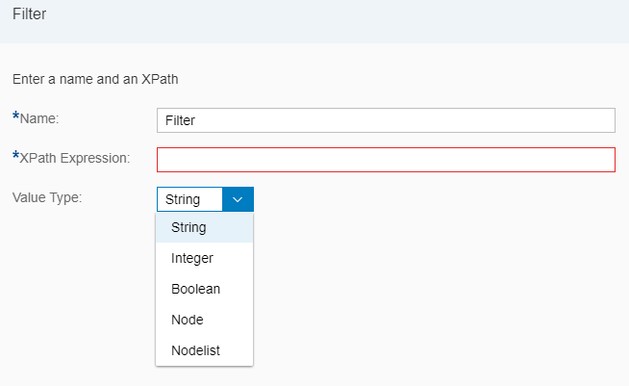

Name: A name to identify the filter – it can be any alpha-numeric name.
XPath Expression: is the XPath of the data that you need to filter out.
Value Type: the type of data you want to retrive from the message.
Consider the following message:
<Students>
<Student>
<Id>1</Id>
<Name>Amit</Name>
<Class>10</Class>
</Student>
<Student>
<Id>10</Id>
<Name>Rahul</Name>
<Class>11</Class>
</Student>
<Student>
<Id>2</Id>
<Name>Varun</Name>
<Class>10</Class>
</Student>
<Student>
<Id>3</Id>
<Name>Vijay</Name>
<Class>4</Class>
</Student>
<Student>
<Id>4</Id>
<Name>Raj</Name>
<Class>12</Class>
</Student>
<Student>
<Id>5</Id>
<Name>Arjun</Name>
<Class>9</Class>
</Student>
<Student>
<Id>6</Id>
<Name>Aditya</Name>
<Class>5</Class>
</Student>
<Student>
<Id>7</Id>
<Name>Arun</Name>
<Class>11</Class>
</Student>
<Student>
<Id>8</Id>
<Name>Naveen</Name>
<Class>1</Class>
</Student>
<Student>
<Id>9</Id>
<Name>Akhil</Name>
<Class>7</Class>
</Student>
</Students>

XPath Expression | Value Type | Output
/Students/Student/Class | Node | <Class>10</Class>
/Students/Student/Id | String | 1
/Students/Student[Id=1] | Node | <Student>  <Id>1</Id>  <Name>Amit</Name>  <Class>10</Class>  </Student>
/Students [Student/Id=1] | Node | <Students>  <Student>  <Id>1</Id>  <Name>Amit</Name>  <Class>10</Class>  </Student>  </Students>
/Students/Student/Id | Nodelist | <Id>1</Id><Id>10</Id><Id>2</Id><Id>3</Id><Id>4</Id>  <Id>5</Id><Id>6</Id><Id>7</Id><Id>8</Id><Id>9</Id>
/Students/Student | Nodelist | <Student>  <Id>1</Id>  <Name>Amit</Name>  <Class>10</Class>  </Student><Student>  <Id>10</Id>  <Name>Rahul</Name>  <Class>11</Class>  </Student><Student>  <Id>2</Id>  <Name>Varun</Name>  <Class>10</Class>  </Student><Student>  <Id>3</Id>  <Name>Vijay</Name>  <Class>4</Class>  </Student><Student>  <Id>4</Id>  <Name>Raj</Name>  <Class>12</Class>  </Student><Student>  <Id>5</Id>  <Name>Arjun</Name>  <Class>9</Class>  </Student><Student>  <Id>6</Id>  <Name>Aditya</Name>  <Class>5</Class>  </Student><Student>  <Id>7</Id>  <Name>Arun</Name>  <Class>11</Class>  </Student><Student>  <Id>8</Id>  <Name>Naveen</Name>  <Class>1</Class>  </Student><Student>  <Id>9</Id>  <Name>Akhil</Name>  <Class>7</Class>  </Student>

Working Integration Flows can be found at:
WebUI Discover View Cloud Integration - Exemplars Artifacts Filter

