SAP Document and Reporting Compliance for Baiwang Cloud:
Setting Up SAP Cloud Integration

You use SAP Cloud Integration to establish the communication with the application service provider Baiwang and transfer to them the electronic tax invoices in XML format you have created in Golden Tax Integration solution. This document lists the required setup steps you must perform in your SAP S/4HANA Cloud tenant and SAP Cloud Integration tenant so that the integration between the systems works. The setup steps are typically done by an SAP Cloud Integration consulting team, which is responsible for configuring the connection with SAP Cloud Integration. This team may be also responsible for maintaining the integration content and certificates/credentials on the SAP Cloud Integration tenant.

1. Prerequisites

1.1 Register with Baiwang
Register with Baiwang to use their APIs to communicate with the Golden Tax Service. You can register with Baiwang on their website at http:/www.baiwang.com/

1.2 Set Up SAP Cloud Integration Tenants
Ensure that your SAP Cloud Integration test and production tenants are live, and users in the tenants have the rights to copy the integration package and to configure and deploy the integration flows (iFlows). When your tenants are provisioned, you receive an email with a Tenant Management (TMN) URL. You need this URL when configuring on your SAP S/4HANA Cloud tenant the communication with the SAP Cloud Integration tenant. To be able to deploy the security content you must be assigned the AuthGroup.Administrator role. If you are a first-time user, you must first set up your users (members) and their authorizations in the SAP Cloud cockpit.

2. Configuration Steps in SAP Cloud Integration

2.1 Deploy Security Materials

When attempting to communicate with Baiwang, you go through an authentication step in which Baiwang asks for some security materials. You must configure these security materials in your SAP Cloud Integration tenant.

Required User Credentials

The required user credentials are as follows:
Name | Description
BaiWang_<tax id>_Credentials | 百望账户用户名和密码

Procedure

To configure the above credentials, follow the steps below:

1. Log into your SAP Cloud Integration tenant.

2. Go to Monitor (Operations view) and open the Security Material app.

3. Click Add on the top right corner of the browser window. Select User Credentials.
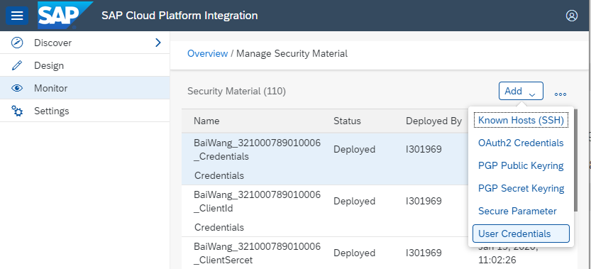

An Add User Credentials dialog box appears.
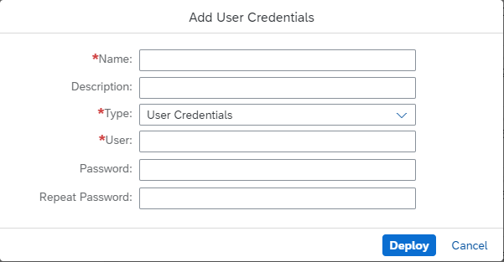

4. Enter BaiWang_<tax id>_Credentials in the Name field. Remember to replace <tax id> with your tax registration number.

5. Enter the value of the username in the User field

6. Enter the value of the password in the Password field and repeat it in the Repeat Password field.

7. Choose Deploy.

Required Secure Parameter

The required Secure Parameter are as follows:
Name | Description
BaiWang_<tax id>_ClientId | 百望账户APP-key
BaiWang_<tax id>_ClientSercet | 百望账户APP-secret
BaiWang_<tax id>_Salt | 百望账户的用户盐值

Procedure

To configure the above credentials, follow the steps below:

1. Log into your SAP Cloud Integration tenant.

2. Go to Monitor (Operations view) and open the Security Material app.

3. Click Add on the top right corner of the browser window. Select User Credentials.
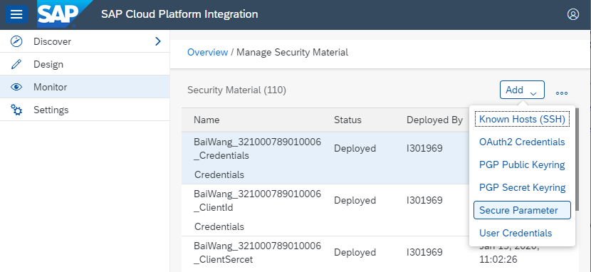

An Add Secure Parameterdialog box appears.
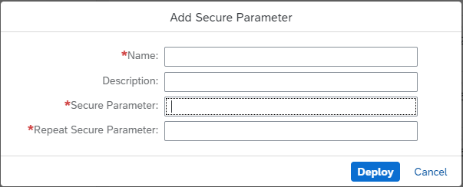

4. Enter BaiWang_<tax id>_ClientId in the Name field. Remember to replace <tax id> with your tax registration number.

5. Enter the value of the credential in the Secure Parameter field and repeat it in the Repeat Secure Parameter field.

6. Choose Deploy.

7. Configure BaiWang_<tax id>_ClientSercet and BaiWang_<tax id>_Salt in the same way.

2.2 Copy Published Package

Procedure

1. In the Discover section of your tenant, select the package SAP Document Compliance: Electronic Invoicing for China Baiwang.
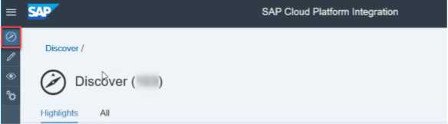

2. Select the package and choose Copy.
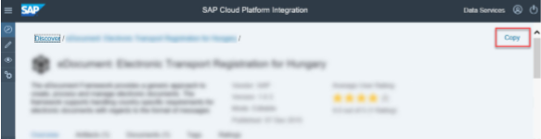

2.3 Configure hard code value to be sent to Baiwang(Optional)
Before our application sends data to Baiwang side, you can configure to replace some value quickly. It is an optional step. If there is no such needed, you can omit this section.

Config the value to be sent to Baiwang.
Open “Baiwang Customized Properties Mapping” and click “Edit”
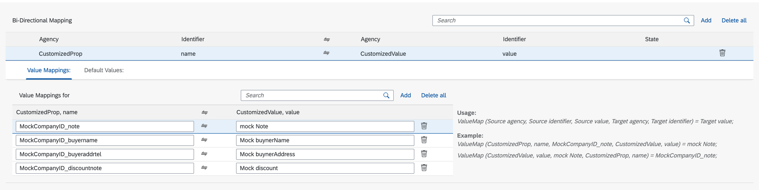

There are few samples. You can remove them and add yours. Maintain mappings from buyerCompanyId_attributeNameToBeReplaced to the final value. After configuration, click save button.

Utilize the hard code configured in mapping
Open iflow “Baiwang Customized Send InvoicePayload”. Click “Edit.”

Open the groovy “Replace HardCode Values”. In the “processData” method, you can add your case or modify the mock to your own by putting your buyer company id as case condition.
Then you can follow the mock log to implement.
- dynamicValueMap(String sAgency, String sSchema, String tAgency, String tSchema, String key) It is responsible for reading value from value mapping.
- changeItemContentWithFixdValue(String attribute, String value, Node rootNode, Message message) It is responsible for replacing value of item attributes.
- changeHeaderContentWithFixdValue(String attribute, String value, Node rootNode, Message message) It is responsible for replacing value of header attributes.

2.4 Deploy Integration Flows

Required steps for configuring the Integration Package and SAP Cloud Integration.

Context

The following integration flows are available:
Integration Flow | Functions
Baiwang Send Tax Invoice | Read invoice request from data store and send to Baiwang Open Platform
Baiwang Query Tax Invoice | Query status of each invoice
Baiwang Invoice Generic Outgoing Receiver | Receive invoice request and send to data store or directly to Baiwang based on sync mode
Baiwang Customized Tax Invoice | Support customer to replace some hardcode value before payload sent to Baiwang
Baiwang Customized Properties Mapping | Record customized value to be used in replacement

Procedure

1. Open the integration package that you copied.

2. Select the Artifacts tab.

3. Select an integration flow. Choose the Actions icon and then Configure.
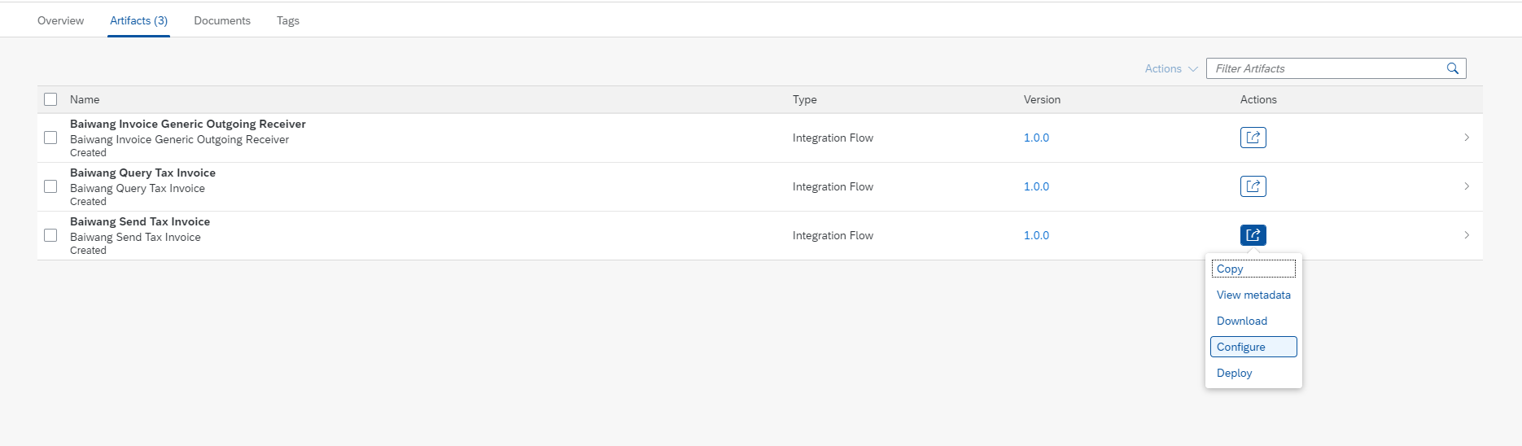

4. Configure the parameters of the integration flow.

5. Choose Deploy.

6. Configure the other integration flows that you want to use. For information on how to configure the parameters of each integration flow, see Parameter Information

2.5 Parameter Information

Learn how you should configure the parameters of each integration flow. The following table explains all the parameters that you should configure and the integration flow that each parameter is relevant to:
Parameter | Integration Flow | Explanation
logEnabled | All integration flows | Default: X, to enable detailed log in monitor
grantType | All integration flows except Baiwang Invoice Generic Outgoing Receiver | Default: password
testMode | All integration flows except Baiwang Invoice Generic Outgoing Receiver | Default: X, connecting to Baiwang Sandbox Env.  Null, connecting to Baiwang Prod Env
Company | Baiwang Send Tax Invoice | Default: Null, used as a prefix in invoice serial no. Displayed in Baiwang platform
Default Push Email | Baiwang Send Tax Invoice | Default email address when no address found in payload, used for receiving e-invoice(PDF/OFD)
Fully Digitalized Invoice Enabled | Baiwang Send Tax Invoice | Default: Null  X, enable fully digitalized invoice
Length of Decimal | Baiwang Send Tax Invoice | Default: 8. The length of decimal used for calculating unit price
Replace BuyerInfo Enabled | Baiwang Send Tax Invoice | Default: Null, read buyer’s info from payload.  X, If required the name/address/bankinfo be fulfilled automatically via Baiwang Cloud
Replace ItemInfo Enabled | Baiwang Send Tax Invoice | Default: Null, use default commodity code  X, use customized commodity code and product information which need to be firstly maintained in Baiwang
version | All integration flows except Baiwang Invoice Generic Outgoing Receiver | Default: 3.0, current Baiwang API version
Start Timer | Baiwang Send Tax Invoice | Default: run per 1mins. Configurable due to requirement
Pre-open Enabled | Baiwang Send Tax Invoice | Default: Null, send invoices to Baiwang invoice opening interface.  X, send invoices to Baiwang invoice pre-issue interface, customer can check the invoice before opening

3. Configuration Steps in SAP S/4HANA Cloud

Required steps on your SAP S/4HANA Cloud tenant.

3.1 Create Communication Configurations
Create the required communication configurations on your SAP S/4HANA Cloud tenant.

Prerequisites
You have a business role that contains the Communication Management (SAP_BCR_CORE_COM) business catalog.

Context
Your SAP Cloud Integration tenant acts as a bridge between your SAP S/4HANA Cloud tenant and Baiwang Platform. SAP S/4HANA Cloud sends tax invoice XML files to SAP Cloud Integration. Then SAP Cloud Integration forwards XML files to Baiwang Platform. SAP Cloud Integration also forwards validation statuses of XML files back to SAP S/4HANA Cloud. To set up the communication between SAP S/4HANA Cloud and SAP Cloud Integration, do the following:
● Create a communication system that represents your SAP Cloud Integration tenant
● Create a communication arrangement that describes the communication between your SAP S/4HANA Cloud tenant and SAP Cloud Integration tenant

Procedure
1. Log into SAP Fiori launchpad.
2. Open the Communication Systems app. Choose New at the bottom right corner of the browser window. A New Communication System dialog box appears.
3. Create a system ID and give it a descriptive name. For example, if the host name of your SAP Cloud Integration tenant is v0347-tmn.avt.eu1.hana.ondemand.com, use GTI_V1234 as the system ID.
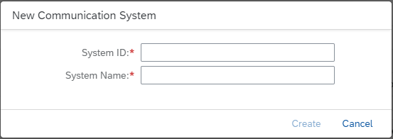
4. Choose Create. An editing screen for the communication system appears.
5. In the Technical Data section, enter the host name and HTTPS port of your SAP Cloud Integration tenant. You can find the host name from the SAP Cloud Integration Web UI.
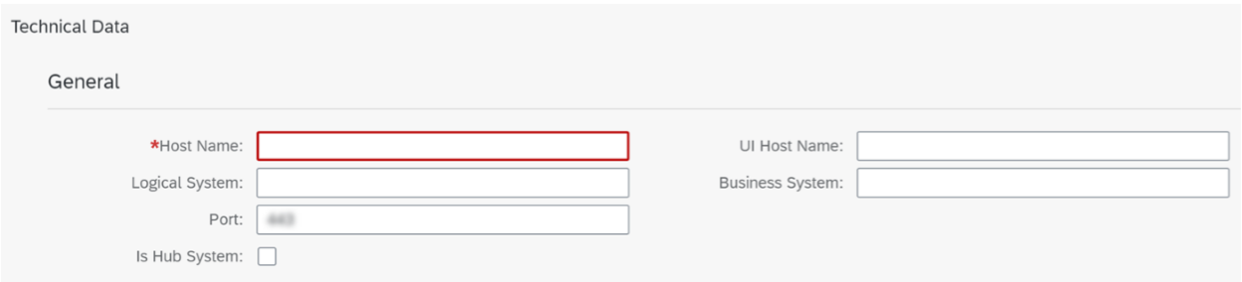
6. In the User for Outbound Communication section, configure an outbound user, as follows:
a. Choose + (Add).
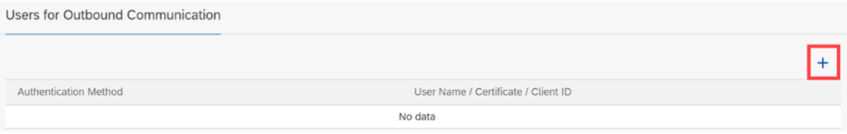
A New Outbound User dialog box appears.
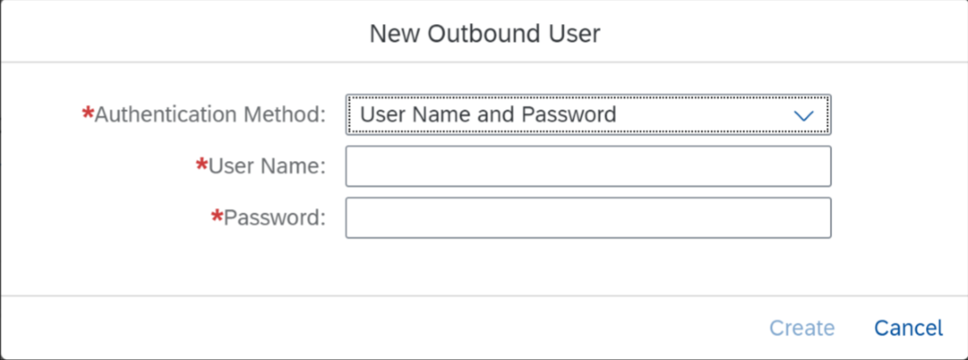
b. Select the User Name and Password authentication method.
c. Enter the name and password of your SAP Cloud Integration tenant user that allows communicating with SAP S/4HANA Cloud.
d. Choose Create.
7. Save the communication system. Don't exit SAP Fiori launchpad.
8. Open the Communication Arrangements app. Choose New at the bottom right corner of the browser window. A New Communication Arrangement dialog box appears.
Enter scenario SAP_COM_0577 and an arrangement name.
For example, if the host name of your SAP Cloud Integration tenant is v0347-tmn.avt.eu1.hana.ondemand.com, use SAP_COM_0468_V0347 as the communication arrangement name.
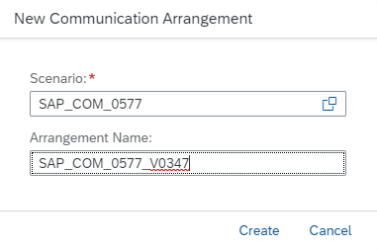
10.Choose Create. An editing screen for the communication arrangement appears.
11. In the Communication System field, enter the communication system that you created earlier. In the Outbound Communication section, the system displays the outbound user that you defined when creating the communication system automatically.
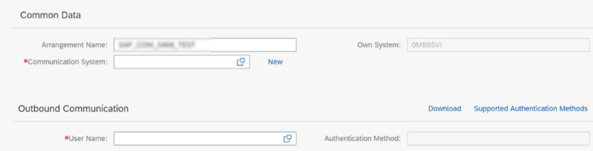
12.In the Outbound Services section, activate the following services by selecting their Active checkboxes and enter the paths provided below:
Outbound Service | Functions | Path
China GTI Invoice Issuing REST API | Send tax request to Baiwang Platform | /http/china/v1/baiwang/sendinvoice
China GTI Invoice Query REST API | Query tax request from Baiwang Platform | /http/china/v1/baiwang/queryinvoice

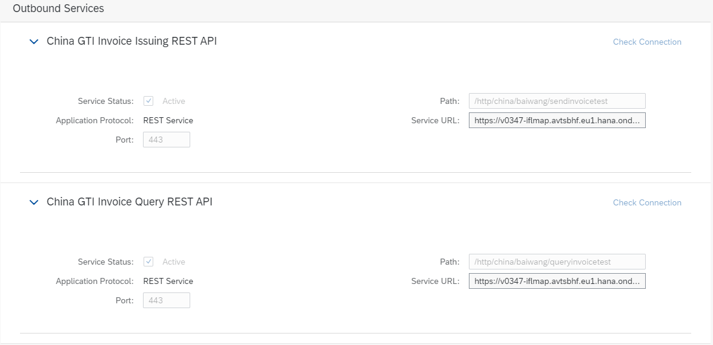
13. Save your communication arrangement.

4. Configurations in SAP S/4HANA and ECC

4.1 Proceed the following configurations in SAP S4/HANA or ECC

- You make the following settings in Customizing for Sales and Distribution, under Billing -> Billing Documents -> Country/Region-Specific Features -> Country-Specific Features for China.
- Define GTI Tax Invoice Keys
Create a new entry with file type “Baiwang Online Integration”. You can also change the file type of an existing entry.
- Configure Tax Entities and Terminals
  - Create a new entry with entity type “Legal Taxpayer”, enter the unified social credit code and issuer name.
  - Choose the created entry and go to Terminal Configuration.
  - Enter the terminal ID and terminal description. You can find the terminal ID in Baiwang platform.
- Run transaction code SM59 to create two RFC destinations.
  - Choose Create.
  - Enter the destination for sending data to Baiwang platform, for example, Z_CONN_GTI_SENDINVOICE and choose the connection type “G HTTP connection to external server”.
  - Choose Continue and go to the Target System Settings under Technical Settings tab. (The screenshot below is for reference only)
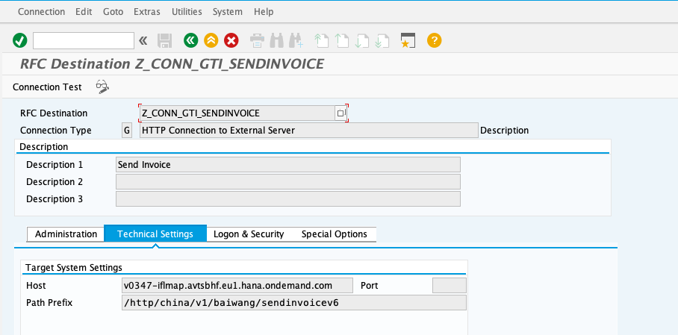
  - Enter the host name and HTTPS port of your SAP Cloud Integration tenant. You can find the host name from the SAP Cloud Integration Web UI.
  - Enter the path prefix “/http/china/v1/baiwang/sendinvoice”.
  - Switch to the Logon & Security tab and maintain the authentication method. (The screenshot below is for reference only)
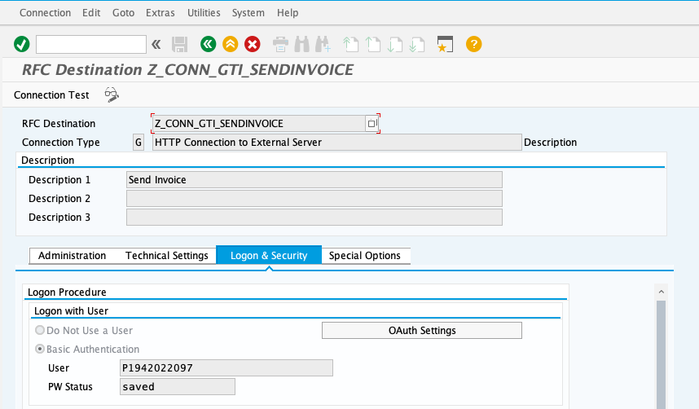
  - Save.
  - Repeat the above steps to create the other destination for querying golden tax invoices from Baiwang platform, for example, Z_CONN_GTI_QUERYINVOICE. The path prefix is “/http/china/v1/baiwang/queryinvoice”. (The screenshot below is for reference only)
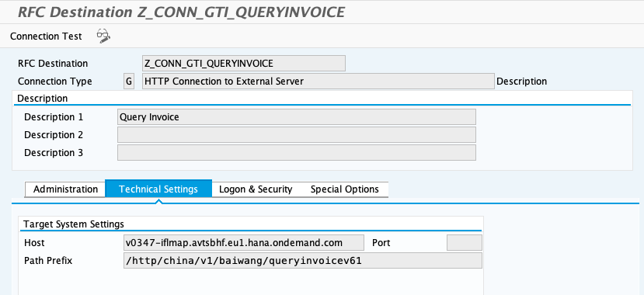
- Run transaction code SM30 to create two new entries in view EIV_CONF_CONN_V, with the following information.
- Set your unified social credit code and terminal ID as primary keys.
- Choose “HTTP” as access mode.
- Choose the call methods and enter the corresponding RFC destinations.
  - Choose “Fetch Invoice API (Baiwang CPI)” as the call method of the RFC destination Z_CONN_GTI_QUERYINVOICE.
  - Choose “Issue Invoice API (Baiwang CPI)” as the call method of the RFC destination Z_CONN_GTI_SENDINVOICE.
See below screenshot as an example:
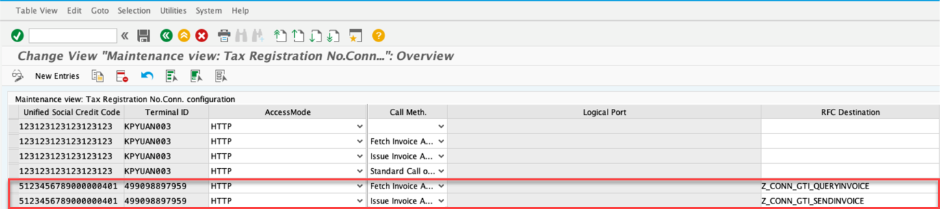

5. Test the Integration

Test the communication between SAP S/4HANA Cloud, SAP Cloud Integration and Baiwang Could Client using your test tenants. The Configure the Creation of Electronic Tax Invoices in XML Format [page 5] topic of this guide describes how to find the documentation about the required configurations and business processes. To test the integration, send and cancel tax invoices as described in the following topics in this documentation:

● Creating and Sending a Tax Invoice in XML Format

● Canceling a Tax Invoice in XML Format

● Query Tax Invoice Status in XML Format

5.1 Re-deploy Iflow

Procedure

To re-deploay the iflows, follow the steps below:

1. Log into your SAP Cloud Integration tenant.

2. Go to Monitor (Operations view) and open the Manage Integration Content app, click on “All”.

3. Search the iflow that need to be re-deploay, click undeploy button.
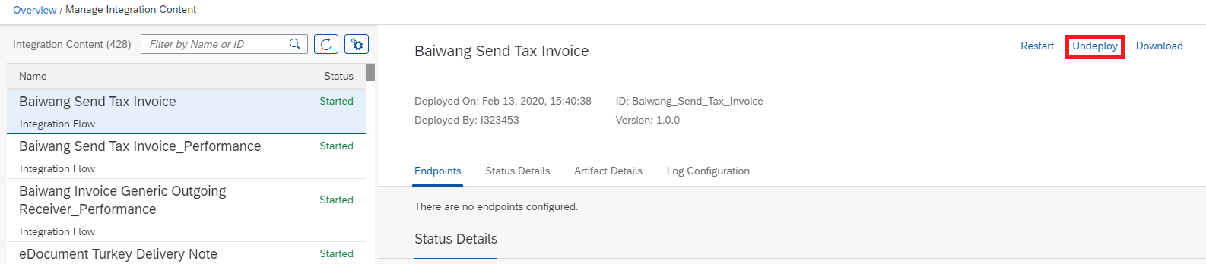

4.Deploy the iflow again following 2.3

5.2 Check Monitor Log

To check the monitor log of each integration flow, follow the steps below:

1. Log into your SAP Cloud Integration tenant.

2. Go to Monitor (Operations view) and open the Manage Integration Content app.

3. Find related integration flow on the left list of the browser window.
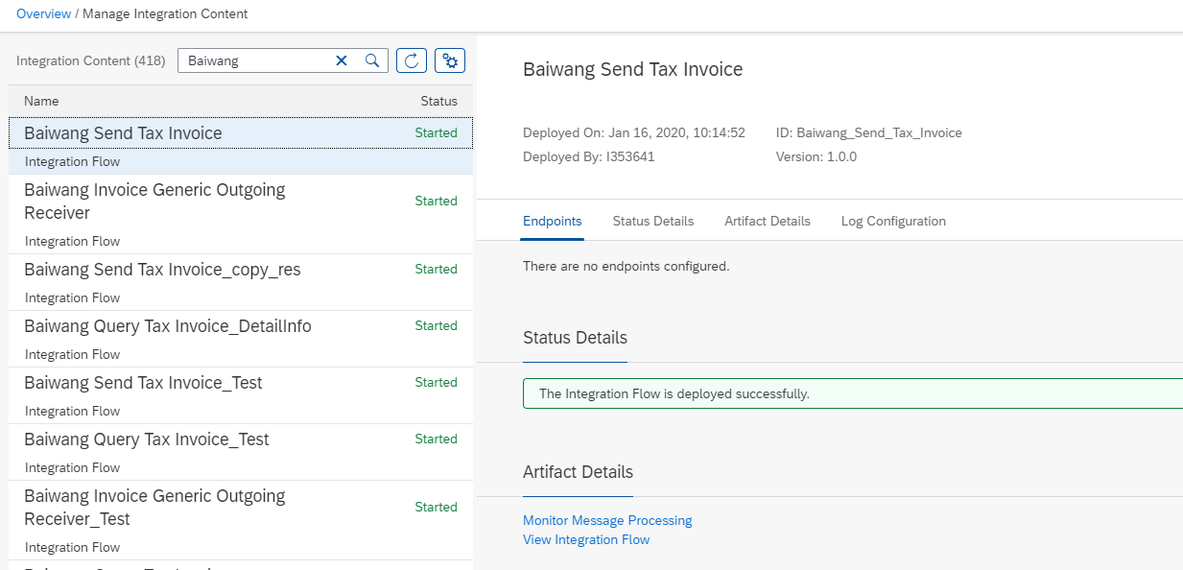

4. Click Monitor Message Process, find the record according to running time.

5. If logEnalbe is active, log will be recorded in Attachments
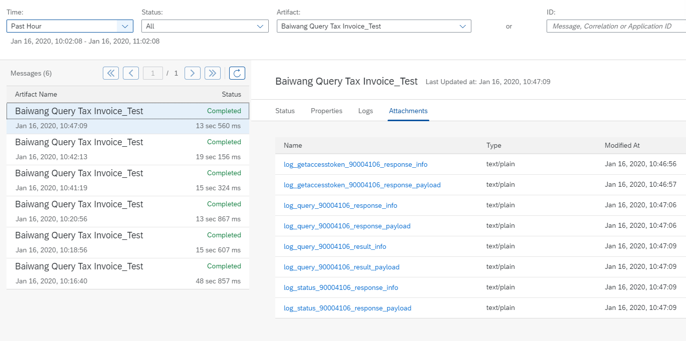

Log Type

1. log_getaccesstoken_<gtdnmbr>_response_info
log_getaccesstoken_<gtdnmbr>_response_payload
List all headers, properties and response body after calling get accesstoken API
2. log_query_<gtdnmbr>_response_info
log_query_<gtdnmbr>_response_payload
List all headers, properties and response body after calling query API
3. log_status_<gtdnmbr>_response_info
log_status _<gtdnmbr>_response_payload
List all headers, properties and response body after calling status API
4. log_query_<gtdnmbr>_result_info
log_query_<gtdnmbr>_result_payload
List all headers, properties and response body after generating final response of Baiwang Query Tax Invoice
5. log_open_<gtdnmbr>_request_info
log_open_<gtdnmbr>_request_ payload
List all headers, properties and request body before calling issue API
6. log_open_<gtdnmbr>_response_info
log_open_<gtdnmbr>_response_ payload
List all headers, properties and response body after calling issue API
7. log_cancel_<invccode>_<invcnmbr>_request_info
log_cancel_<invccode>_<invcnmbr>_request_payload
List all headers, properties and response body before calling cancel API
8. log_cancel_<invccode>_<invcnmbr>_response_info
log_cancel_<invccode>_<invcnmbr>_response_payload
List all headers, properties and response body after calling cancel API

5.3 Check Data Store

Procedure

To re-deploay the iflows, follow the steps below:

1. Log into your SAP Cloud Integration tenant.

2. Go to Monitor (Operations view) and open the Data Store app.

3. Search the data store that need to check.

4. Select one data entry and click download.
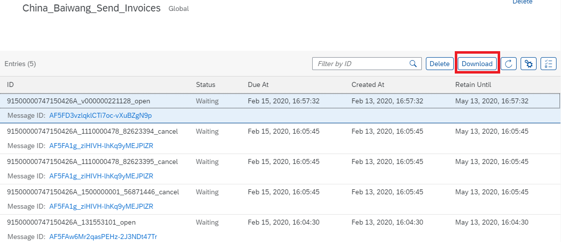

Currently there are two data store entries:

China_Baiwang_Send_Invoices, storing open or cancel request in below format

<taxno>_<invccode>_<invcnmbr>_cancel

<taxno>_<gtdnmbr>_open

The data entries will be deleted once handled by Baiwang Send Tax Inovice iflow

China_Baiwang_Send_Invoices_Error, storing error message in below format

<taxno>_<invccode>_<invcnmbr>_cancel_errormessage

<taxno>_<gtdnmbr>_open_errormessage
The data entries will be deleted once handled by Baiwang Query Tax Inovice iflow when query result return successfully operated by Baiwang

5.4 Trace Integration Flow

Procedure

To check each component of integration flow, follow the steps below

1. Log into your SAP Cloud Integration tenant.

2. Go to Monitor (Operations view) and open the Manage Integration Content app, click on “All”.

3. Search the iflow that need to be traced, change Log Configuration – log level from info to trace.
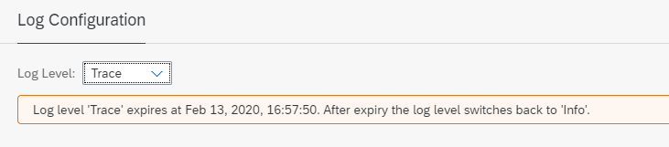

* the trace log level will be only last 10 mins and the iflow trace log will be deleted after 1 hour

4.Re-test the cases and check the monitor log following 4.2, click Trace to enter detailed view.
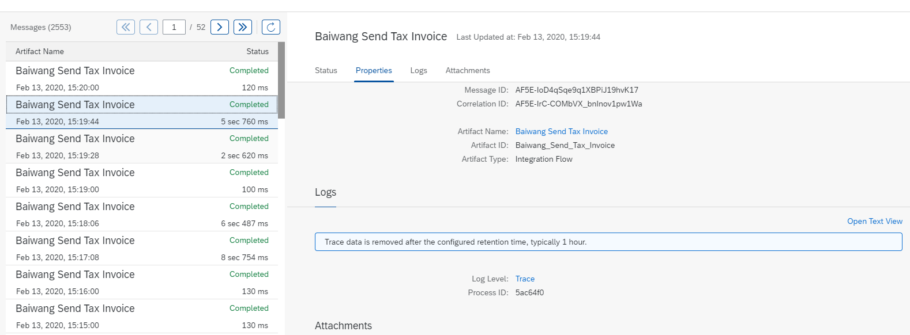

5.In detailed view, click on each component to check the data info and payload via Message Content tab.
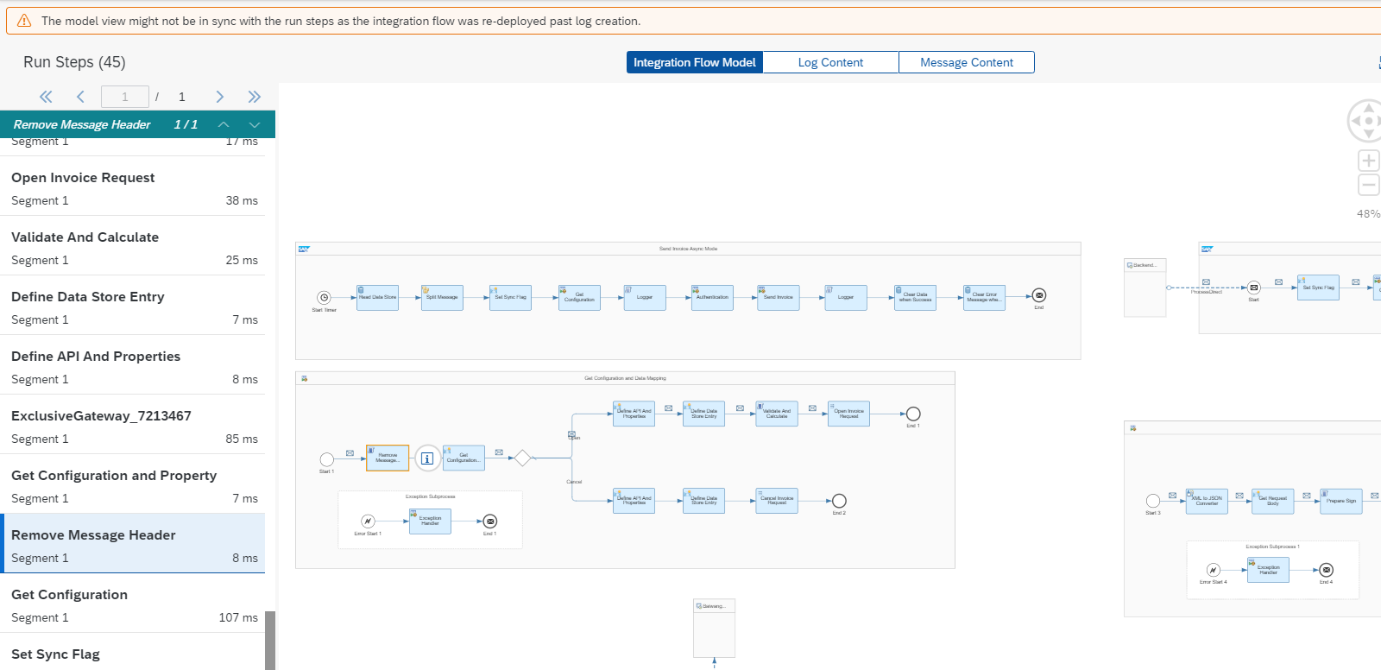

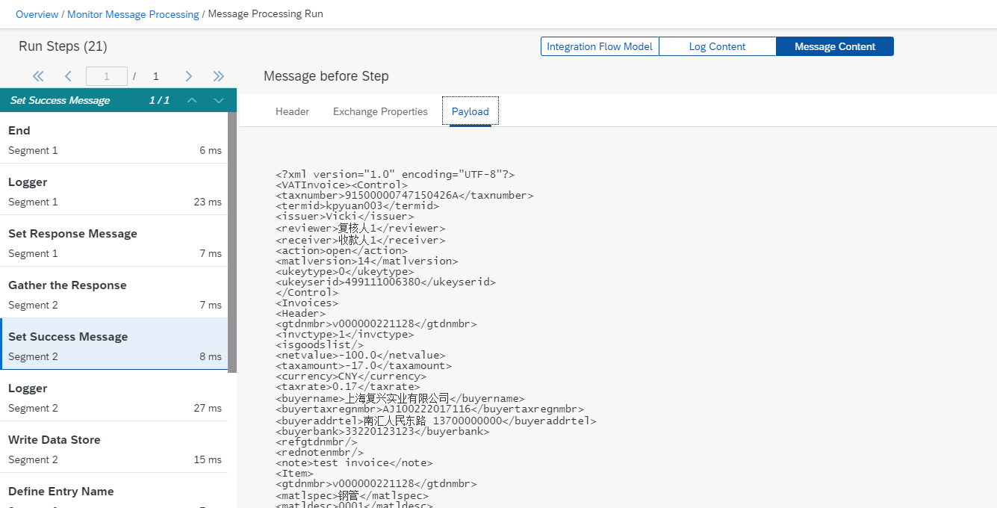

More detail information via https://help.sap.com/viewer/368c481cd6954bdfa5d0435479fd4eaf/Cloud/en-US/a9db4eab676443ec999e8f7f5b760c2e.html

5.5 Retry Mechanism

Retry

If the request doesn’t reach Baiwang Cloud, failed by internet issues, it will keep in data store and retry until next schedule running in Baiwang Send Tax Invoice

Check error

If anything goes wrong in the iflow or API calls, please follow 4.4 and 4.2 to check the detailed message. Also using Baiwang Query Tax Invoice can return the error message stored in data store for checking.

Re-submit

If find the error reason in previous request, please modify the request and re-post to iflow, it will override the existing request in data store and process with the modified request

