Assigning Roles and Authorization to users:
The management of authorization for Cloud Platform Integration happens from the Cloud Platform Cockpit because as the default setting, Cloud Integration uses the Identity Provider of the Cloud Platform. As a result, all the users who need to be added as members must have a valid S-user or a P-user ID.
Goto https://account.hana.ondemand.com/cockpit, login and choose the tenant for which you want to grant authorization.
Now expand Security on the left panel and click on Authorizations:
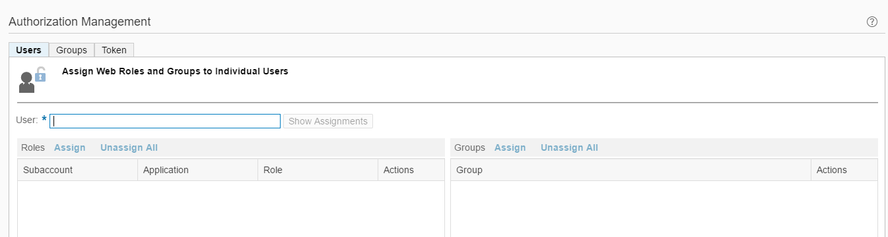
To assign users to your Cloud Platform Integration tenant account navigate to Authorizations.
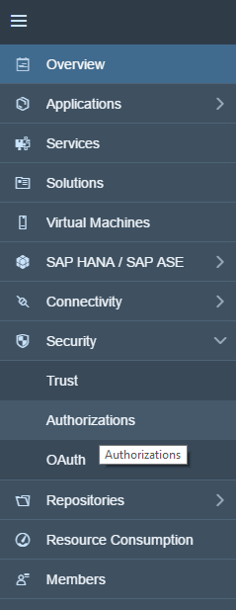

Now enter a value for User and click on Show Assignment. The corresponding assignments shall be listed.
Use Assign and Unassign to add/remove authorizations for the user.
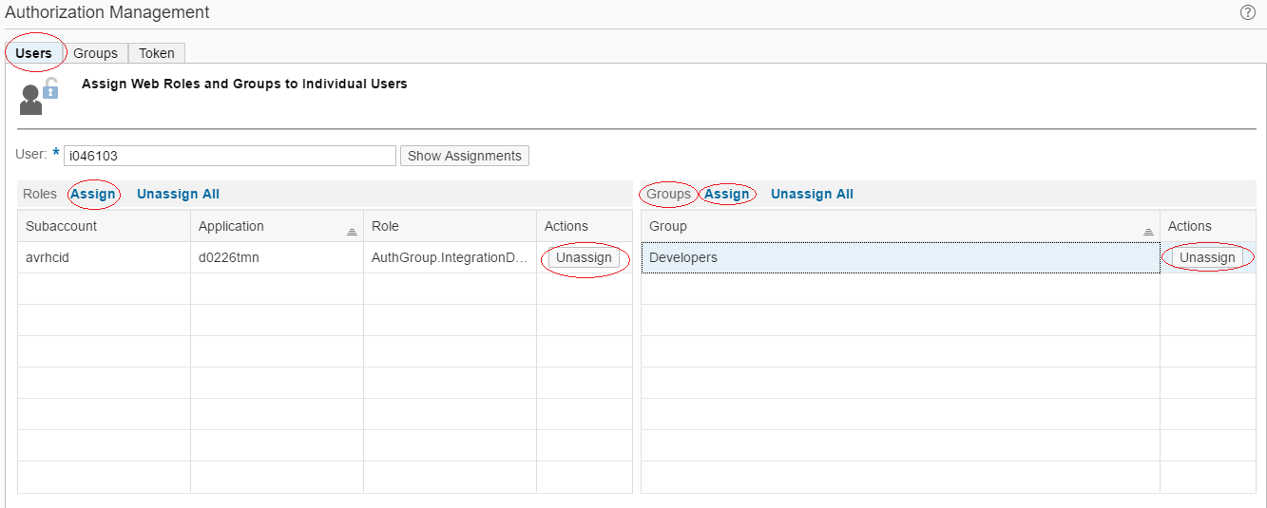
Alternatively, when you need to assign the same set of roles to many users, it is a good idea to create a Group, assign roles to the Group and then assign the Group to the user.
Groups can be managed by using the Group Tab
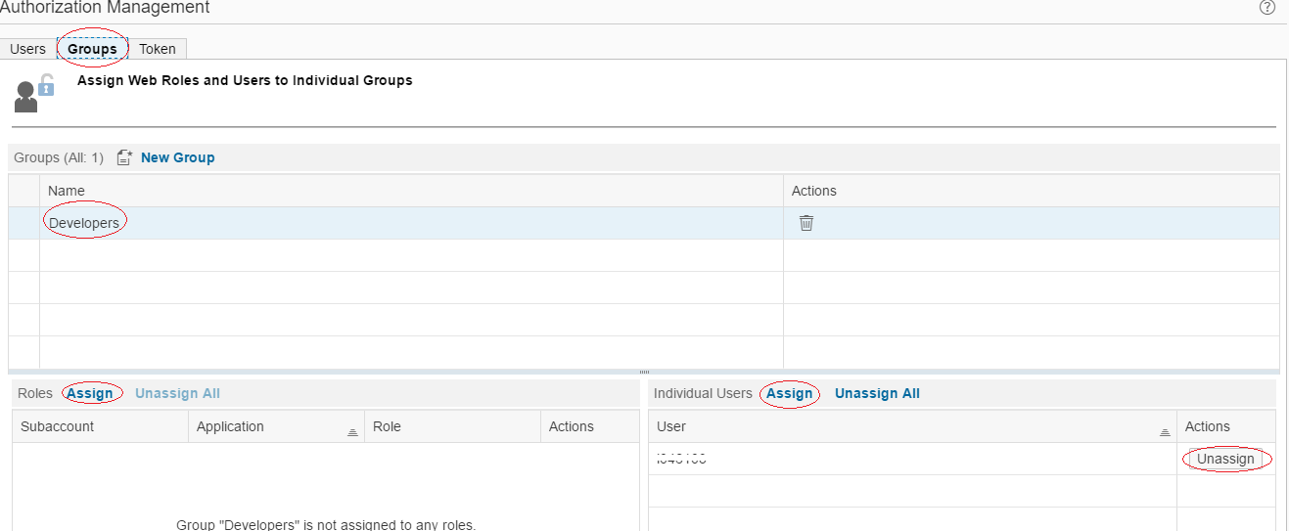
You must add users and authorizations on each of the tenants individually.
Supported list of roles and its usage
Role | Description
AuthGroup.BusinessExpert | Enables a business expert to perform business tasks like, for example, examining the payload. This includes tasks like:  - Monitoring integration flows  - Reading the message payload
AuthGroup.Administrator | Enables the administrator of the tenant cluster (also referred to as the tenant administrator) to connect to a cluster and to perform administrative tasks on the cluster. This includes tasks like:  - Deploying security content (for example, keystores or SSH known hosts artifacts) (Important note: As of today, self-service is supported/allowed only for HCI Developer Edition for partners for non-productive tenantsP4EAD" For all other scenarios, keystores and SSH known host is maintained by SAP Cloud Operations team.). See Security section for more details  - Deploying integration flows  - Cancelling messages  - Monitoring integration flows  - Deleting messages from transient data store
AuthGroup.IntegrationDeveloper | Enables an integration developer to connect to a cluster using Integration Designer and to display, download and deploy artifacts (for example, integration flows). This includes tasks like:  - Monitoring integration flows  - Deploying integration flows  - Deploying security content included in integration flows (for example, keystores or SSH known hosts artifacts)  - Cancelling messages
AuthGroup.ReadOnly | Enables you to connect to a tenant cluster (from customer side) and to display nodes and node properties as well as to monitor messages.
AuthGroup.SystemDeveloper | Enables a system developer to perform tasks required for system support. This includes tasks like:  - Monitoring integration flows  - Restarting subsystems of the tenant cluster  - Software development tasks on VMs of the tenant cluster  Note  System developer tasks are typically required in the support case by SAP experts who are supposed to perform tasks like debugging (for example) on the tenant cluster.

For detailed steps and latest updated documentation on how to assign Roles, see official documentation at https://cloudintegration.hana.ondemand.com/PI/help

