
EXTERNAL
Automated Purchase Order Upload Bot (2R2)
Technical Specification

Table of ContentS
Technical Overview 3
Prerequisites 3
Bot Setup 3
Bot Workflow 4
Output and Logs 4
Software Requirements 4
Constraints 4
Common Errors 5
Security 5
Appendix 5

Technical Overview
The SAP Automated Purchase Order Upload bot is an SAP Business ByDesign product. It scans a folder where purchase order data is maintained in an Excel template and then calls the purchase order creation web service to create purchase orders in the SAP Business ByDesign system. With the template provided, the bot can handle the creation of multiple purchase orders in one run provided that the information is maintained in the Excel template.
The Automated Purchase Order upload bot can be used as a standalone bot as well as in conjunction with other SAP Business ByDesign iRPA Best Practice bots, and is designed to work in conjunction with the following automation processes:
- Business Document Extraction from Email (1x1)

Cloud Edition | On Premise Edition | Attended | Unattended | Screen Scrapping
Yes | No | No | Yes | No

Prerequisites
- Root folder: A folder with arbitrary name must be created anywhere in the local system that will function as the root folder for the automation. This folder must contain the configuration file that is attached to the bot in the iRPA Store. The bot will use this folder to
  - create a log folder where log files will be stored.

If this bot is being used in conjunction with the Business Document Extraction from Email (1x1) bot, you must execute the Business Document Extraction bot before the Automated Purchase Order Upload bot. For the folder structure to be set up properly, please maintain the configuration file for the Business Document Extraction from Email bot as follows:

After the successful execution of the Business Document Extraction from email bot, the system will create a folder with the name “Create Purchase Order from Excel”. In this folder, the following four folders will be created:

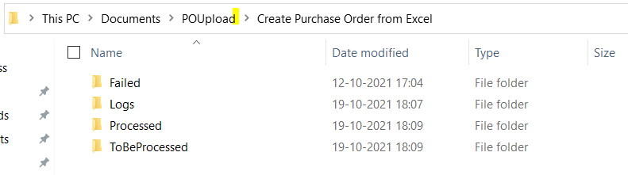

- Communication Scenario: A Communication Scenario and Arrangement for SOAP must be set up before using the Automated Purchase Upload Bot in SAP Business ByDesign. You can find the setup instructions on the SAP Help page for SAP Business ByDesign in Set Up SOAP Web Services in SAP Business ByDesign.

The following APIs are used by the bot:

Service Name | Request | Response | Link | Attachment
Create Purchase Order | Method: POST | Status – 200 | Manage Purchase Order

- Windows Credentials: Communication arrangement credentials must be maintained within the Windows Credential Manager. You can learn more about how to do this in How to Set Up Windows Generic Credentials.

Software Requirements
- iRPA Cloud Studio 2.0.8 or higher.
- iRPA Desktop Agent 2.0.8 or higher.
- Microsoft Excel.

Bot Setup
- Acquire the Automated Purchase Order Upload (2R2) package from the iRPA Store. (iRPA Help)
- Create an environment in the iRPA Cloud Factory. (iRPA Help)
  - Add the Desktop Agent to the environment.
  - Add the bot package to the environment.
  - Create a scheduled trigger for the bot package in the environment. Insert the needed input information in the trigger variables as per the table below.
- Wait for the scheduled trigger or start a bot run immediately by triggering it via the Options menu of the trigger and the “Run Now” option. (“Next Steps” in iRPA Help)
This example video demonstrates how to setup a bot in the Cloud Factory.

Cloud Factory Trigger Variables
The following table provides details on the Cloud Factory trigger variables required for executing the bot.

Variable Name | Type | Sample Value | Description
rootFolderPath | Text | C:\Users\Desktop\RPA | Location where the Create Purchase Order from Excel folder is placed.
bydCredentialEntryName | Text | myCred | Communication arrangement credentials maintained in the Windows Credential Manager. In the field "Internet or network address" you can put a name of your choice for that credential. This name must be entered here for reference.
tenantURL | Text | http://myxxxxxx.sapbydesign.com/ | SAP Business ByDesign Tenant URL

Bot Workflow
For the bot workflow, please refer to the attached flowchart in the Appendix.

Output and Logs
- Root Folder Structure: If one is not using the Automated Business Document Extraction from Emails bot in advance, then one needs to manually create the following folder structure inside the root folder:

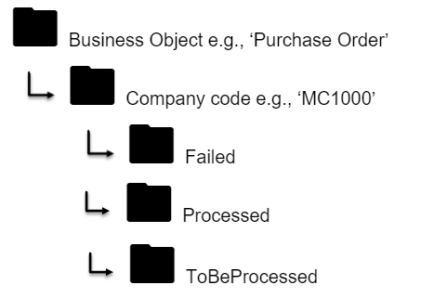

The Purchase Order upload template files should be placed in the ToBeProcessed folder before the bot is run. They will be moved to the Processed folder if the automation on the file was successful, or to the Failed folder if the automation was unsuccessful.
- Logs: If a log file does not already exist, the bot creates a folder named “Logs” inside the root folder. There, the log files of each bot run will be stored.
 Log files should not be opened during the bot execution.

Constraints
- This bot can only work with Microsoft Windows OS.
- All required software must be installed.

Security

Protecting user credentials
In certain configuration scenarios, a technical user is required. In such cases, every natural person needs a separate technical user (for example, a separate communication arrangement).
The user must not share their credentials with any other natural person.

Appendix

Components

Library | Type | Comments
Excel | Read | Used to get input data from the end user.
Excel | Write | Used to write/ create/ modify files during the bot execution.

Flowchart

