Ahgora Platform Time & Attendance Package Installation Document

First go to the SAP cockpit via the https://account.hana.ondemand.com/#/home/welcome link and click Sign In

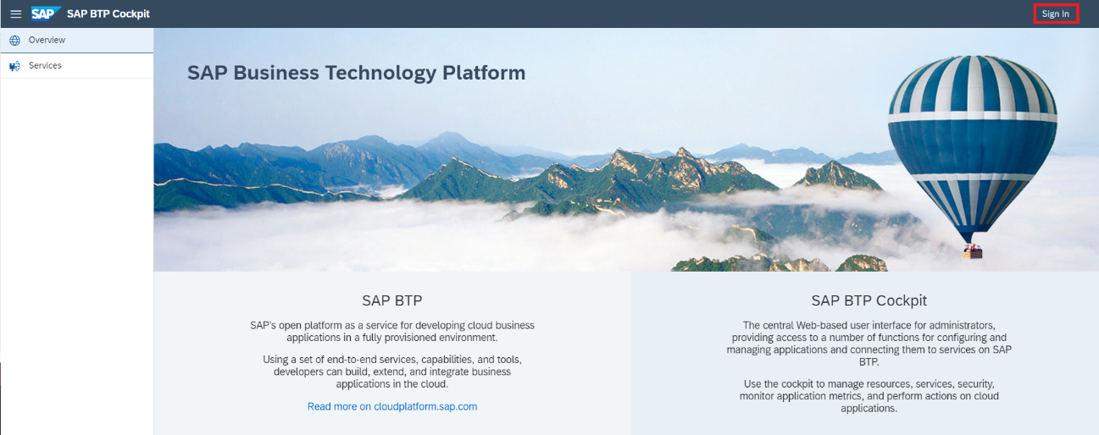

Enter your login credentials and click Log on

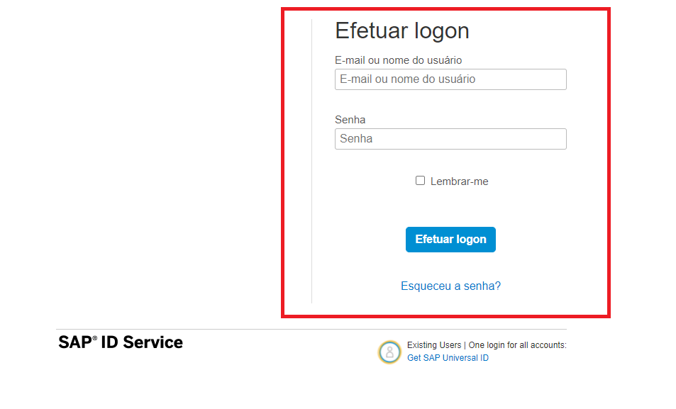

Choose the Global Account where the Integration packages will be

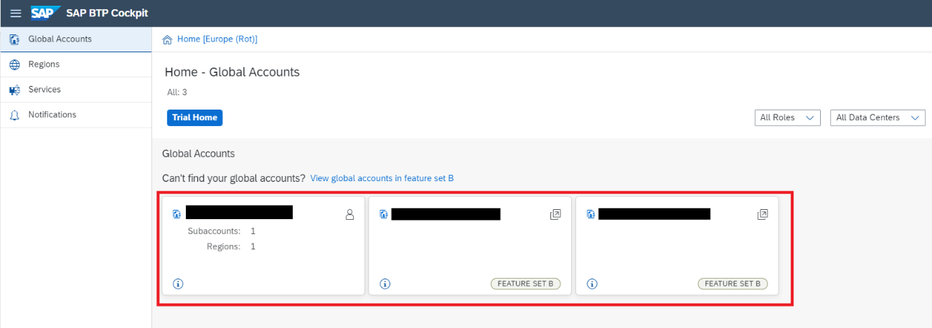

Choose subaccount where the Integration Packages will be

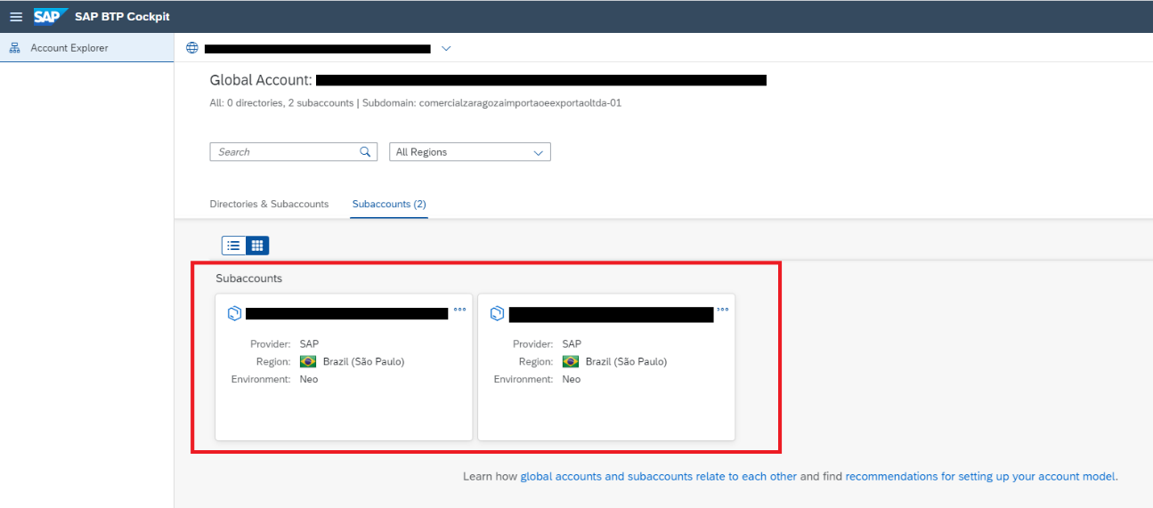

On the left side of the page click Subscriptions

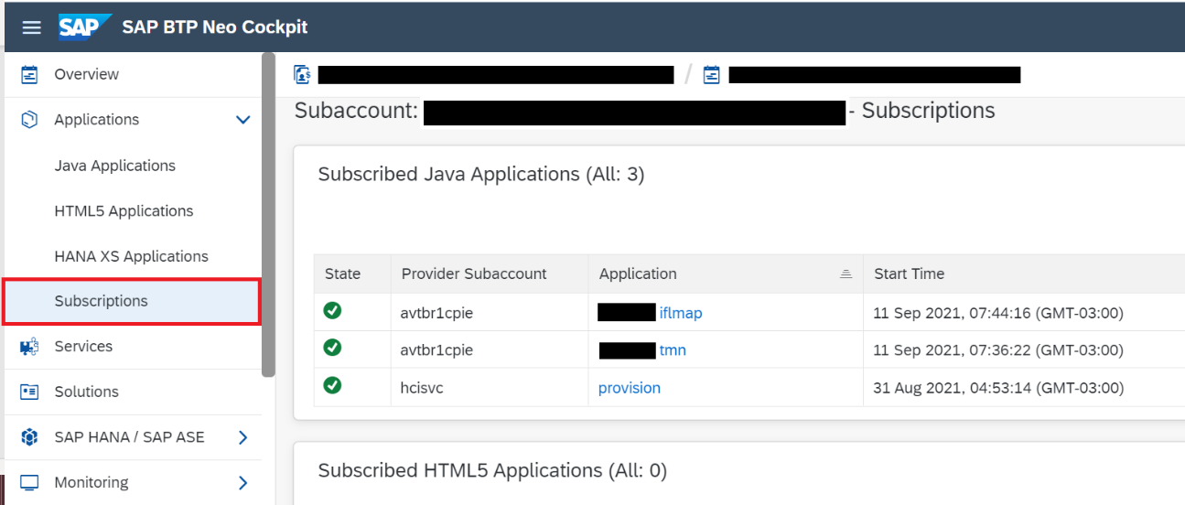

Now click on the application that at the end has "tmn"

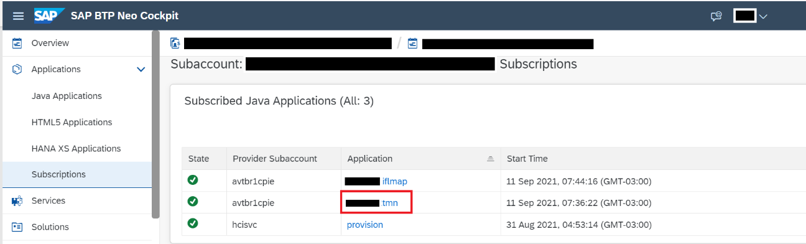

Click the Application URL that has the name “itspaces"

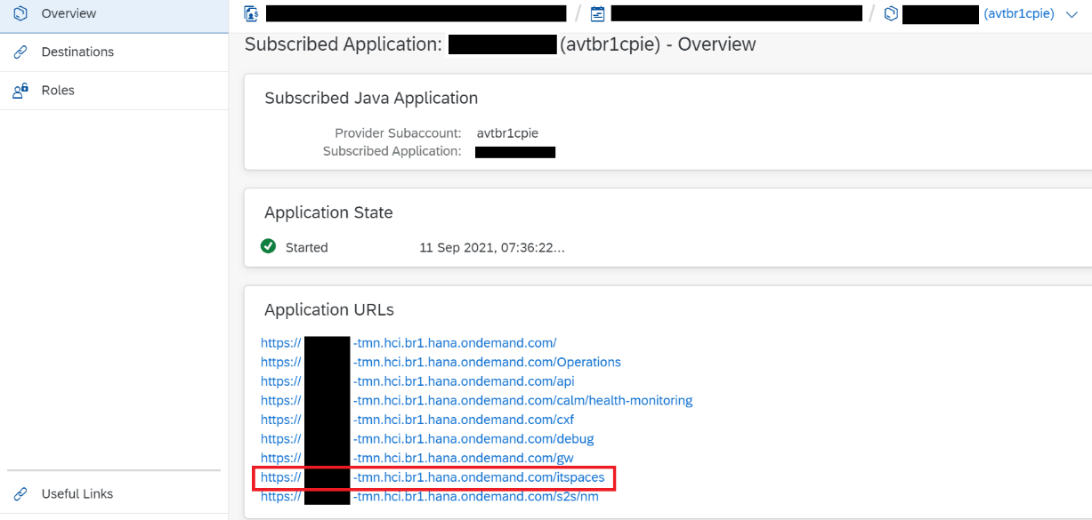

By clicking on the link, you will be directed to the CPI environment

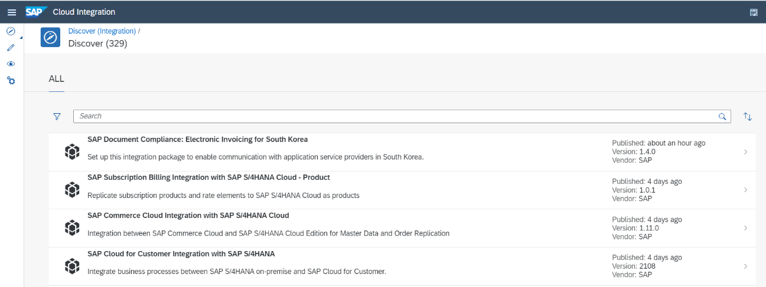

Credentials configuration

We will set up three credentials in the CPI environment where Iflows will be located
AHGORA_CREDENTIAL, SFSF_CREDENTIAL_BASIC and SAPPAYROLL

Click the icon that looks like an eye

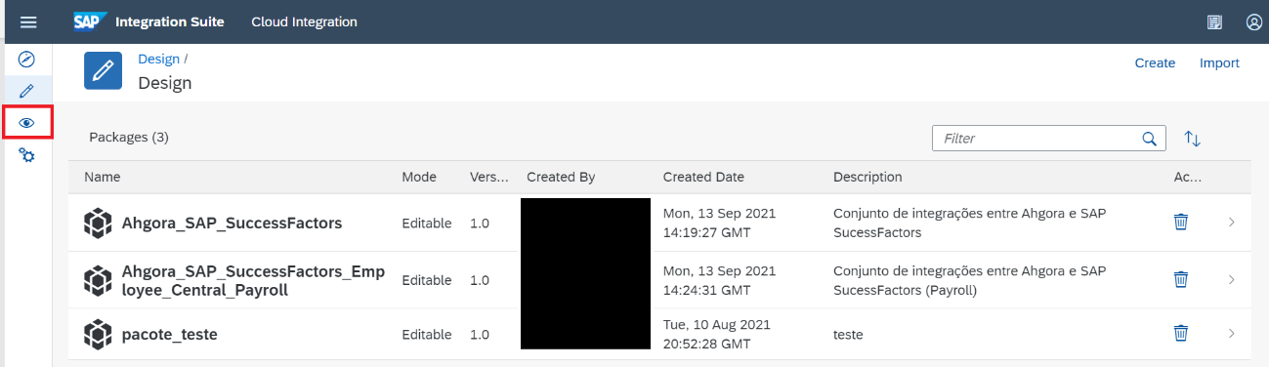

In Manage Security click Security Material

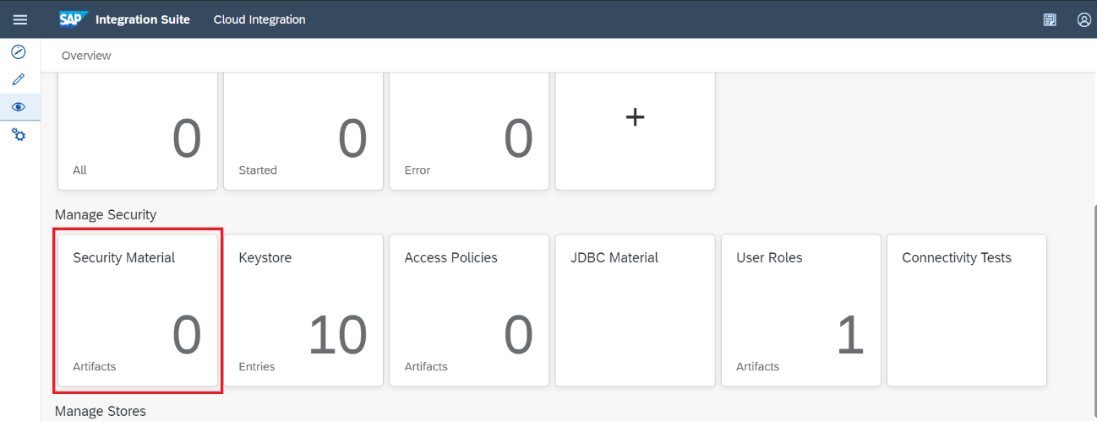

Click Create and User Credentials

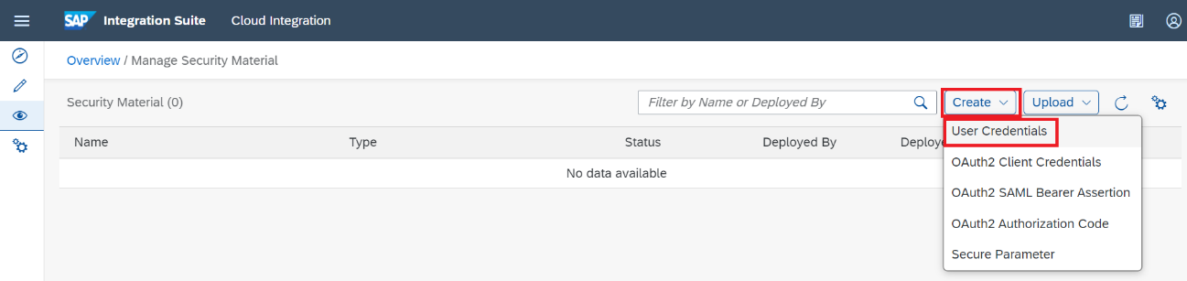

In Name enter AHGORA_CREDENTIAL
In User the user Ahgora
Enter and repeat the password

Click Deploy

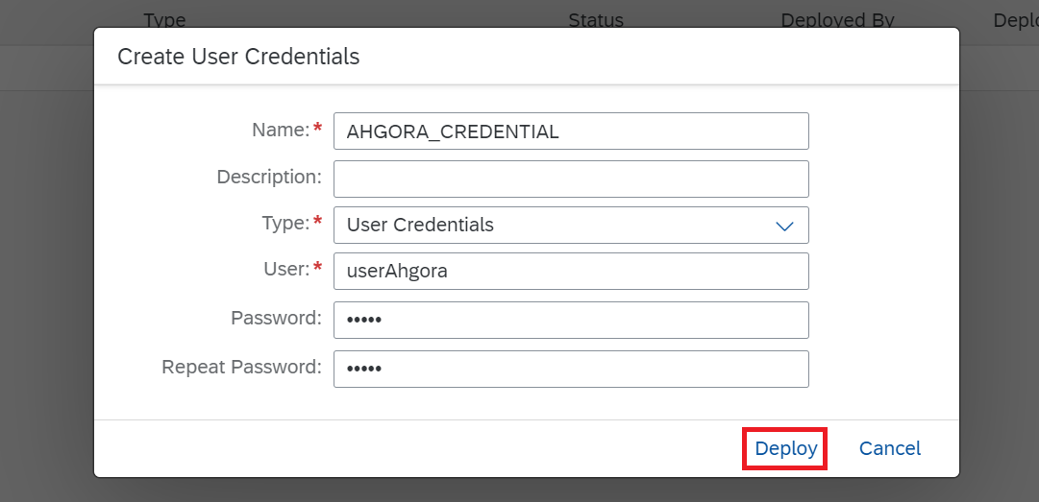

Note that the credential will appear in the list and its correct status is Deployed

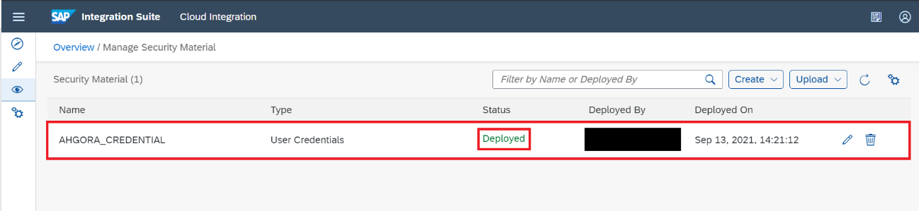
Click the Create button again and user credentials

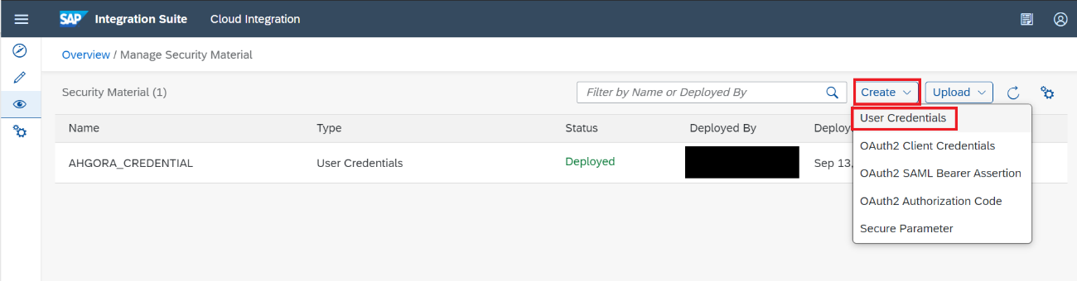

In Type switch to SuccessFactors

In Name enter SFSF_CREDENTIAL_BASIC
In User user SAP SuccessFactors
Enter and repeat the password
Enter Company ID
Click Deploy

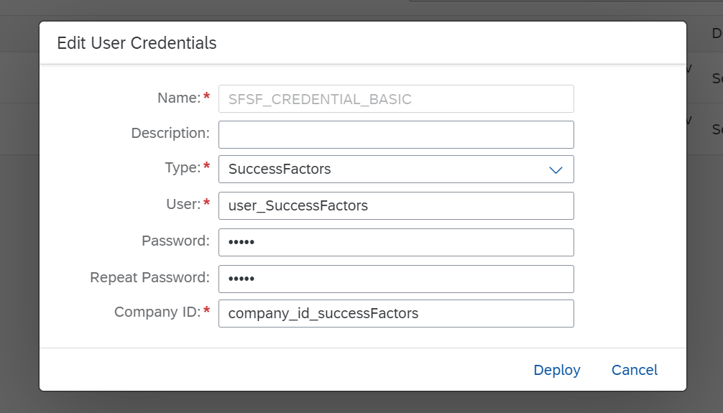

The credential will appear in the list with the status Deployed

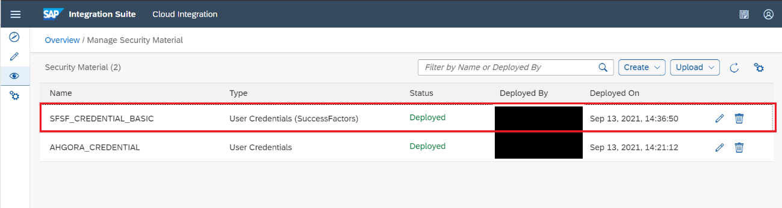

Click the Create button again and user credentials

In Name enter SAPPAYROLL
In User Sap SuccessFactors employee central payroll (ECP)
Enter and repeat the password
Click Deploy

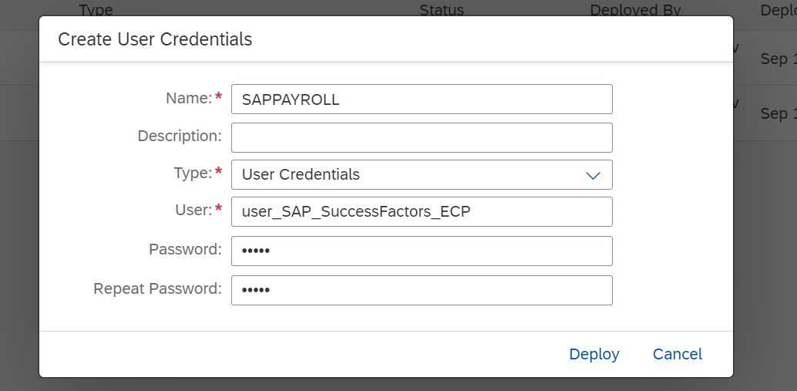

The credential will appear in the list with the status Deployed

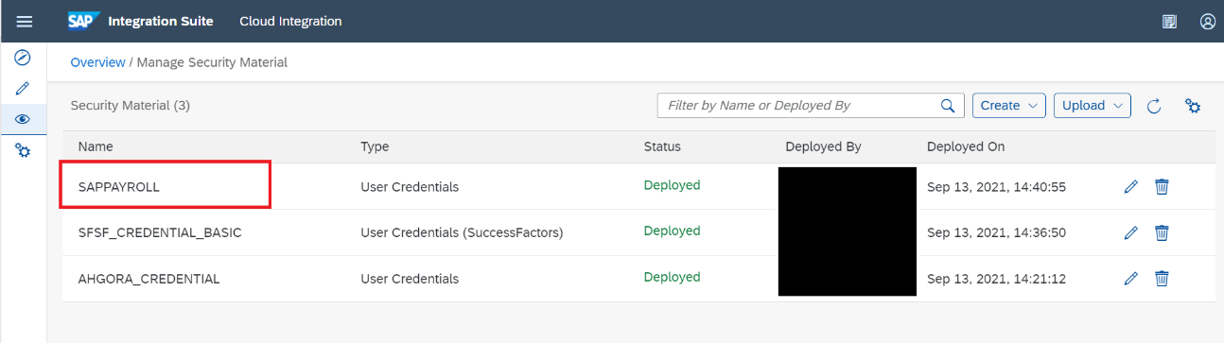

Installation of the Ahgora Certificate in the CPI environment

Click the icon that looks like an eye

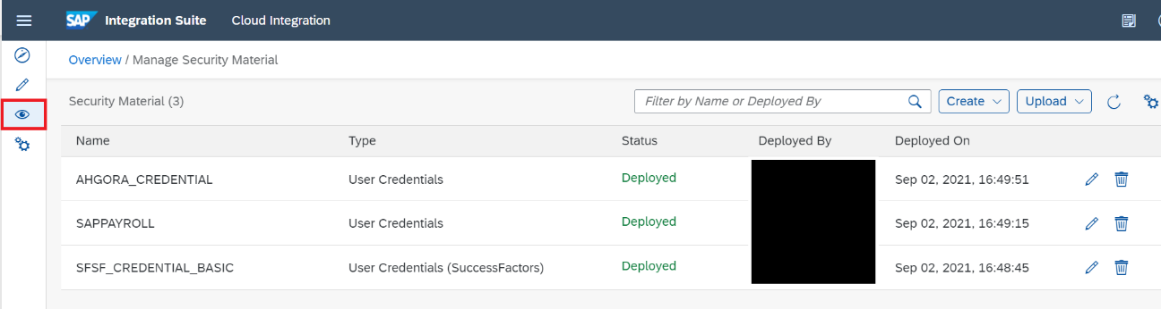

In Manage Security click Keystore

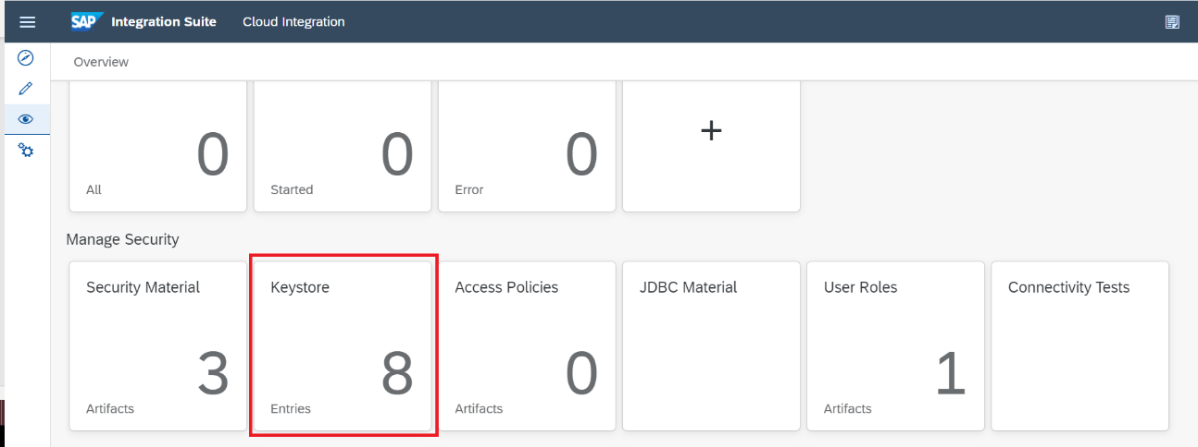

Click Add and Certificate

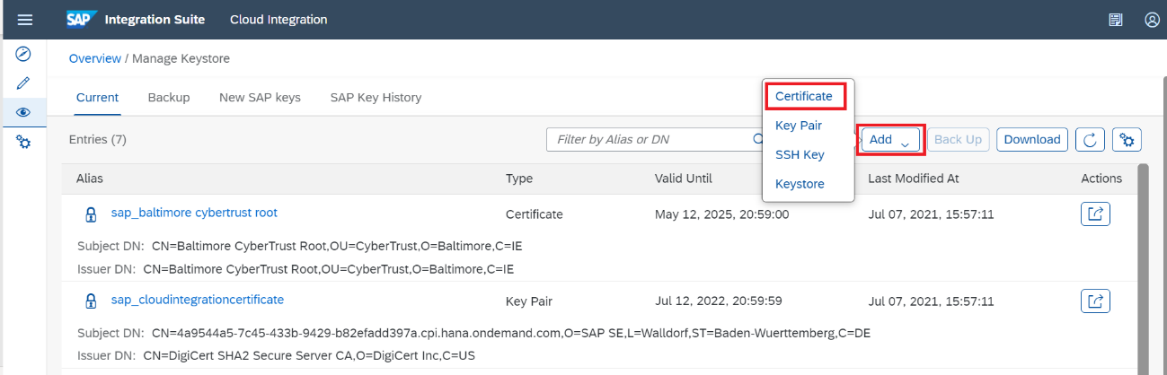

Click Browse, select the Ahgora certificate file and click Open

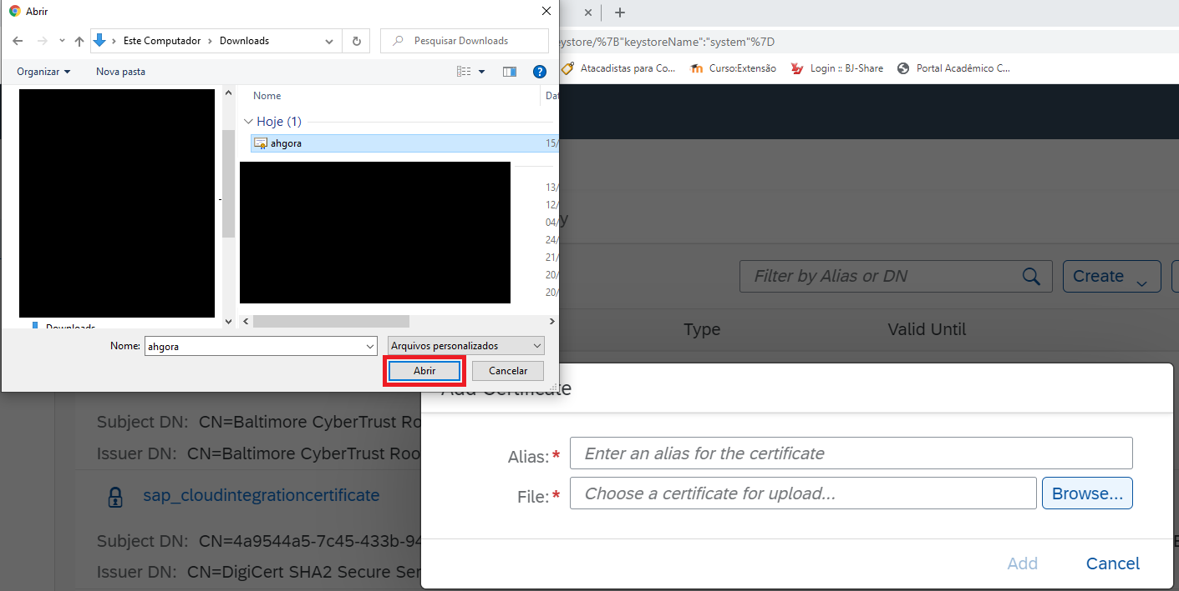

Click Add

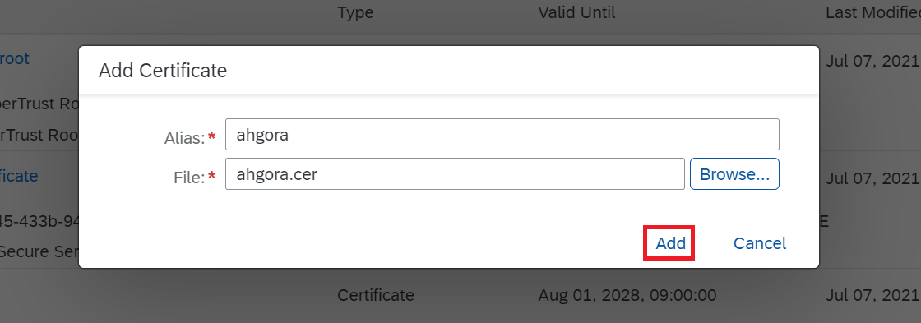

Click Confirm

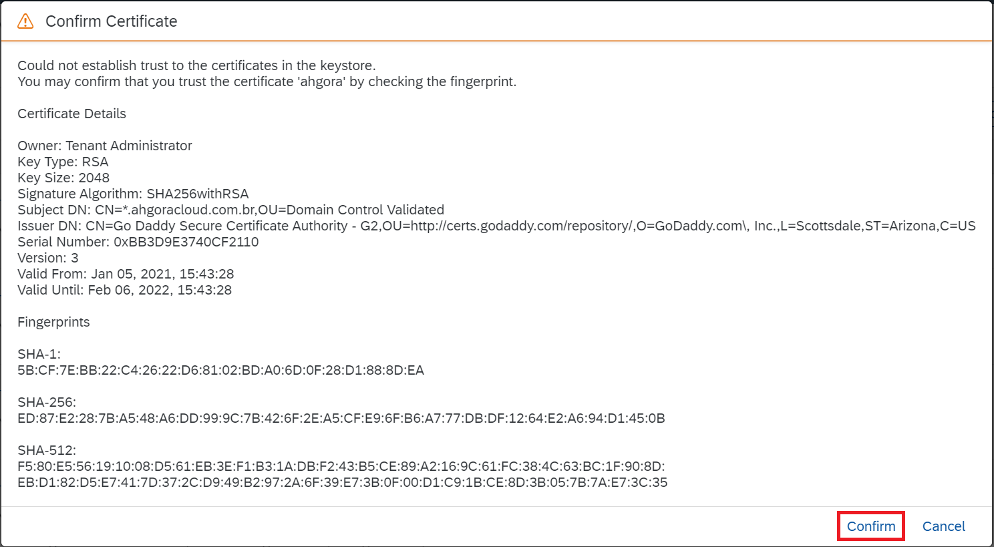

The certificate will appear in the list

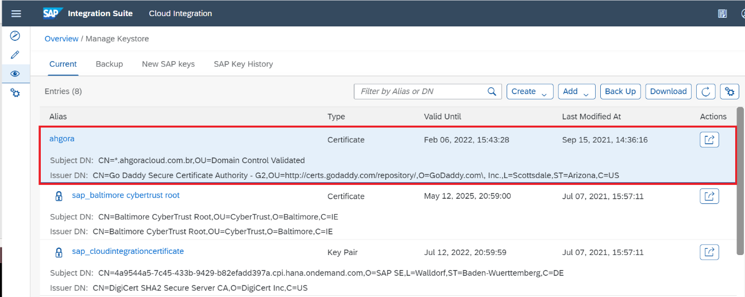

Procedure performed correctly!

Installation of Integration Packages

Now click on the icon that looks like a pencil

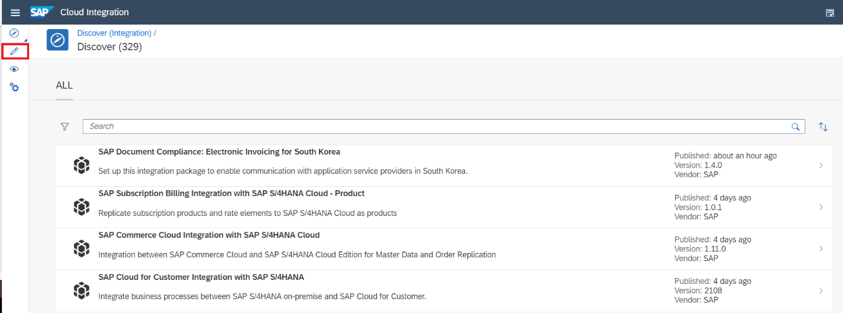

Now click Import and select package files, click Open
NOTE: These files will be made available

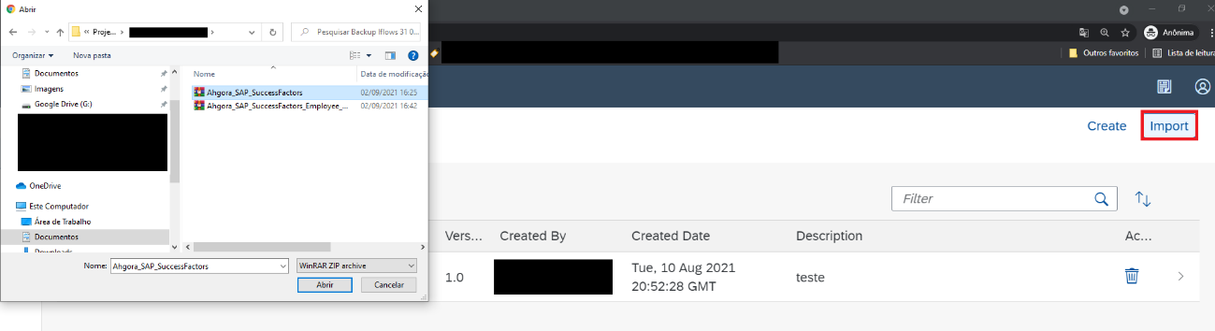

NOTE: Repeat this procedure for packages that want to import

Once this is done the package that was imported will appear in the list along with other existing packages in the environment

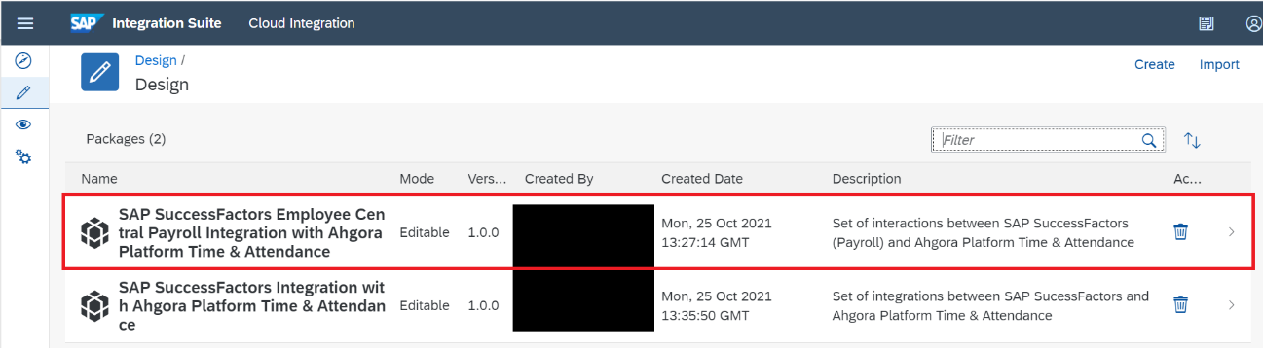
Now let's set up the Integration flows (Iflows)

Click the SAP SuccessFactors Integration with Ahgora Platform Time & Attendance package

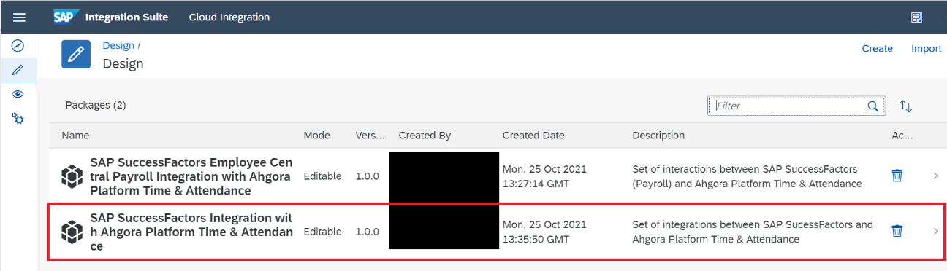

Click Artifacts, this is where Iflows will be

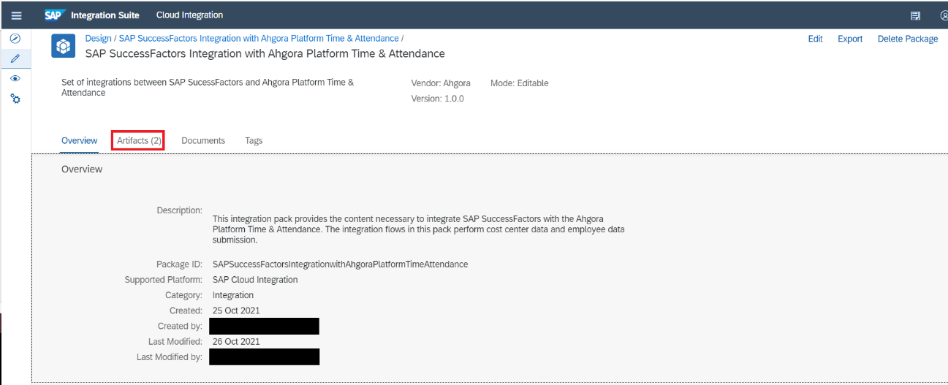

Select the Iflow SAP SuccessFactors Out Ahgora Platform Time Attendance In Cost Center in the Checkbox on the left and click the action button on the right, click Configure

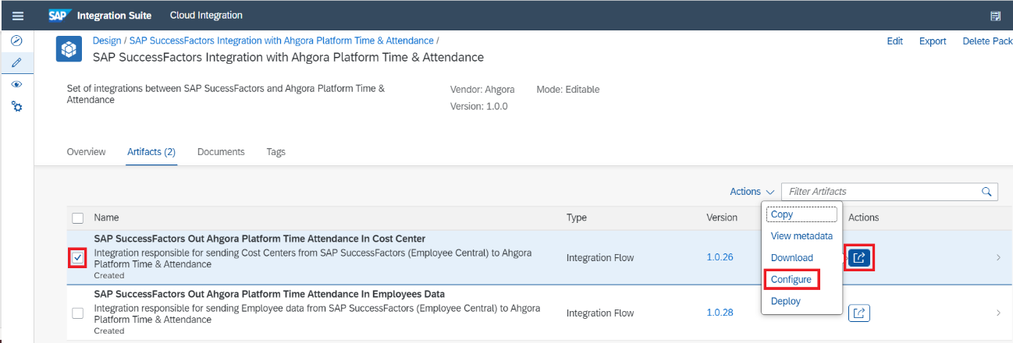

This Iflow is a JOB (runs automatically) and we can configure it according to the need for execution.
In the Timer tab is precisely the execution setting. We can run it only once in the Run Once option

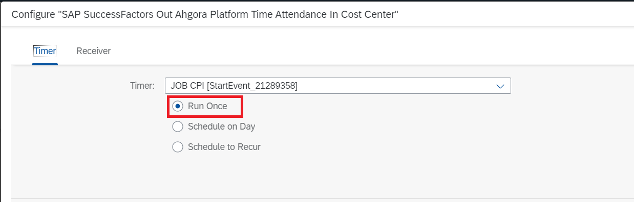

Run it on a certain date in the Schedule on Day option

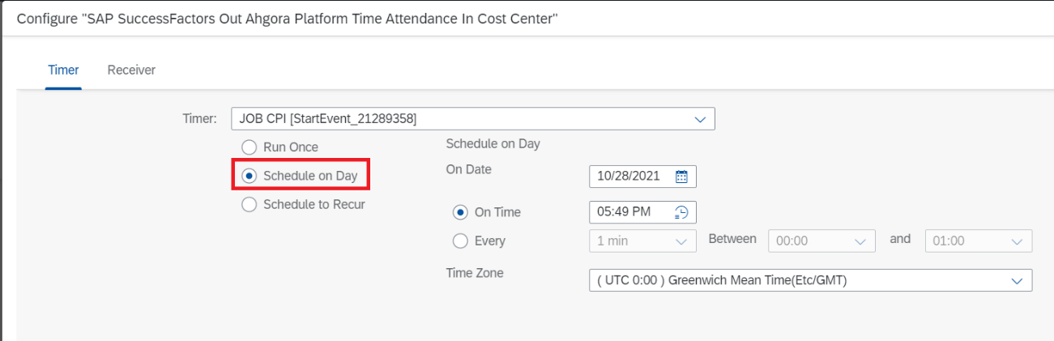

Either choose between the Daily, Weekly, and Monthly periods ata certain time (On Time) or every time every time in the Schedule to Recur option. In the case of the Every option we can also choose the execution interval, period. We can also choose the Time Zone

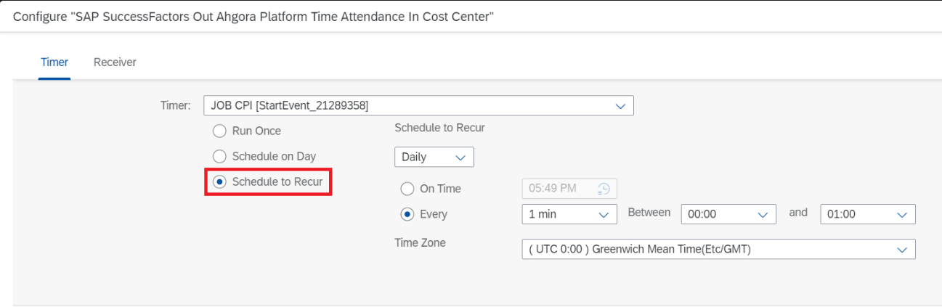

Now click the Receiver tab
In receiver Ahgora_WS_01 we must enter the value in the company field, referring to the company code to send data to the Ahgora Platform TimeAttendance.

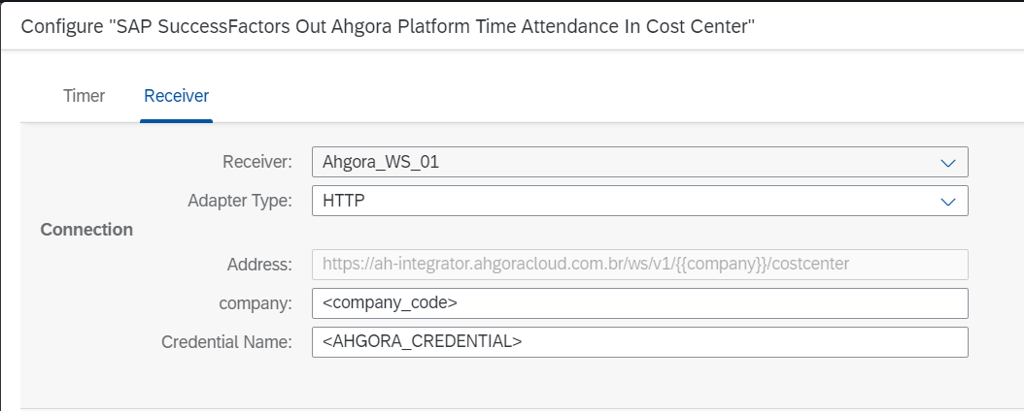

Now let's select another Receiver
Click the selection icon in the Receiver field and choose SFSF_CostCenter

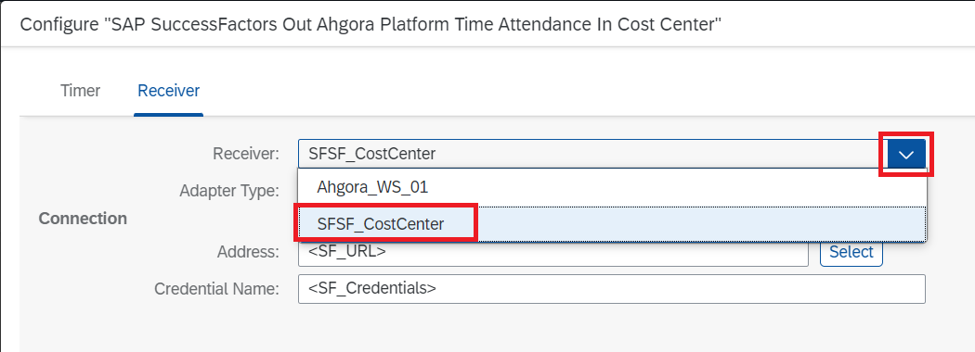

In the Address field enter the SAP SuccessFactors instance contracted by your company

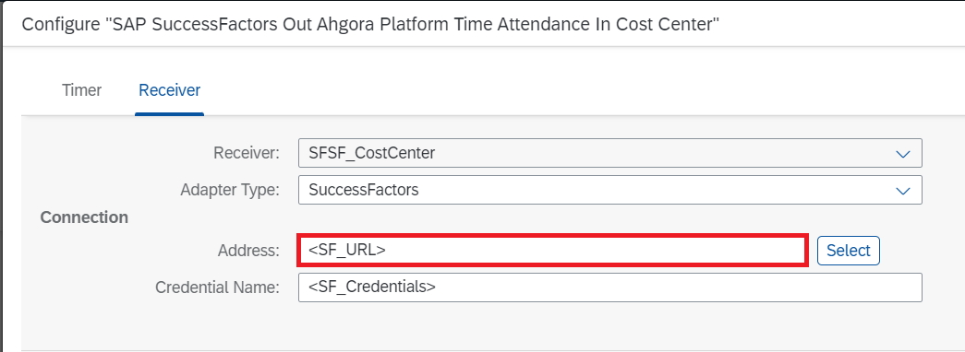

In the Credential Name field enter the credentials of the SAP SuccessFactors instance configured in the Credentials Configuration step

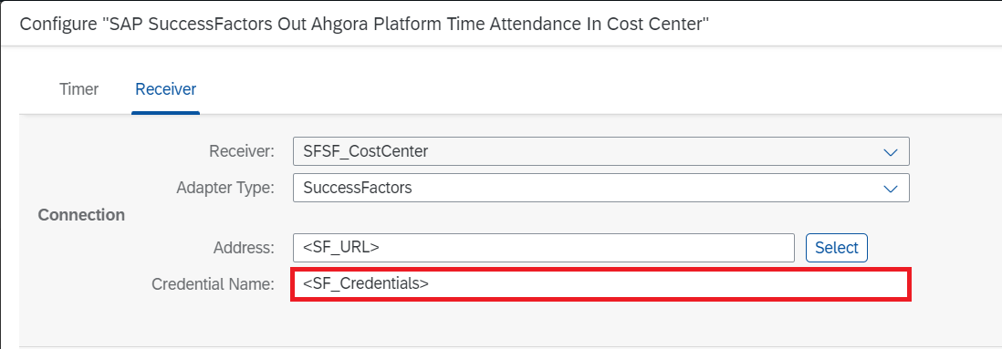

After performing all settings click Save

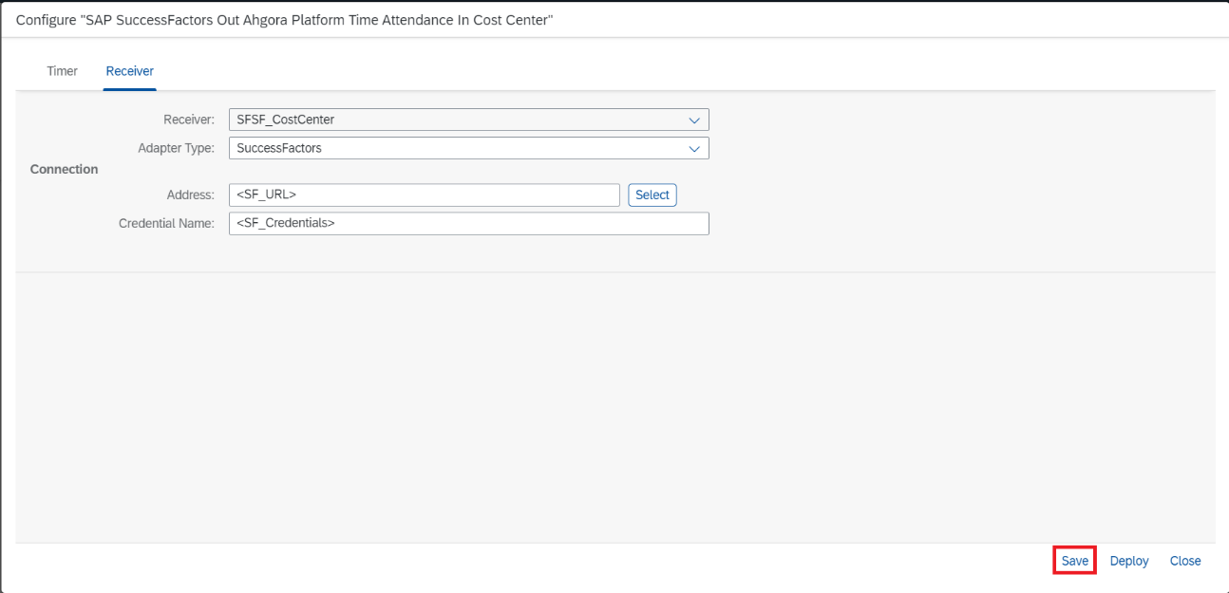

If any warning window opens, click Close

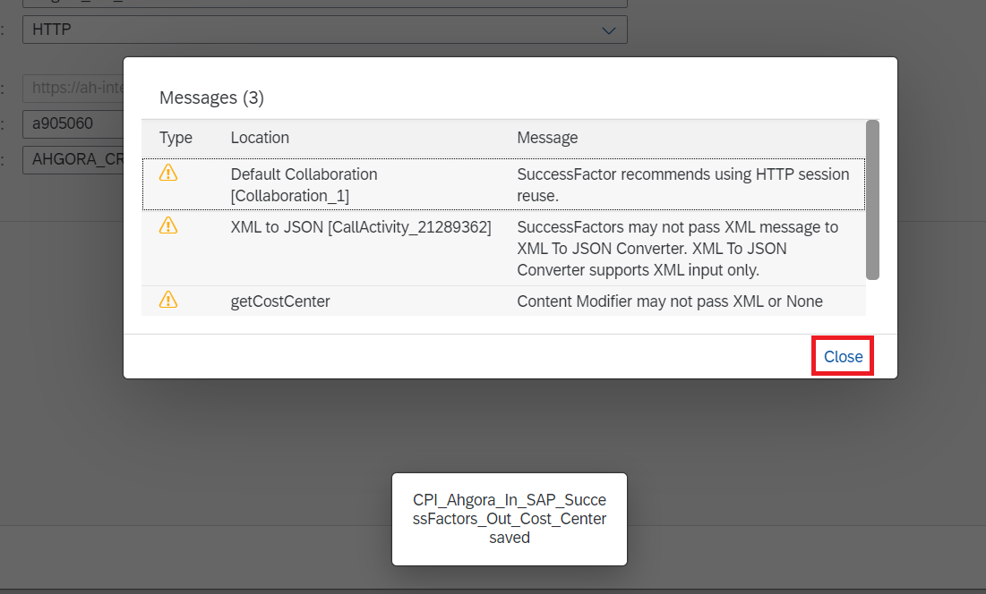

Once that's done click deploy

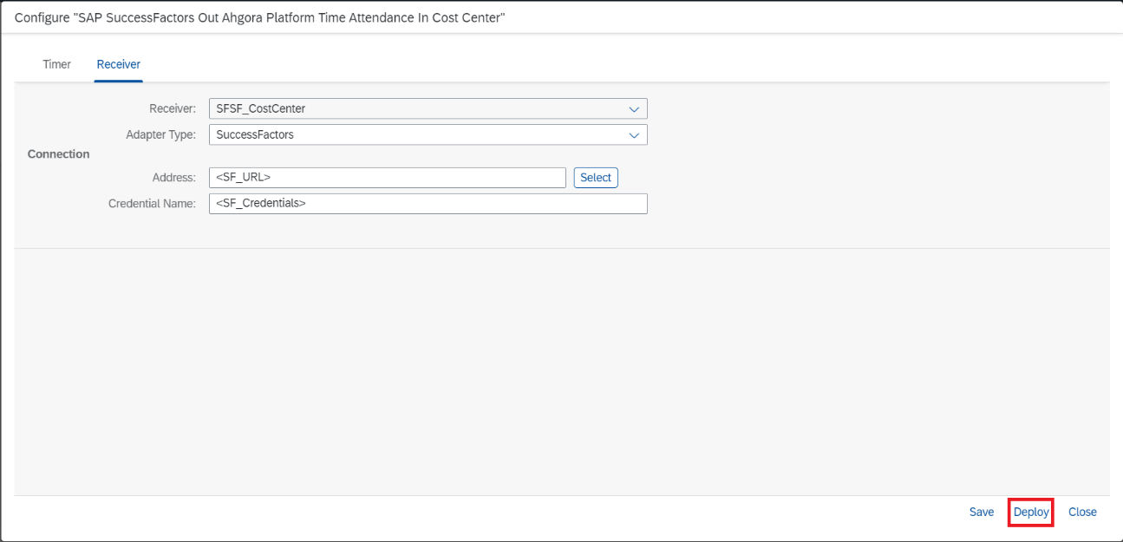

Click Yes

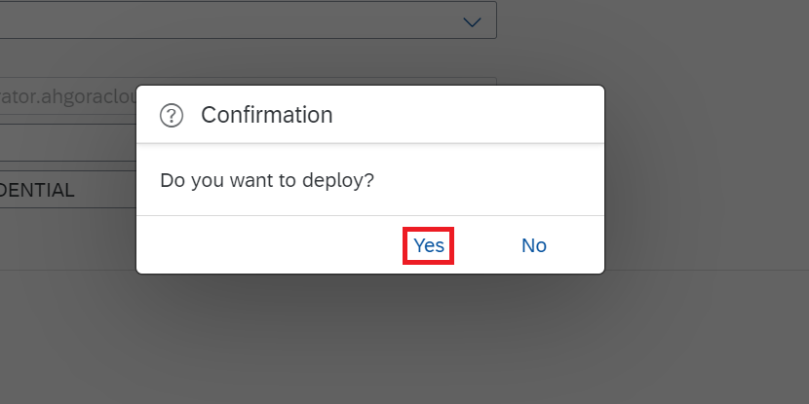

Click OK

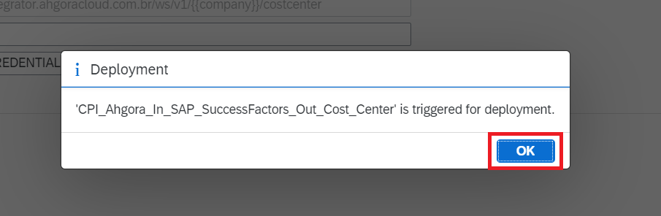

Successful procedure!

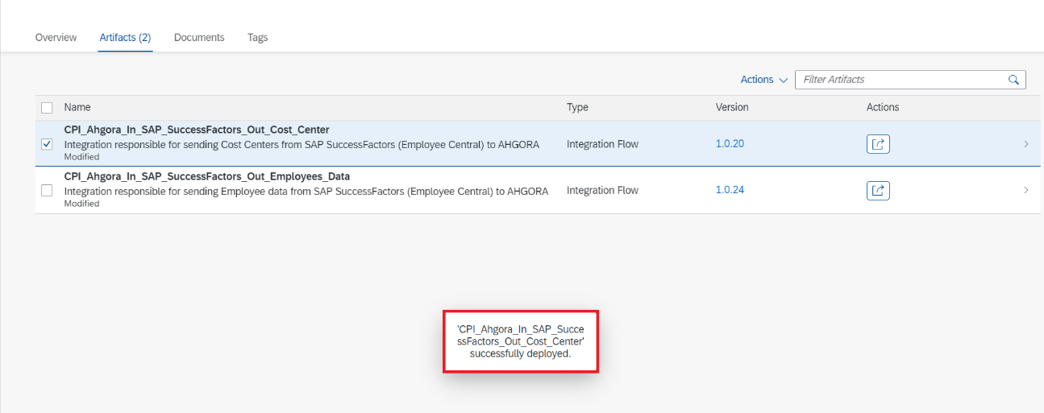

For Iflow SAP SuccessFactors Out Ahgora Platform Time Attendance In Employees Data what will be distinguished the configuration of Iflow SAP SuccessFactors Out Ahgora Platform Time Attendance In Cost Center will be the More tab, there we will have four external parameters:
- external_code_ctps -> in the demo instance behind the employee's CTPS field (by default we leave the value 2)
- external_code_pis -> in the demo instance behind the employee's PIS field (by default we leave the value 6)
- external_code_rg -> in the demo instance behind the employee's RG field (by default we leave the value 8)
- zdias -> days before the current day (we leave 5 days, i.e. current day - 5)

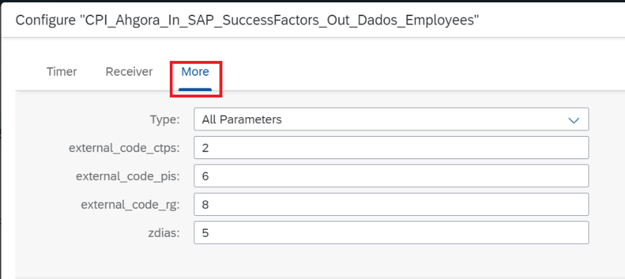

In the rest repeat the same configuration of the iflow SAP SuccessFactors Out Ahgora Platform Time Attendance In Cost Center

Now let's set up sap successfactors employee central payroll integration with Ahgora Platform Time & Attendance package flows

Click the pencil icon

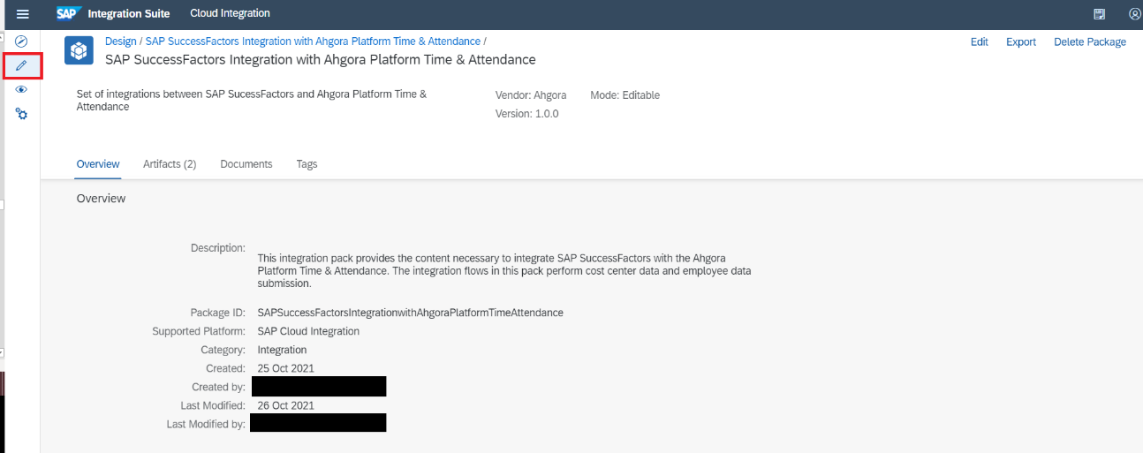

Click the SAP SuccessFactors Employee Central Payroll Integration with Ahgora Platform Time & Attendance package

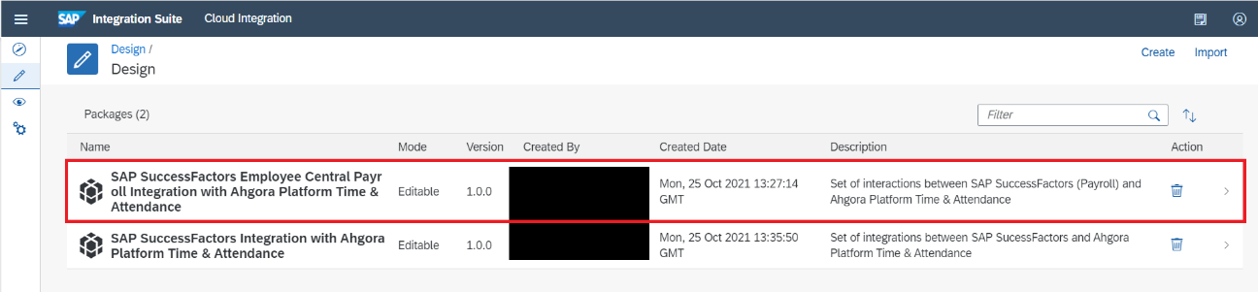

Click Artifacts

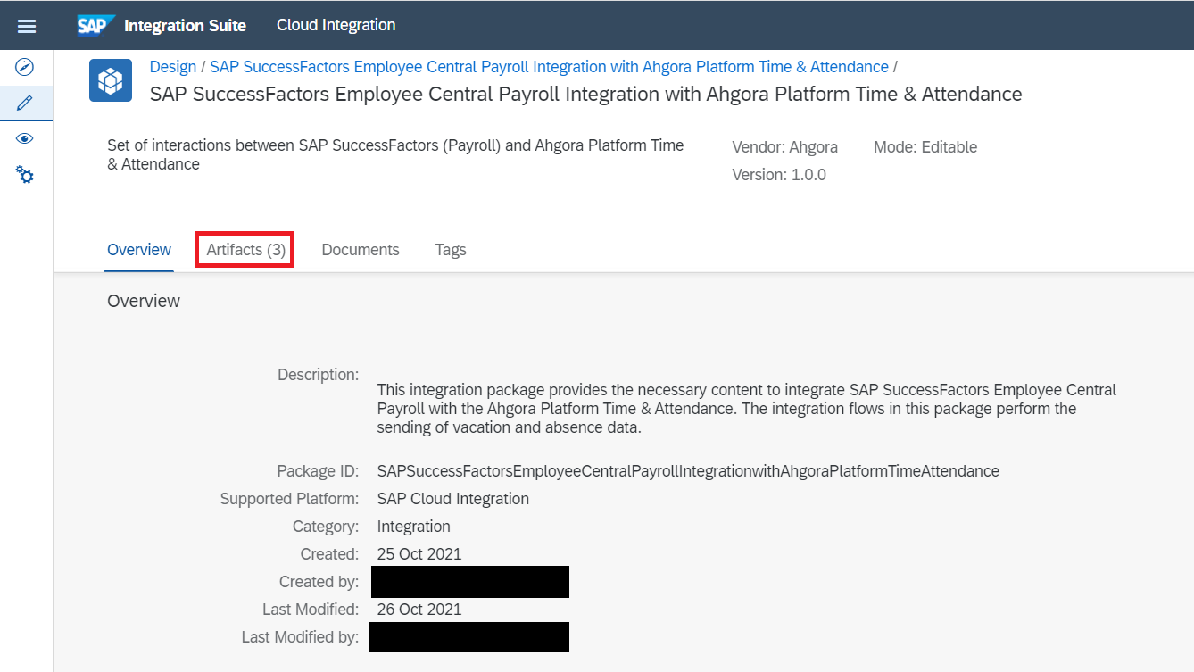

Select the Iflow Ahgora Platform Time Attendance Out SAP SuccessFactors Employee Central Payroll In Absences, click the action button and click Configure

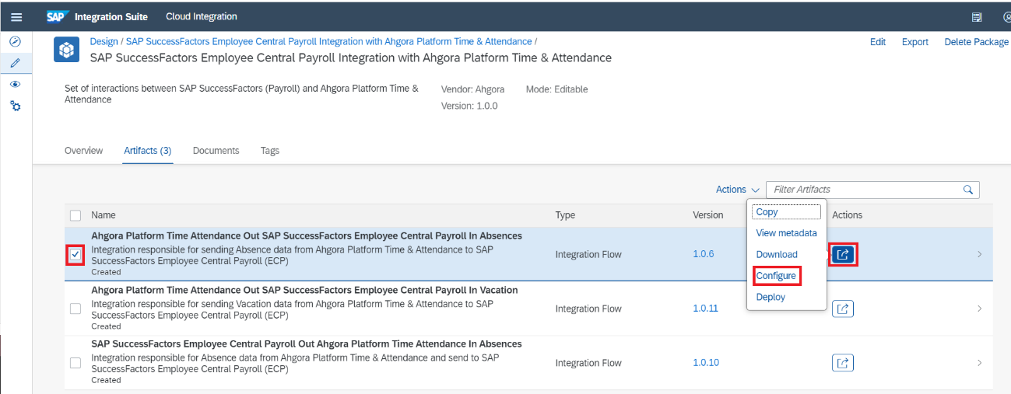

In the ECP_URL enter the value for the SAP SuccessFactors Payroll instance
Example -> https://{{my...}}. payroll.ondemand.com

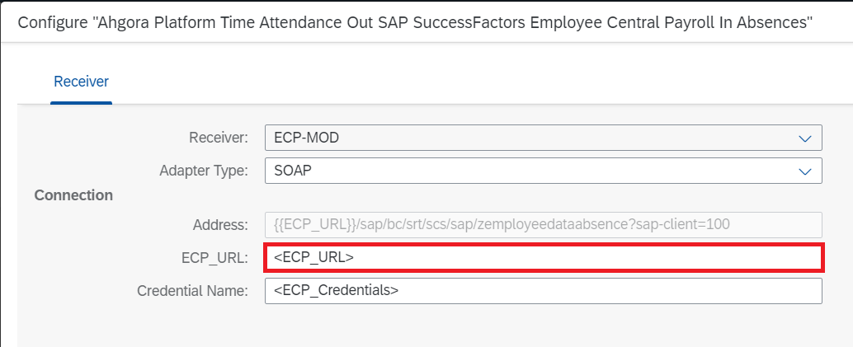

Under Credential Name enter the name of the SAP SuccessFactors Employee Central Payroll access credential

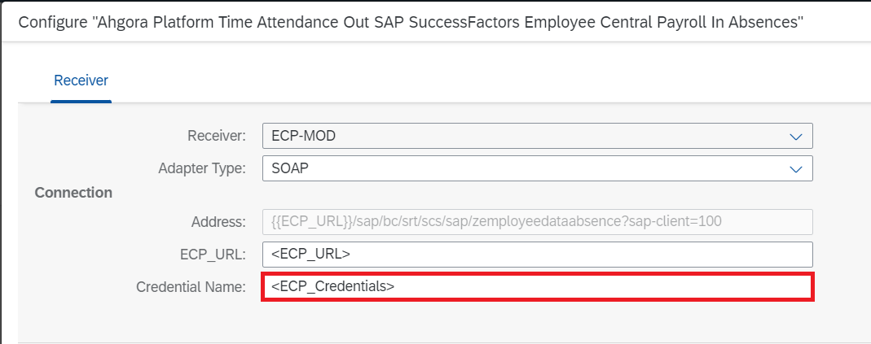

Click Save

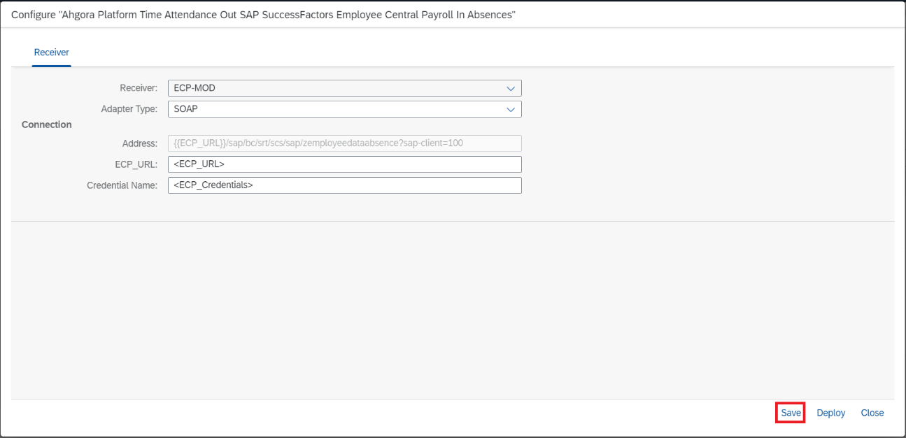

If any warning window appears click Close

Click Deploy

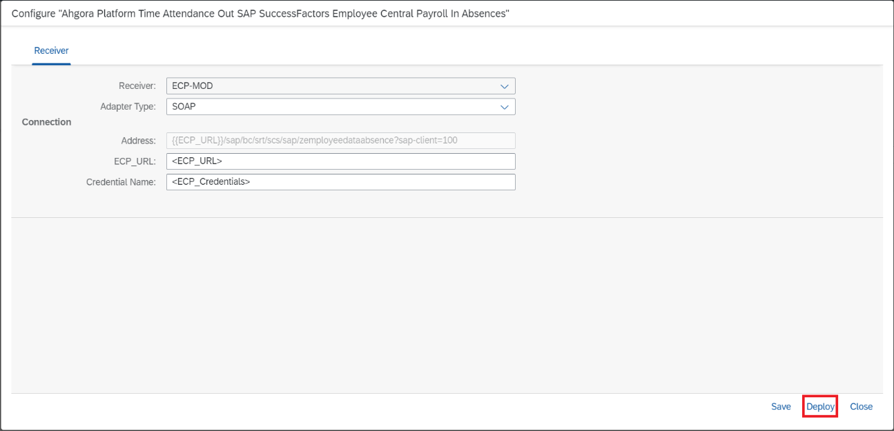

Click Yes

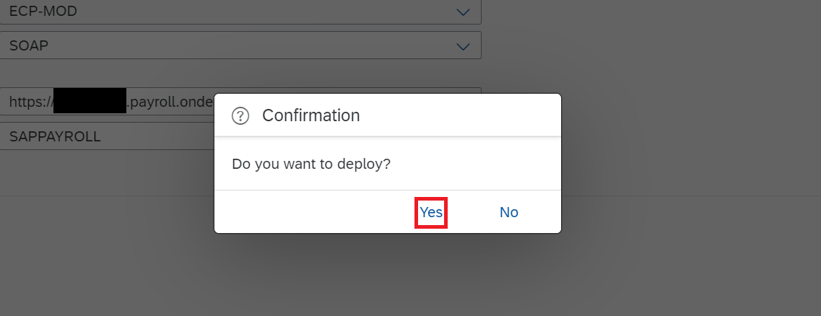

Click OK

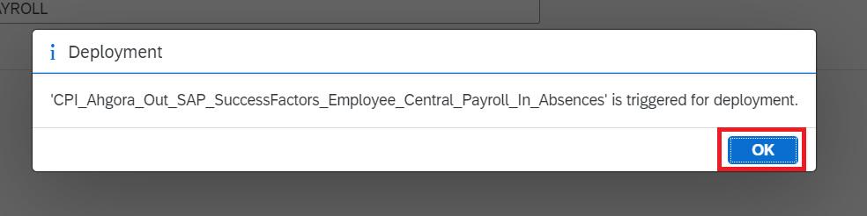

Successful procedure!

Repeat the same procedure for the Iflow Ahgora Platform Time Attendance Out SAP SuccessFactors Employee Central Payroll In Vacation.
In Iflow SAP SuccessFactors Employee Central Payroll Out Ahgora Platform Time Attendance In Absences in the Timer tab, configure the JOB according to your need (you can follow the example mentioned earlier in this document). In the More tab is the listAwart parameter which are the scode s of the types of clearance s, in the remainder of the configuration follow the procedure of the Iflow Ahgora Platform Time Attendance Out SAP SuccessFactors Employee Central Payroll In Vacation.

