Motivation:
Taking content from Eclipse to the WebUI

Solution:
Goto to Windows Explorer and browse to the location of the package:
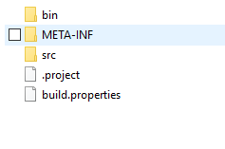
Now create a zip file out of all the content except the bin folder:
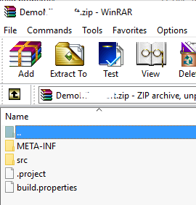

Now goto to the webUI of the tenant where you would like to import the package.
Goto the design tab.
Open the Integration Package where you want to add the new package: either open an existing one or create a new one.
Once there, click on Add Process Integration
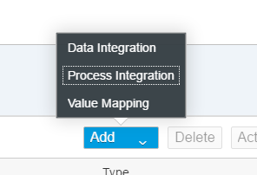

Now choose Upload and browse to the zip file that you just created.
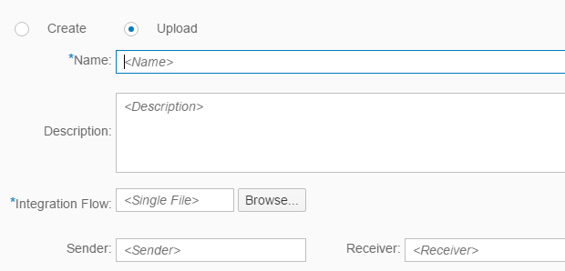

Your integration flow shall be imported into the package.

