SAP Business Network Integration with Non-SAP ERP - Translate CSV PO to cXML Order Request

Table of Contents
Contents
Table of Contents 1
Purpose 2
Integration Specification 2
Purchase Order csv File 3
Ariba Network Connector 3
Data Mapping Logic 4
Security Material 5
Parameters Usage Guide 6
Scripting 8

Purpose
Quick start to develop an interface which sends Purchase Orders to SAP Business Network Integration (Ariba Network).

Integration Specification

Type of Integration (outbound or inbound) | Outbound
Data Source Entities | Purchase Order Extract as csv file
Average Number of Records | 1 or more
Maximum number of Records | 100
Processing Type | Batches
Job Schedule | Hourly (configurable)
Data Description (xml, comma delimited etc…) | CSV
Target Location | SAP Business Network Integration (Ariba Network)

This IFLOW pulls Purchase Orders (csv file) from the SFTP server, maps the csv records to cXML and uploads the Purchase Orders to SAP Business Network Integration (Ariba Network). It also implements exception handling and emails the exceptions to the configured SMTP server.

Purchase Order csv File
Purchase Orders will be extracted into csv file and uploaded into the designated SFTP location (outbox). For detailed information about csv file format, please check the csv.schema.with.fieldnames.xsd schema available in the Resources Tab of the IFLOW

Ariba Network Connector
Ariba Network Connector is a standard integration function which provides both upload and download of Ariba Network data.
NOTE: This IFLOW can process one or more Purchase Orders in any given csv file, i.e. it handles batches.
Because the Ariba Network processes one single Purchase Order record at a time, the batches are split before the csv content is mapped to Ariba’s cXML format. Therefore, please exercise caution in the number of Purchase Order records you include in the same csv file. A maximum of 10 Purchase Orders in any given csv file is recommended. Test thoroughly before deploying to Productive environments.
IMPORTANT: including the same Purchase Order number more than once in any given csv file is not allowed and will most certainly result in unexpected and undesired behavior. For example: even if one instance of same Purchase Order number is a “new” Purchase Order and another instance is a “changed” or “canceled” Purchase Order, these two or more Purchase Order instances cannot coexist in the same csv file.

Data Mapping Logic
Note: The mappings provided with this IFLOW were authored and maintained using Integration Advisor. You may choose to use a different approach for the csv to cXML mapping, such as message mapping or using raw xslt code.
In addition to the csv to cXML mapping, additional custom xslt code has been implemented and provided with this IFLOW for the batch processing functionality.

Security Material
Before deploying the IFLOW, following security material should be deployed first.
- User credential (username and password) for accessing the SFTP server
- User credential (username and password) for accessing the SMTP server
- User credential (Shared Secret) for accessing SAP Business Network Integration (Ariba Network)

Parameters Usage Guide
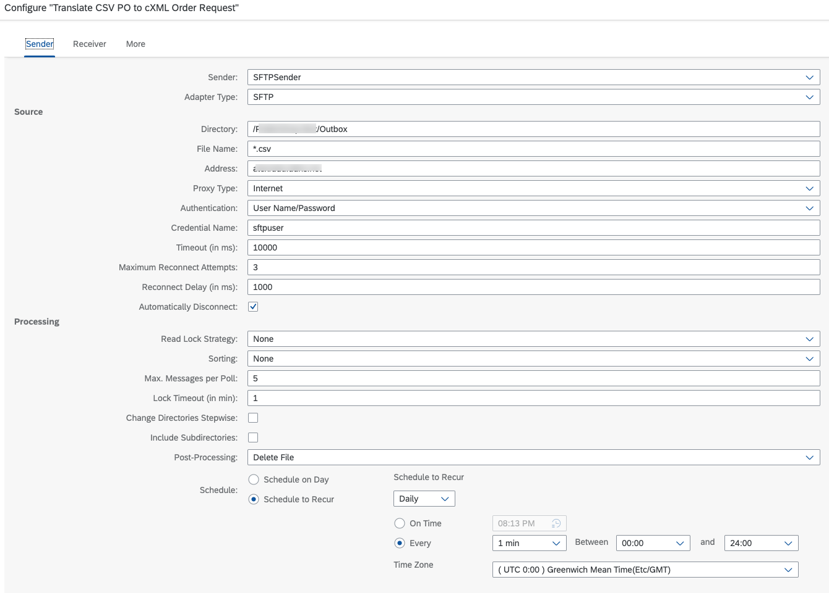
Name | Remarks
sftp_directory | Directory on SFTP to put the Purchase Order csv batch file, normally should be under folder “outbox”.
file_extension | file extension mask
sftp_host | SFTP server address
sftp_credentials | SFTP server username and password
post_processing | In order to make sure no duplicated reading for one file, there are 3 options can be selected.  - Delete File: delete file from SFTP server after read.  - Keep File and Mark as Processed in Idempotent Repository: don’t delete file from SFTP server after read, keep file name as processed in CPI repository to make sure next run the processed file will not be read again.  - Move File: move the file to archive folder after read.
scheduler | When you want the IFLOW to run, fetch file from SFTP server.

Scripting
Name | Description
Set MPL Custom Header with Purchase Order number | Sets the MPL Custom Header value with Purchase Order number. Groovy script file: SetMPLCustomHeader.groovy

