Electronic Invoicing for China Baiwang

API Document

This document is about API provided by iFlow deployed in Cloud Integration. It is designed to receive data from Backend System and sent them to Baiwang Cloud Platform.

Update to Baiwang Api version 6.0 and support E-invoice

Outgoing invoice
This API supports invoice operation through Baiwang Cloud Platform
- Open Invoice
- Cancel Invoice
- Query Invoice

Version 1.0.0

Open invoice

Request details:
API Endpoint: https://<Cloud Integration_tenant>/http/china/v1/baiwang/sendinvoice
Methods: POST
Action: open

Sample request:
Data Mapping Detail:
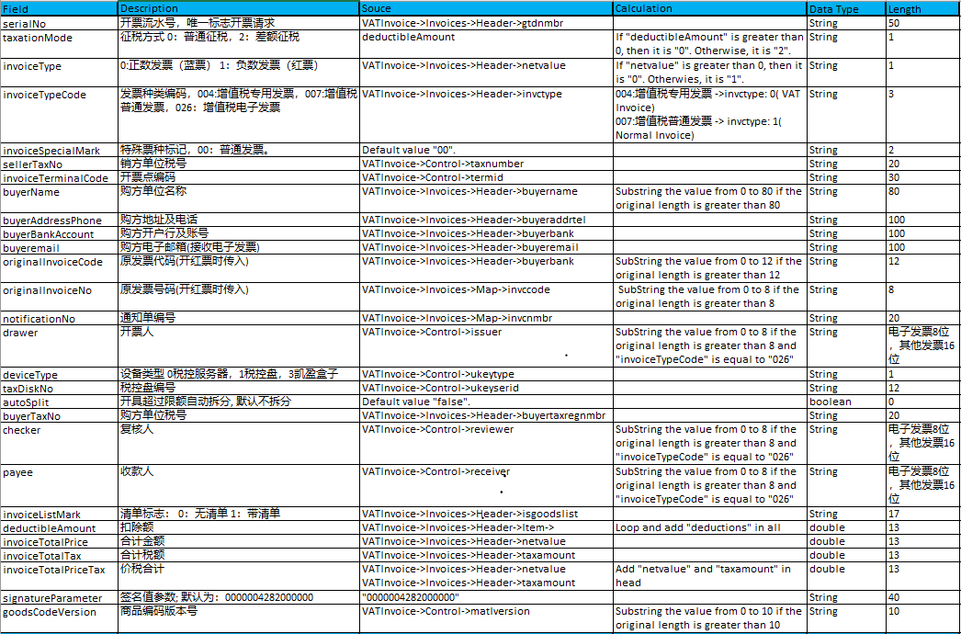
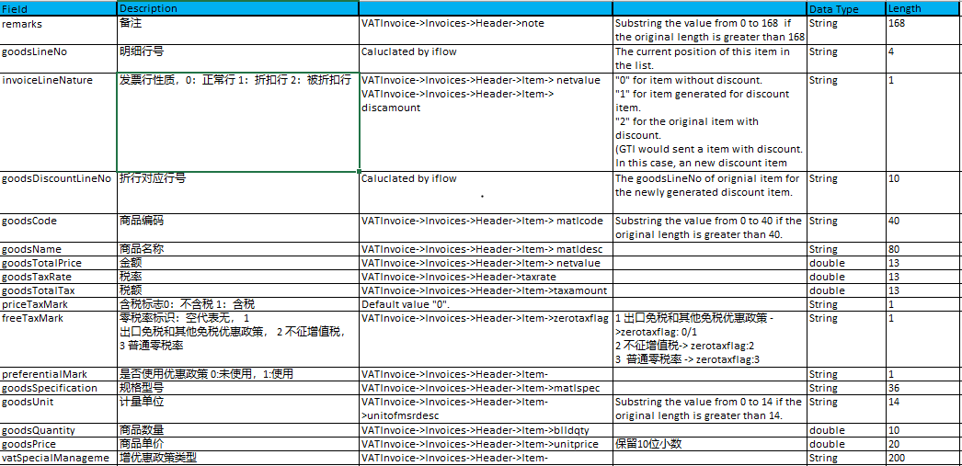

Response details:

Success response:
<ResponseMessage>
<method>open</method>
<taxnumber>91500000747150426A</taxnumber>
<Result>
<gtdnmbr>90024089</gtdnmbr>
<successcode>000000</successcode>
<message>数据已成功接收</message>
<detailmessage/>
<Invoice>
<invccode></invccode>
<invnmbr></invnmbr>
</Invoice>
</Result>
</ResponseMessage>

Parameter | Name | Type | Length | Description
method |  |  |  | Operation for invoice
taxnumber | 税号
gtdnmbr | 发票流水号
successcode | 返回代码 | String | 6 | Succ:“000000”  Error from Baiwang: “1*****”  Error from CLOUD INTEGRATION: “2*****”
message | 返回信息 | String
detailmessage | 详情 | String |  | 错误详细信息
invccode | 发票代码 | String | 12
invnmbr | 发票号码 | String | 8

Failed Response:
<ResponseMessage>
<method>open1</method>
<taxnumber>91500000747150426A</taxnumber>
<Result>
<gtdnmbr></gtdnmbr>
<successcode>200001</successcode>
<message>不支持的操作类型</message>
<detailmessage>操作为空或不支持的操作类型，目前支持的类型为open和cancel</detailmessage>
<Invoice>
<invccode/>
<invnmbr/>
</Invoice>
</Result>
</ResponseMessage>

Cancel invoice

Request details:
API Endpoint: https://<Cloud Integration_tenant>/http/china/v1/baiwang/sendinvoice
Methods: POST
Action: cancel

Sample request:
Data Mapping Detail:
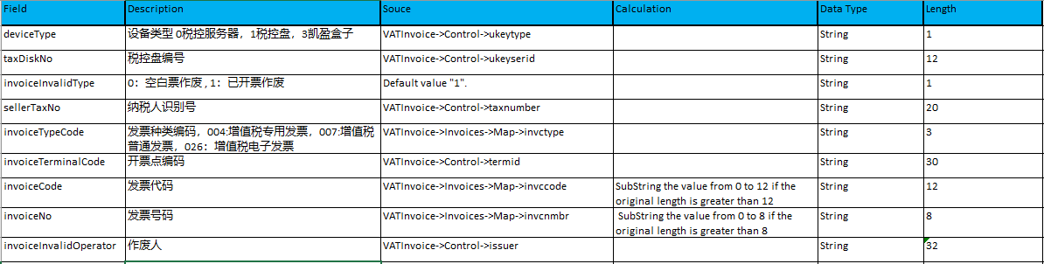

Response details:

Success response:
<ResponseMessage>
<method>cancel</method>
<taxnumber>91500000747150426A</taxnumber>
<Result>
<gtdnmbr>90024089</gtdnmbr>
<successcode>000000</successcode>
<message>发票已成功作废</message>
<detailmessage/>
<Invoice>
<invccode>1500000001</invccode>
<invnmbr>56871329</invnmbr>
<InvoiceInvalidDate>20200115105619</InvoiceInvalidDate>
</Invoice>
</Result>
</ResponseMessage>

Parameter | Name | Type | Length | Description
InvoiceInvalidDate | 发票作废日期 | String | 32 | 格式：yyyyMMddHHmmss

Failed Response:
<ResponseMessage>
<method>cancel</method>
<taxnumber>91500000747150426A</taxnumber>
<Result>
<gtdnmbr>90024089</gtdnmbr>
<successcode>100006</successcode>
<message>远程服务错误</message>
<detailmessage>调用[发票作废]接口失败，所传发票类型与需要作废的发票类型不一致！</detailmessage>
<Invoice>
<invccode>1500000001</invccode>
<invnmbr>56871329</invnmbr>
</Invoice>
</Result>
</ResponseMessage>

Query invoice

Request details:
API Endpoint: https://<Cloud Integration_tenant>/http/china/v1/baiwang/queryinvoice
Methods: POST
Action: query

Sample request:
Data Mapping Detail:

Response details:

Success response:
<ResponseMessage>
<method>query</method>
<taxnumber>91500000747150426A</taxnumber>
<Result>
<gtdnmbr>90004106</gtdnmbr>
<successcode>000000</successcode>
<message>发票已成功查询</message>
<detailmessage/>
<Invoice>
<response>
*The whole invoice details*
</response>
</Invoice>
</Result>
</ResponseMessage>

Failed Response:
<ResponseMessage>
<method>query</method>
<taxnumber>91500000747150426A</taxnumber>
<Result>
<gtdnmbr>90004107</gtdnmbr>
<successcode>100006</successcode>
<message>远程服务错误</message>
<detailmessage>调用[发票状态查询]接口失败，未查询到流水号对应的开票信息!</detailmessage>
<Invoice>
<invccode/>
<invnmbr/>
</Invoice>
</Result>
</ResponseMessage>

Success Code List

1. Success (000000)

2. Baiwang Error (1*****)
100000 | 缺少参数 | 请检测输入参数的正确性
100001 | 参数取值范围错误 | 检查参数的值
100002 | token失效或者无效 | 重新登录获取token
100003 | appKey错误或无访问权限 | Api无访问权限，联系运营
100005 | 请求过于频繁 | 默认一个app最大并发为10，请控制并发或者联系运营
100006 | 远程访问错误 | 业务错误，一般是业务参数写错了，请检查
100007 | 无效的签名 | 注意sign参数的正确性
100008 | 系统内部超时 | 请重试三次
100009 | 超过系统最大容流量 | 请控制并发或者过段时间重试
100010 | 请求超时 | 请重试三次
60 | 未知错误 | 具体分析

错误码100006常见问题
- 金税盘不在线，请检查助手是否已开启及配置信息是否正确
请确保金税盘插入电脑并连接网络，开票过程中请全程保持连接

3. CLOUD INTEGRATION Error (2*****)

GTI Send Invoice Outgoing Receiver
200001: 操作为空或不支持的操作类型，目前支持的类型为open和cancel
200002: 发票请求中，税号不能为空，请确保taxnumber不为空
200003: 开具请求中，发票流水号不能为空，请确保gtdnmbr不为空
200004: 作废请求中，发票代码或发票号码不能为空，请确保invccode和invcnmbr不为空
200005: 开具请求为红普票，发票代码或发票号码不能为空，请确保invccode和invcnmbr不为空
200006: 开具请求为红专票，红票通知单号不能为空，请确保rednotenmbr不为空

200007: XML格式错误，<Item>节点不能为空
200008: XML格式错误, 找不到<Control>节点
200009: XML格式错误, 找不到<Invoices>节点下的<Map>节点
200010: XML格式错误, 找不到<Invoices>节点下的<Header>节点
200014: XML字段错误, ******必须为数字且不能为空

Baiwang Send Tax Invoice
200013: 未在CLOUD INTEGRATION中找到相应的Security Material，请确保（********）维护在CLOUD INTEGRATION中

Baiwang Query Tax Invoice
200001: 操作为空或不支持的操作类型，目前支持的类型为query
200002: 发票请求中，税号不能为空，请确保taxnumber不为空
200003: 查询请求中，发票流水号不能为空，请确保gtdnmbr不为空
200012: 发票正在开具中，请稍后再查询
200013: 未在CLOUD INTEGRATION中找到相应的Security Material，请确保（********）维护在CLOUD INTEGRATION中

CLOUD INTEGRATION Exception in All iflows
299999: CLOUD INTEGRATION运行时发生异常

