Taulia Integration Flow Configuration Guide
Taulia Engineering team

document history
Version | Date | Change
1.0.0 | 2024-01-18 | First version
2.0.0 | 2024-05-01 | Support OAuth authentication
2.1.0 | 2026-04-01 | Use generic IdP reference instead of IAS

CONTENTS
document history 2
CONTENTS 3
Summary 4
Overview 4
Prerequisites 5
CONfiguration 5

Summary
The purpose of this document is to describe the general configuration steps required to manually set up the integration for SAP ERP or S/4HANA with Taulia cloud platform.

Overview
The Taulia integration flow connects your on-premise SAP ERP or SAP S/4HANA backend systems to the Taulia platform.
This package and integration flow will direct the flow of all Taulia API transactions from your back-end systems to the Taulia platform through SAP Integration Suite.
The integration flow is provided as an artifact in the integration package SAP ERP and SAP S/4HANA Integration with Taulia in SAP Cloud Integration, available on the SAP Business Accelerator Hub (https://api.sap.com). You can access the integration package from the catalogue page in the Discover section in the SAP Integration Suite.

Prerequisites
Before configuring the Taulia integration flow, please make sure the following prerequisites have been met:
- The SAP Taulia solution has been activated or installed and configured on your backend on-premise system.
  - Please note the supported deployment models of SAP Taulia solution and the availability of the Taulia integration flow.
SAP System | SAP Deployment Model | Supported Components of SAP Taulia
ECC or S/4HANA | On-premise add-on | TAULIA and TAUCC, version 400 or higher  Refer to OSS note 336387 for more details
S/4HANA | On-premise / Private cloud | S/4HANA 2025 SPF0 or higher
Note: The minimum backend on-premise system version supported is ECC 6.0.
- Standard Authentication Prerequisites (Non-OAuth 2.0)
  - Access credentials are provided and configured in the Add-on to connect to the Taulia cloud platform. Contact your Taulia representative for more information.
Note: If OAuth2 authentication is configured in Integration Suite, this step is not needed.
- The Taulia platform uses certificates signed by DigiCert, which are part of the SAP Global Trust List. Therefore, no manual certificate upload to the Cloud Integration Keystore is required.
However, please refer to step no. 4 to verify the connection. If the connectivity test fails due to a certificate error, you may then upload the required certificate(s) from the provided URL.
- You can test the Taulia platform connection by navigating to the Monitor section and selecting the Connectivity Tests tile. Host names are as follows:
  - For Staging/Quality: buyerintegration.staging.taulia.com
  - For Production (NA): buyerintegration.taulia.com
  - For Production (EU): buyerintegration-eu.taulia.com

CONfiguration
Note: Configuration for the Taulia integration flow in SAP Integration Suite is the same for SAP ERP and SAP S/4HANA backend on-premise system. All transactions are outbound from the backend system; therefore, Cloud Connector is not required.
Receiver authentication:
Type: OAuth2 Client Credentials
Taulia platform now supports OAuth2.0 authentication method. Customers who have access to an Identity Provider (IdP) such as SAP Cloud Identity Services, can configure the Taulia integration flow to use this feature. Please see below for more information.
Type: None
Selecting None indicates that the Taulia platform will use the standard authentication method (rather than OAuth 2.0). In this mode, Taulia platform uses the traditional approach by authenticating transactions based on the following two message header values passed by the caller.
- API key – which uniquely identifies the customer account
- Signature – is an encrypted string that is used to verify the shared secret key between the caller (backend) and Taulia cloud platform. Its purpose is to securely validate the customer’s identify and intended API usage (via HTTP verb and target URL). This signature value is unique for each call.
These two values are generated automatically by the on-premise Add-on and no additional configuration is required in SAP Integration Suite.
Note: When OAuth2 Client Credentials is being used, these two message headers are not required by Taulia platform for authenticating incoming calls.

Exception handling:
Our integration flow is a pass through and does not contain any customized exception handling. In case of timeout, the standard HTTP 500 timeout error will appear inside Cloud Integration Monitor. In case of payload size exceeding the limit, a standard HTTP 500 error will also appear inside Cloud Integration Monitor. In the backend system, the Add-on will detect HTTP errors and data will be retransmitted automatically (no data loss and no manual data reprocessing required).
The following steps cover how to set up and configure the Taulia integration flow for transactions to successfully flow from backend SAP system to Taulia Platform:
- Logon to your SAP Cloud Integration tenant as an administrator.
- Navigate to the Discover section to see all the published integration packages.
- Select the following integration package and click Copy:
  - SAP ERP and SAP S/4HANA Integration with Taulia
- Navigate to the Design section and click on the Taulia integration package.
- Click on the Artifacts tab.
- Click the Actions icon next to the following integration flow and select Configure
  - Integrate SAP ERP or SAP S4HANA to Taulia cloud platform
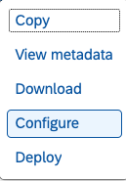
- Configure the following values if needed. Otherwise, use the default values
Sender:
Parameter Name | Default Value | Remarks
SessionReuse | onIntegrationFlow | SAP Blog
TransHandling | Not Required | SAP Blog
UserRole | ESBMessaging.send | You can define your own user role for the iFlow
Receiver:
Parameter Name | Default Value | Remarks
Authentication | None
Credential Name | Not Required | Displayed if Authentication is set to OAuth
Timeout | 60000 | This is in milliseconds
Note:
  - SAP Cloud Integration iFlow supports more than OAuth2, however, only OAuth2 Client Credential (other than None) is supported by Taulia.
  - If you define a user role other than the default, you must create the role in Manage User Roles tile under the Monitor section. The role must also correspond to the service key created for your instance in your BTP Cockpit.
- After you finish configuring the values, click on Save and then click Deploy.
- After the integration flow is deployed, the integration endpoint can be found in the tile under Monitor section and under the Manage Integration Content heading.
The endpoint will look similar to the following:
https://<CI tenant>.hana.ondemand.com/http/TAUDIR_TO_Platform
- You are now ready to test the integration

SET UP OAuth2 Authentication
This authentication method is optional. If you choose to use this authentication method, below are the recommended steps for setting it up.
Prerequisites:
- You have obtained the OAuth client credentials including the Client ID, Client Secret, and the token generation URL
- You have set up OAuth 2.0 Token Authentication in your Taulia platform Buyer Admin account to authenticate all API requests. Contact Taulia Support for additional assistance.
Create an OAuth Profile:
- Inside Integration Suite, navigate to the Monitor section and click on tile “Security Material”
- Click on Create and select OAuth2 Client Credentials
- Enter the following information on the create screen:
  - Name
  - Description
  - Token Service URL (Your IdP’s token generation endpoint)
  - Grant Type – select Send as Part of Body
  - Client ID
  - Client Secret
  - Client Authentication – select Send as Body Parameter
  - Scope – leave blank
  - Content Type – select application/x-www-form-urlencoded
  - Resource – leave blank
  - Audience – leave blank
  - Custom Parameters – leave blank
Below is an example for reference: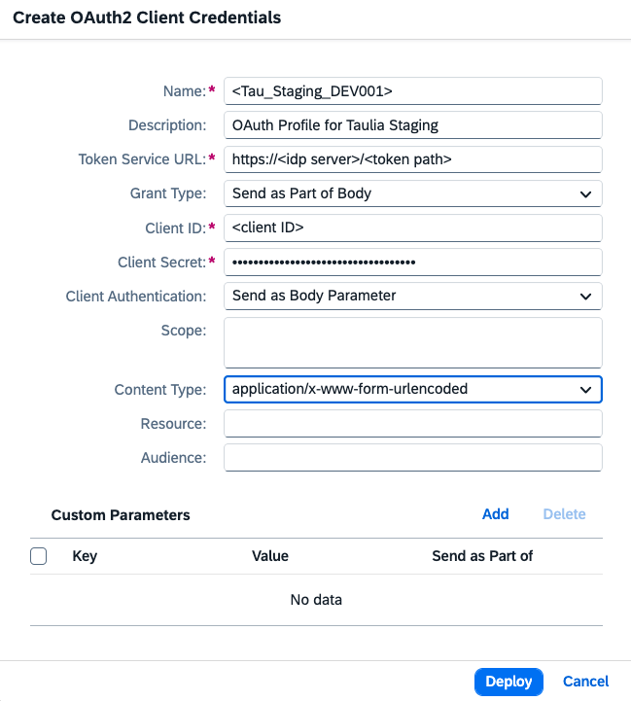
Note: This is dated March of 2026. The fields or names may change in the future.
- Click on Deploy

Configure Receiver Connection in Integration Flow:
- Navigate to the Design section and click on the Taulia integration package.
- Click on the Artifacts tab.
- Next to the following integration flow, click the Actions icon and select Configure.
  - Integrate SAP ERP or SAP S4HANA to Taulia cloud platform
- Go to the Reciever Tab
- In the Authentication drop down, select OAuth2 Client Credentials
- Enter the credential name that you created in above step
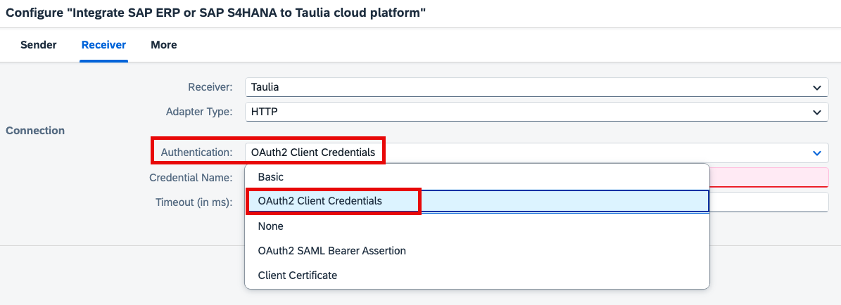
- Click on Save
- Click on Deploy
- You are ready to test the integration using OAuth2 authentication

Disclaimer
TAULIA INC. CONFIDENTIAL AND PROPRIETARY INFORMATION
All information in this document and accompanying presentation is to be used only for the purpose of evaluating Taulia’s financial supply chain, eInvoicing, and procure-to-pay software solutions, and is to be kept confidential by recipient and may not be copied, reproduced, distributed or otherwise disclosed unless specifically authorized in writing by Taulia Inc. The information in this document is available for information purposes only and does not constitute an offer or sale.

