Problem:
During message processing, the execution fails with “Unable to find valid certification path to requested target”.

Solution:
In order to allow Cloud Platform Integration, trust the corresponding backend system, add the system’s certificate into the keystore of Cloud Platform Integration.

From CLOUD PLATFORM INTEGRATION server 2.x onwards, it is possible for the customers to manage the keystore by themselves.
Follow the below steps if you wish to add additional certificates to the Cloud Platform Integration keystore:
- Go to the tenant’s deployed artifacts tab. Select the keystore (system.jks) and click on download:

- Open the downloaded keystore in any keystore explorer like Portcle, KeyStore Explorere, etc. You will need a password to open the keystore.
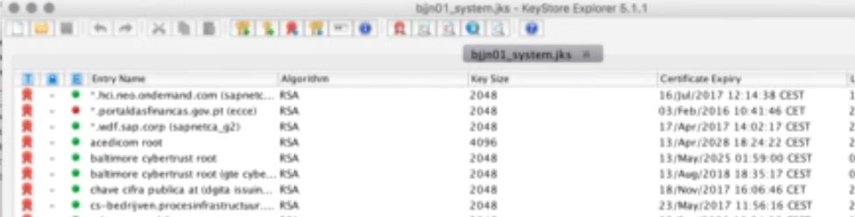

- Now browse to the service that represents the endpoint that Cloud Platform Integration shall be connecting to. Load the corresponding certificate:


- Export the root certificate into your local system.
- Go back to the keystore explorer and import the exported certificate into it.
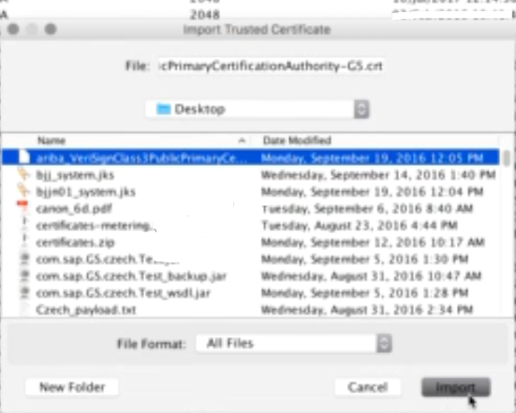

- Now save the keystore and exit.
- Redeploy the new keystore back into the tenant.

