

Create-Read Appointment from Microsoft Booking
Version 1.0

Date: 21st Jul 2025



RICEFW ID:
TD Created By: | Yogesh Wadakar
TD Reviewed By: | Krishna Kumar
TD Status: | Approved
TD Completion Date: | 21st Jul 2025
TD Approved Date:
Current TD Version: | 1.0

1

Usage guidelines and Specific Instructions:
- Document Flow- The flow of the document is generic. Specific changes to the flow will be required to be made by the client team to suit the client context.

- Document Content-The content explains the technical specification in a generic manner. Specific changes are required to be made to meet client requirements.

- Section 1 - The overall requirement summary, General technical Information, assumptions, dependencies, and messages volume details need to be documented as a part of this section.

- Section 2 – This section caters to the detailed functional requirement. The technical flow diagram and description are to be compulsorily designed and documented here. This should also include each processing step details, Exception handling, Message transformation and value mapping details.

- Section 3 – Finer details like Tenant Database area requirement like Data Store, variables and JMS queues requirement and specify the transport details.

- Section 4 - The section needs to cover all the key business test conditions and assembly test conditions that the enhancement must satisfy.

- Section 5 – All issues that have cropped up so far and their present status are to be highlighted in this section.

2

Revision History

Version No. | Change Date | Author | Revision Short Description | ITSM Ticket No
1.0 | 21st Jul 2025 | Yogesh Wadakar | Document prepared

Other Related Documents

Related Document | Comment

Document Approvals for all changes

Version No. | Author Name | Approver Name | Approver Role | Approve Date
1.0 | Yogesh Wadakar | Krishna Kumar | Delivery Lead | 22nd Jul 2025

Contents
- DEVELOPMENT OVERVIEW 5

3

  - Requirements Summary with Process flow diagram 5
  - Cloud Integration – General Technical Details 5
  - Assumptions 5
  - Messages Volume 6
  - Messages Archival requirement 6
  - Integration Flow /process model Execution Details 7
  - Naming Convention Guidelines Details 8
  - Security, Integrity, and Controls (systems Authentication details) 8
- DETAILED TECHNICAL SPECIFICATIONS 9
  - Integration Flow / Process Model Flow Diagram including all sub processes and dependent
Integration Flows 9
  - Technical Flow Description for each Integration Process model wise 9
  - Channels Configurations 9
  - Externalization (Configuration) 10
- TESTING REQUIREMENTS 11
  - Test Body 9
  - Key Unit/Assembly Test Conditions 11

4

- Development Overview
  - Requirements Summary with Process flow diagram
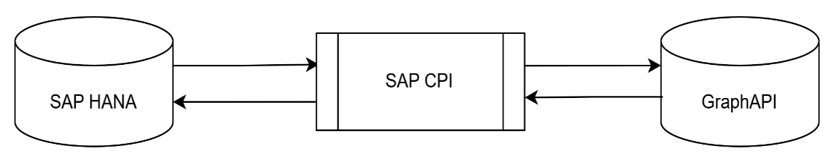

Using this integration, we can create and get the Microsoft Booking ID and booking appointments.
  - Cloud Integration – General Technical Details

Parameter | Description
Integration Scenario Technical Description | This integration is used to Create-Read Microsoft booking appointments.
Business Benefits | Help to create-read booking appointments.
Process Owner | Krishna Kumar
Technical Owner | Krishna Kumar
Systems/Applications Involved | HANA 2.0
Integration Package Technical Name | MicrosoftBookingIntegrationwithSAPHANA
Integration Package Name | Microsoft Booking Integration with SAP HANA
Integration Flow Technical name | Create-Read_Appointment_from_Microsoft_Booking
Integration Flow Name | Create-Read Appointment from Microsoft Booking

  - Assumptions
The sender will send the correct booking ID to read the appointment.

  - Messages Volume

Parameter | Description
Total Number of Messages per day | As per requested.
No of Messages per single Iflow/Process model execution | Single
Per message size in Bytes | As per body

  - Messages Archival requirement
Business
Explain:
YES
No
2 If YES to question 1:
Audit
Explain:
Tax
Explain:
1. Messages Archival required?
Legal requirement:
Explain:
- How long messages to be save in Archived area? days
- Please specify reason / explain the need for these data required? Please check all that applies.
Others: Specify
Explain:

6

  - Integration Flow /process model Execution Details
x

Data Source/sender System: | Microsoft Teams
Data Target  /Receiver System: | SAP HANA 2.0
Reference system for Direction below | Either sender or Receiver system mentioned above
Direction  (With respect to Source/sender system) | x Inbound Interface data flows inbound to Reference system Outbound Interface data flows outbound from Reference system Other Specify:
Interface Type | Batch  Near Real-Time Real-Time  File Upload  Other
Interface Frequency | Hourly Details:  Daily Details:  Weekly Details:  Monthly Details:  Quarterly Details:  Yearly Details:  x On-Demand How As per request. often:  Other Specify:
Type of Records Sent | Full record  load Send all records every time interface is executed  Delta full Only send records where one or more fields have records changed since previous execution  Only send fields (and keys) that changed since Delta records previous interface execution  Other Specify:
Quality of | x Good

7
x

Legacy Data | Average Poor
Complexity of Legacy Data | x | Good Average Poor
Attachments | x | YES NO  Other | Specify: type and number of attachments Specify:

  - Naming Convention Guidelines Details
- Name of the package – 120 characters (Flexible based the involved product names)
- short text of the package – 120 characters
- Description of the package – 1-3 paragraphs
- Name of the Artifact – 80 characters
- Integration Flow (Artifact) Description (Short Text): 120 Characters
  - Security, Integrity, and Controls (systems Authentication details)

System | Authentication Method | Cloud Integration (Security Artifact) | Type of Security Artifact | Version No | Created By | Status
Graph API | OAuth2 Authorization | AzureCerdential with scope of https://graph.microsoft.com  /Bookings.Read.All | OAuth2 Authorization Code (Microsoft 365) | 1.0 | - | Deploy ed

8

- Detailed Technical Specifications
  - Integration Flow/Process Model Flow Diagram including all sub processes and dependent Integration Flows
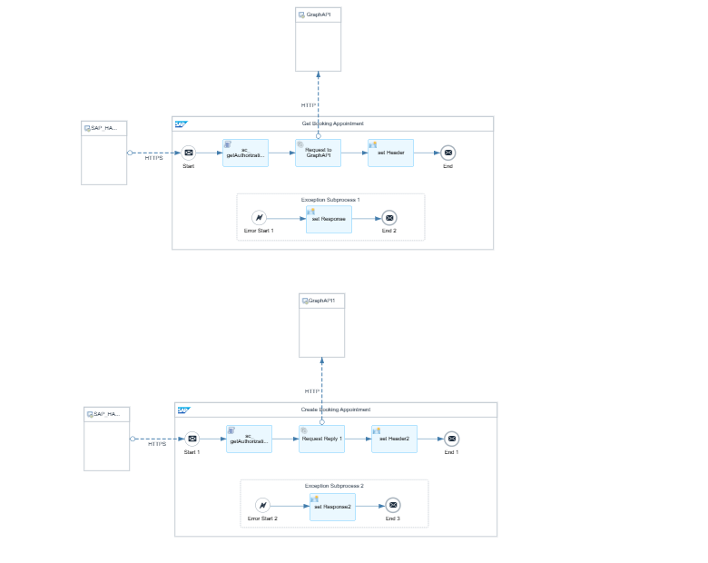

  - Technical Flow Description for each Integration Process model wise
    - To retrieve booking appointments, the sender will send a GET request with the booking ID(<booking- id>/ appointments). Using OAuth credentials, a Groovy script will retrieve the token, add it to the Authorization header, and send the GET request to the Graph API.
    - To create booking appointments, the sender will send a POST request with the booking-id. Using OAuth credentials, a Groovy script will retrieve the token, add it to the Authorization header, and send Post Request to the Graph API.

9

  - Channels Configurations

Step ID | requeust system | Adapter Type | Security Artifact/Authnticati on | Trigger details (End points, HTTP method, file name, etc..)
Sender | SAP HANA | HTTPS | Bearer Token | Get <Endpoint Address> Post <Endpoint Address>
Receiver | Microsoft | HTTP | OAuth2 Authorization Code (Microsoft 365) | Get <graphAPI>

  - Externalization (Configuration)

Parameter | Value
Endpoint URL | Enter endpoint address as per naming convention.
graphAPI | Graph API.

10

- Testing Requirements
  - Test Body
Retrieval booking appointment: Get - /getbookingBusinesses/<booking-id>/appointments Create booking appointment: Post - / getbookingBusinesses /<booking-id>/appointments

  - Key Unit/Assembly Test Conditions

Unit Test Log
Test Objective
Ste p No. | Date | Description | Expected Output/Re sults | Actual Output/Result s | Require ment ID | Sign-off
1 | 21st Jul 2025 | We send a GET request with the booking ID to retrieve the appointments. | Sender will get booking appointmen ts. | Sender got booking appointments. |  | Tested successfully.
No tes

11

