Motivation:
You want to call an asynchronous web service but do not want to block the sender. Instead you want to send a response to the sender as soon as you receive a message from it.
This response does not contain any information about the actual message processing status. The system will send an HTTP 200 response to indicate that the request is received successfully.
Solution:
In order to enable this, we will need 2 integration flow processes:
- The asynchronous flow that performs the actual processing of the message
- The synchronous flow that receives the request, passes it on to the asynchronous flow, sends a response back to the sender and finally exits.
In order to ensure that the synchronous flow passes the request to the asynchronous flow and continues processing (and not wait for the asynchronous flow to respond back) the following settings need to be made in the sender channel of the asynchronous flow:
- Message Exchange Pattern – One-way
- Processing settings – Standard (or WS Standard)
- Also in case you need to pass a WSDL to the asynchronous flow, ensure that the Operation is defined without output parameters.
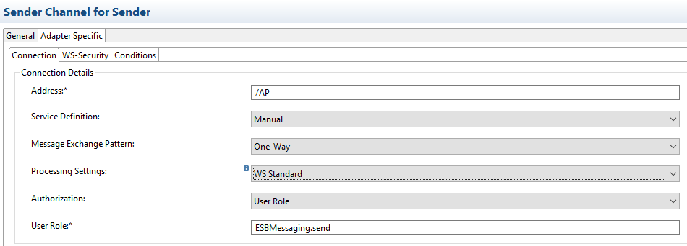

Working integration flow can be found at:
Discover Cloud Integration – Exemplars Artifacts Asynchronous Process
Discover Cloud Integration – Exemplars Artifacts Synchronous Process

To test, deploy both the flow on your tenant and then invoke the following endpoint:
<Worker node URL>/cxf/SP
This will invoke the synchronous Process flow, which will in turn trigger the Asynchronous Process flow and return the control back to the sender with an HTTP 200.
In order to simulate this, there is a script in the asynchronous flow that puts the flow to sleep for 5 mins. This is done to simulate that the process is working on something. It also gives us the chance to see that the response does not take 5 mins to get back to the sender from the synchronous Process flow, but rather almost immediately.
Asynchronous Process flow:
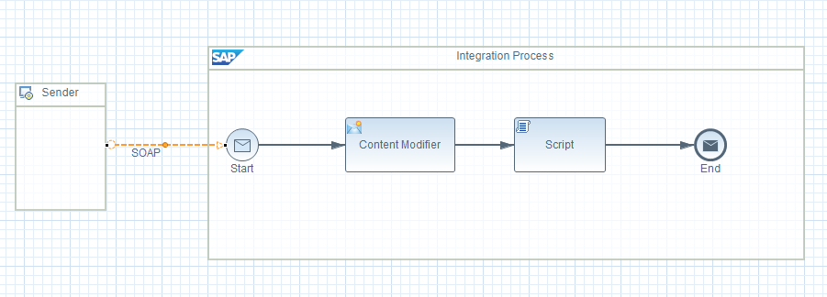
Synchronous Process flow:
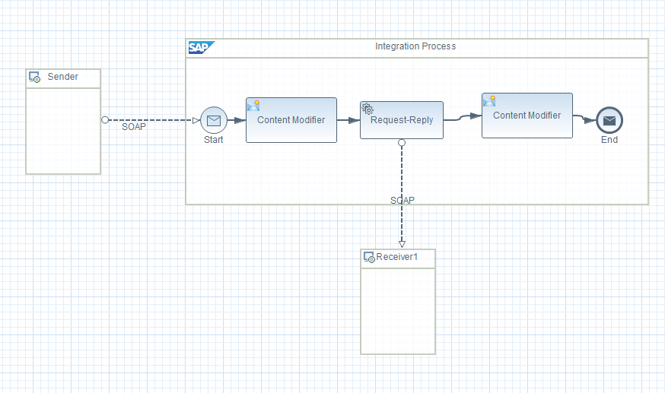
Additionally, in case there is an issue/error/exception in the processing or while dispatching the request to the receiver, there should be a means to convey that back to the sender.
This could be another flow that you can trigger from the exception sub-process of the Asynchronous Process flow.

