Sending and Receiving MIME Multipart Messages-

When a message contains one or more different sets of data in a single body, it is referred to as multipart. The multiple parts can be represented as:

- Attachments – the first message is the body and the rest are attachments

- 1 plain text body containing one or more body parts, each representing one part and preceded by an encapsulation boundary. Each part contains a header area, a blank line, and a body area.
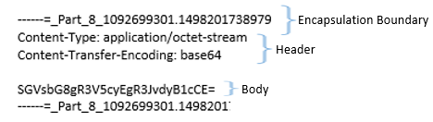
When you want to send a message with multiple parts to a system or via a protocol that does not support attachments, the message is transformed into a multipart text message.

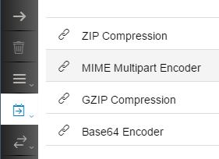

The Content-Type of such messages is set in the header as Multipart/XXX.
The value of XXX can be one of the following. It helps the receiver of the multipart message to understand how the multiple parts relate to the main message:
- Mixed: When the parts are of different type, like text, PDF, image, etc.
- Alternate: when the parts are alternative representations of one another. Like a text version, HTML version, etc. If the receiver is unable to render the HTML format, it will just use the equivalent text format.
- Digest: indicates that one part is a digest of the other.
- Parallel: indicates that all parts of the message form the main message and all need to be loaded together by the receiver to form a meaningful message.
- Related: when the different parts are related to the main message. Like an image supporting the main message.

Using the Encode step, you can convert a message with attachments into a multipart text message. Using the drop down in the Encode step configuration, you can define how the parts relate to one another:

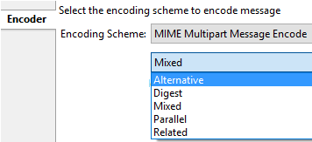

This will be set as the content type of the multipart message and shall help the receiver make correct sense of the parts.
Cloud Platform Integration passes the exchange headers as headers of the message. Some receivers do not understand the message header. In such a case, you can choose to add the header to the multipart text message:
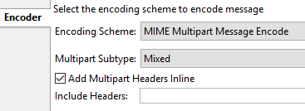

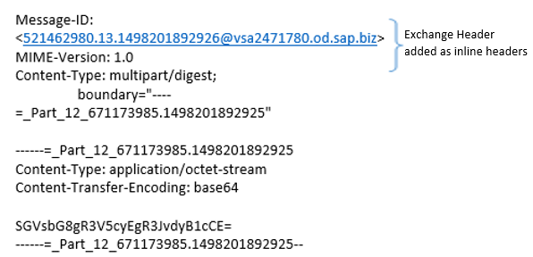

If you have header that were added via the Content Modifier step, add the names of those headers (pipe separated)


Add these headers to the Encoder configuration:

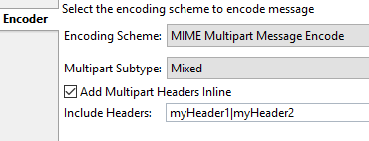

The result would look like:

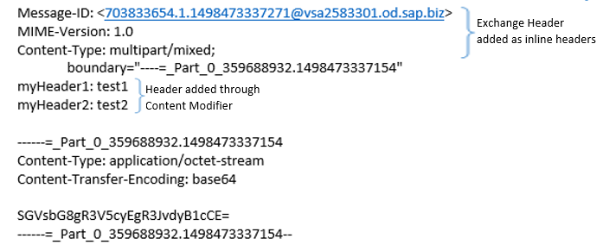

Using the Decoder, you can convert a multipart text message into a message with attachments. The decoder in Cloud Platform Integration checks if the incoming is multipart before decoding it. If it is not multipart, it simply passes through the message as it is.

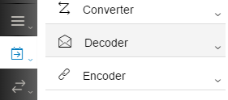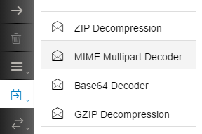
Using the checkbox, you can indicate if headers were added inline, so they can be decoded accordingly:

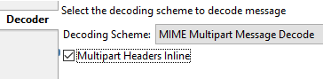

Working sample at WebUI Discover Cloud Integration - Exemplars Multipart Message Decode Encode

