Documentation
Synchronization of SAP Business Technology Platform Account Structure and SAP LeanIX
SAP Integration Package

10 February 2025 | Document Version 1.0.0
NTT Data Business Solutions AG

Contents
1. Overview & Introduction 4
2. iFlows and configuration in detail 5
2.1. Fullsync SAP BTP Account Structure 5

Document history
Issue | Date | Comments | Pages Affected
1.00 | 02.10.2025 | Original | All

Overview & Introduction
This integration package is designed to synchronize the SAP Business Technology Platform (SAP BTP) Account Structure (Global and Subaccounts) with SAP LeanIX, automatically creating Platform Factsheets in SAP LeanIX based on SAP BTP best practices for account structuring.

Currently, this package includes one integration flow (iFlow), designed to operate independently. This iFlow ensures that SAP BTP account structures are reflected accurately in SAP LeanIX, creating Platform Factsheets based on best practices.

- Fullsync SAP BTP Account Structure: This integration synchronizes SAP BTP Global Accounts and Subaccounts with SAP LeanIX. It retrieves the account structure from SAP BTP and automatically creates Platform Factsheets in SAP LeanIX based on SAP’s best practices for BTP account structuring. This interface requires manual triggering and operates once per trigger.
Each integration is designed to ensure that your IT integration strategies are supported by the most current and relevant data, fostering informed decision-making and efficient management of IT resources.

iFlows and configuration in detail

Fullsync SAP BTP Account Structure

This interfaces synchronizes SAP BTP Global Accounts and Subaccounts with SAP LeanIX.
It retrieves the SAP BTP account structure from SAP BTP Core Services and automatically creates Platform Factsheets in LeanIX based on SAP’s best practices for BTP account structuring.For more details, refer to the SAP LeanIX Documentation: Modeling SAP BTP.
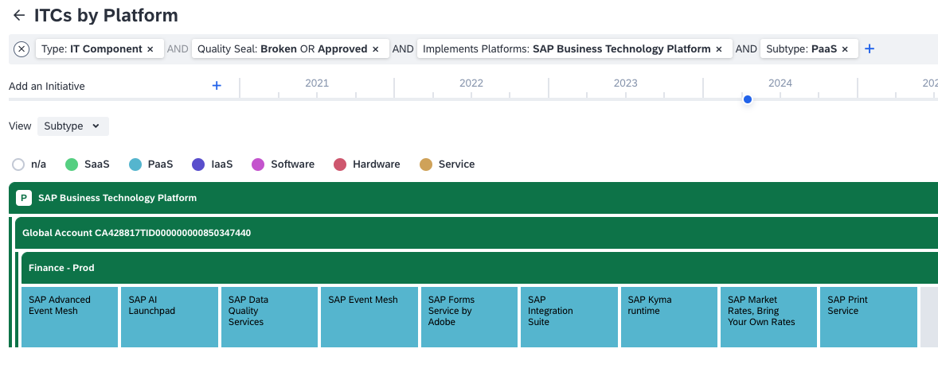

This interface requires manual triggering and operates once per trigger.
To initiate this integration, the following parameters must be configured in the iFlow:

Receiver: SAP_LeanIX

Address | Enter the SAP LeanIX API URL. The address should follow this pattern:  https://<customerdomain>.leanix.net/services/pathfinder/v1/graphql
Credential Name | Enter the credential name of a SAP LeanIX API user (OAuth2). To set this up, please create OAuth2 client credentials (refer to SAP LeanIX Developer Docs) and add these credentials as security material (OAuth2 Credentials) in the SAP Integration Suite. Then, enter the created credentials.

Receiver: SAP_BTP_CoreServices

sap.btp.core-services.address | Use the SAP BTP Core Services URL:  https://accounts-service.cfapps.<region>.hana.ondemand.com/accounts/v1
Credential Name | Use your SAP BTP Core Services credentials (OAuth2). To set this up, create a “SAP Cloud Management service (Cis)”-instance in BTP and create OAuth2 client credentials (see SAP HELP). Add these credentials as security material (OAuth2 Credentials) in the SAP Integration Suite. Then, enter the created credentials.

Please ensure that the client credentials are functioning correctly. To start the iFlow, deploy it. The integration will automatically commence (once) and the vendors will be synchronized. You can view all synchronized vendors in the monitoring section – an attachment with all status codes will be created.

