Scenario:
The incoming message contains a list of records. We use a splitter to separate each record. Based on the value of a field of the record, we need to group the records into 2 categories and then process the 2 message groups separately.
Assume you have a resultset with 100 records, each having the following structure:
<Student>
<Id>
<Name>
<Class>
<Student>

Now you want to separate all the students as
Group A – Class 10 and above
Group B – Class 1 to 9

Classification of the student records and separately processing them thereafter can be done in 2 ways:
- In-memory filtering of the entire resultset based on condition:
Content Modifier Property Add
Action - Create
Name - <any name you want to use>
Type - XPath
Data Type - org.w3c.dom.NodeList
Value - <XPath with condition>, example /Students/Student[Class < 10]
Default -

Use a content modifier to assign the value of the properties created above to the body of the message in the pipeline:

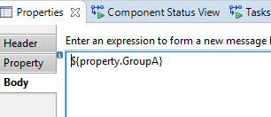

Now the body only contains filtered content. Process this sub-set. Once you are done with the processing, transmit it to the desired receiver and then allocate the value of property GroupB to the body of the message in the pipeline and then process them separately. Alternatively, you can also create a parallel multicast and triggers both sub-set processing together.

Please note that this option “In-memory filtering” is not optimal when you have a large dataset because it keeps the entire resultset in memory.

- Explicit classification: Start by splitting the resultset into individual records. For each record, check the condition and based on the condition, allocate the record to one of the 2 groups. This is done by using a datastore.
Message groups are stored in individual Datastores (in the DB).
First use a splitter to break the incoming message into individual records:
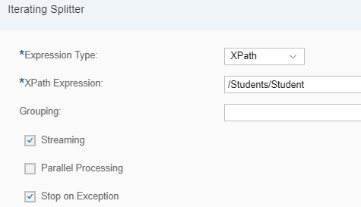

Now segregate each record based on the desired condition:

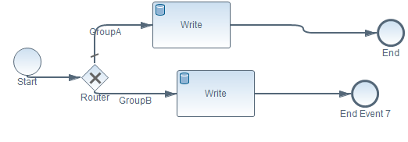

The Write step is configured as follows:

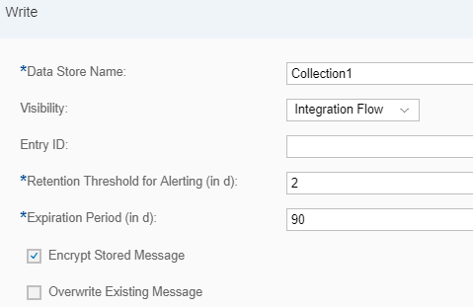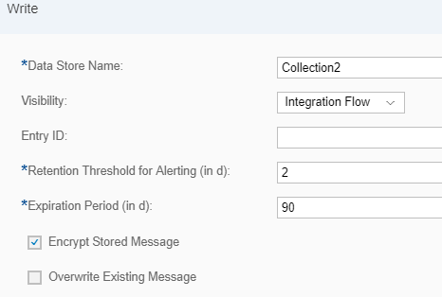

In my example, I used:

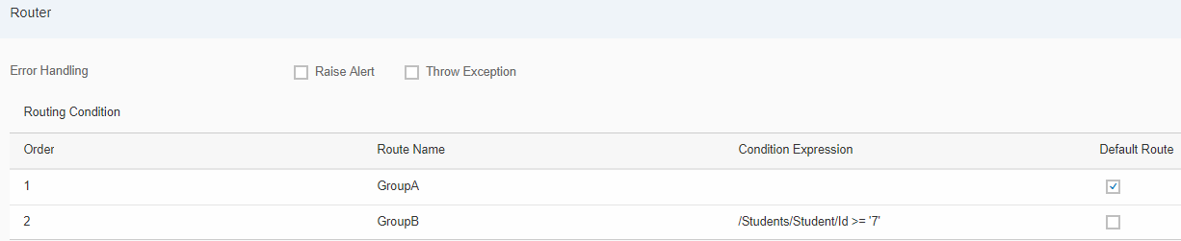

I use the Gather step to mark the end of the looping through the split message.

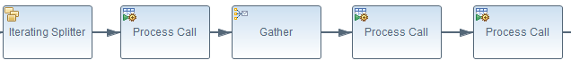
As soon as the message segregation is done, it is a good idea to reset the message body to release space.

Now retrieve the data stored in individual datstores and perform any processing that is intended for that sunset. In this case, I am just sending out an email with the collected records.

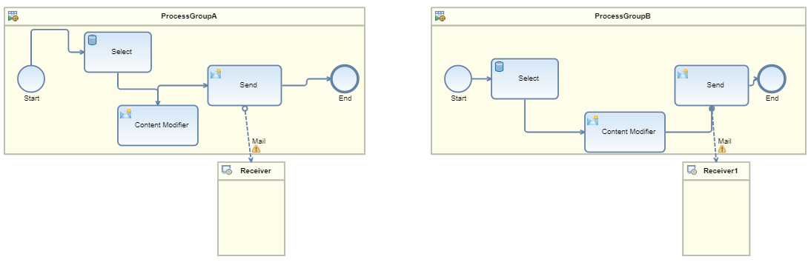

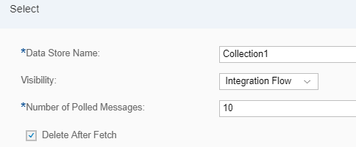

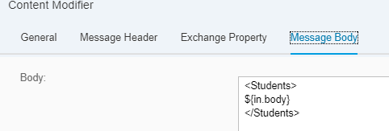

This process is specifically relevant when you need to multicast the resultset.

Working integration flow can be found at:
Discover Cloud Integration – Exemplars Artifacts In-memory resultset classification
Discover Cloud Integration – Exemplars Artifacts Processing resultset subsets differently

