

[Contacts Reconciliation From SAP Marketing Cloud To ThirdPartySftp]

Date: 10/03/2020 Version: 1.0 Author: Oleg Veliks

DOCUMENT CONTROL

Owner | Client contact | Status | Date issued
Oleg Veliks | N/A | N/A | N/A

Version history log

Version | Description of change | Date | Author
1.0 | Initial version | 10.03.2020 | Oleg Veliks

TABLE OF CONTENTS
- PURPOSE 3
- OVERVIEW 4
- PRE-REQUISITES 5
- INTEGRATION FLOW CONFIGURATION 6
  - Configuration Parameters 6
- HANA RECONCILIATION SQL SCRIPT 7
- STEPS FOR TESTING THE IFLOW 8

PURPOSE
This document provides configuration steps of the integration flow to extract the loaded customers from SAP C/4 Marketing Cloud System via OData and transforms them as AWS S3 files to reconcile data between sap marketing cloud and third party systems. The output files are then fed to other SAP Cloud Integration Data Service Flows to load SAP C/4 Marketing Cloud System data into Staging DB and compare customers loaded into SAP Marketing Cloud with Legacy Data in Staging DB. We used SCP HANA DB in our scenario but you can use any staging DB that SAP Cloud Integration DS or PI supports.

OVERVIEW
This IFLOW is used to reconcile the customer data between SAP Marketing Cloud Systems and Legacy Source Systems. The output files are then fed to SAP Cloud Integration data service Flows to compare customers loaded into SAP Marketing Cloud with Legacy Source Data Staging DB.

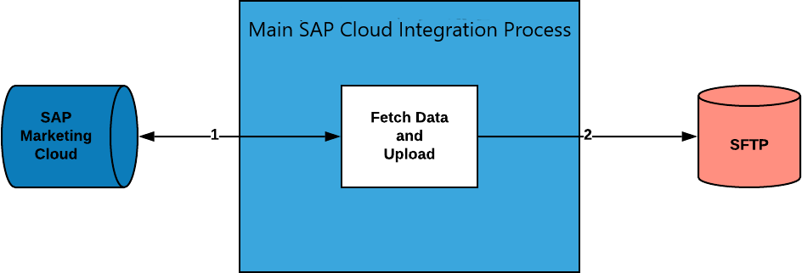

Step 1. Fetch Contact records via OData call in pages from SAP Marketing Cloud. This process will repeat until there are no records to be fetched.
Step 2. Convert the records retrieved via OData call for each 5k record page with a time stamp from SAP Marketing Cloud into CSV format and save it as separate files under SFTP directory.

PRE-REQUISITES
Before configuring Integration Flow, please make sure the following prerequisites have been met:

- SAP Marketing Cloud API for fetching Contact data is enabled and up and running.
- Amazon Web Services account is enabled. S3 bucket is created and SFTP Transfer server is up and running. S3 bucket is a root directory of SFTP.
- SFTP server is configured and connectivity between SAP Cloud Integration tenant and SFTP is established.
- SFTP user having permissions to create and update folders and files.

INTEGRATION FLOW CONFIGURATION

Configuration Parameters

Externalized Parameter Name | Description | Sample Value
Receiver - C4M(Address) | Host address of SAP Marketing Cloud API for fetching Contacts
Receiver - C4M (Credential Name) | Credential name to connect to the system as deployed in the tenant. | KAPIUSER
Receiver - C4M (Page Size) | Specify page size to retrieve required number of records from C4M | 4900
Receiver - C4M (Timeout in min) | Maximum time the system wait before operation is terminated. | 10
Receiver - SFTP(Directory) | File path from where log files should be written. | DevelopmentLoads/LoadFiles/Contacts/C4M/R econciliation
Receiver - SFTP(File Name) | Name of the file name to be written. | Customers_Reprocess_C4M.csv
Receiver - SFTP(Address) | Host name or IP address and port of the SFTP server. | sftphostname
Receiver - SFTP(User Name) | ID of the user performing file transfer. | CPI_USER_PROD

HANA RECONCILIATION SQL SCRIPT

This step assumes that you loaded the SAP C/4 marketing cloud data into HANA DB that you extracted into AWS S3 files via SAP Cloud Integration Data Service flows. You can use the following script to reconcile legacy system customer data with SAP C/4 Marketing Cloud System.
//Creation of missing Customers-
Description of Query: selecting customer data from table “ CUSTOMERS” (legacy data) which is not present in table “ CUSTOMERS_RECONCILIATION” and inserting them into new table “ CUSTOMERS_RECONCILIATION_C4M_Temp”.

create column table prod_hana_ds.CUSTOMERS_RECONCILIATION_C4M_Temp as ( SELECT customerid FROM (SELECT customerid FROM prod_hana_ds.CUSTOMERS except SELECT customerid FROM prod_hana_ds.CUSTOMERS_RECONCILIATION));

STEPS FOR TESTING THE IFLOW
Step 1. Deploy iflow and wait until it is finished. Iflow Components:
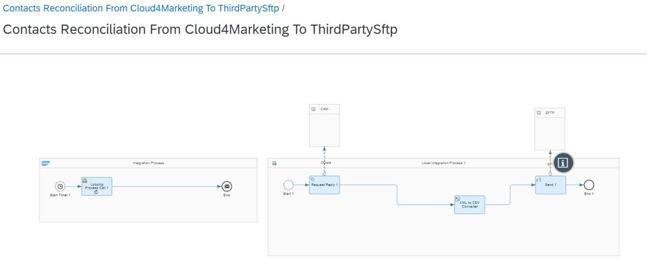
Status of message is successful.
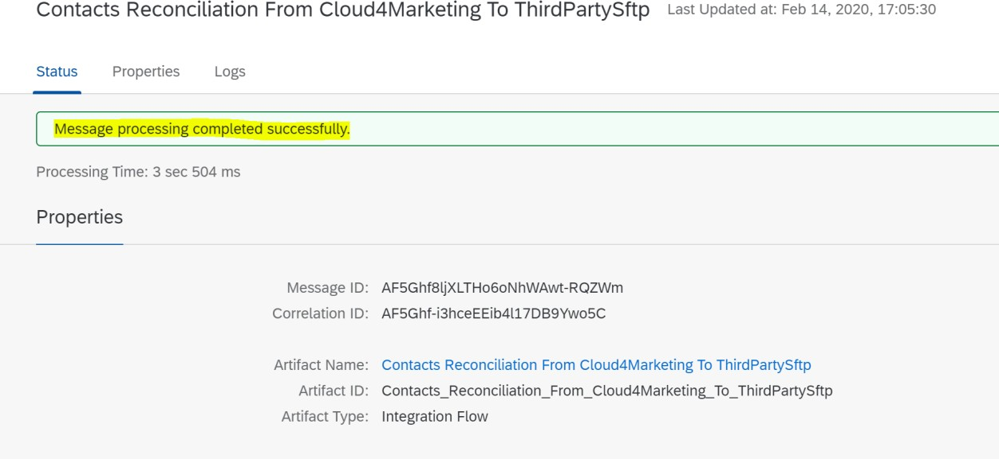
Overview of Trace Logs:

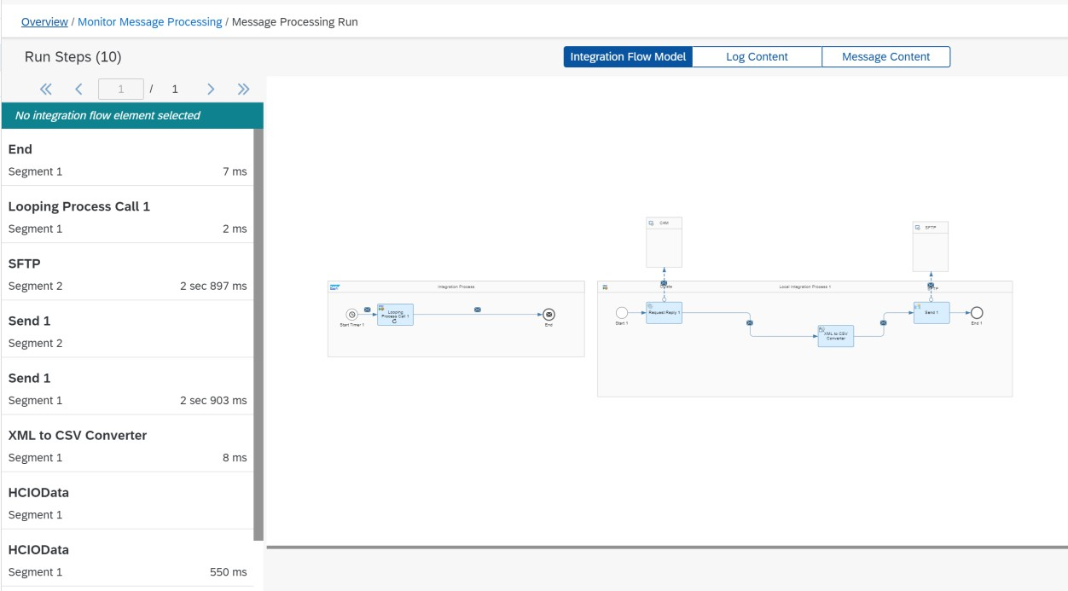

Step 2. Login to AWS S3 bucket folders using FileZilla and Explore the SFTP directory specified in "Receiver - SFTP(Address)" and make sure all contacts which exist in SAP Marketing Cloud appear in file Receiver - SFTP(File Name)

