

[Contacts Data Load From ThirdPartySftp To SAP Marketing Cloud _HANA LOGS]

Date: 10/03/2020 Version: 1.0 Author: Oleg Veliks

DOCUMENT CONTROL

Owner | Client contact | Status | Date issued
Oleg Veliks | N/A | N/A | N/A

Version history log

Version | Description of change | Date | Author
1.0 | Initial version | 10.03.2020 | Oleg Veliks

TABLE OF CONTENTS
- PURPOSE 3
- OVERVIEW 4
- PRE-REQUISITES 5
- INTEGRATION FLOW CONFIGURATION 6
  - Configuration Parameters 6
- STEPS FOR TESTING THE IFLOW 10

PURPOSE
The purpose of this document is to describe the general configuration steps required to set up the integration flow for migrating millions of Customers from/to third Party systems to SAP C/4 Marketing Cloud Systems. The integration flow provides out of the box capability to consume millions of customers in files of size 100k records from S3
buckets and splits them into smaller OData (5k) Packets and provides full traceability on whether each 1k or 5k packet is processed successfully or failed in SAP C/4 Marketing Cloud System.

This IFLOW is an enhancement of SAP Standard
Content https://api.sap.com/package/SAPHybrisMarketingCloudfilebaseddataload?se ction=Artifacts that will address the following limitations of the standard content:

  - The error handling capability delivered in the standard integration triggers alerts via e-mail which is really not a good use case for complex large volume migration projects unless someone wants to jam their inbox with millions of error e- mail alerts.
  - There is no mechanism for full audit logging of what packets failed and what packets are successfully sent to marketing cloud for each file. Imagine a scenario where we need to migrate 20 million customers that are split into 200 files of 100k records and split into 1000k packet for each OData call to optimize performance and client want to have full traceability to extract files to understand what records failed and what records are processed successfully in SAP C/4 Marketing Cloud System for each file..
  - There is no standard SAP Cloud Integration mechanism to automatically move the error files to error folder. Due to that limitation, the files are reprocessed in the next run by the SAP Cloud Integration IFLOW resulting in many message failures in SAP Cloud Integration and also adversely effecting performance.

In this IFLOW, the error logs for each packet of source files are written in HANA Data base. It provides flexibility of customers to review the results of the file packets that failed in graphical HANA reports and helps them to resolve data issues quickly.

OVERVIEW
This Integration Flow reads millions of customers from AWS S3 Buckets (100k files) and splits them into 5K or 1k OData API packets before sending data to the SAP Marketing Cloud Systems (5k OData Packet).
Please check the below diagram to understand the end-to-end process.

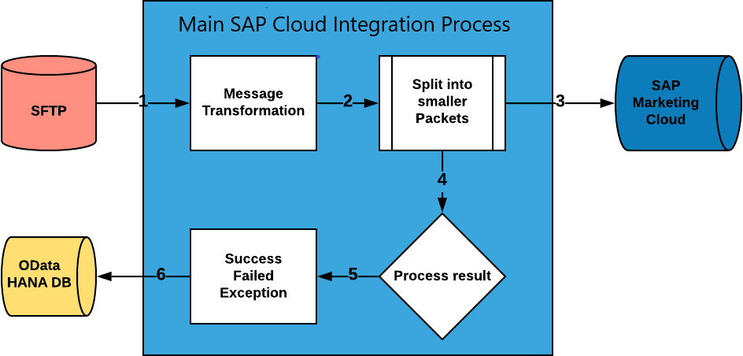

Step 1. The file is uploaded on AWS S3 bucket and AWS SFTP service is set up to read and write files into S3 via SFTP.
Step 2. SAP Cloud Integration Flow splits100k files into smaller OData API packets.
Step 3. SAP Cloud Integration Flow Sends OData packets one by one to SAP Marketing Cloud.
Step 4. SAP Cloud Integration Flow analyses the SAP Marketing Cloud response of each packet.
Step 5. SAP Cloud Generates the log for each packet of each file indicating which file is successful and which packet is failed. Logs sent to HANA DB via exposed table as OData service. Source filed is moved to Archive or Error folder based on results. The file is automatically moved into error folder if there is an error in processing the full file else it is moved into an archive folder.

PRE-REQUISITES
Before configuring Integration Flow, please make sure the following prerequisites have been met:

- The SAP HANA Cloud Platform Integration has been delivered.
a. SAP HANA Cloud Platform Integration - https://www.sap.com/products/hana-cloud-integration.html https://cloudplatform.sap.com/index.html
- Amazon Web Services account is enabled. S3 bucket is created and SFTP Transfer server is up and running. S3 bucket is a root directory of SFTP.
- SFTP server is configured and connectivity between SAP Cloud Integration tenant and SFTP is established. SFTP user having permissions to create and update folders and files.
- HANA database is up and running. A table called log table is exposed as OData service with CRUD operations.
Here is table definition:
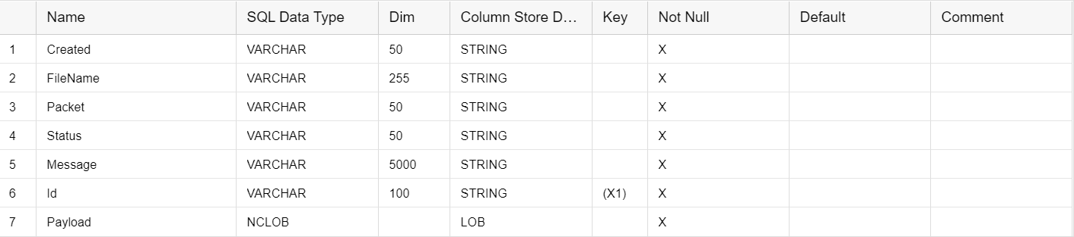

INTEGRATION FLOW CONFIGURATION

4.1 Configuration Parameters

Externalized Parameter Name | Description | Sample Value
Sender (Directory) | Root SFTP directory. A source directory of SFTP server. | DevelopmentLoads/LoadFiles/Contacts/C4M/After Split/Current
Sender Processing (Lock Timeout) | How long to wait before  trying to  process the file again. | 20
Sender (User Name) | SFTP User  Name. SFTP user which has access to SFTP directories. | CPI_USER_PROD
Sender (Timeout) | Maximum waiting time to contact the FTP server while establishing connection or performing a read operation. | 10000
Sender (Post- Processing) | Controls which actions should be done after file processing. | Move File
Sender (Max. Messages per Poll) | Maximum number of  messages to  gather for each poll. | 50
Sender (FileName) | Source File Name on SFTP server. A file from where to load data. | test_contacts.csv
Sender (Change Directories Stepwise) | Changes directory levels one at a time | true

Sender (Buffer size) | Write the file content using the mentioned buffer size. | 128
Sender (Archive Directory) | Specifies the directory and the file name when moving the file after processing. | ${property.archiveDirectory}/${property.origFileNa me}
Sender (Address) | SFTP server host name. | xxx.server.transfer.eu-west-2.amazonaws.com
Receiver - SAPMkt (Timeout) | Maximum time system waits before termination. | 10
Receiver - SAPMkt (SAP_Mkt_Host) | Host address of SAP Marketing Cloud | https://myxxx.s4hana.ondemand.com
Receiver - SAPMkt (Credential Name) | Credential name to connect to the system as  deployed in the tenant. | KTAPIUSER
Receiver - SAPMkt (Authentication) | Authentication type of OData service for SAP Marketing Cloud | Basic
Receiver - SAPMkt (Address) | Service root  URL of the OData service provider. | {{SAP_Mkt_Host}}/sap/opu/odata/SAP/API_MKT_C ONTACT_SRV;v=0002
Receiver -  HANA_DB  (Credential Name) | Credential name to  connect to OData service | KTAPIUSER
Receiver -  HANA_DB (Address) | Enter service root URL of the OData service provider. | hanadbODATAURL
Receiver -  AWS_SFTP_LOG  (User Name) | ID of the user performing file transfer. | CPI_USER_PROD
Receiver -  AWS_SFTP_LOG (File  Name) | Name of the file name to be written. | error_log.csv

Receiver -  AWS_SFTP_LOG  (Directory) | File path from where log files should be written. | DevelopmentLoads/LoadFiles/Contacts/C4M/After Split/Current/Error
Receiver -  AWS_SFTP_LOG  (Address) | Host name or IP address and port of the SFTP server. | xxx.server.transfer.eu-west-2.amazonaws.com
Receiver -  AWS_SFTP (User Name) | ID of the user performing file transfer. | CPI_USER_PROD
Receiver -  AWS_SFTP (Address) | Host name or IP address and port of the SFTP server. | xxx.server.transfer.eu-west-2.amazonaws.com
More (XML Converter - XSD Path) | Path to Target Element in XSD | CSV_Contacts/Contact
More (Splitter XPath Expression) | Xpath expression to navigate to the split item using absolute path. | /CSV_Contacts/Contact
More (Splitter Timeout) | Maximum waiting time to contact the FTP server while establishing connection or performing a write operation. | 10800
More (Splitter Grouping) | This configuration parameter is used to split the file into multiple OData packets  . If the packet size is 5000 then 5000  interactions will be sent to marketing system in one API Call | 5002
More (Splitter Concurrent Processes) | Number of processes running in | 5

 | parallel. Used for Splitter step.
More (Path to Successful Logs) | Path on FTP server where to write logs of successfully processed records | DevelopmentLoads/LoadFiles/Contacts/C 4M/AfterSplit/Current/Logs/  ${property.origFileName}/${property.CamelSplitInd ex}_Success_${property.SAP_MessageProcessingLo gID}.xml
More (Path to Failure Logs) | Path on FTP server where to write error logs | DevelopmentLoads/LoadFiles/Contacts/C 4M/AfterSplit/Current/Logs/  ${property.origFileName}/${property.Cam  elSplitIndex}_Failure_${property.SAP_Messa geProcessingLogID}.xml
More (Path to Exception Logs) | Path on FTP server where to write exception logs | DevelopmentLoads/LoadFiles/Contacts/C 4M/AfterSplit/Current/Logs/  ${property.origFileName}/${property.Cam elSplitIndex}_Exception_${property.SAP_M essageProcessingLogID}.xml
More (Enable Hana Logging) | Enables hana logging via OData. | X

STEPS FOR TESTING THE IFLOW
Step 1. Access the WEB UI URL on your SAP Cloud Platform Integration tenant. It should be in the format https://.hci.us1.hana.ondemand.com/itspaces
Step 2. Place the file in the SFTP server using Filezilla or other FTP client in the designed directory
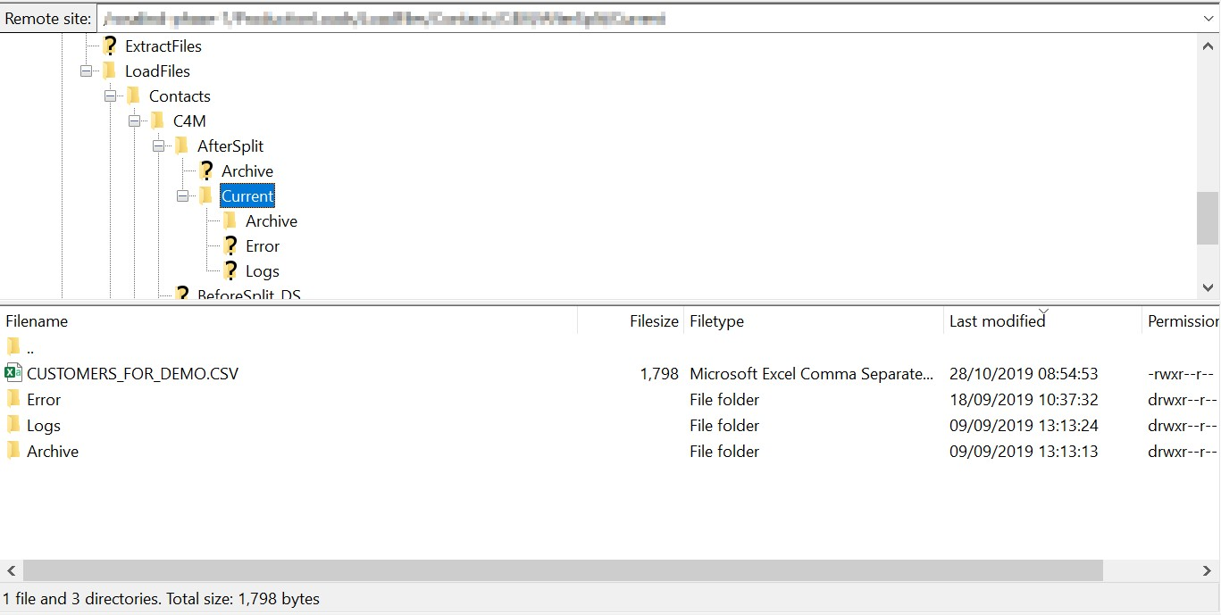
Step 3. Configure iflow and deploy. The iflow should be deployed.
Step 4. Login to SAP Marketing Cloud and go to Import Monitor app. You should be able to see status of processed message.
If there is a message - fix an error and start process from the beginning.
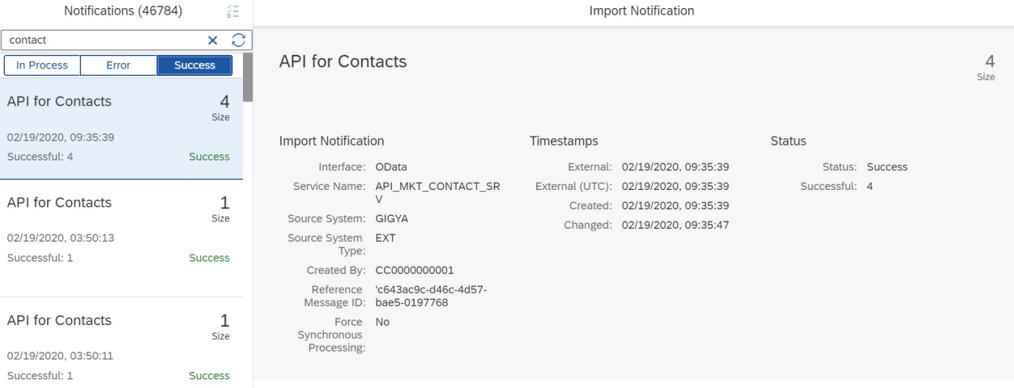
Step 5. Check the customer is created in the SAP Marketing Cloud Using the Fiori App "Inspect Contact"

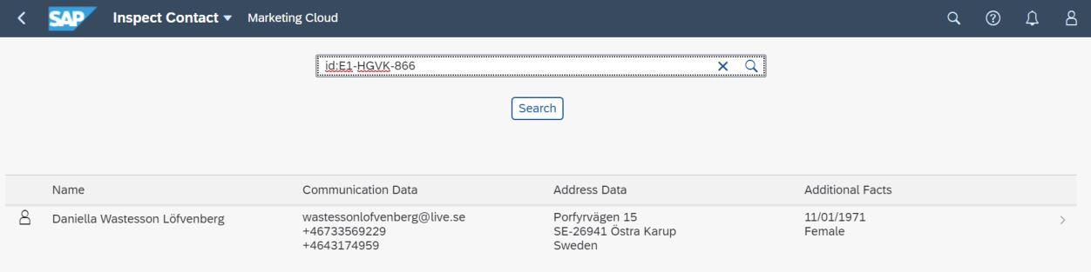
Step 6. Make sure source file has been moved to Archive folder after it has been processed.
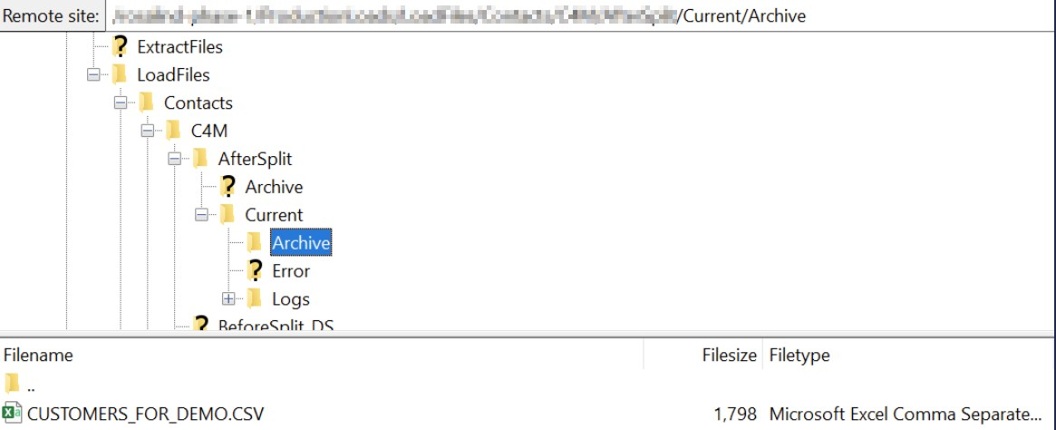
Step 7. If hana_log parameter is "X" - check the HANA log table to see how many packets are successfully processed and how many packets failed.
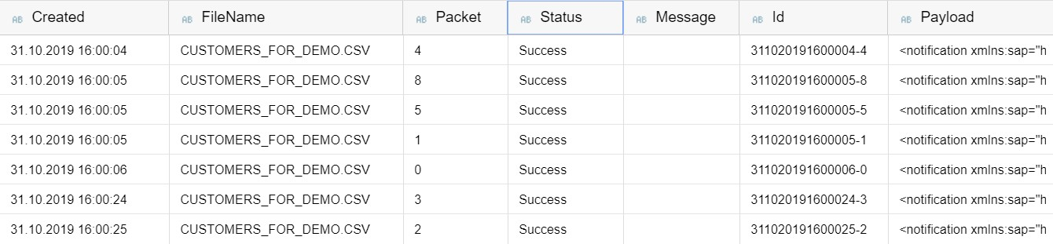
Step 8. Access the Monitor tab (Operations view) on the left side in the navigation for the "Integration Flow " to see the IFLOW processing status

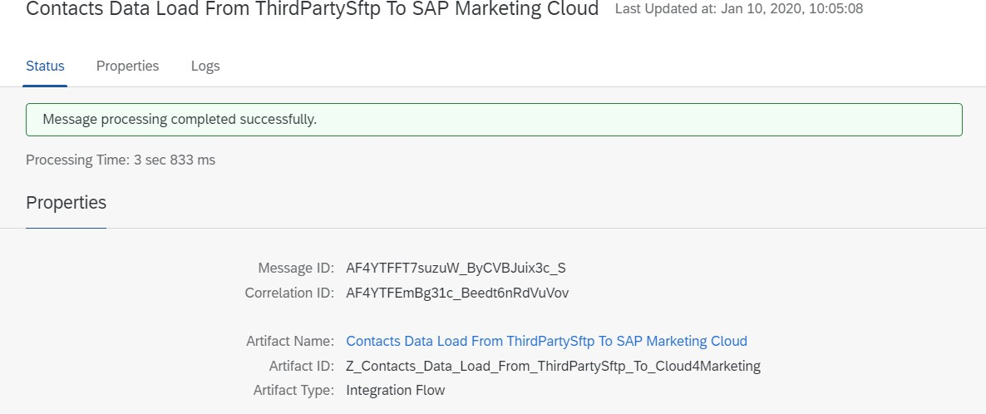
Step 9. To make sure iflow has been processed in the right way - increase log to debug or trace and check detailed log.
