Accessing credentails from a script:

The user/password configured in a deployed credential can be accessed programmatically from a script with the help of the getUserCredential api of the SecureStoreService class

Classes needed:
com.sap.it.api.securestore.SecureStoreService;
com.sap.it.api.securestore.UserCredential;

Method signature:
public UserCredential getUserCredential(String alias)

Sample Code:
Get a handle to the SecureStoreService service:
def service = ITApiFactory.getApi(SecureStoreService.class, null);

Retrieve the target value using:
def credential = service.getUserCredential("<Name of Credential that is deployed on the tenant>");

Finally retrieve the username and password from the credential object:
String userName = credential.getUsername();
String password = new String(credential.getPassword());

Example:

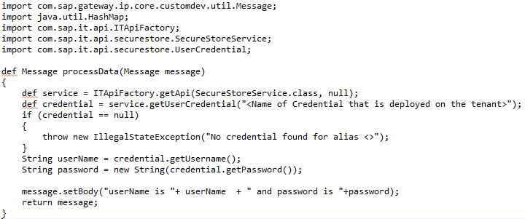

The above code will print the retrieved user and password to the message payload (body).

Working integration flow can be found at:
Content hub Discover Cloud Integration – Exemplars Artifacts Accessing Credentials in Scripts

