Motivation:
You need to access and set Header, Property and Externalized Parameters in Message Mapping

Solution:
Create a script with an extension .gsh in the script folder of your project containing the following code:

import com.sap.it.api.mapping.MappingContext

def String getProperty(String myProperty, MappingContext context) {
def myPropertyValue = context.getProperty(myProperty);
return myPropertyValue;
}

def String getHeader(String myHeader, MappingContext context) {
def myHeaderValue = context.getProperty(myHeader);
return myHeaderValue;
}

For an Externalized Parameter, use a content modifier to assign the value of the externalized parameter to either a property or a header:

Then using the above script, you can use getHeader/getProperty to retrieve the value.

Now goto the message mapping and add Custom function, browse to the script file that you created above:

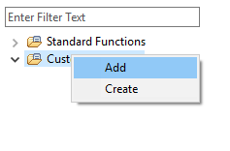
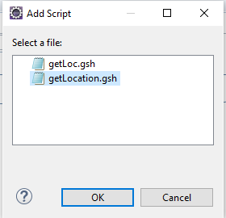
Once the script gets added, you see a new entry under Custom function:
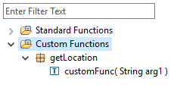

Now drag the function to your mapping canvas:

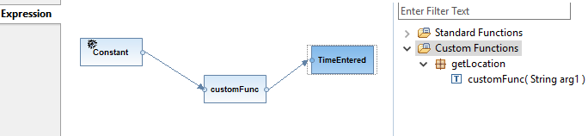

Add a Const and assign it the name of the header or property you want to retrieve.

The name of the header or property shall be used to retrieve its value using the custom function and the retrieved value shall be assigned to the target node.

Working integration flow can be found at: Discover Cloud Integration - Exemplars Artifacts Accessing Header Property and Externalized Parameter from Message Mapping

