SAP Document and Reporting Compliance for China Incoming VAT Invoice: Setting Up SAP Cloud Integration

This document lists the required setup steps that you must perform in your SAP Cloud Integration tenant so that the integration between the partner and SAP S/4HANA works. The setup steps are typically done by an SAP Cloud Integration consulting team from customer, which is responsible for configuring the connection with SAP Cloud Integration. This team may be also responsible for maintaining the integration content, certificates/credentials on the SAP Cloud Integration tenant.

1. Prerequisites

1.1 Enable China Incoming VAT Invoice Management Solution
You have enabled the China Incoming VAT Invoice Management solution in SAP S/4HANA Document and Report Compliance.

1.2 Register with Partner
You have registered with a partner to use its APIs for communicating with the Golden Tax Service.

1.3 Set Up SAP Cloud Integration Tenants
You have SAP Cloud Integration test and production tenants that are live, and users in the tenants have the rights to copy the integration package, to configure and deploy the integration flows. When your tenants are provisioned, you receive an email containing a Tenant Management (TMN) URL. You need this URL when configuring the communication between the SAP Cloud Integration tenant and your SAP S/4HANA tenant. To be able to deploy the security content, you must be assigned to the AuthGroup and Administrator roles. If you are a first-time user, you must first set up your users and their authorizations in the SAP Cloud cockpit.

2. Configuration Steps in SAP Cloud Integration

2.1 Deploy Security Materials

2.1.1 OAuth2 Client Credentials for Partner

When attempting to communicate with the partner, you need to configure OAuth2 client credentials and grant them to integration flows. You configure the security materials in your SAP Cloud Integration tenant.

The required OAuth2 client credentials are as follows:
Name | Description
Token Service URL | URL provided by the partner for acquiring the OAuth2 token to secure their service.
Client ID | Client ID provided by the partner for acquiring the OAuth2 token to secure their service.
Client Secret | Client secret provided by the partner for acquiring the OAuth2 token to secure their service.

Procedure

To configure the above credentials, follow the steps below:

1. Log on to your SAP Cloud Integration tenant.

2. Go to Monitor (Operations view) and open the Security Material app.

3. Click Add on the top right corner of the browser window. Select OAuth2 Client Credentials.
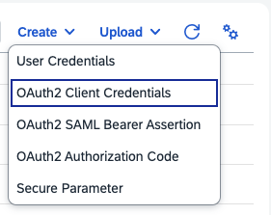

The following dialog box appears:
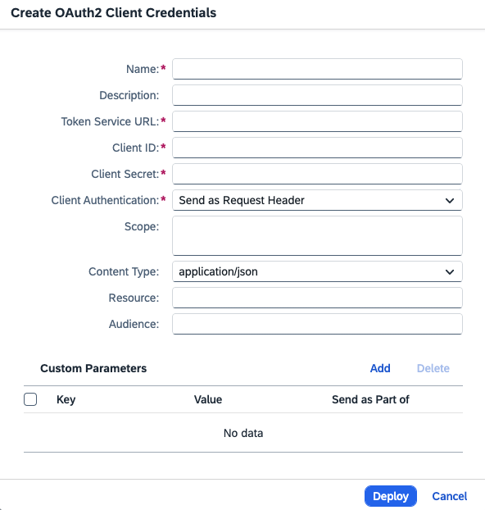

4. Enter a credential name and remember it for later integration flow configuration.

5. Enter the aforementioned token service URL, client ID, and client secret.

6. Keep the default client authentication and content type.

7. Choose Deploy.

2.1.2 User Credentials for SAP S/4HANA

Integration flows also provide integration with SAP S/4HANA for operations like invoice write-back, therefore the user credentials for the OData service API_CN_VAT_INVOICE_SRV need to be configured as well.

The required OAuth2 user credentials are as follows:
Name | Description
Username | Inbound user in SAP S/4HANA communication arrangement
Password | Password of the inbound communication user

Procedure

To configure the above credentials, follow the steps below:

1. Log on to your SAP Cloud Integration tenant.

2. Go to Monitor (Operations view) and open the Security Material app.

3. Click Add on the top right corner of the browser window. Select User Credentials.
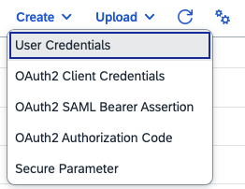

The following dialog box appears:

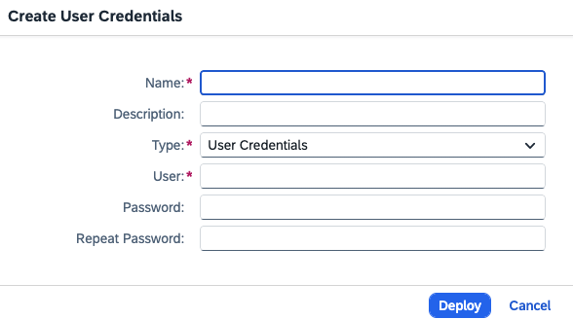

4. Enter the name for the credential and remember it for later integration flow configuration.

5. Enter the aforementioned user, password, and repeat the password.

6. Keep the default type.

7. Choose Deploy.

2.2 Copy Published Package

Procedure

1. In the Discover section of your tenant, select the package "SAP Document and Reporting Compliance: Direct Connection for China Incoming VAT Invoice - Generic Templates".

2. Choose Copy.

2.3 Deploy Integration Flows

Required steps for configuring the integration package and SAP Cloud Integration.

Context

The following integration flows and value mapping are available in this package:

Integration Flow and Value Mapping | Function
Dispatch SAP S4HANA Requests to Partner- Template | Template integration flow to receive and dispatch direct connection requests from SAP S/4HANA to the corresponding partner services.
Forward Partner Requests to SAP S4HANA - Template | Template integration flow to receive and forward callback requests from the partner to SAP S/4HANA OData services.
Tax Number Partner Value Mapping - Template | Template for mapping tax numbers from SAP S/4HANA request payload to partner service URL and credential name.

Procedure

1. Open the integration package that you copied.

2. Select the Artifacts tab.

3. Select the integration flow "Forward Partner Requests to SAP S4HANA - Template".

4. Choose the Actions icon and then choose Configure, the following dialog box appears:
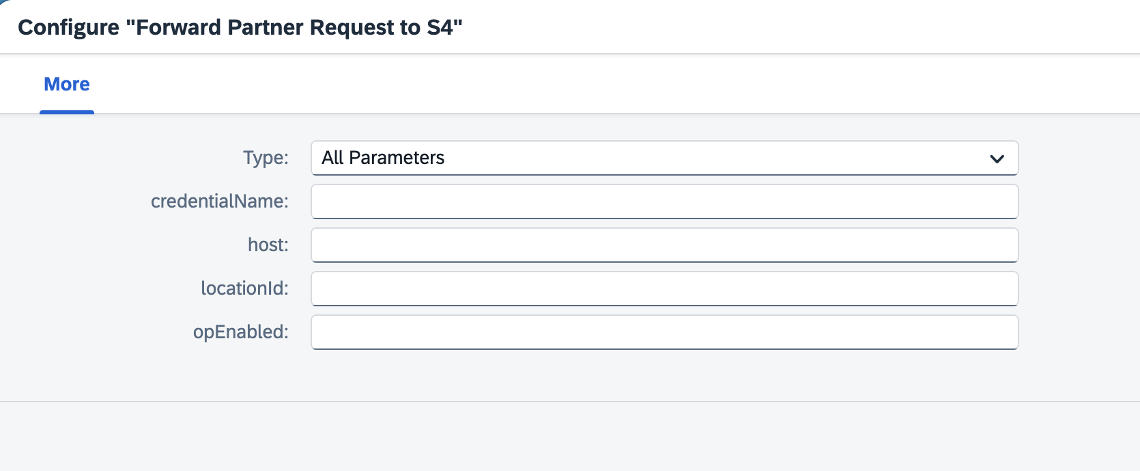

5. Configure the parameters in the integration flow and save them.

6. Select the value mapping "Tax Number Partner Value Mapping - Template".

7. Choose the Actions icon and then choose Configure.

8. Configure the entries of the value mapping and save them.

9. Choose Deploy on the integration flow and value mapping respectively.

For information on how to configure the parameters of the integration flow and value mapping, see below "Parameter Information" and "Value Mapping Configuration" sections.

2.4 Parameter Information

The following table explains all the parameters that you should configure.

For integrating with the SAP S/4HANA product, you need to configure the cloud connector instance first, then you choose ‘X’ for the “opEnabled” parameter in our integration flows, and fill in the location ID.

For integrating with the SAP S/4HANA Cloud Public Edition product, you should only configure the credential name and host.

Parameter | Explanation
credentialName | The credential name configured in 2.1.2 section.
host | SAP S/4HANA service URL in your system plus the hardcoded OData service configured in iFlows.  URL example: http://xxx-xxx-api.devsys.net.sap:443/sap/opu/odata/sap
locationId | Location id in cloud connector configuration

opEnabled

2.5 Value Mapping Configurations
The value mapping contains bi-directional mappings as shown in the screenshot below:

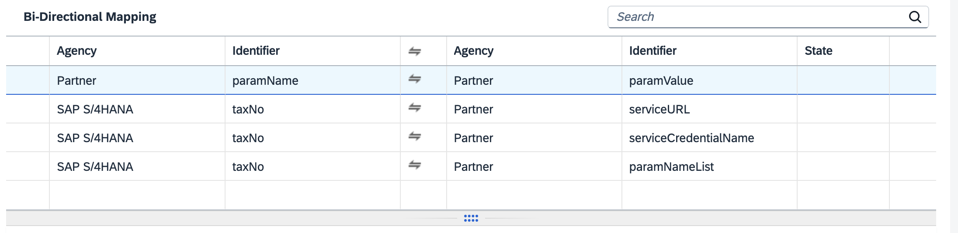

2.5.1
The second and third entries in the above screenshot (hereafter refers to "value mapping screenshot"), which includes "serviceCredentialName" and "serviceURL," are related to the OAuth settings for connecting to partner-exposed APIs. Configure them by following the procedure below:

Procedure

1. Choose the third entry in the value mapping screenshot, the following dialog box appears:
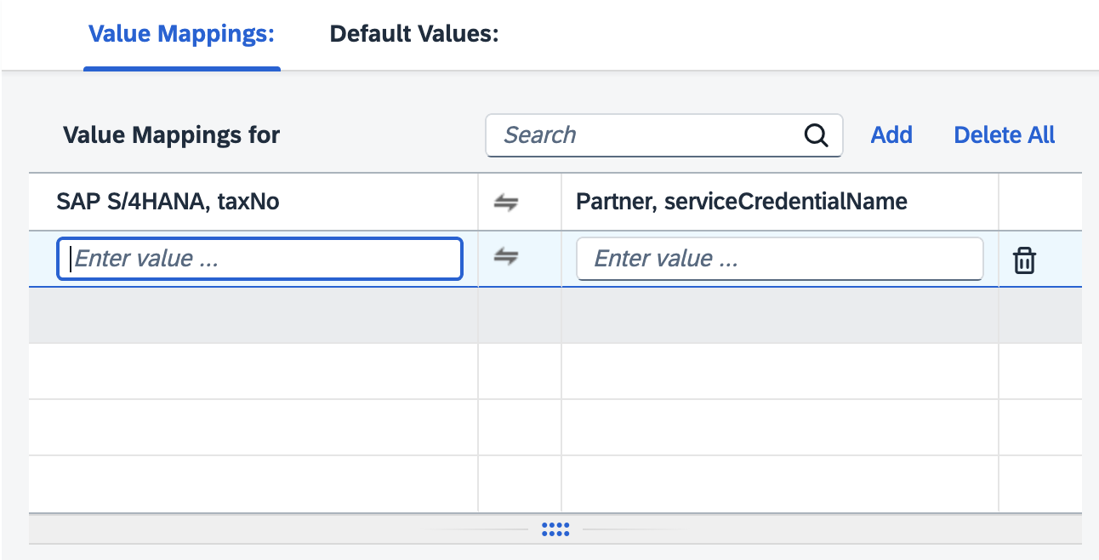

2. Enter the customer tax number and the credential name configured in the section 2.1.1.
Tax number can be configured and checked as the “Unified Social Credit Code” in the activity "Define Business Place" as shown in the screenshot below:
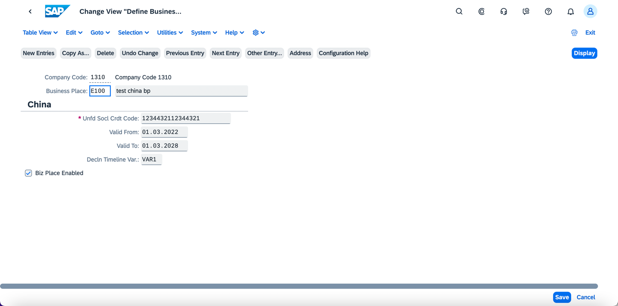

For details, refer to the section “Define Business Place” in the documentation “China_Incoming_VAT_Invoices_Implementation_Guide”.
3. Choose the second entry in the value mapping screenshot, the following dialog box appears:
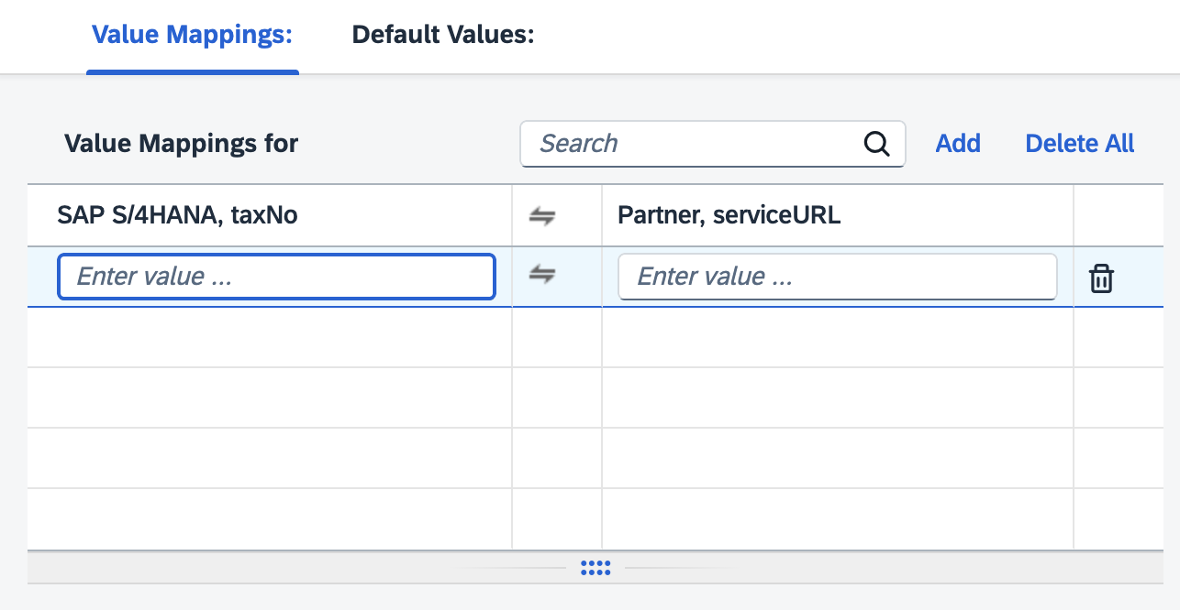
4. Enter the customer tax number and the service URL provided by the partner so that the integration flow can directly forward the API.

2.5.2

The first and last entries in the value mappings are about adding simple customized fields in the request payload body from SAP S/4HANA to the partner, without modifying the backend code in SAP S/4HANA.
If this feature is not required for any business places (taxNo), simply enter "dummy" in each entry as empty values are not allowed here. If required, configure them by following the procedure below:

Procedure

1. Choose the last entry in the value mapping screenshot, the following dialog box appears:
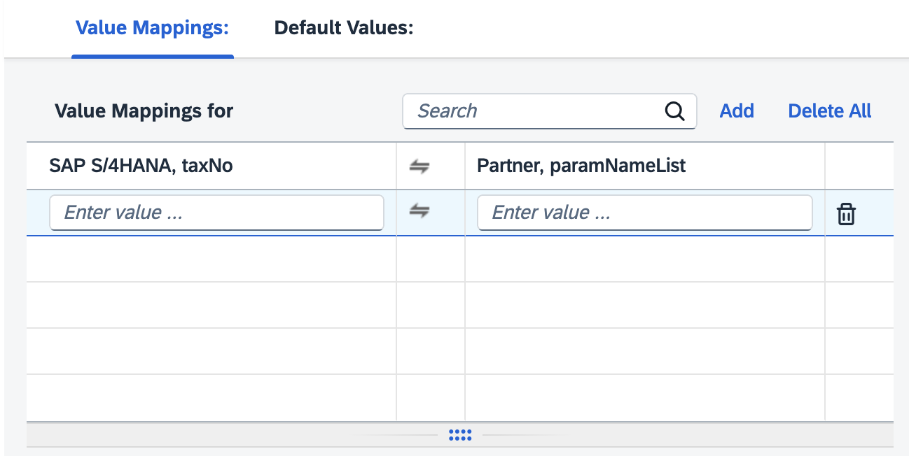
Enter the customer tax number, and the comma-separated parameter names that should be added to the "BusinessInfo" section of the payload. For example, if you enter the value "test1,test2," the payload body from SAP S/4HANA to the partner looks like this:
{
"Control": {
"PayloadFormat": "JSON"
},
"BusinessInfo": {
<some key>: <some value>,
"test1": <some value>,
"test2": <some value>
}
}
Please note that each parameter name must be unique, not only within a single tax number (taxNo), but also across all tax numbers. Duplicate names may cause confusion when you configure the parameter values in the next step.
The value configuration for the "test1" and "test2" keys is explained in the next step.

2. Choose the first entry in the value mapping screenshot, the following dialog box appears:
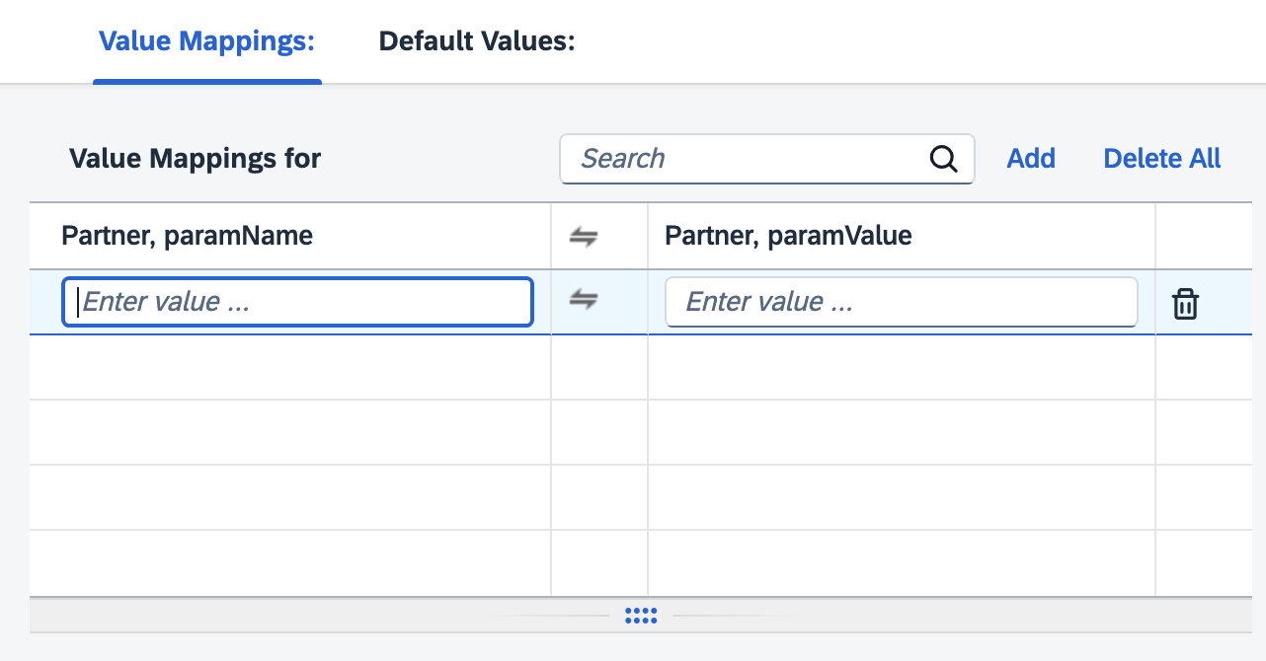
Enter the parameter names. In the previous example, you should add two value mapping entries here, with "test1" and "test2" as separate parameter name entries, and their corresponding values, so that the integration flow can append these key-value pairs to the payload body.

