INTEGRATION GUIDE | Public
2023-09-04
BN MT to AAS - SAP Cloud Platform

Integration Guide
©
2018 SAP SE or an SAP
affiliate
company. All rights reserved.
THE BEST RUN 
Content
1 Disclaimer 2
2 Introduction 3
3 Prerequisites 4
3.1 Installation of eDocument Solution 4
3.2 Set Up of Secure Connection 4
3.3 Set Up SAP Cloud Platform Integration Tenants 5
3.4 Registration at Tax Authorities 5
4 Configuration Steps 6
4.1 General Information 6
4.2 Deploying Key Pairs, Certificates and Credentials 6
4.3 Copying Integration Flows 8
4.4 Configuring Integration iFlows 8
5 Configuring SAP S/4HANA cloud communication system. 11
6 Configuring SAP S/4HANA cloud communication arrangement 15

Content

Disclaimer
The delivery is for the Catena-X Project. We fully support the AAS Standard with this delivery of an iFlow based solution. We also fullfill the requirement of the tractus-x document (link). There is only one Exception regarding the presentation of the identifiers (Ids). We are not using the UUID-V4 format in this implementation. Technically and related to the AAS standard, this does not result in any restrictions. Later the implementation of the iFlows will be replaced and could be exchanged by another implementation of the AAS registry which will allow the use of UUID-V4 format for the Ids.
Disclaimer

Introduction
You use SAP Cloud Platform Integration to establish the communication in the context of Catena-X for the traceability scenario. The implementation of the described iFlows from Package “BN MT to AAS” is fulfilling the AAS Standard and is functional as described in the Tractus-X Document (link). The Integrations Suite Package BN MT to AAScontains four iFlows:
- BN MT to AAS Lookup
- BN MT to AAS Main
- BN MT to AAS Registry
- BN MT to AAS Submodel Transformation

 Note
This document describes functionality that is provided by the Integration Package itself, that is, by the artifacts that are deployed in the SAP Cloud Platform Integration tenant. Official documentation about Cloud Integration Suite can be found here: https://help.sap.com/docs/integration-suite
Introduction

Prerequisites

Set Up SAP Cloud Platform Integration Tenants
This step has probably been done before. SAP Cloud Platform Integration test and productive tenants are live and users in the tenants have the rights to copy the integration package and to configure and deploy the integration flow.
To be able to deploy the security content you must be assigned the AuthGroup.Administrator role.
When your tenants are provisioned, you receive the Tenant Management (TMN) URL. You need this URL for the configuration of the SAP back-end systems.

Version Restrictions
This project is developed to support the following Version of the referenced Tools.
- Catena-X Release 23.09 (3.2)
- Business Network material Traceability Q3 2023
- Eclipse Dataspace Connector 0.5.0
- Decentral Digital Twin Registry 0.3.x

Prerequisites

Configuration Steps

General Information
The package “BN MT to AAS” contains the following iFlows:
iFlow Name ID
BN MT to AAS Lookup | BNMT_to_AAS_Lookup
BN MT to AAS Main | BN_MT_to_AAS_Main
BN MT to AAS Registry | BN_MT_to_AAS_Registry
BN MT to AAS Submodel Transformation | BN MT to AAS Submodel Transformation

Manage Security / Credentials
Context
You deploy the credentials to the SAP Cloud Platform Integration tenants.

Procedure
- Inside your Integration Suite Tenant go to Monitor-> Integrations as seen in the Screenshot below (also described in the official help documantation link ).
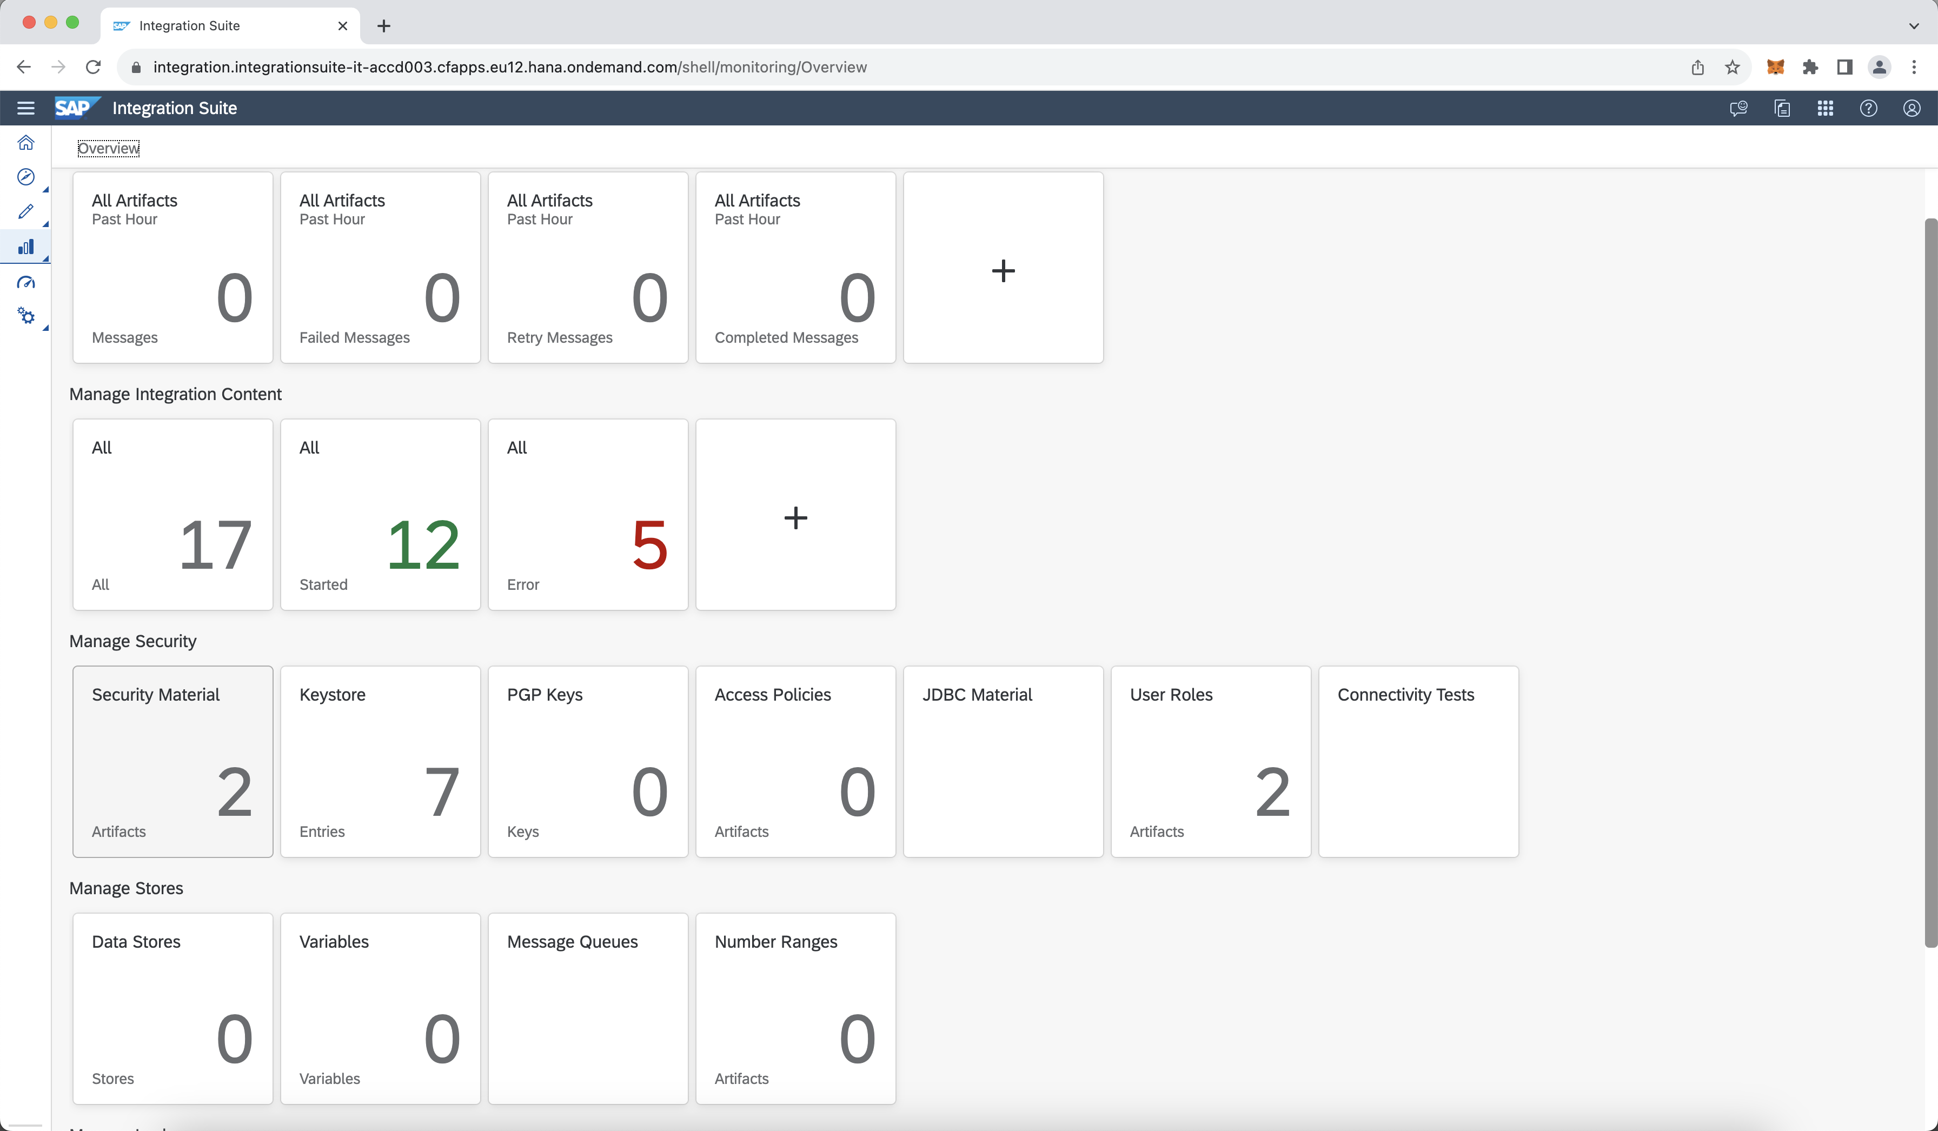
.
- Go to Manage Secutiry Material Secutiry Matieral
- Go to Create User Credentials and enter the ClientID and ClientCredentials to ensure the backend connection to the BN MT, BN MT Genealogy and BN MT Products:
Value Description
BN_MT | To assure connectivity to the iFlows get Assembly Part Relation_V2 and get Serialpart Typization_V2 of the Package MT Integration Content
BN_MT_ClientCredentials_Genealogy | To assure connectivity to the Genealogy API of BN MT  (API Hub - Product_Batch, API Hub - Serialized Product)
BN_MT_ClientCredentials_Product | To assure connectivity to the Product API of BN MT (/api/v1/ctxproduct/{ctxId})

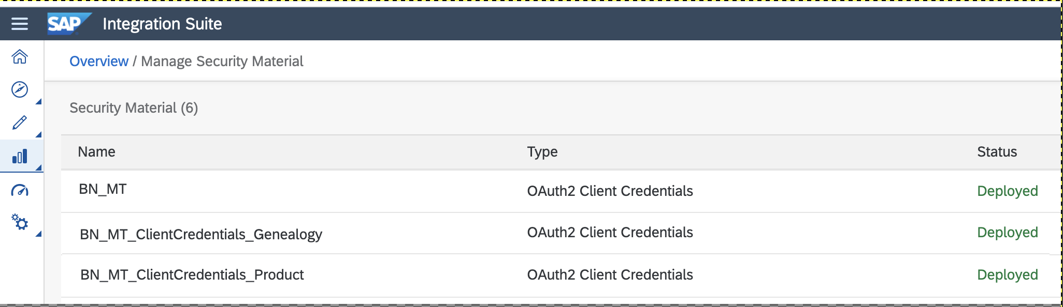
Complete the information related to your credentials.
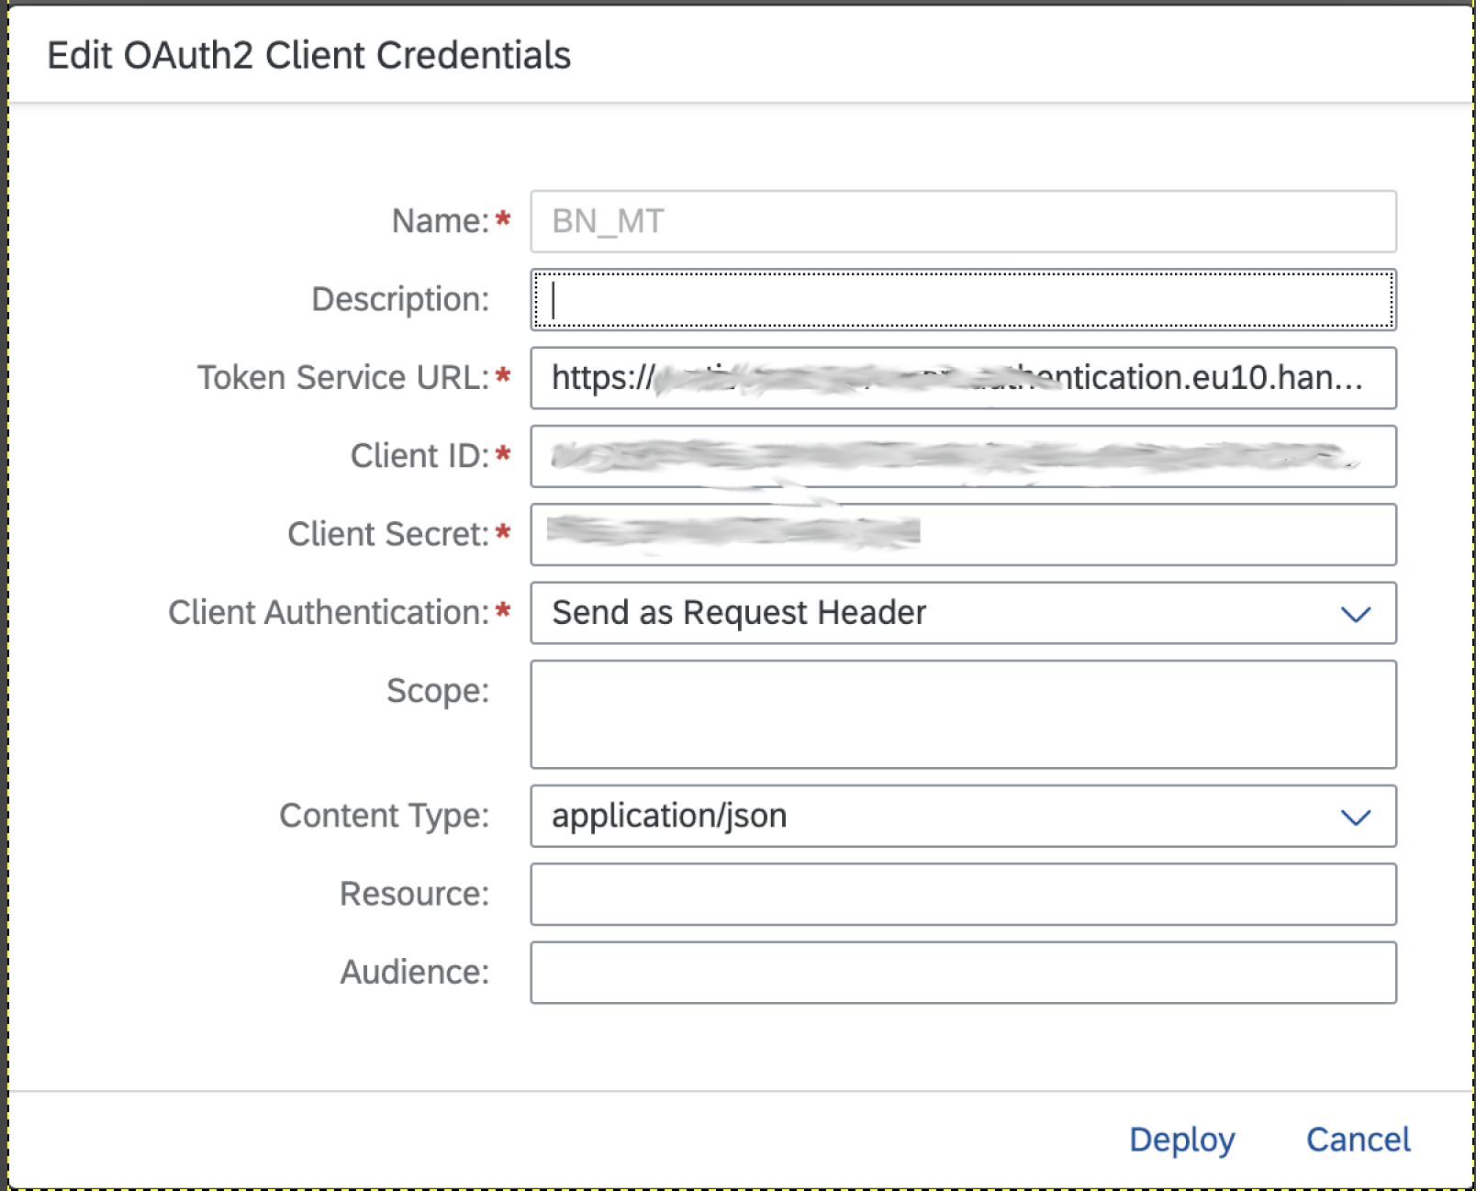
Figure 1: Example for BN_MT. Dot this also for the other two Credentials.

Copying Integration Flows
Context
Copy all iFlows in the package BN MT to AAS to the target tenant as follows:

Procedure
1. In your browser, go to the WebUI of the tenant (URL: <Tenant URL>/itspaces/#shell/catalog).
2.
Choose
Discover
All
.
.
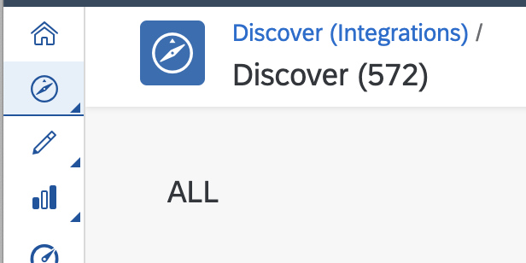

- Search for BN MT to AAS.

- Select the Package and choose Copy.
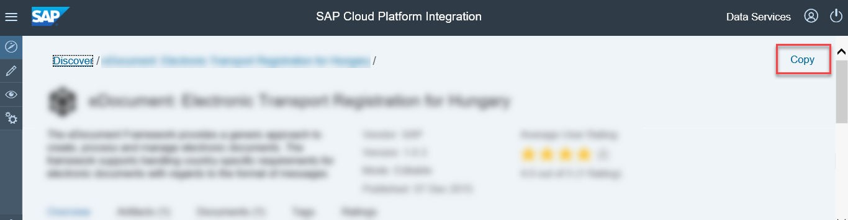
Placeholder

Configuring Integration iFlows
Context
You configure the package that you have copied as described in 4.3.

Procedure
- There are 4 iFlow Artifacts in the integration package eDocument: Electronic Invoicing for Italy:
○ BN MT to AAS Main
○ BN MT to AAS Lookup
○ BN MT to AAS Registry
○ BN MT to AAS Submodel Transformation
- All the configuration could be done in the Main iFlow. Choose Actions Configure for the artifact BN MT to AAS Main.
Here we have to configure all the endpoints corresponding tot he Credentials we have created in Step 4.2
BN_MT_iFlows corresponds to the Credential BN_MT
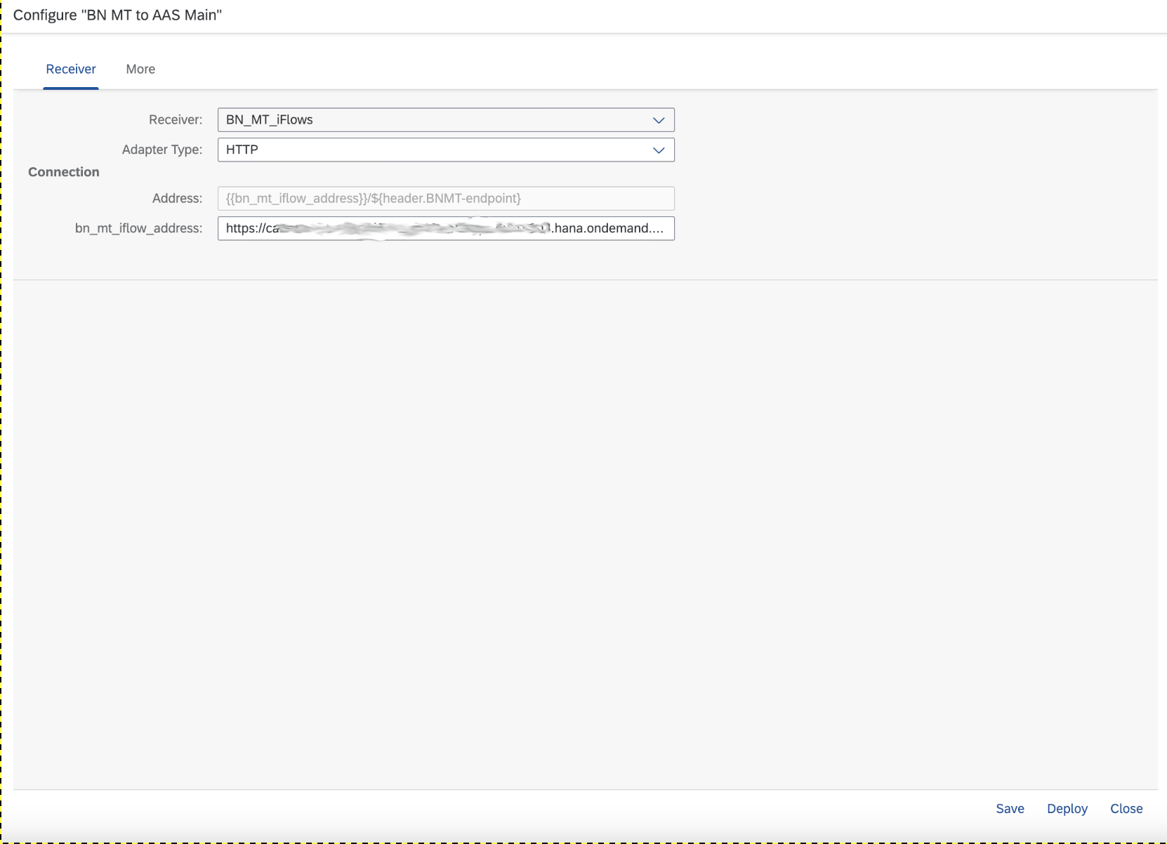
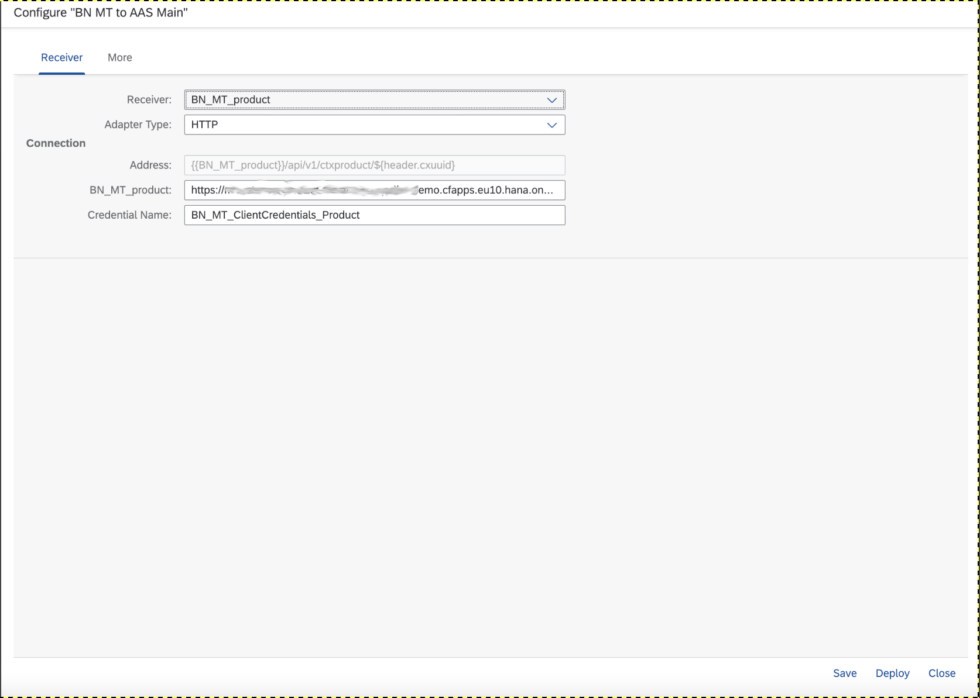
BN_MT_product corresponds to the Security Material BN_MT_ClientCredentials_Product
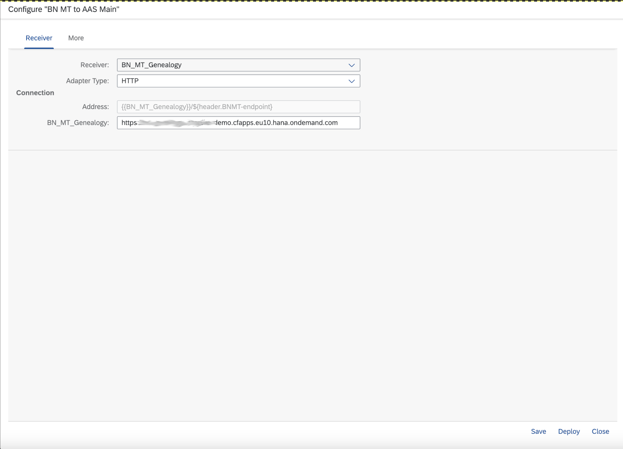
BN_MT_Genealogy corresponds to the Security Material BN_MT_ClientCredentials_Genealogy
- Choose Configure More tab
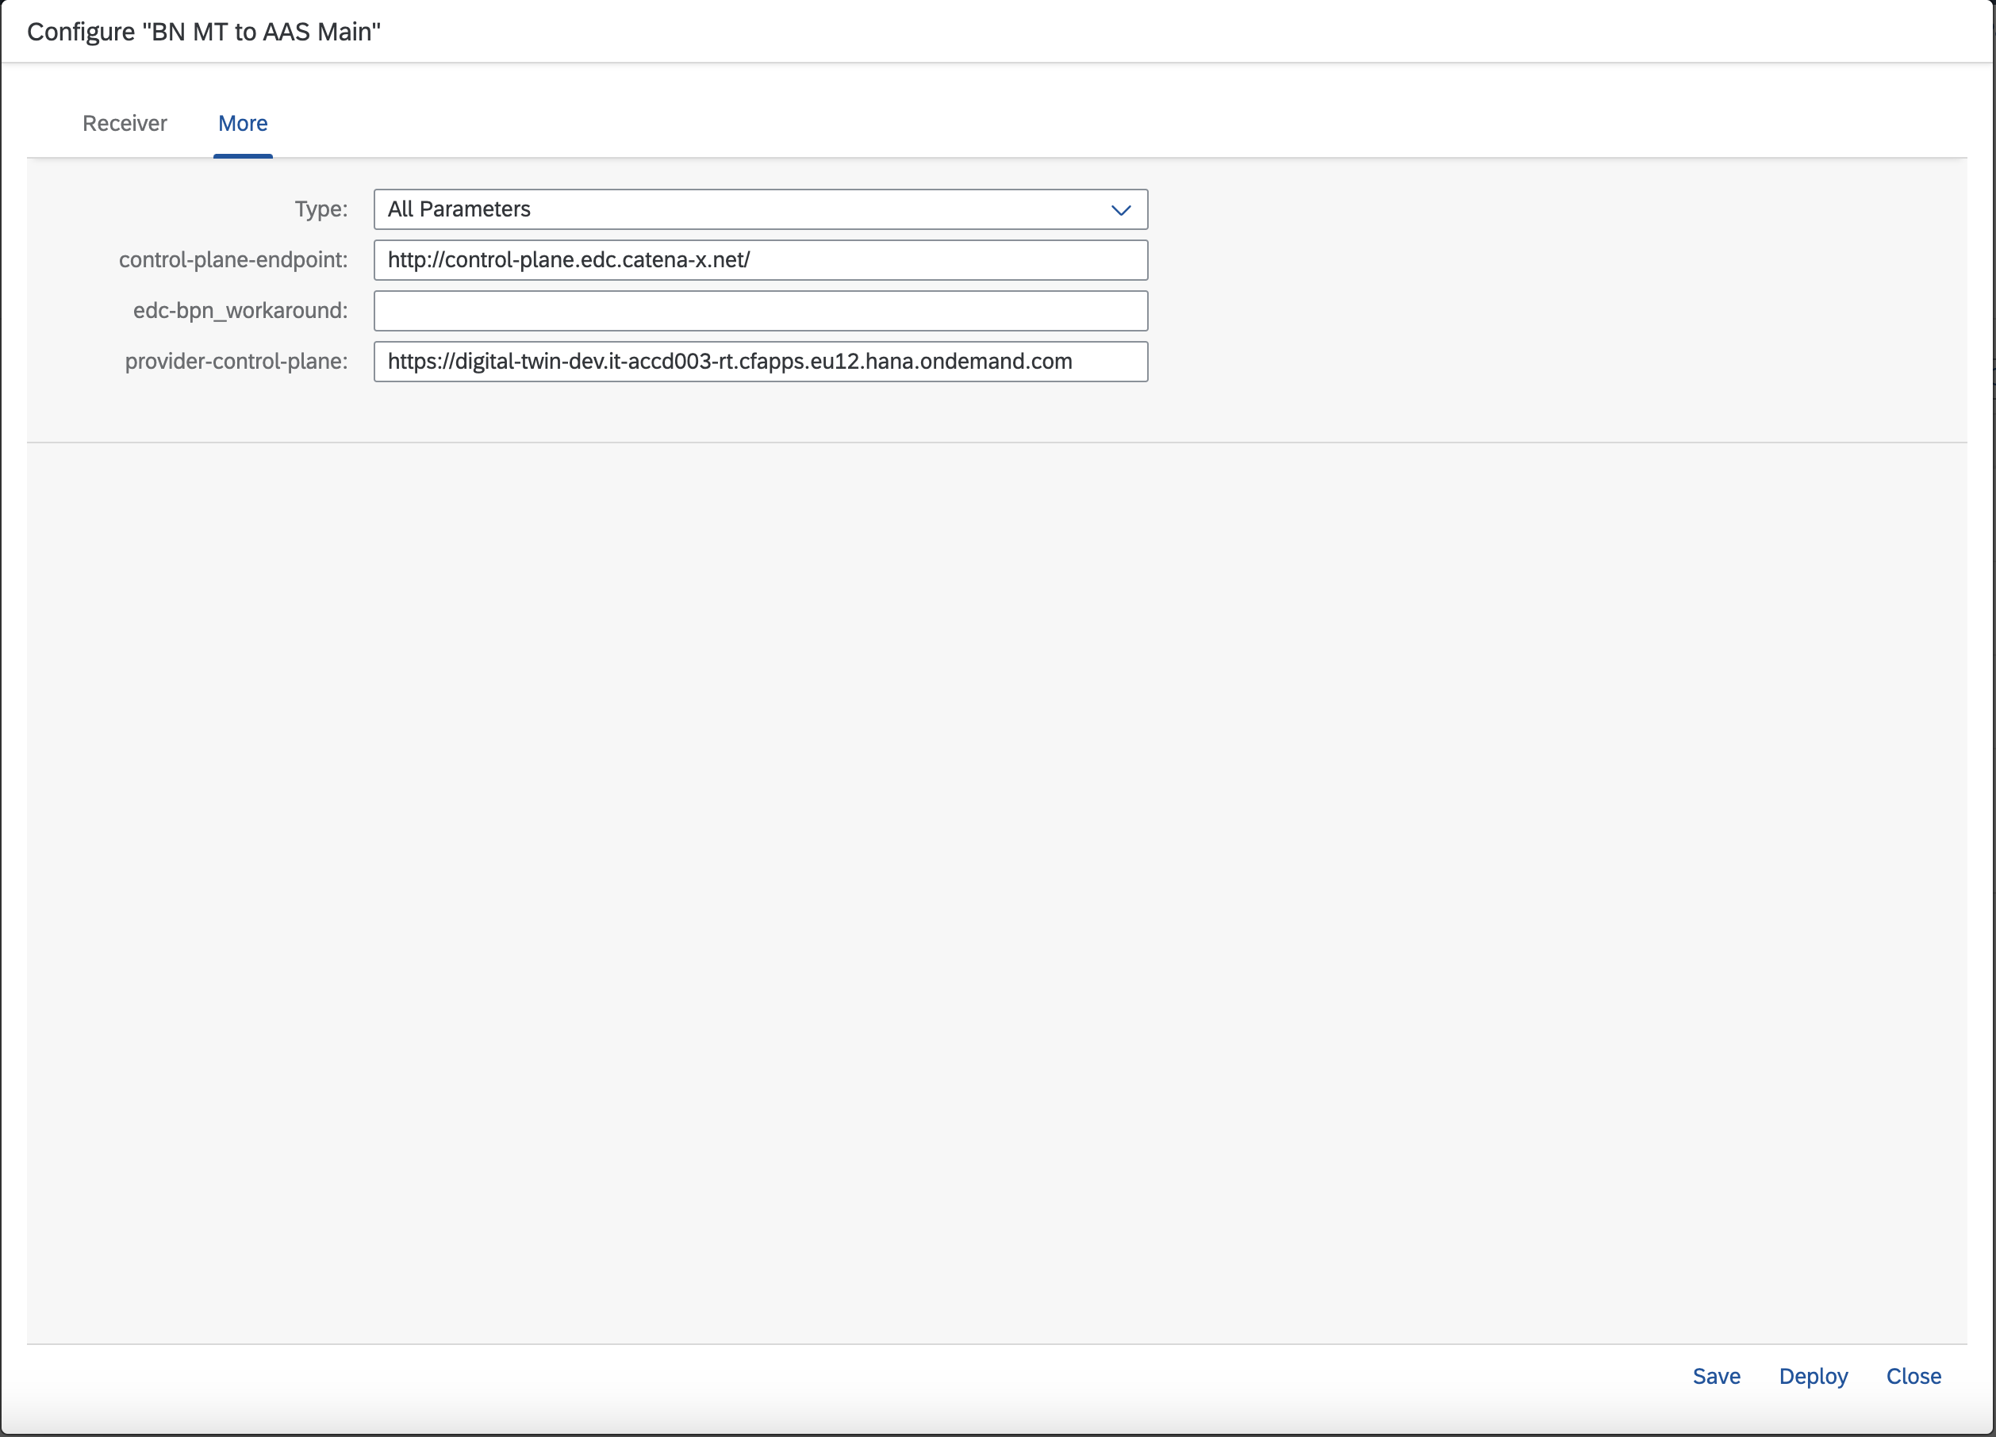
○ under All Parameters you will find three Parametes to manipulate:

control-plane-endpoint will be used in the response message for the /api/v3.0/shell-descriptors/{{AASId_base64url-encoded}} . It will be used in the submodel-descriptors -> endpoints -> protocolinformation -> subprotocolBody after dspEndpoint=http://control-plane.edc.catena-x.net/",

edc_bpn_workaround should be left empty. The only purpose is, if you want to overwrite the edc_bpn coming from the edc with a fixed other value. This was designed for testing purposes only.

provider-control-plane is visible in the response message fort he the /api/v3.0/shell-descriptors/{{AASId_base64url-encoded}}. It will be used in the submodel-descriptors -> endpoints -> protocolinformation -> href.

After configure all your entries just deploy your configuration. After you have deployed your configuration just deploy all the other iFlows in Package BN MT to AAS by pressing Actions Deploy

All the deployed iFlows should now be visible in the monitor in the section Manage Integration Content. At the iFlow BN MT to AAS Main you can also see which endpoints are available.
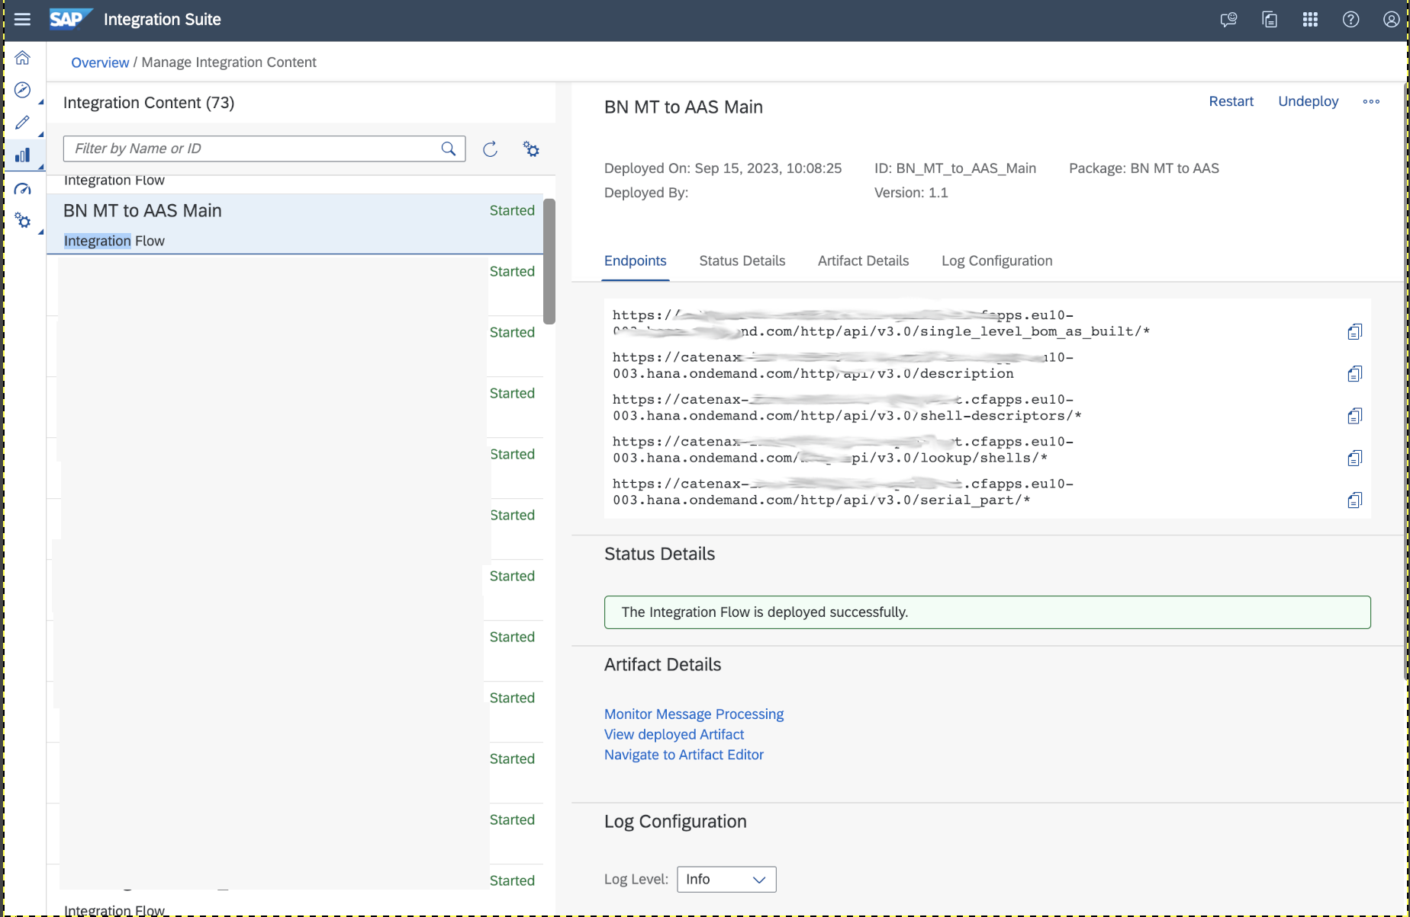

Testing the configuration
Describes the steps to test the integration of BN MT with the integration scenarion from SAP Cloud Platform Integration.

Context
The Best way to test the deployed iFlows is by trying out the API Calls for all endpoints with the help oft he attached Postman Collection.

Important Disclaimers and Legal Information

Hyperlinks
Some links are classified by an icon and/or a mouseover text. These links provide additional information. About the icons:
- Links with the icon : You are entering a Web site that is not hosted by SAP. By using such links, you agree (unless expressly stated otherwise in your agreements with SAP) to this:
- The content of the linked-to site is not SAP documentation. You may not infer any product claims against SAP based on this information.
- SAP does not agree or disagree with the content on the linked-to site, nor does SAP warrant the availability and correctness. SAP shall not be liable for any damages caused by the use of such content unless damages have been caused by SAP's gross negligence or willful misconduct.
- Links with the icon : You are leaving the documentation for that particular SAP product or service and are entering a SAP-hosted Web site. By using such links, you agree that (unless expressly stated otherwise in your agreements with SAP) you may not infer any product claims against SAP based on this information.

Beta and Other Experimental Features
Experimental features are not part of the officially delivered scope that SAP guarantees for future releases. This means that experimental features may be changed by SAP at any time for any reason without notice. Experimental features are not for productive use. You may not demonstrate, test, examine, evaluate or otherwise use the experimental features in a live operating environment or with data that has not been sufficiently backed up.
The purpose of experimental features is to get feedback early on, allowing customers and partners to influence the future product accordingly. By providing your feedback (e.g. in the SAP Community), you accept that intellectual property rights of the contributions or derivative works shall remain the exclusive property of SAP.

Example Code
Any software coding and/or code snippets are examples. They are not for productive use. The example code is only intended to better explain and visualize the syntax and phrasing rules. SAP does not warrant the correctness and completeness of the example code. SAP shall not be liable for errors or damages caused by the use of example code unless damages have been caused by SAP's gross negligence or willful misconduct.

Gender-Related Language
We try not to use gender-specific word forms and formulations. As appropriate for context and readability, SAP may use masculine word forms to refer to all genders.

www.sap.com/contactsap
© 2018 SAP SE or an SAP affiliate company. All rights reserved.
No part of this publication may be reproduced or transmitted in any form or for any purpose without the express permission of SAP SE or an SAP affiliate company. The information contained herein may be changed without prior notice.
Some software products marketed by SAP SE and its distributors contain proprietary software components of other software vendors. National product specifications may vary.
These materials are provided by SAP SE or an SAP affiliate company for informational purposes only, without representation or warranty of any kind, and SAP or its affiliated companies shall not be liable for errors or omissions with respect to the materials. The only warranties for SAP or SAP affiliate company products and services are those that are set forth in the express warranty statements accompanying such products and services, if any. Nothing herein should be construed as constituting an additional warranty.
SAP and other SAP products and services mentioned herein as well as their respective logos are trademarks or registered trademarks of SAP SE (or an SAP affiliate company) in Germany and other countries. All other product and service names mentioned are the trademarks of their respective companies.
Please see https://www.sap.com/about/legal/trademark.html for additional trademark information and notices.

THE BEST RUN

