Motivation:
Renaming integration projects on eclipse can be tricky due to some eclipse restrictions.

Solution:
The following steps need to be performed to fully rename an integration project in your eclipse workspace:
- Rename project via context menu Refactor Rename
- Rename integration flow file
- Update the corresponding field on manifest file
- Rename containing folder (move option on context menu/refactor) (optional – only if applicable)

- Please follow the following steps if you need to change the name of an Integration Project:
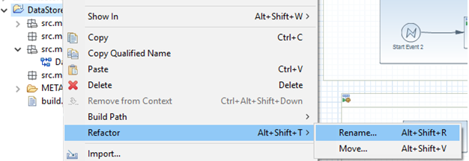

Enter a new name and hit Ok
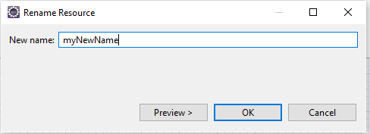

- Now Right click on the integration flow and click on Rename:

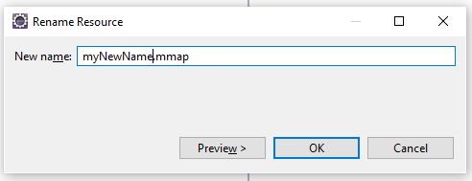

- Now also update the symbolic name in the Manifest file:

In the Overview tab, ensure that the ID and Name of the project is also set to the new name:
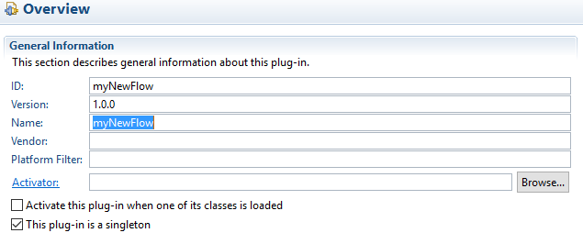
Goto the Manifest.MF tab: Ensure that Bundle-Name and Bundle-SymbolicName are set to the right name:
