Frequently Asked Questions  Document Version: 1.1 – 2021-04-28 | Customer
GSP Integration FAQ - Neo

See \\dwdf212\Info_Dev\KM_Layouts\LayoutSpecs\PDF_Documents\Final\DocuTemplateDOCX_instructions.pptx on how to use the template.
NOT INTENDED TO BE TRANSLATED.

Typographic Conventions
Type Style | Description
Example | Words or characters quoted from the screen. These include field names, screen titles, pushbuttons labels, menu names, menu paths, and menu options.  Textual cross-references to other documents.
Example | Emphasized words or expressions.
EXAMPLE | Technical names of system objects. These include report names, program names, transaction codes, table names, and key concepts of a programming language when they are surrounded by body text, for example, SELECT and INCLUDE.
Example | Output on the screen. This includes file and directory names and their paths, messages, names of variables and parameters, source text, and names of installation, upgrade and database tools.
Example | Exact user entry. These are words or characters that you enter in the system exactly as they appear in the documentation.
<Example> | Variable user entry. Angle brackets indicate that you replace these words and characters with appropriate entries to make entries in the system.
EXAMPLE | Keys on the keyboard, for example, F2 or ENTER.

Document History
Version | Date | Change
1.0 | 2018-04-30 | Added FAQs
1.1 | 2021-04-28 | Updated the entire document as per the new SAP Branding changes
Contents
1 How Do I Get the SAP Cloud Integration Account URL, Runtime URL and Tenant Web UI URL? 5
2 How Can I Add Members to the SAP Cloud Integration Account? 6
3 How Can I Provide Authorizations to Users? 7
4 How Can I Create a Service User in SAP Cloud Integration? 8
5 How Can I Deploy Client Certificate in SAP Cloud Integration? 9
6 How Can I Add New Certificates or Private Keys to the SAP Cloud Integration Tenants Keystore? 10
7 How Can I Perform a Connectivity Test? 12
8 How Can I Add User Credentials (per GSTIN credentials provided by GSP/NIC) to SAP Cloud Integration? 13

How Do I Get the SAP Cloud Integration Account URL, Runtime URL and Tenant Web UI URL?
You should have received a mail from SAP Cloud Integration with the account, logon and tenant URL details that looks as shown below:

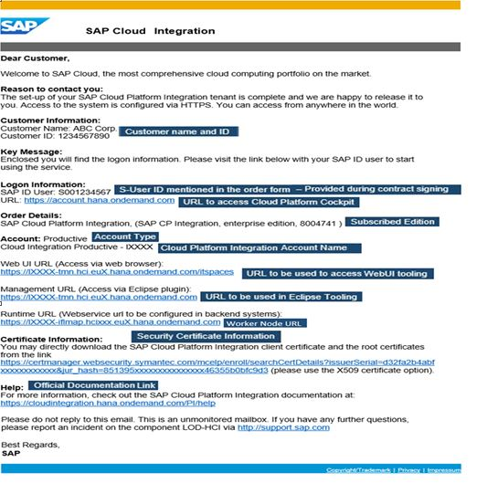

How Can I Add Members to the SAP Cloud Integration Account?
To add members to the SAP Cloud Integration account, follow the below steps:
- Logon to the Account URL with the SAP ID user provided in the mail.
- Add members and assign roles on this account by navigating to Members -> Add Members.
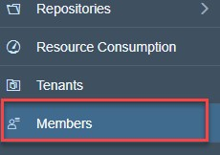

- Assign the following Roles.
- Administrator - Assign role Administrator to the user who is supposed to have the full permissions of an administrator
- Application User Admin - Assign role Application User Admin to the user who is supposed to have restricted administrator permissions
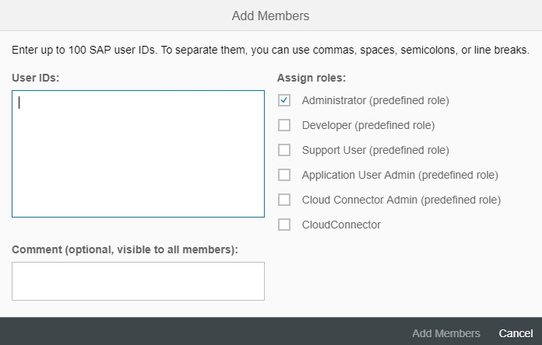

How Can I Provide Authorizations to Users?
To add Authorizations to the existing users:
- Logon to the Account URL with the SAP ID user provided in the mail.
- In the Navigation Pane, choose Security -> Authorizations
- Create a Group and Assign the Roles and Assign users for this Group.

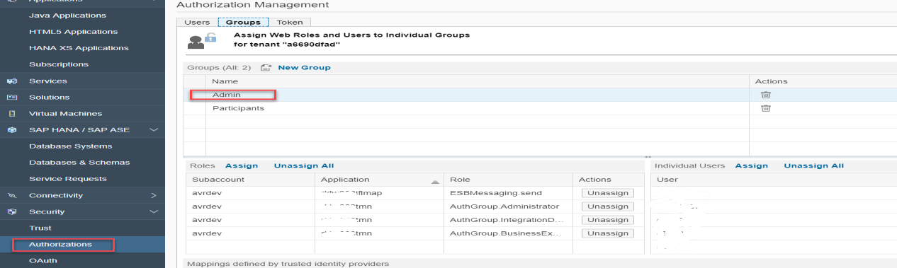

The authorization group AuthGroup.Administrator is designed for the administrator at customer side who administers a (customer-specific) tenant management node.
The authorization group AuthGroup.IntegrationDeveloper has to be assigned on TMN-level. The main difference between the authorization groups AuthGroup.IntegrationDeveloper and
AuthGroup.Administrator is the AuthGroup.Administrator group allows in addition to deal with security artifacts.

Note
For more details refer here.

How Can I Create a Service User in SAP Cloud Integration?
The integration between SAP ERP or SAP S/4HANA and GSP is done through SAP Cloud Integration. The service user in SAP Cloud Integration facilitates this integration. Perform the below steps to create a service user and assign the necessary role:

- Register a new user at https://account.hana.ondemand.com/#/home/welcome
- Assign the ESBMessaging.Send role to the user

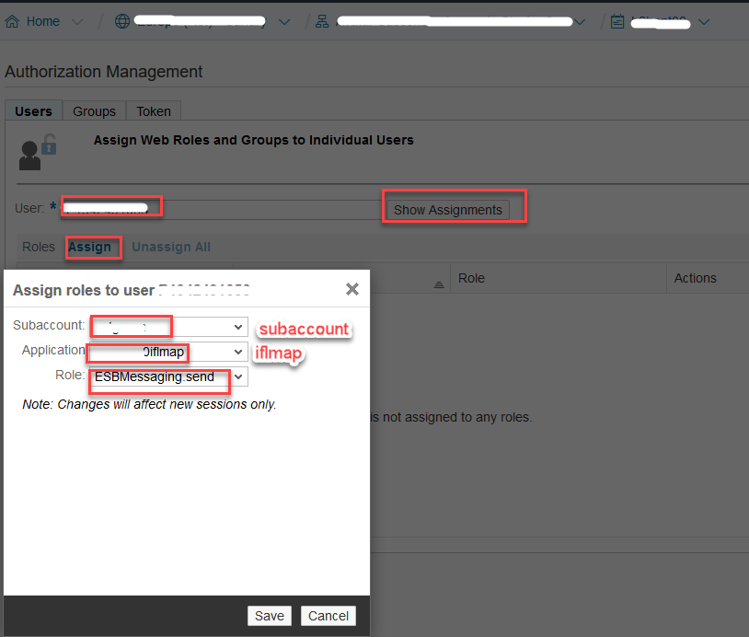
2635620

How Can I Deploy Client Certificate in SAP Cloud Integration?
For inbound HTTP connections to SAP Cloud Integration, you define Authorization options for the communication user associated with the sender system to define how it accesses the Cloud Integration components. We recommend that you use Client-Certificate with certificate-to-user mapping. Using this option, authentication of a sender is performed based on a client certificate. With a certificate-to-user mapping, the certificate is mapped to a user, whose authorizations are checked on the tenant.

- Navigate to Monitor->Manage Security-> Manage Certificate-to-User Mappings
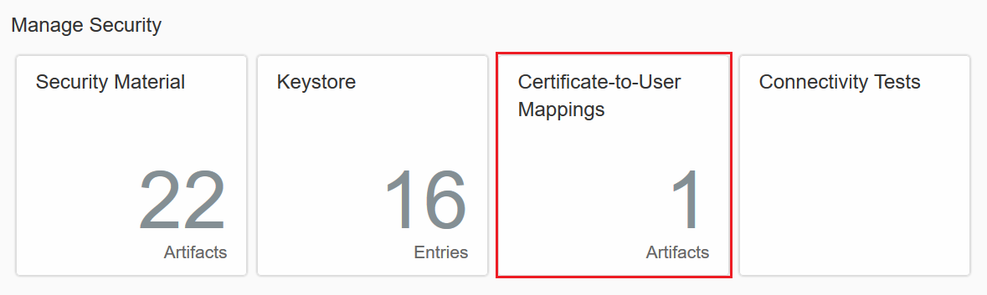

- Click on Add button

- Enter the service user and deploy the client certificate obtained from SAP ERP
Note that the service user should have the ESBMessaging.Send role assigned to it.
For more information on how to obtain client certificate obtained from SAP ERP, refer the Master guide attached to SAP Note 2631687.
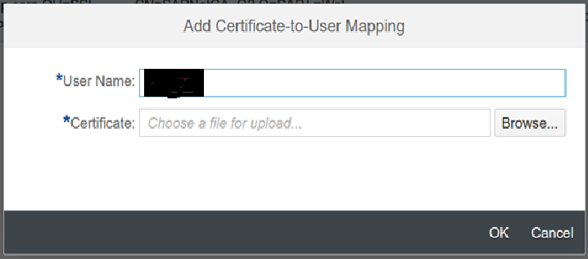

How Can I Add New Certificates or Private Keys to the SAP Cloud Integration Tenants Keystore?
You can add the security artifacts like keystore entries following the process mentioned here.

Note
You should have Tenant Admin authorizations (AuthGroup.Administrator role) for the tenant to perform this operation.
- Navigate to Monitor->Manage Security->Keystore
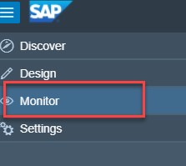

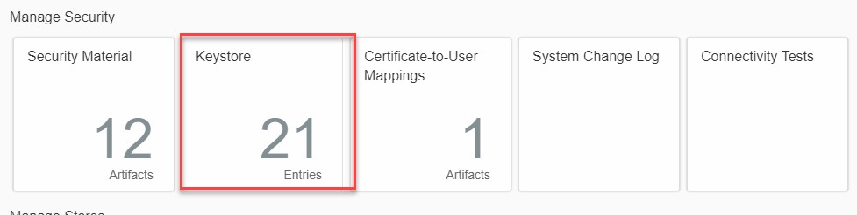

- Enter the new Keystore Entry
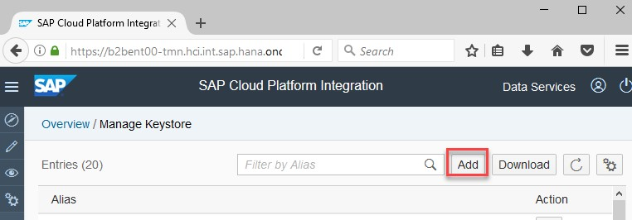

- Click on Add button
System displays the Add Keystore screen

- Browse the relevant Keystore. Click on Deploy.
System displays the following message.

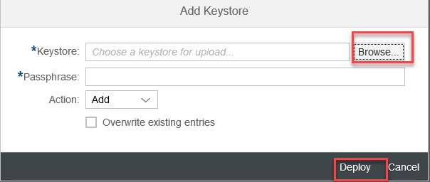

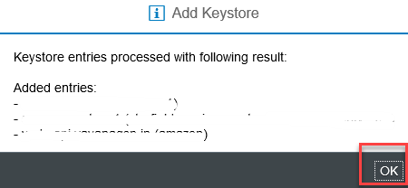

- Click on OK.

How Can I Perform a Connectivity Test?
You can perform the Connectivity test of the receiver by using the feature TLS Connectivity Test as mentioned here.
- Go to connectivity tests
You can find the connectivity tests under Monitor->Manage Security->Connectivity Tests
- Click Send
On successful connection, system displays a successful response message.

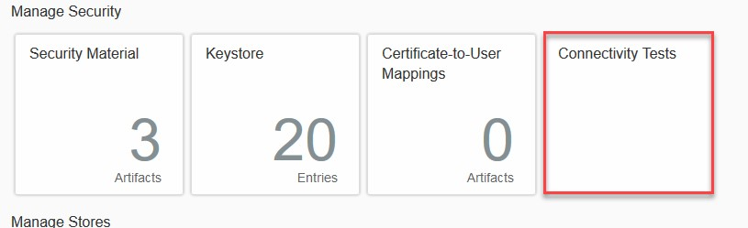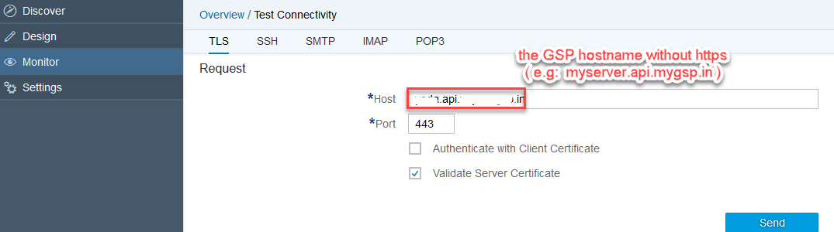

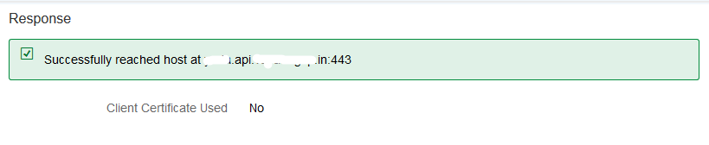

How Can I Add User Credentials (per GSTIN credentials provided by GSP/NIC) to SAP Cloud Integration?
You register user per business place in NIC. Use the following steps to add these NIC users in SAP Cloud Integration:
- Go to Security material. Navigate to Monitor->Manage Security->Security Material
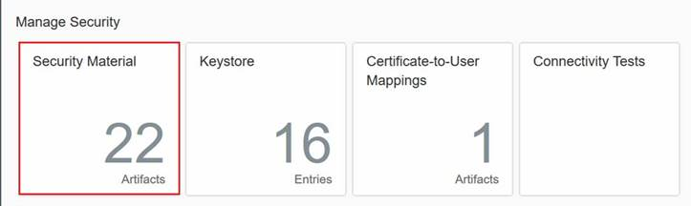

- Add a new user credential
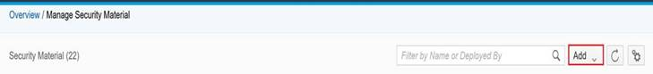

- Click on User Credentials
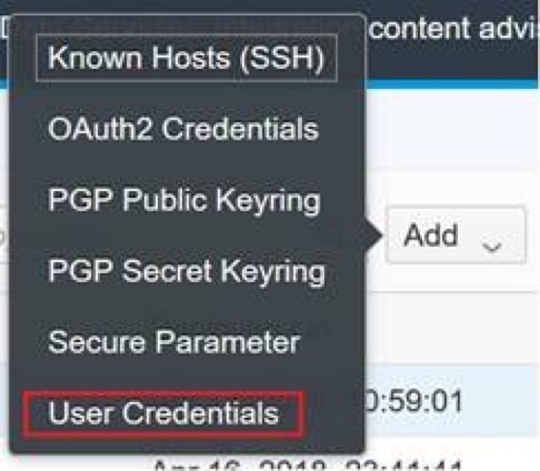

- Add and Deploy the user credentials
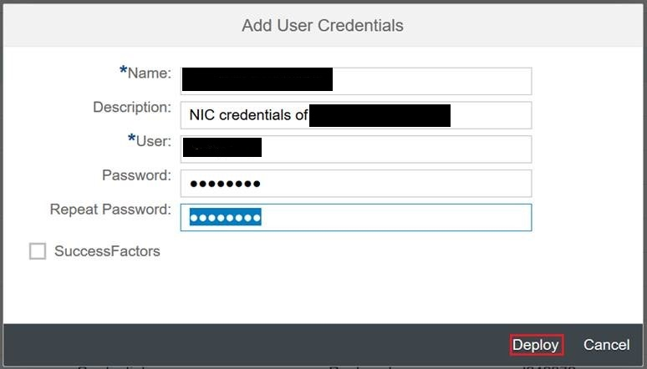

Add the Caution/Example/… paragraphs to your Quick Parts in the Insert ribbon (Insert → Quick Parts → Save Selection to Quick Part Gallery). Then delete these paragraphs below.
Note:
In the Name field, enter the GSTIN of the business place to which this user belongs

www.sap.com/contactsap

