Tracing an Integration Flow execution:
Tracing allows a user to log the payload and header of the message in the processing pipeline at each process step.
Tracing can be enabled from the Trace Configuration view of the Operations Perspective only in the Eclipse Interface.
Tracing needs to be enabled explicitly for each integration flow by either an Integration Developer or a Tenant Administrator. Once enabled, tracing for an integration flow shall remain enabled for 10 minutes. Tracing can be re-enabled repeatedly as required.
Tracing can be enabled only for those integration flows whose log level is set at debug.
Enabling of trace and changing of log levels require neither of the following:
- Editing the integration flow
- Redeploying the integration flow
Enabling trace for an Integration Flow:
- Deploy the integration flow.
- Go to the Web tooling interface and open the Operations View. Choose the integration flow whose tracing needs to be enabled. Here we will set the log level of the integration flow to Debug.
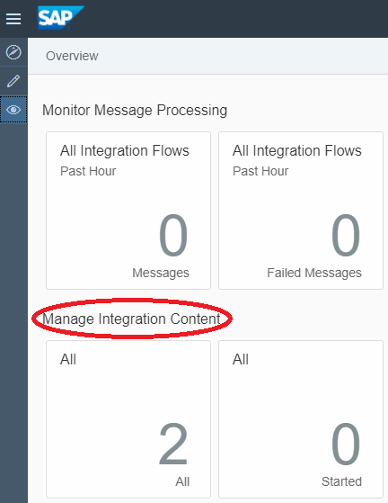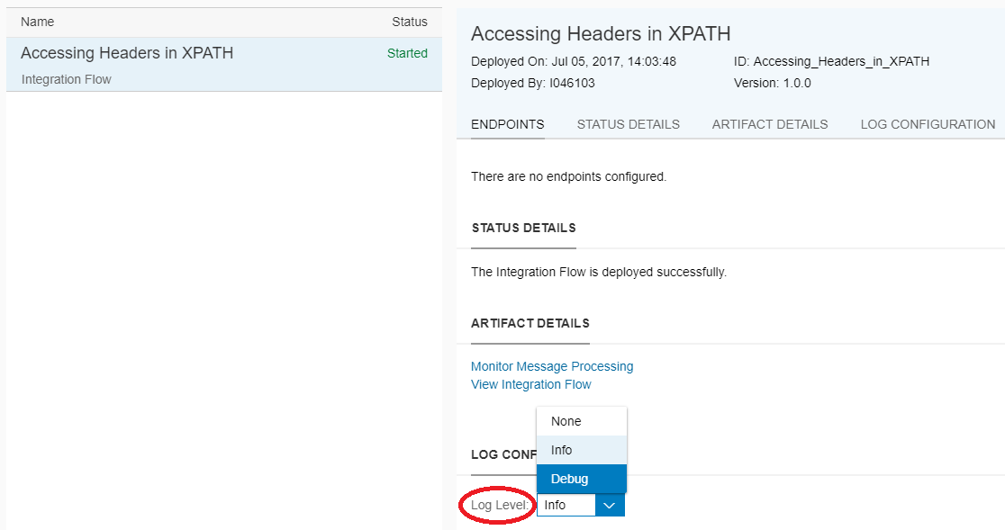

The log level shall stay as set until you un-deploy your integration flow.
Redeploying the integration flow shall keep the log level unchanged.
- Now go to the Eclipse Interface, launch the Operations Perspective and open the Operations View. Open the Trace Configuration tab and choose the integration flow whose trace you want to set. Click on Enable.
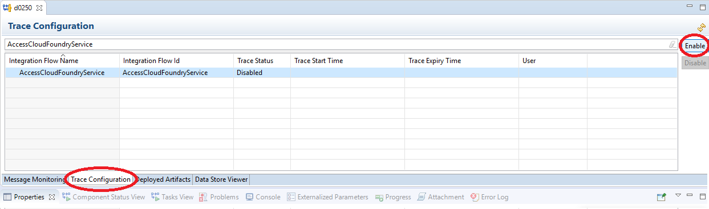
Once enabled, the entry will look like:
As you can see, the trace is enabled for 10 mins – indicated by the Trace Start Time and Trace Expiry Time.
Trace Status indicates the current state of the trace. You can see one of the following statuses:
- Enabled: indicates that the trace is enabled. All executions of the corresponding integration flow shall log both payload and header at each step.
- Disabled: indicates that the tracing for the integration flow is not enabled.
- Expired: indicates that the 10-minute duration of the trace enabled state is over.
- Suspended: indicates that the trace is disabled centrally at the tenant level – hence all integration flows deployed on that tenant will be displayed with Suspended trace status.

Viewing the trace:
- Ensure that your integration flow has its trace status set to enabled.
- Execute your integration flow and go to Message Monitoring.
- Click on the instance of the execution that was processed after enabling the trace.
- Click on View Trace:
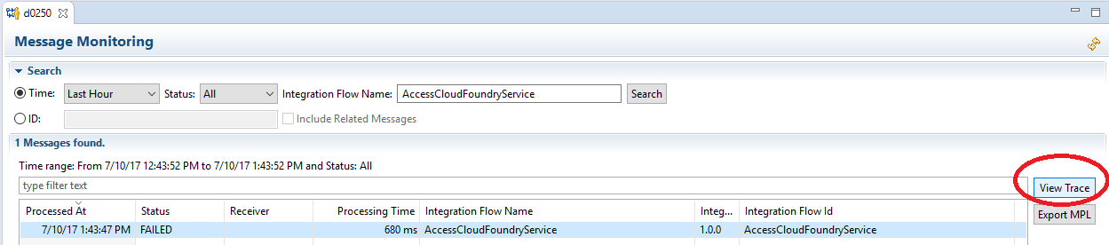

Clicking on View Trace decorates the integration flow like the following:
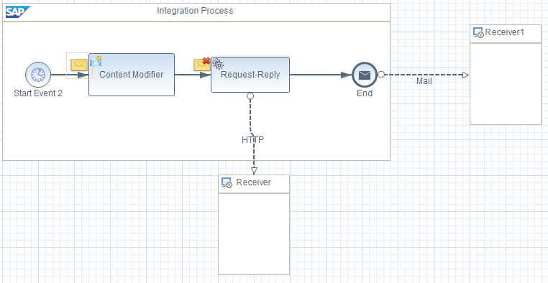

Click on the yellow envelopes and go to the Properties tab, to see the details of the message payload and header at that step:
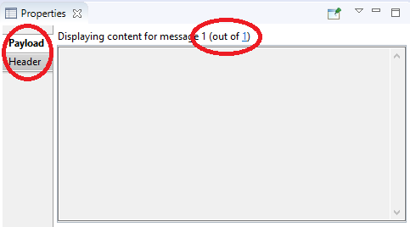
The 1 (out if 1), is used to switch context between various split messages (if applicable) at that step.
In case an exception occurs, the above window shows an additional tab for exception:
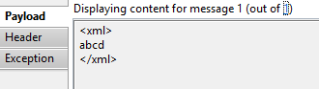
You need the Business Expert role to view the trace.
After generation, the trace shall be available for 60 mins. Alternatively, you can store the trace in a file and later load it.
In Message Monitoring, choose the entry whose trace has been generated and needs to be stored. Now click on Export MPL. In the pop-up, you can choose any of the following 2 options:
- MPL with Trace Content
- MPL with Trace Content and Integration Bundle

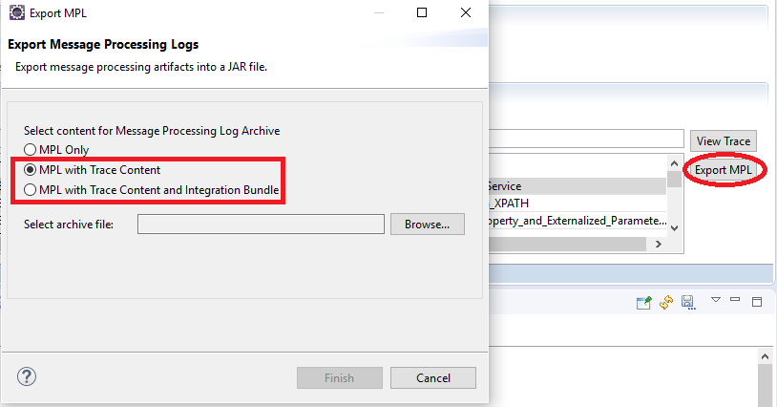

When you want to view the trace, go to the integration flow, right click on the canvas and click on Import Message Processing Log. When prompted, browse and select the file you generated in the previous step.
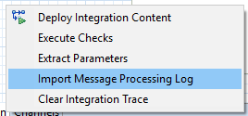

The integration flow will get decorated with the trace content.

