Message Processing log:
Also commonly known as the MPL is the first level of logs that provides detailed information about each integration flow processing. It provides step-by-step overview of the whole message execution from the time the message enters the pipeline until it is sent out to all the receivers. It can be accessed from the Monitoring Message Processing view under Operations View of the WebUI.
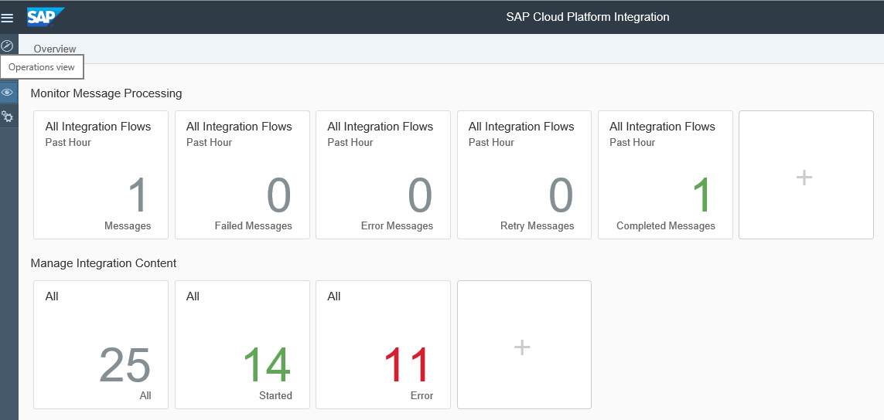
The first row of tiles in the Operations View provides several views to monitor message processing based on the Status of processing.
As you can see above, there are several tiles that provide quick access to a specific category of message monitoring logs. You can edit/delete/move these tiles and also add new tiles based on your usecase.
Simply click and hold a tile to edit/delete/move it.
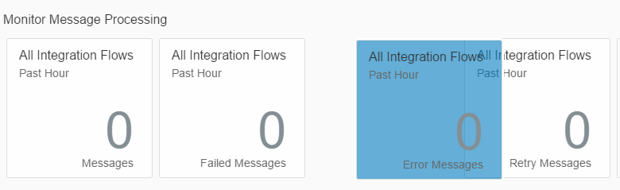
Click on the  tile to add more tiles. This will allow you to add a tile based on the following parameters:
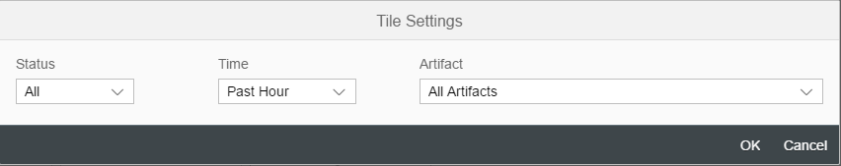

The number on each tile represents the number of message monitoring logs for that tile in the past hour.
Clicking on any tile will launch the following UI:
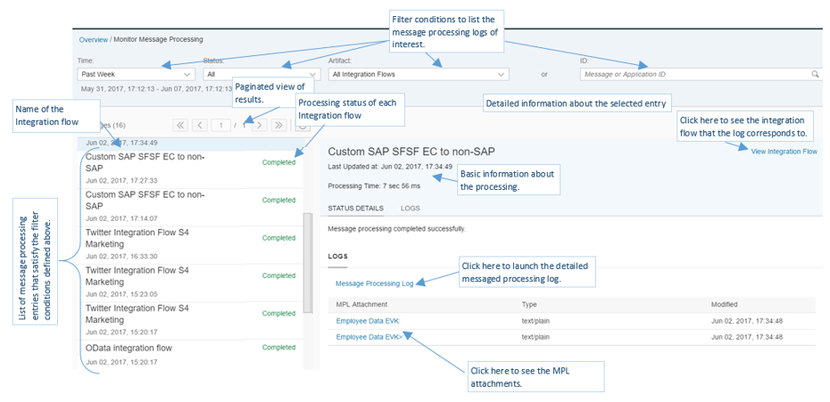
Clicking on “Message Processing Log” launches the detailed information:
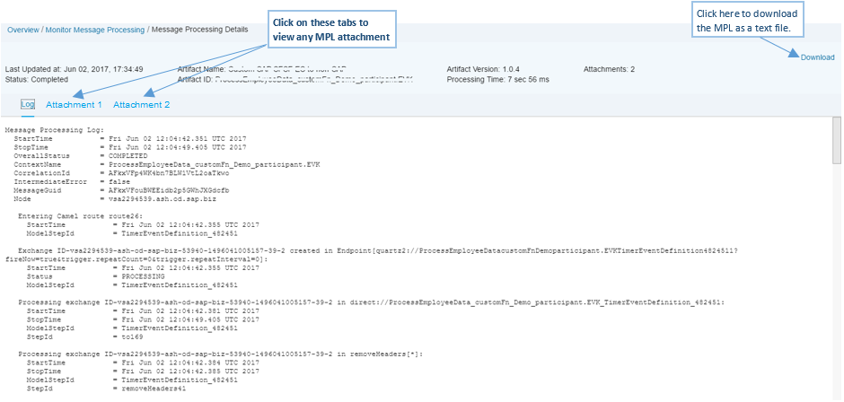
g:
The message processing log contains the following information:
Start time/Stop time: timestamp (in millisecond) of the start and end of the integration flow execution in UTC timezone.
Overall Status: the end-to-end status of message execution.
Context Name: name of the integration flow.
CorrelationId: a common ID that links all integration flow processings that are involved in one end-to-end flow on the same tenant. Example when one integration flow triggers other integration flows on the same tenant, each flow’s processing log will carry the same correlation id.
IntermediateError: indicates if there was an error during the message processing. This status also covers any temporary errors that may have occurred during processing.
MessageGuid: a unique identifier for each message processing log.
Node: the worker node where the message was processed.

Any message processing attachments (if present) shall be displayed next to the log as tabs.

The interface allows you to download the log as a text file.

Log level: Cloud Platform Integration allows you to control the level of details that are added to the Message processing logs. This is configured via a property of a deployed integration flow from the Manage Integration Content view – click on the deployed integration flow whose log level needs to be changed; on the right pane, you shall get the option to set log level under the Log Configuration:

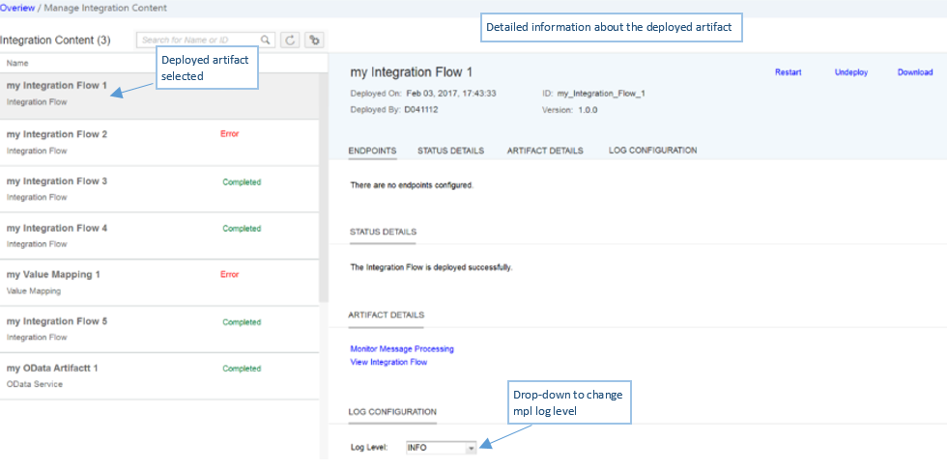
The advantage of setting the log level after deployment versus at design time is that the log level can be changed at runtime without the need to edit or redeploy the integration flow.

The system provides 3 pre-defined log levels that you can choose from. It can be configured by an Integration Developer or a Business Expert persona.
- None – No processing information is logged for this option. There will be no entry in the message monitoring for integration flows that are processed with log level None.
- Info – this is the default log level. It provides only MPL level metadata in case of a successful execution. In case of error, it contains step-wise detailed information about the last 50 steps in chronological order.
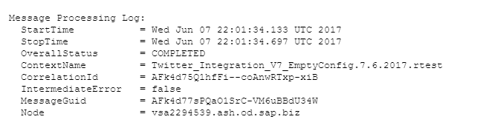

- Debug – this log level provides the most detailed information about the message processing. In addition to what you can see in Info level logs, the debug level logs provide step-wise information of the message processing, like status of processing at each process step, start and end time of each process, basic configurations made in the process step, etc.

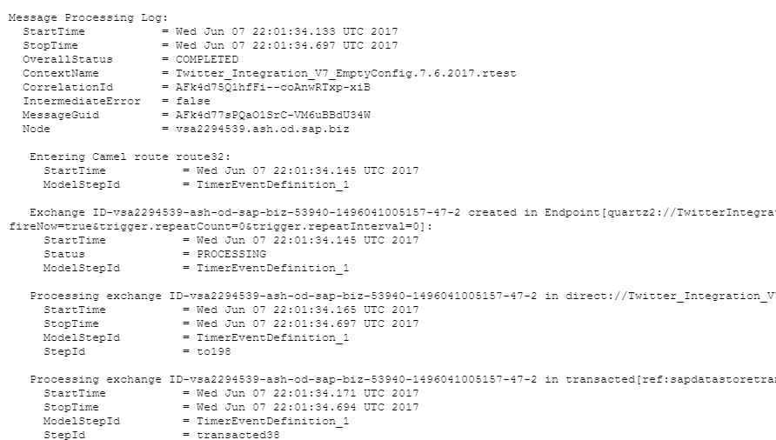

Changing log level: In order to change the log levels, choose the desired log level from the drop down. The log level shall be retained during redeployment but if you undeploy and deploy, the log level shall be reset to Info. Click change on the confirmation pop-up. The log level change takes effect as soon as you confirm. All subsequent message executions for the corresponding integration flow shall be logged as per the configured log level.
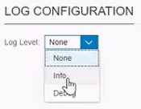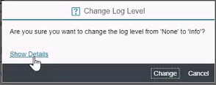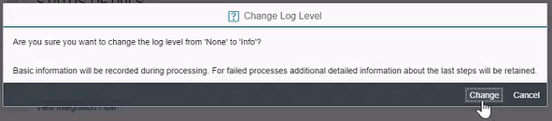
Log configuration is also supported for configure-only content.

Setting log level for Run-Once scenarios: since run-once scenarios are executed immediately after deployment, there is no possibility to change the log level before its execution. Only Info level logs are stored for such flows. To change log level for run-once scenarios, follow one of the following approaches:
- Instead of run-once, set the timer to a suitable time sufficient to deploy and set log level before the integration flow gets triggered.
- Deploy the run-once scenario and let it execute with log level info and then change the log level. Second time onwards, the configured log level shall take effect. Use redeploy to retrigger the flow instead of undeploy-deploy.

Log level for already deployed flows: The log level configuration was a part of the integration flow design-time configuration earlier and now it has been moved to the run-time configuration of an integration flow’s deployed entity.
This allows us to overcome the limitations of configure-only content and the content update contract.
The log level of configure-only content can now be changed. For all other content, the log level can be changed without breeching the content update contract.
The log level of all the integration flows that are already deployed shall be computed as follows:
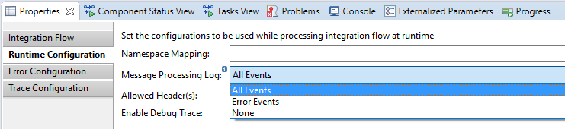
Message Processing Log set to (refer to the screenshot above) | Evaluated Log level
All Events | Debug
Error Events | Info
None | None

Retention period for message processing logs: All message processing logs shall be stored in the system for 30 days. After 30 days, these logs will be deleted from the system.
The retention period can be updated on request. The requester needs to create a BCP ticket on LOD-HCI-PI-OPS.

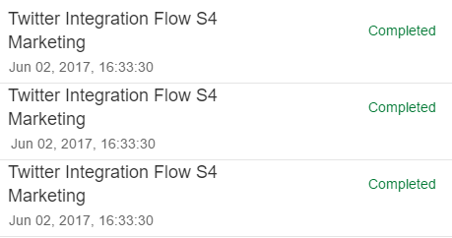
Multiple Message Processing Logs for one message execution: When there are multiple worker nodes allocated to a tenant, there will be multiple message processing log entries for each message processing. The number of entries is equal to the number of worker nodes. Each node picks the message processing however only the first node to start the message processing shall actually execute the pipeline after setting a lock on the current execution instance. All other nodes shall terminate the execution immediately after detecting the execution lock. The only exception to this rule is a scenario with an sFTP sender. In such a case, the exchange is initiated only when the poll finds a file in the source directory. So, all nodes shall poll the source directory – the first one shall pick the file and start the execution. The other nodes shall not enter the exchange since they would not find any relevant file in the source location and hence there will be no additional MPL entry.
Additionally, every aggregate step used an integration flow will also have an additional message processing log entry.
Accessing message processing log ID in the integration flow

Accessing message processing log ID in script:
def Message processData(Message message)
{
//create a variable to pull the map of all the properties of the integration //flow
def map = message.getProperties()
//the keyword SAP_MessageProcessingLogID refers to the property that holds then //message processing log GUID
def mpl_guid = map.get("SAP_MessageProcessingLogID")
…
}

Assigning to the header/property through a content modifier:
Name: MPL_ID (can be any name)
Type: Property
Value: SAP_MessageProcessingLogID

Writing additional log entries to the message processing log from the integration flow:

Check the article: Content hub Design Cloud Integration - Exemplars Documents HowTo- Write additional log entries to the message processing log from the integration flow.
Working integration flow can be found at:
Content hub Design Cloud Integration - Exemplars Artifacts Add additional logs to monitoring processing log

API to access monitoring and runtime entities:

Message processing log and other runtime entities can be read using REST based OData APIs. These APIs can be used to render the corresponding information in other applications and interfaces.

For more details, refer the article: HowTo- access monitoring and runtime information through an OData API

