Writing additional log entries to the message processing log from the integration flow:
Additional log entries can be written to the message processing log from the integration flow by making use of the script step.
It allows you to add custom entries that you may want to record as a part of the processing.

Here you have the option to add additional entries as:

- Custom headers in the message processing log header: custom header are added using the function addCustomHeaderProperty on the messageLog object:

Signature: void addCustomHeaderProperty(String Name, String Value);
Sample: messageLog.addCustomHeaderProperty("MyCustomeHeader","MyValue");

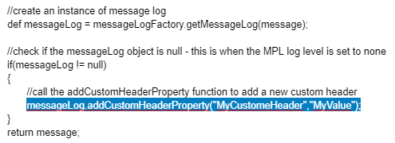
Note that before you issue any command on the messageLog object, you must check if it is null – when the MPL log level is set to none, no MPL object is created.

Results: on adding a custom header using the above script, the message processing log’s header gets updated with an additional header:

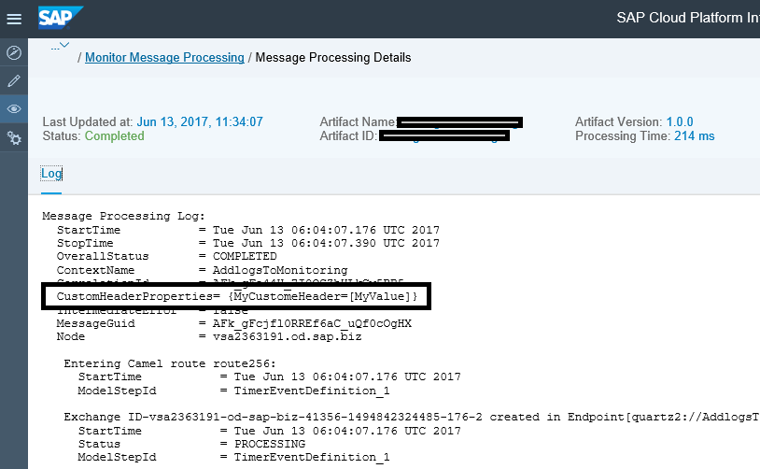

- Adding an entry to the message processing log as a type key-value pair: additional entries can be added to the message processing log using one of the function on the messageLog object:

Signature:
void setStringProperty(String name, String value)
void setDateProperty(String name, Date value)
void setBooleanProperty(String name, Boolean value)
void setIntegerProperty(String name, Integer value)
void setDoubleProperty(String name, Double value)
void setLongProperty(String name, Long value)
void setFloatProperty(String name, Float value)

Sample: messageLog. setStringProperty("MyStringProperty"," MyStringPropertyValue");

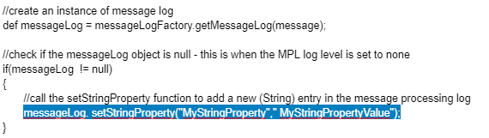

Note that before you issue any command on the messageLog object, you must check if it is null – when the MPL log level is set to none, no MPL object is created.
This method should only be used to enter a small amount of information to the logs.

Results: on adding a string property using the above script, the message processing log gets updated with an additional entry:

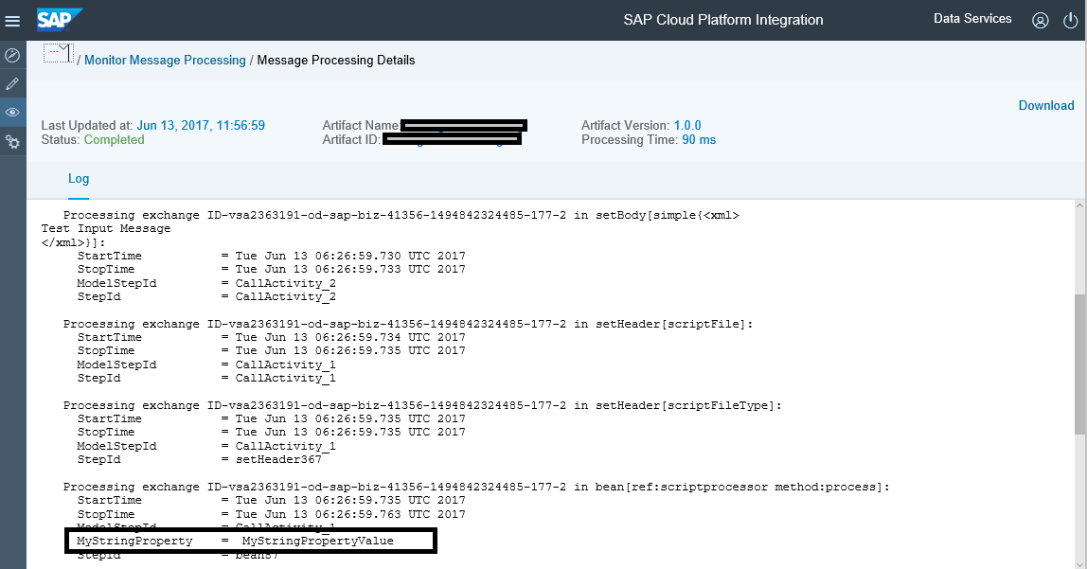

- Adding an attachment to the message processing log: detailed information can be logged into the message processing log by using the addAttachmentAsString on the messageLog object. Using a script step, add all the details to a String object and finally use this object in the above function.
Alternatively, you could use this method to log the payload as a String.

Signature: void addAttachmentAsString(String name, String logValue, String contentType);
Sample: messageLog.addAttachmentAsString(“myAttachment”, stringBody, "text/plain");

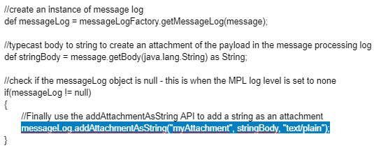
Note that before you issue any command on the messageLog object, you must check if it is null – when the MPL log level is set to none, no MPL object is created.
This method can be used to enter larger log entries.

Results: on adding an attachment using the above script, the message processing log gets an additional tab, one for each attachment:

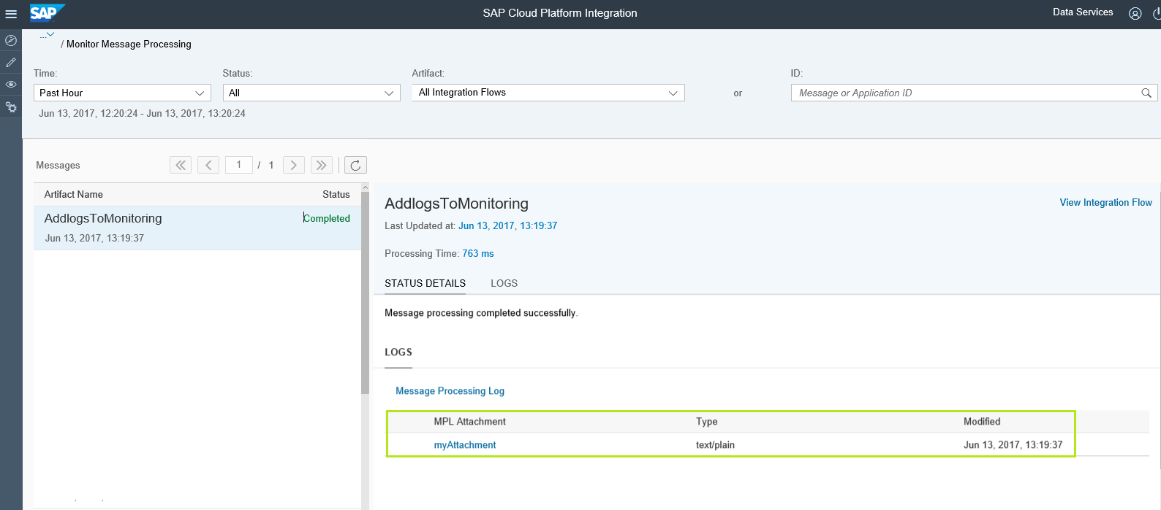

Click on the attachment name to see the content:

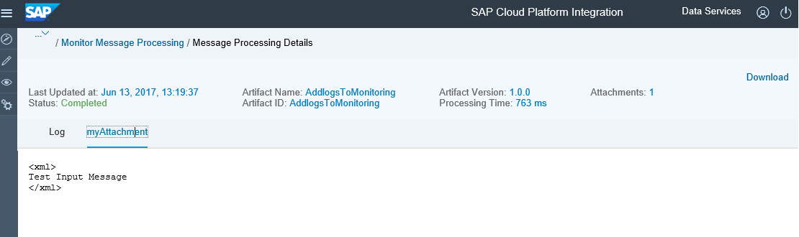
Working integration flow can be found at:
Content hub Discover Cloud Integration - Exemplars Artifacts Add additional logs to monitoring processing log

